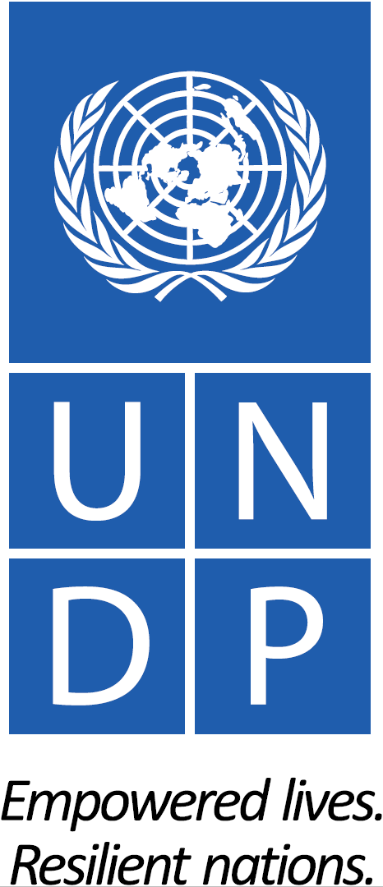 | 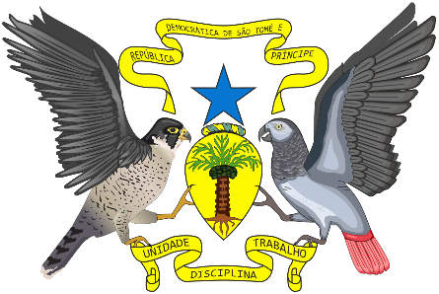 | 
United Nations Development Programme
Project Document for projects financed by the various GEF Trust Funds

Project title: Enhancing Biodiversity Conservation and Sustainable Land and Natural Resource Management
Country:  São Tomé and Príncipe | Implementing Partner: Ministry of Infrastructure, Public Works, Natural Resources and Environment / General Directorate for Environment |  | Management Arrangements:  Supported NIM
Contributing to UNDP Strategic Plan: Under SP OUTCOME 1. Advance poverty eradication in all its forms and dimensions. SP Signature Solution #4 SUSTAINABLE PLANET – PROMOTE NATURE BASED SOLUTIONS FOR A SUSTAINABLE PLANET. SP OUTPUT 1.4.1 Solutions scaled up for sustainable management of natural resources, including sustainable commodities and green and inclusive value chains SP Output Indicator 1.4.1.2: Natural resources that are managed under a sustainable use, conservation, access and benefit-sharing regime: b) Area of existing protected area under improved management, d) Area under sustainable forest management, e) Biodiversity.
Contributing to UNDAF/CPD 2017-2021 OUTCOME “Employment and competitiveness are assured by diversifying the economy and resilience to climate Change, improving the quality of life of poor and vulnerable populations and access to financial aid and markets by youth and women”, OUTPUT 3.3 “Public and private institutions and rural communities are able to apply sustainability principles for better use of natural resources, biodiversity conservation and protection for inclusive growth”.
UNDP Social and Environmental Screening Category: Moderate |  | UNDP Gender Marker: 2
Atlas Award ID: 00112508 |  | Atlas Project/Output ID: 00118062
UNDP-GEF PIMS ID number: 5881 |  | GEF Project ID number: 10007
LPAC meeting date: January 2020 TBC (must be before the CEO endorsement date)

Latest possible date to submit to GEF: 26 Dec 2019
Latest possible CEO endorsement date: N/A
Planned start date: 01 July 2020 |  | Duration/Planned end date: 5 ½ years (66 months) until 31 December 2025
Expected date of posting of Mid-Term Review to ERC:  31 March 2023 |  | Expected date of posting Terminal evaluation report to ERC:  30 November 2025
Key GEF Project Cycle Milestones:
- Project document signature: within 25 days of GEF CEO endorsement
- First disbursement date: within 40 days of GEF CEO endorsement
- Inception workshop date: within 60 days of GEF CEO endorsement
- Operational closure: within 3 months of posting of TE to UNDP ERC
- Financial closure: within 6 months of operational closure
Brief project description: The terrestrial biodiversity and forest ecosystems of São Tomé and Príncipe are under pressure from various threats, especially conversion for infrastructure and agricultural developments and forest degradation from unsustainable exploitation. There is one protected area on each island, however, management is weak due to limited staffing, capacity and financing. The buffer zones are poorly defined, and land and resource use unsustainable. This is compounded by weak legal and institutional frameworks and the absence of land-use planning and environmental law enforcement. There are no attempts to reduce the impacts from charcoal-making, and there are few livelihood options for communities to reduce unsustainable activities. The project aims to “Safeguard globally significant terrestrial biodiversity and ecosystems services by strengthening national capacities and frameworks for biodiversity and natural resource management, integrated land use planning and environmental law enforcement as well as enhancing protected area management and the sustainability of charcoal production” through the implementation of four project components: 1) Enhancing systems and enforcement for biodiversity conservation and integrated landscape and natural resource management; 2) Management, monitoring and financing of PAs and adjacent key biodiversity and forest areas; 3) Reducing forest degradation and ecosystem loss from unsustainable charcoal-making; and 4) M&E, Knowledge Management and Gender.

Financing Plan (USD)
GEF Trust Fund |  |  | 4,262,559
UNDP |  |  | 20,000
- Total budget administered by UNDP |  |  | 4,282,559
Further Co-financing (USD) (not administered by UNDP)
Directorate General for Environment / MOPIRNA |  | In-kind | 516,000
Directorate of Forests and Biodiversity / MAPDR |  | In-kind | 306,000
Regional Government of Príncipe |  | In-kind | 282,000
Birdlife International |  | Grant | 4,550,000
Birdlife International |  | In-kind | 250,000
Valudo |  | Grant | 225,000
Valudo |  | In-kind | 75,000
(2) Total Further Co-financing |  |  | 6,204,000
Total Co-financing |  |  | 6,224,000
(3) Grand-Total Project Financing (1)+(2) |  |  | 10,486,559
Signatures
Agreed by Government Development Coordination Authority  Please add name and position | Signature: |  | Date:  Day Month 2020
Agreed by Implementing Partner  Please add name and position | Signature: |  | Date:  Day Month 2020
Agreed by UNDP  Katarzyna Wawiernia, Resident Representative  UNDP São Tomé & Príncipe | Signature: |  | Date:  Day Month 2020

Table of Contents

I. Development Challenge 8
1.1 Context and overall development challenge 8
1.2 Terrestrial and coastal biodiversity and ecosystems including forests 10
1.3 Marine biodiversity and fisheries 15
1.4 Agriculture and land use 16
1.5 Threats to biodiversity and ecosystems 20
II. Strategy 22
2.1 The long-term solution 22
2.2 Key past and ongoing interventions 22
2.3 The projected baseline scenario 36
2.4 Barriers and theory of change 36
III. Results and Partnerships 38
3.1 Project Description and Expected Results 38
3.2 Project area and sites with map and geospatial coordinates 49
3.3 Alignment with GEF focal area strategy 52
3.4 Incremental Cost Analysis (Baseline vs Alternative Scenario) and Global Environmental Benefits 54
3.5 Local and national project beneficiaries and benefits 56
3.6 Alignment with national convention strategies/plans/reports/assessments and priorities 57
3.7 Relevance to SDGs 60
3.8 Stakeholder engagement and partnerships 61
3.9 Gender equality and empowering women 61
3.10 Social/environmental risks and risks to project success 61
3.11 Innovativeness, sustainability and potential for scaling up 62
3.12 Knowledge Management 63
3.13 South-South and Triangular Cooperation 64
IV. Project Results Framework 65
V. Monitoring and Evaluation (M&E) Plan 69
VI. Governance and Management Arrangements 73
VII. Financial Planning and Management 77
VIII. Total Budget and Work Plan 81
IX. Legal Context 86
X. Risk Management 86
XI. Annexes 89
Annex 1: Recent and ongoing investments relevant in project design 89
Annex 2: Multi-Year Work Plan 97
Annex 3: UNDP Social and Environmental Screening Procedure (SESP) 98
Annex 4: UNDP Risk Log 115
Annex 5: Monitoring Plan 128
Annex 6: GEF Core Indicators at Baseline with GEF PA Management Effectiveness Tacking Tool 133
Annex 7: UNDP Capacity Development Scorecard 135
Annex 8: Project Design Decision Tree / Theory of Change 142
Annex 9: Stakeholders consultations during project design 143
Annex 10: Stakeholder Engagement Plan 153
Annex 11: Gender Analysis and Gender Action Plan 172
Annex 12: Overview of Technical Consultancies and Contractual Services under IP 180
Annex 13: Terms of References 181
Annex 14: Initial Project Procurement Plan (Year 1) 189
Annex 15: Knowledge Management Plan 194
Annex 16: GEF OFP Endorsement Letter 196
Annex 17a: UNDP Support Services: GEF OFP Request Letter 197
Annex 17b: UNDP Support Services: Letter of Agreement 199
Annex 18: Co-financing letters 203
Annex 19: Responsible Party Agreement between UNDP and BirdLife International 209
Annex 20: Threats to biodiversity and ecosystems 222
Annex 21: HCV of São Tomé and Príncipe 234
Annex 22: Boundary definition of the two Natural Parks 243
Annex 23: Environmental Finance Options Matrix – Preliminary Assessment 245

Tables

Table 1: São Tomé and Príncipe forest area in 2015 (estimated by Directorate of Forests and Biodiversity, 2019)
Table 2: Forest area in São Tomé in 2014 (Soares 2017) and Príncipe in 2016 (Freitas 2019)
Table 3: Overview of direct drivers of ecosystem and biodiversity loss (expert opinion by PPG Lead)
Table 4: Existing protected areas in São Tomé and Príncipe
Table 5: Extract from the 8 recommendations formulated by the PNOT Unit to the Government of STP in 2019
Table 6: National Forest Development Plan 2018-2030 strategic & operational objectives (from de Carvalho & al. 2018)
Table 7: Overview of direct drivers of ecosystem and biodiversity loss (expert opinion by PPG Lead)
Table 8: Direct and indirect project support to landscapes of STP, by Component
Table 9: Local Communities targeted by the project
Table 10: Number of direct and indirect beneficiaries disaggregated by gender expected from GEF investment
Table 11: Responsible Parties, Engagement Modalities, Roles and Responsibilities
Table 12: HACT and PCAT Capacity Assessment ratings of Responsible Party BirdLife International, and of DFB and RSESD
Table 13: Co-financing – sources, use and risks

Figures

Figure 1: Location and characterization of São Tomé and Príncipe (bottom map from PNOT, 2019)
Figure 2: Key Biodiversity Areas of São Tomé and Príncipe
Figure 3: Land cover with forest area in São Tomé in 2014 (left, Soares 2017) and Príncipe in 2016 (right; Freitas 2019 – 1: native forest, 2: secondary forest, 3: shade plantations, 4: non-forested)
Figure 4: Records of Critically Endangered Birds (BirdLife International 2019, unpublished database); the orange dotted line shows an estimation of the area of PA and the (poorly defined) buffer zone.
Figure 5: Protected beaches, of priority importance for sea turtles nesting in STP (Programa Tatô)
Figure 6: Agricultural zoning in Sao Tomé, showing especially the prevalence of cocoa shade plantations (cacausal)
Figure 7: Cocoa beans production quantity on São Tomé
Figure 8: Príncipe 2014 cadastre (individual 1.5 ha plots, medium-sized enterprises and glebas; NB: incomplete and somewhat erroneous but best available data/maps)
Figure 9: São Tomé land use and 2014 cadastre (individual 1.5 ha plots, medium-sized enterprises, glebas and palm oil concessions; NB: incomplete and somewhat erroneous but best available data/maps)
Figure 10: Above: Deforestation in Sao Tomé 2009-2012/13 (Source: GeoVille, 2013). Bottom: Heatmaps of timber logging and charcoal production in Sao Tomé and Príncipe
Figure 11: HCV Areas of Sao Tomé
Figure 12: Agencies to involve in institutional streamlining for biodiversity and protected area management
Figure. 13: 5-step charcoal value chain: wood extraction/forest management; carbonisation; transport; distribution, warehousing and retail; and consumption.
Figure 14: Main direct beneficiary communities of the project on Príncipe Island
Figure 15: Main direct beneficiary communities of the project on Sao Tomé Island
Figure 16: Project Organisation Structure

Acronyms

AFD Agence française de développement
AfDB African Development Bank
BD Biodiversity
BLI BirdLife International
CEPF Critical Ecosystem Partnership Fund
CHM Clearing House Mechanism
CR Critically Endangered (IUCN Threat Category)
DD Data Deficient (IUCN Threat Category)
DFB Directorate for Forests and Biodiversity of São Tomé & Príncipe / MAPDR
DGA General Directorate for the Environment of São Tomé & Príncipe / MOPIRNA
EEZ Exclusive Economic Zone
EIA Environmental Impact Assessment
EN Endangered (IUCN Threat Category)
EU European Union
FAO UN Food and Agriculture Organization
FNA National Environment Fund (Fundo do Ambiente)
GDP Gross Domestic Product
GEB Global Environmental Benefits
GOVSTP Government of São Tomé & Príncipe
HACT UN Agencies’ Harmonized Approach to Cash Transfers Framework
HDI Human Development Index
HR Human Resource(s)
IAS Invasive Alien Species
ICCAT Commission for the Conservation of Atlantic Tunas
IMF International Monetary Fund
INE Instituto Nacional de Estadisticas
IP National Implementing Partner / Executing Agency (DGA in the present project)
KBA Key Biodiversity Area
KM Knowledge Management
LC Least Concern (IUCN Threat Category)
LDC Least Developed Country
M&E Monitoring & Evaluation
METT GEF PA Management Effectiveness Tracking Tool
MAPDR Ministry of Agriculture, Fisheries and Rural Development
MOPIRNA Ministry of Infrastructure, Public Works, Natural Resources and Environment
MOF Ministry of Finance
MOU Memorandum of Understanding
MPA Marine Protected Area
MRV Monitoring Reporting and Verification
MSP Medium Sized Project
NBSAP National Biodiversity Strategy and Action Plan
NGO Non-Governmental Organization
NT Near Threatened (IUCN Threat Category)
PA Protected Area
PCAT UNDP Partnership Capacity Assessment Tool
PIF Project Identification Form
PIR GEF Project Implementation Report
PNOST Parque Natural Obô de São Tomé
PNP Parque Natural do Príncipe
PNOT National Land Use and Management Plan (PNOT – Plano Nacional de Ordenamento do Território)
POPP Programme and Operations Policies and Procedures
PPG GEF Project Preparation Grant
RSESD Regional Secretariat for Environment & Sustainable Development, Regional Government of Príncipe
RTA UNDP-GEF Regional Technical Advisor
SGP GEF Small Grants Programme
SIDS Small Island Developing States
SPEA Sociedade Portuguesa para o Estudo das Aves (Portuguese Society for the Study of Birds)
ST São Tomé
STAP GEF Scientific Technical Advisory Panel
STP São Tomé & Príncipe
TT GEF Tracking Tool
UNDP United Nations Development Programme
UNDP-GEF UNDP Global Environmental Finance Unit
UNEP United Nations Environment Programme
UNESCO United Nations Educational, Scientific and Cultural Organization
VU Vulnerable (IUCN Threat Category)

Development Challenge

1.1 Context and overall development challenge
- The Democratic Republic of São Tomé and Príncipe (STP) is a Small Island Developing State located between 220 and 350 km off the coast of western central Africa in the Bight of Bonny/Gulf of Guinea. STP forms part of a chain of extinct volcanic islands stretching from Mt Cameroon in a south-south-westerly direction: first Bioko (Equatorial Guinea), then Príncipe, then São Tomé a further 146 km away straddling the equator, and finally Annobon (Equatorial Guinea). The nearest countries on the continent are Gabon, Equatorial Guinea, Cameroon and Nigeria. The islands have never been in contact with the African mainland, from which they are separated by ocean depths in excess of 3000 m.
- A former Portuguese colony that achieved independence in 1975, STP is Africa’s second-smallest country, after the Seychelles. Its total land area is 964-1001 km2, and its coastline 209 km long. The main island São Tomé has a land area of 824-859 km2 (82,400-85,900 ha; up to 48 km long x 32 km wide) with a highest point of 2,024 m (Pico de São Tomé), the island of Príncipe has a land area of 142 km2 (14,200 ha; up to 30 long x 6 km wide) with a highest point of 948 m, and there are c. 20 associated mostly uninhabited islets.
Figure 1: Location and characterization of São Tomé and Príncipe (bottom map from PNOT, 2019)
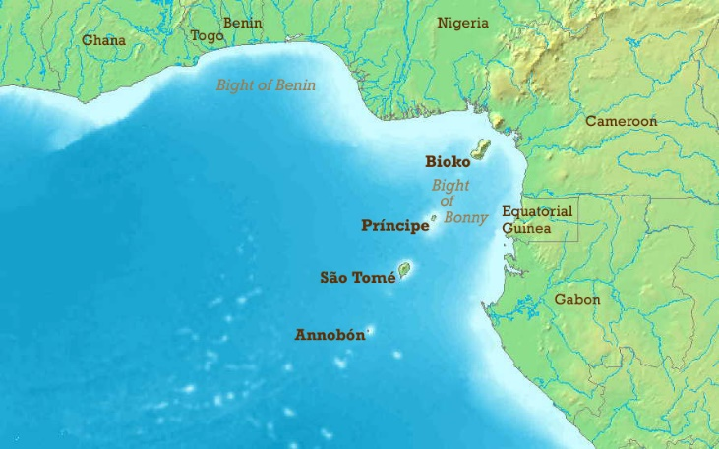
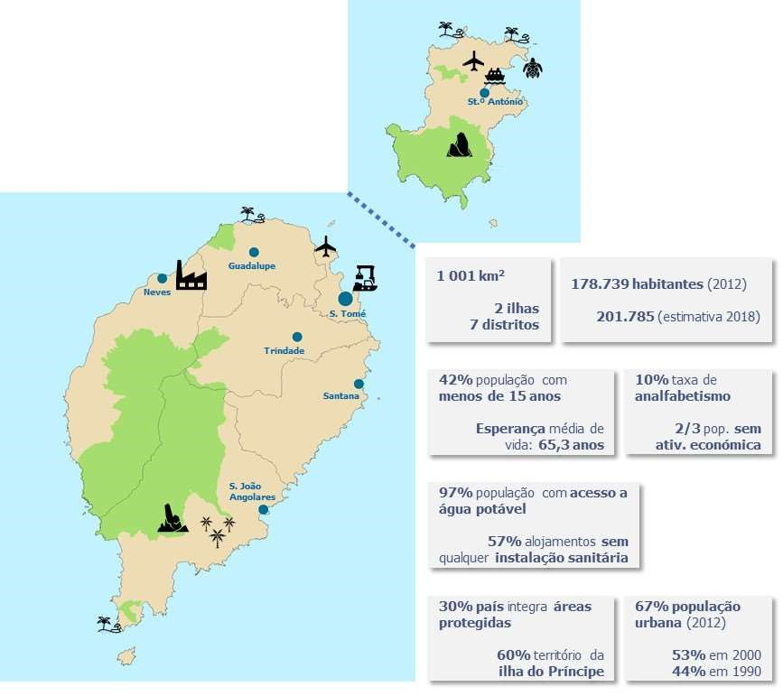

- STP has a population of c. 200,000, of which c. 10,000 live on Príncipe. As the islands are small, population density is high at 200 inhabitants/km2 in São Tomé and 53 inhabitants/km2 in Príncipe. Population growth is high at a rate of between 1.7% (CIA World Factbook) and 2.5% (INE 2012), and more than 60% of the population is under the age of 25. The labour force is estimated at 72,600 (2016, CIA World Factbook). The northern areas of both islands have the highest population densities. São Tomé, the capital city, has roughly a quarter of the nation's population. Santo Antonio is the largest town on Príncipe. The island of São Tomé is administratively divided into 6 districts: Agua Grande, Cantagalo, Caue, Lemba, Lobata, Me-Zochi; while the island of Príncipe was designated a single-district autonomous region in April 1995.
- STP is a Least Developed Country with a small economy and about half or more of the population living below the poverty line (40-70% depending on the source). In 2017, the country’s GDP was USD 393 million (USD 686 million PPP) and its GDP/capita USD 3,200 PPP. GDP growth has been strong over the last years at around 4-5%. The contributions by sectors to GDP were 73% from services (incl. 14% from tourism), 15% from industry (light construction, textiles, soap, beer, fish processing, timber) and 12% from agriculture.
- Over the last years, the government annual budget has been around USD 110 million, of which 90-95% have stemmed from development assistance, noting that aid and investment inflows have been volatile. With a public debt burden of around 90% of GDP, STP has had difficulty servicing its external debt and has relied heavily on concessional aid and debt rescheduling. In 2016, São Tomé and Portugal signed a five-year cooperation agreement worth approximately $64 million, some of which will be provided as loans. In 2017, São Tomé and China signed a five-year cooperation agreement worth approximately $146 million to focus on areas including infrastructure, health, and agriculture. The country is engaged in some austerity measures in line with recommendations by the IMF under a three-year extended credit facility, which involved a recent ban on public service recruitments.
- While other sectors dominate GDP, STP’s primary foreign currency earnings have been based on plantation agriculture. The related exports amounted to c. USD 16 million in 2017, especially from the export of cocoa beans (68% in 2010 per CIA World Factbook, 95% by INE 2015) but also coconut/copra, coffee, palm oil/kernels, cinnamon, pepper, and vanilla. These exports go especially to Guyana 44%, Germany 24%, Portugal 6%, Netherlands 6%, Poland 4% (2017). Agriculture accounts for a significant share of employment on STP – depending on the information source between 26% of the labour force (incl. fisheries and forestry, CIA World Factbook; which would represent c. 18,000 people) and around 60% of the active population (de Carvalho, 2018; which would represent c. 40,000 people).
- The foremost priority of the Government of STP is to expand existing and develop new sources of economic growth and development, to provide employment to its citizens and raise living standards including through a stable provision of electricity. The Government aims to become an international logistical hub and has signed an agreement with China to build a deep-water port to that purpose. In 2019, the 263 ha-large Malanza Free Trade Zone in southern São Tomé was legally created, following efforts by the Trade and Investment Promotion Agency (APCI) with various state entities, in particular the Ministry of Agriculture, Fisheries and Rural Development and the Ministry of Infrastructure, Public Works, Natural Resources and Environment. At the same time, the GOVSTP seeks to further develop fisheries, another major economic activity of critical importance for food security in the country yet not presently important in terms of exports and foreign earnings. Another key objective is to raise production and revenue from plantation agriculture. Significant revenue opportunities also exist in the exploitation of oil & gas resources in STP’s territorial waters in the oil-rich Gulf of Guinea, some of which are being jointly developed with Nigeria; production is several years off but expected to take off at some point.
- At the same time, STP portrays itself as a paradise archipelago and has committed to preserve its unique natural heritage. The island of Príncipe has an ambitious sustainability Vision 2030 and successfully pushed to be designated as a UNESCO Biosphere Reserve. The islands’ offer considerable potential for further development of tourism, and the Government has taken steps to expand tourist facilities in recent years.
- The overall development challenge is how to reconcile the different streams of development objectives and investments, most of which depend on natural resources and ecosystem services and/or will have negative impacts on these. Without a dedicated and continuing effort to protect the islands’ ecosystems and renewable natural resources, continuing population growth and business-as-usual short-termism economic development are prone to lead to the same environmental degradation increasingly observed on other remote island states – undermining long-term sustainability and the achievement of the SDGs as well as STP’s international commitments under the Rio Conventions. The scarce financial resources that the GOVTSP has at its disposition make this particularly difficult.

1.2 Terrestrial and coastal biodiversity and ecosystems including forests
Key biodiversity summary
- Despite STP’s small size, the islands’ tropical climate and relief as well as their geographical location and the isolation from the African continent have given rise to a remarkable wealth in terms of ecosystems and biodiversity. Sometimes referred to as the "Galapagos of Africa", STP is classified amongst the countries with the highest levels of endemic species in the world (RDSTP, 2014), mainly birds, amphibians, plants, bats, reptiles, butterflies and molluscs distributed in different terrestrial and marine ecosystems and habitats (Vaz & Oliveira, 2007).
- STP is part of the Guinean Forests of West Africa biodiversity hotspot (Myers et al. 2000);
- The São Tomé, Príncipe and Annobón moist lowland forests (AT0127) are part of the Congolian Coastal Forests, which are amongst the 200 most threatened WWF terrestrial ecoregions of the world (Olson & Dinerstein 2002), and have been identified as the 3rd most important ecoregion for the conservation of forest-dependent birds worldwide (Buchanan et al. 2011);
- STP has been recognized as Centre of Plant Diversity (WWF & IUCN 1994-1997);
- São Tomé and Príncipe are each classified as an Endemic Bird Area, with "São Tomé Island" (EBA-082) listed as "Critical" and "Príncipe Island" (EBA-083) listed as "Urgent" in terms of conservation need (Stattersfield & al., 1998; BirdLife International, 2019);
- STP holds two Alliance for Zero Extinction sites: the São Tomé Uplands, covering 4,839 ha triggered by the Endangered São Tomé Shrew Crocidura thomensis and São Tomé Giant Reed Frog Hyperolius thomensis; and the São Tomé lowlands, covering 21,832 ha triggered by the Critically Endangered Dwarf Olive Ibis Bostrychia bocagei, São Tomé Fiscal Lanius newtoni and São Tomé Grosbeak Crithagra concolor (AZE 2019);
- STP holds seven Key Biodiversity Areas (five of which are also Important Bird Areas, BirdLife International 2019):
  - São Tomé Low Forest (KBA 6881, IBA ST001), located in the southwest of the island, between the Binda and Quija rivers, the west coast until the confluence of the Ana Chaves and Ió Grande rivers; the area includes the most central part of the Obô São Tomé Natural Park (Pico de Cabumbé, 1,403m); the southern slopes of the Pico de São Tomé massif delimit it to the north; near the coast, some areas of old "capoeiras" in the Binda, São Miguel and Quija streams belong to the site.
  - São Tomé Montane and Cloud Forests (KBA 6882, IBA ST002), which includes the highest areas of 1,000m in the northern part of the Obô São Tomé Natural Park (peak of São Tomé - 2,024 m, Calvário - 1,594 m and peak Ana Chaves - 1,630 m, Amélia Lagoon).
  - São Tomé Northern Savannahs (KBA 6883, IBA ST003), which covers 526 ha on the north coast between Lagoa Azul and Diogo Nunes and includes the vegetation of dry forest and shrubby and herbaceous savannah.
  - São Tomé Obô Natural Park & Buffer Zone (KBA 45720), which covers 45,132 ha mostly over-imposed over other KBAs.
  - Malanza River Mangrove Ecological Zone (KBA 45721).
  - Príncipe Forests (KBA 6884, IBA ST004), covering the southern third of Príncipe from sea level to the summit of the 948m Pico do Príncipe; four other peaks greater than 500 m are included: Mesa (537 m), Pico Papagaio (680 m), Carriote (839 m) and Pico Mencorne (921 m).
  - Tinhosas Islands (KBA 6885, IBA ST005), with Tinhosa Pequena (3 ha) and Tinhosa Grande (20 ha) located 22 km south-south-west of Príncipe.
- Worldwide, the Obô Natural Park, was considered the 32nd most important protected area for the conservation of mammals, birds and amphibians, the 17th if only threatened species are accounted for, and the 2nd ex aequm for the conservation of threatened bird species (Le Saout et al. 2013).
- São Tomé alone holds at least 59 threatened species, including 33 Vulnerable, 22 Endangered and four Critically Endangered (IUCN 2019).

Figure 2: Key Biodiversity Areas of São Tomé and Príncipe
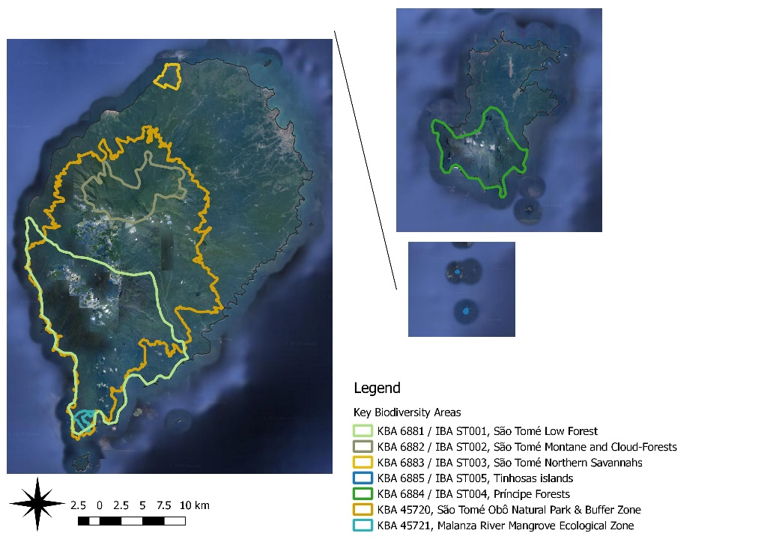
Forest types, cover and plant diversity
- According to Jones et al. (1991) the most complete list of vegetation in São Tomé and Príncipe is that given by Exell (1944, 1956), who carried out detailed samples on both islands in 1932-33. Apart from some very small areas of mangroves and sand dunes on the coast, Exell considered that STP’s original vegetation was made up of tropical rainforests that evenly covered the coastal island almost to the top of Pico of São Tomé. Excell identified different communities depending on island and elevation:
- Lowland forest, from 0 to 800 m altitude: equivalent to Africa’s nearby continental forests. The characteristic species of this formation are, in São Tomé: Rinoera chevalieri, Zanthoxylum thomensi, Drypetes glagra, Anisophyllea cabole and Sorindeia grandifolea; in Príncipe: Rinorea insularis, Ouratea nutans, Casearia mannii, Croton stelluliferus and Erythrococca columnaris.
- Mountain forest, from 800 to 1400 m altitude: presents a slow transition of species, with greater variety than in lower altitude formations, but with a similar general appearance. The trees are tall (30 to 40 m) with dense canopy and the high humidity favours the development of tree ferns, epiphytes, vines and ferns, which cover the trunk of the large trees. The characteristic tree species of these formations are: Trichilia grandifolia, Pauridiantha insularis, Pavetta montícola, Erytrococca molleri, and Tabernaemontana stenosiphon.
- Mist forest, from 1400 to 2024 m altitude: Characterised by high rainfall and humidity, with constant fog and low temperatures, making the trees smaller, dominated by Scheffleras, and rarely exceeding 10m in height. The epiphytes, in particular orchids and ferns, have an important place in these formations. The characteristic trees are: Podocarpus mannii, Baltasaria mannii, Psychotria guerkeana and P. nubicola.
- Coastal formations, including riparian forests and mangrove areas. The mangrove is essentially composed of Rhizophora racemosa, R. harrisonii and Avicennia germinans, and occupies small areas, the most important of which are Malanza, Praia das Conchas, Praia dos Tamarindos, Pantufo and Água-Izé located at the southern end of São Tomé.
- However, the status and distribution of STP’s forests has been exposed to centuries of human occupation. Discovered by Portuguese navigators at the end of the 15th century, the islands have been used to produce plantation crops. Numerous exotic species were introduced (Monod, 1960), modifying and disturbing the ecological balance.
- In consequence, forest distribution evolved as follows:
- Lowland forests largely disappeared in their primary form. Most of the lowland forests and part of the mountain forests were deforested in the northern and eastern areas of the island of São Tomé. Intact areas remain primarily on the less intensely colonised/developed southern part of Príncipe and on the abrupt slopes of southwestern São Tomé (according to the PNOST Management Plan, the last remaining areas of low altitude forests are concentrated around Maria Fernandes, Iô Grande, Angolares, Pico Cão Grande, Caué, Quija, Mussacavu and São Miguel, some of which are in the Buffer Zone, especially around the southeast limit of the Park). In some of the southern parts of both islands, where agricultural crops have been abandoned for several decades, mature secondary lowland forests have developed.
- Mountain and mist forests have not been used for any intensive cultivation or exploitation and have remained in a generally good state of conservation if not entirely protected from human activity, particularly in higher altitude areas.
- According to the degree of anthropogenic modification (Jones 1991), the forests of STP are classified as follows:
- Native (or Primary) forest, includes forest areas that have never been cultivated, with little or no human intervention, made up of natural vegetation, with the sporadic presence of some species introduced and favoured by human action (e.g. Bambusa vulgaris, Musanga cercopioides, Persea americana, Chinchona sp.). The main limitations to the use of these formations were their location in areas of extremely hilly relief (making it difficult or impossible to access and transform them), the climate and the depth and type of soil.
- Secondary forest (capoeira), secondary formations of variable age, in which it is still possible to identify traces of previous use, namely through the existence of a significant proportion of introduced species. Of the same composition as the shade plantation where the main distinguishing factor is the presence or absence of coffee or cocoa plants. These are areas that were used for these crops in the past and are now abandoned. Some of these areas were in fact abandoned several decades ago and tend towards a ‘primary’ formation through natural regeneration. The first areas of coffee and cocoa to be abandoned were probably those located on soils with marginal aptitude, with steep slopes and difficult accessibility, usually on the edge of the primary forest, and now constitute a transition and protection strip for these formations. The secondary forests are host to many endemic species and act as a buffer, protecting the native forest from human influence.
- Shade plantations, marked by the presence of cocoa or coffee crops with a shade canopy of varying density of natural and introduced species but mainly introduced Erythrina sp.; these plantations in the mid-nineteenth century covered about 70% of São Tomé; the importance of this shade forest has suffered important variations, notably due to some attempts to reduce shade, which may have resulted in reduced soil fertility, strong attacks from trips and armillaria infections in cocoa plantations, drastically reducing their production. The species used for shading, in addition to the improvement of cocoa production, additionally responds to objectives of food production and quality wood production.
- Savannah and other un-forested areas. This includes the north-east region of São Tomé (Praia das Conchas and Lagoa Azul areas), the region of the country with the least precipitation (<1,000 mm/year), with two well marked dry seasons and with the mildest relief of the archipelago. This area is covered by a mosaic of herbaceous savannah interrupted by small tree and shrub formations of small dimensions that, due to the absence of a continuous tree cover, contrast strongly with the rest of the country. It is believed that these formations resulted from the intense deforestation and frequent fires that have been practised since the beginning of colonisation, particularly for sugar cane cultivation. Adansonia digitata stands out for its silhouette, and the presence of Ziziphus mauritania, Capparis tomentosa, Parkia biglobosa and Borassus aethiopium in this area should also be mentioned.
- STP’s latest official Forest Resources Inventory dates back to 1999 (ECOFAC). However more recent estimates are available: i) an estimate for the 2015 forest area by the Directorate of Forests and Biodiversity (Table 1); and ii) forest cover data/layers prepared by two master theses under the universities of Porto and Lisbon for Sao Tomé in 2017 (based on data from 2014) and for Príncipe in 2019 (based on data from 2016) (Table 2 and Figure 3). Both datasets show the prevalence of shade plantations, at 29-32%.
- Recent PA management plans indicate plant species richness at 1,200 species of flora in the archipelago, of which around 900 are indigenous (100 pteridophytes and 800 spermatophytes) and about 300 are introduced. There are 148 endemic plant species (14% of the national flora), of which 50 are restricted to Príncipe, 98 are restricted to São Tomé and 25 are shared endemics) (NBSAP 2015-2020). The most representative angiosperm families are Rubiaceae (27 species), Orchidaceae (135 species with 35 / 23% endemic), Euphorbiaceae (11 endemic species), Melastomataceae (17 species with 8 / 47% endemic), Begoniaceae (11 species with 6 / 55% endemic). Only 90 of STP’s plant species have been assessed regarding their conservation status on the global IUCN Red List (which include few of the endemic taxa, and many dated assessments).
Table 1: São Tomé and Príncipe forest area in 2015 (estimated by Directorate of Forests and Biodiversity, 2019)
Forest type | Area (ha) | Area (%)
Primary Forest | 28,000 | 28.3
Secondary Forest | 27,000 | 27.3
Shade Plantation | 32,000 | 32.3
Other Areas | 12,000 | 12.1
Total | 99,000 | 100

Table 2: Forest area in São Tomé in 2014 (Soares 2017) and Príncipe in 2016 (Freitas 2019)
# | Name | Príncipe Island |  |  | Sao Tomé Island |  |  | Total
# | Name | Area (ha) | Distribution (%) |  | Area (ha) | Distribution (%) |  | Area (ha) | Distribution (%)
1 | Native Forest | 3,478.50 | 25.0% | 90.8% | 22,607.80 | 26.4% | 85.5% | 26,086.30 | 26.2% | 86.2%
2 | Secondary Forest | 4,926.96 | 35.4% | 90.8% | 26,120.30 | 30.5% | 85.5% | 31,047.26 | 31.2% | 86.2%
3 | Shade Plantation | 4,237.13 | 30.4% | 90.8% | 24,418.25 | 28.5% | 85.5% | 28,655.38 | 28.8% | 86.2%
4 | Non-Forest | 1,274.41 | 9.2% | 9.2% | 12,423.30 | 14.5% | 14.5% | 13,697.71 | 13.8% | 13.8%
 | TOTAL | 13,917 | 100.0% | 100.0% | 85,569.65 | 100.0% | 100.0% | 99,486.65 | 100.0% | 100.0%

Figure 3: Land cover with forest area in São Tomé in 2014 (left, Soares 2017) and Príncipe in 2016 (right; Freitas 2019 – 1: native forest, 2: secondary forest, 3: shade plantations, 4: non-forested)
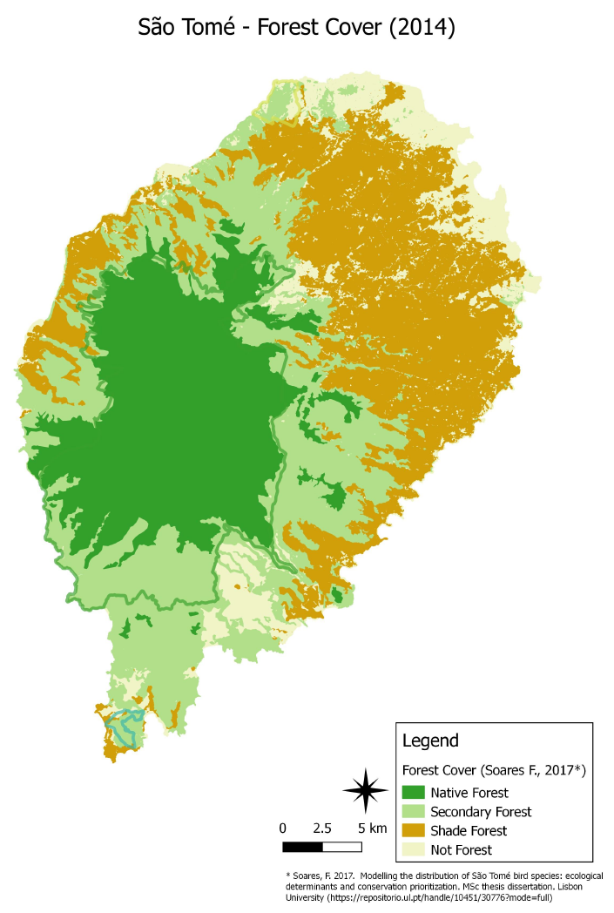 | 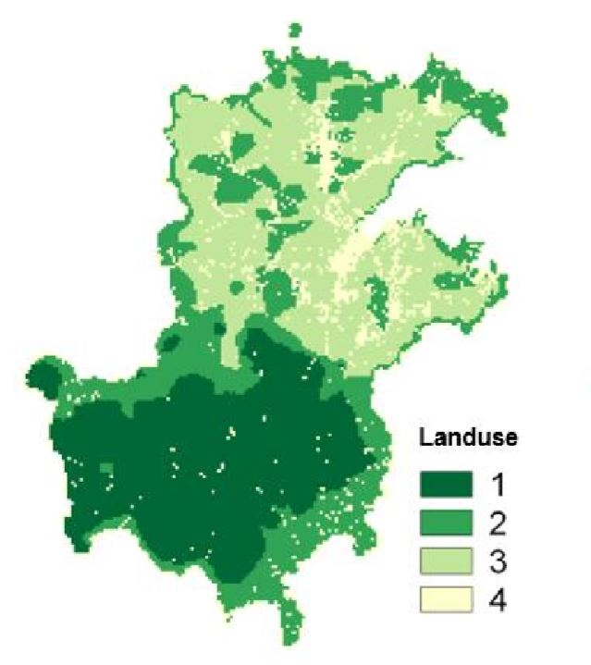
Land fauna diversity
- As implied in the key biodiversity summary, STP is rich also in terms of faunal diversity.
- Knowledge of invertebrates is still limited, and a comprehensive study is required to provide an overall understanding of presence and distributions of invertebrates, as well as their conservation status. However, isolated studies have established inter alia that endemism is high among land snails, with about 60 endemic species in São Tomé, Príncipe and Annobon, including one endemic family and six endemic genera (Gascoigne, 1994); and that among butterflies, São Tomé has 64 endemic species and Príncipe 45, 28 of which are shared among them (Pyrcz, 1992 in Carvalho, 2015; versus NBSAP 2015-2020: 89 species of butterflies in STP, 47 in ST and 42 in Príncipe with an endemism rate of 38% and 21% respectively). The West African Giant Snail (Archachatina marginata) was introduced to the island.
- Native vertebrates include 60 endemic taxa. On São Tomé, native terrestrial mammals include 2 endemic shrews (São Tomé Shrew Crocidura thomensis EN and Fingui White-Toothed Shrew Crocidura fingui on Príncipe) and at least 10 bat species (4 endemic species and 1 endemic subspecies, including São Tomé Collared Fruit Bat Myonycteris brachycephala EN and São Tomé Free-tailed Bat Chaerephon tomensis EN; versus NBSAP 2025-2020: two species and three endemic subspecies on ST, and one endemic species and one endemic subspecies on Príncipe).
- Aside from bats and shrews, all larger mammals were accidentally or deliberately introduced after the arrival of the colonizers in 1471. Along with the classic introductions of dogs, cats, rats and domestic animals including feral pigs (Sus domesticus), African Civet (Civettictis civetta LC) and Least Weasel (Mustela nivalis) were introduced, probably to combat rodents in agricultural areas. Moreover, Mona Monkey (Cercopithecus mona LC) were introduced to São Tomé.
- The terrestrial and freshwater herpetofauna of STP consists of 30 species. This includes 22 species of reptiles, of which c. 18 are currently considered endemic including all eight snake species: São Tomé Cobra Naja peroescobari, São Tomé House Snake Boaedon bedriagae, and São Tomé Wood Snake Philothamnus thomensis on São Tomé; Fea’s Beaked Snake Letheobia feae and Newton’s Beaked Snake Letheobia newtoni on both São Tomé and Príncipe islands; Príncipe Green Snake Hapsidophrys principis, Elegant Worm Snake Afrotyphlops elegans and an undescribed species of brown house snake Boaedon sp. on Príncipe. Other endemic reptiles being Greeff’s Giant Gecko Hemidactylus greeffii, Príncipe Giant Gecko Hemidactylus Príncipensis, Príncipe Burrowing Skink Feylinia polylepis, Guinea Lidless Skink Panaspis africanus, São Tomé Leaf-litter Skink Panaspis thomensis, Adamastor Skink Trachylepis adamastor, Trachylepis Príncipensis, Trachylepis thomensis. In addition, there 8 amphibians all of which are endemic: São Tomé Caecilian Schistometopum thomense LC in ST; Peters' River Frog Phrynobatrachus dispar LC in STP; São Tomé Puddle Frog Phrynobatrachus leveleve LC in ST; Newton's Grassland Frog Ptychadena newtoni EN in ST; São Tomé Oceanic Treefrog Hyperolius molleri LC in ST; São Tomé Giant Reed Frog Hyperolius thomensis EN in ST; as well as Drewes' Reed Frog Hyperolius drewesi DD and Palm Forest Tree Frog Leptopelis palmatus VU endemic to Príncipe. The IUCN conservation status has not been reliably established for most of these taxa.
- The islands harbour at least 89 species of birds, by far the most studied taxa in STP. There are 28 breeding endemics (21 on ST and 7 on Príncipe), including 62 land bird, 12 sea bird and 20 water bird species. 13 species (15%) are globally threatened (4 CR, 5 EN, 4 VU; plus 4 NT), including the smallest ibis Dwarf Olive Ibis Bostrychia bocagei CR, São Tomé Grosbeak Crithagra concolor CR, Newton's [São Tomé] Fiscal Lanius newtoni CR, Príncipe Thrush Turdus xanthorhynchus CR, São Tomé Olive-pigeon Columba thomensis EN, São Tomé Green-pigeon Treron sanctithomae EN, Cape Gannet Morus capensis EN, Grey Parrot Psittacus erithacus EN, Príncipe White-eye Zosterops ficedulinus EN, São Tomé Short-tail Amaurocichla bocagii VU, São Tomé Scops-owl Otus hartlaubi VU, São Tomé Oriole Oriolus crassirostris VU, and finally the world's largest sunbird Giant Sunbird Dreptes thomensis VU (http://datazone.birdlife.org/country/sao-tome).
- The breeding avifauna encompass forest, savannah, water, shore and seabirds. Most of the endemics are found in the forests; but bird surveys done in 2015 and 2016 (BirdLife International, 2017) also recorded 26 species (including 10 endemic) in the mangroves of Príncipe and 29 species, including the São Tomé Green Pigeon Treron sanctithomae EN and São Tomé White Eye Zosterops feae NT, both endemic in the mangroves of São Tomé (Haroun & al., 2018). Around 60 bird species, as well as the endemic bat Chaerephon tomensis, have been described in the savannah ecosystem of São Tomé, including 3 species of global conservation concern and several restricted-range species. However, it is probable that most or all the 16 savanna species were originally introduced by man at least a century ago, as cage or gamebirds.
- The seabird colonies of Príncipe and the surrounding islands are the largest of the tropical eastern Atlantic Ocean including the Gulf of Guinea. Surveys conducted in 2017 (Bollen et al. 2018) revealed eight seabird species, of which six were confirmed to be breeding. Around Príncipe, Boné de Joquei is the present main stronghold for Brown Boobies Sula leucogaster and White-tailed Tropicbirds Phaethon lepturus. The important Tinhosas Islands hold an estimated 300,000 seabirds, predominantly Sooty Terns Onychoprion fuscatus, but also Brown Boobies, Black Noddies Anous minutus and Brown Noddies Anous stolidus (Valle & al., 2016). The more accessible seabird colonies have disappeared.
- The diversity, endemism and importance of STP’s avifauna has led to the declaration of five IBAs on the islands (see § 10).

Figure 4: Records of Critically Endangered Birds (BirdLife International 2019, unpublished database); the orange dotted line shows an estimation of the area of PA and the (poorly defined) buffer zone.
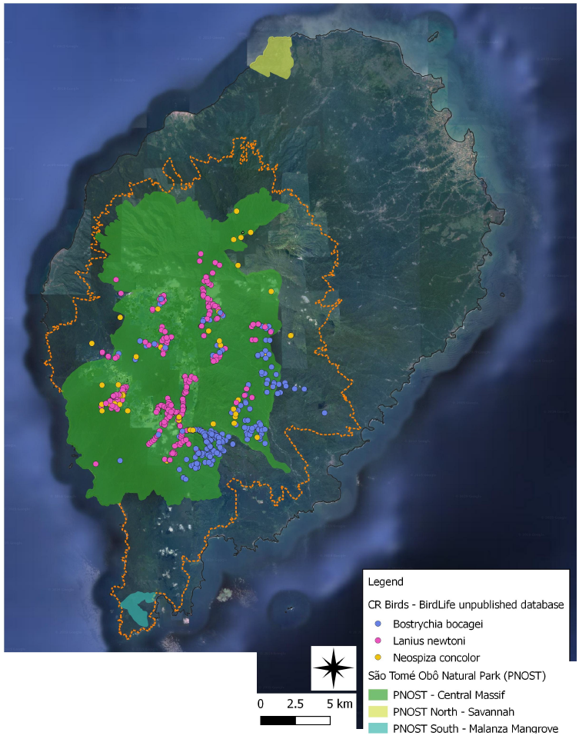

1.3 Marine biodiversity and fisheries
- The archipelago of STP has a large maritime territory of 160,000 km2, however, its marine ecosystems/biodiversity and resources remain relatively poorly studied and understood.
- STPs maritime territory holds or forms part of two Ecologically and Biologically Sensitive Areas (EBSAs):
- The Tinhosas Islands located between São Tomé and Príncipe, which provide important nesting habitat for over 300,000 migratory seabirds (see §10 and 24 above) but also attract key marine megafauna.
- The Equatorial Tuna Production Zone, which encompasses portions of the coastal waters of Gabon, Congo, Equatorial Guinea and STP, and is important for the life cycles of several large, commercially valuable, pelagic, migratory fish species.
- Noteworthy established records include Scalloped Hammerhead Shark Sphyrna lewini EN, Sunfish Mola mola, Whale Shark Rhincodon typus, manta rays Manta sp. There are important nursing and recovery sites for Humpback Whale Megaptera novaeangliae. The coral reefs host great marine biodiversity including threatened fish species of high importance in terms of ecosystem functionality and composition, such as Atlantic Blue Marlin Makaira nigricans, Oceanic Whitetip Shark Carcharhinus longimanus, Sandbar Shark Carcharhinus plumbeus and Sand Tiger Shark Carcharias taurus.
- Marine surveys conducted around Príncipe in 2016 identified key biodiversity areas in the Baia das Agulhas (West) and Baia de Abade (East). In Príncipe and in the south of São Tomé (Caué district), there is considerable overlap between the key areas of ecological importance and the preferred fishing sites, which negatively impacts resident, transient and migratory species.
- Of the seven species of sea turtles globally, five occur in STP including four that nest on the islands’ beaches:
- Loggerhead Caretta caretta VU the only species not nesting;
- Hawksbill Eretmochelys imbricata CR, which on São Tomé most often uses the beaches of the southern part;
- Leatherback Dermochelys coriacea VU, which on São Tomé equally most often uses the beaches of the southern part;
- Green Turtle Chelonia mydas EN, quite common on the beaches of São Tomé and Príncipe.
- Olive Ridley Lepidochelys olivacea VU, which uses the beaches of the north of the island of São Tomé to breed.
Figure 5: Protected beaches, of priority importance for sea turtles nesting in STP (Programa Tatô)
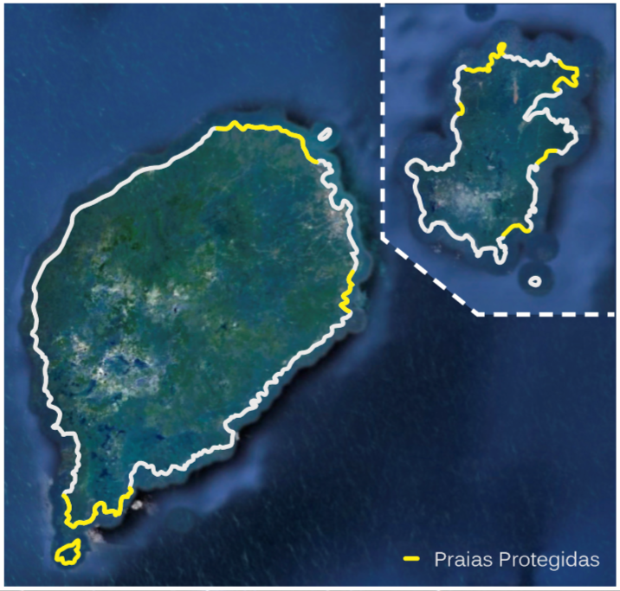

- STP’s fisheries resources are/were vast, however statistics are poor and inconsistent. Fishing potential was estimated to between 12,000 T/year (DG Pescas) and 29,000 T/yr (large pelagics 17,000, coastal pelagics 4,000, demersal 2,000, cephalopods 6,000; ICCAT).
- Approximately 5,000 people are involved in local fisheries and sales, and a further 30,000 people benefit economically indirectly from this activity. Net income from fishing on the islands is around €10 per day on Príncipe and up to €81 per month on São Tomé. Fishing is primarily artisanal and the organisation of the sector very rudimentary. While semi-industrial fisheries are only emerging, STP has no national industrial fishing vessels but enters into fishing agreements with countries and foreign operators with industrial fishing fleets. There are 44 landing sites (29 on São Tomé and 15 on Príncipe).
- STP has a long tradition of fish consumption, with an average of 24 kg/capita/year, well above the world average (17 kg/capita/yr) and the average in Africa (8 kg/capita/yr). This represents 70% of the animal protein ingested by the population, which in the world average is only 15%. Fisheries resources are therefore critical for food security and nutritional quality in STP.

1.4 Agriculture and land use
- STP agriculture has long been dominated by cash crops, most notably sugar cane, coffee and cocoa. Today, cocoa remains the main crop representing between 68-95% (depending on information source) of the export income generated. The remaining export crops are coffee, coconut/copra, palm oil/kernels, flowers, pepper, cinnamon, vanilla and other spices. The production for the local food market focuses especially on banana, rice, tubers, beans, cassava, vegetables and breadfruit. Most of the rural population engaged in agriculture do so in a context of subsistence economy in which self-consumption predominates and only production surplus is sent to markets for sale. Transformation resources are limited and rudimentary (PNOT 2018). Food production is insufficient to meet domestic demand wherefore most food must be imported to the country. Increasing production across the different agricultural sub-sectors to enhance food security and income levels is a key priority.
- The agricultural production systems include
- i) annual and perennial crop systems under open skies (i.e. with tree cover removed; including mixed horticultural production areas at 700-1000 m asl, other crops like pepper and vanilla at 200-600 m, and monospecific plantations at lower elevations of sugar cane, coconut palm, oil palm on São Tomé [AgriPalma], and pineapple on Príncipe);
- ii) different agroforestry systems: cocoa, sometimes in association with banana and matabala; coffee, sometimes in association with banana and matabala; coconut, sometimes in association with cocoa; and palms in association with cocoa. Figure 2 above shows how agroforestry/shade plantations dominate the landscape in STP, and Figure 6 shows how much of this are cocoa plantations (cacausal) in São Tomé.
Figure 6: Agricultural zoning in Sao Tomé, showing especially the prevalence of cocoa shade plantations (cacausal)
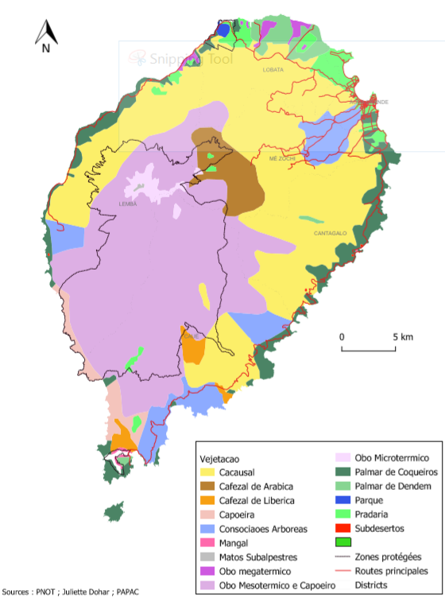
- Today there are four types of rural land ownership/tenure in STP (see distribution in Fig. 9):
- Private plantations claimed by a few families from before independence, called glebas (8 glebas @ 284 ha avge = c. 2,300 ha);
- Private smallholder plots distributed to family farms under a World Bank land reform in the early 1990s (c. 12,000 plots @ 1.7 ha avge = c. 20,000 ha);
- Private medium-size plots distributed to private enterprises/investors under the said land reform (162 plots @ avge 43 ha = c. 7000 ha);
- A few larger plantations newly granted to larger enterprises and cooperatives, such as Agripalma (oil palm, 2,100 ha planted of the 4,917-ha concession in the south of São Tomé), SATOCAO (the largest private cocoa producing and exporting company in STP) and CECAB (Cooperativa de Exportação do Cacau Biológico).
- Public lands (much of which is under forest).
- As per the above, about 30% of STP’s land area (c. 30,000 ha of c. 100,000 ha) is under private agricultural plots.
- The tenure of the plots distributed under the 1990s land reform is not passed on to the next generation, which creates a fragile situation and discourages investment. Compounded by limited financial and technical support, this had led to a gradual decline in cash crop production over the last decades (especially cocoa, Fig. 6) as well as to an over-exploitation of natural resources in the aforementioned plots. Many small and medium sized plots and glebas have been abandoned (needs assessment but estimated 40% on Príncipe). Most of the country's agricultural infrastructure is in poor condition, except for those associated with export crops held by larger enterprises and or cooperatives.
Figure 7: Cocoa beans production quantity on São Tomé
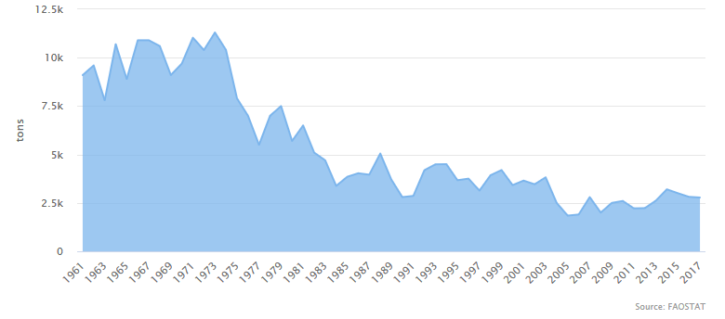
- Livestock production is modest providing 14% of agricultural production and 3% of GDP. Livestock production satisfies the essential food needs of the population. About half of farming families produce livestock and the vast majority are backyard farmers; of these, more than half are women.
- Agricultural land use data from 2011 indicates that about 51% of STP/ST’s land area was used for agriculture – 41% for permanent crops, 9% for annual crops and 1% for permanent pasture; 28% were forests ad 21% other forms of land use. Irrigated lands were estimated at 100 km2 (2012).
Figure 8: Príncipe 2014 cadastre (individual 1.5 ha plots, medium-sized enterprises and glebas; NB: incomplete and somewhat erroneous but best available data/maps)
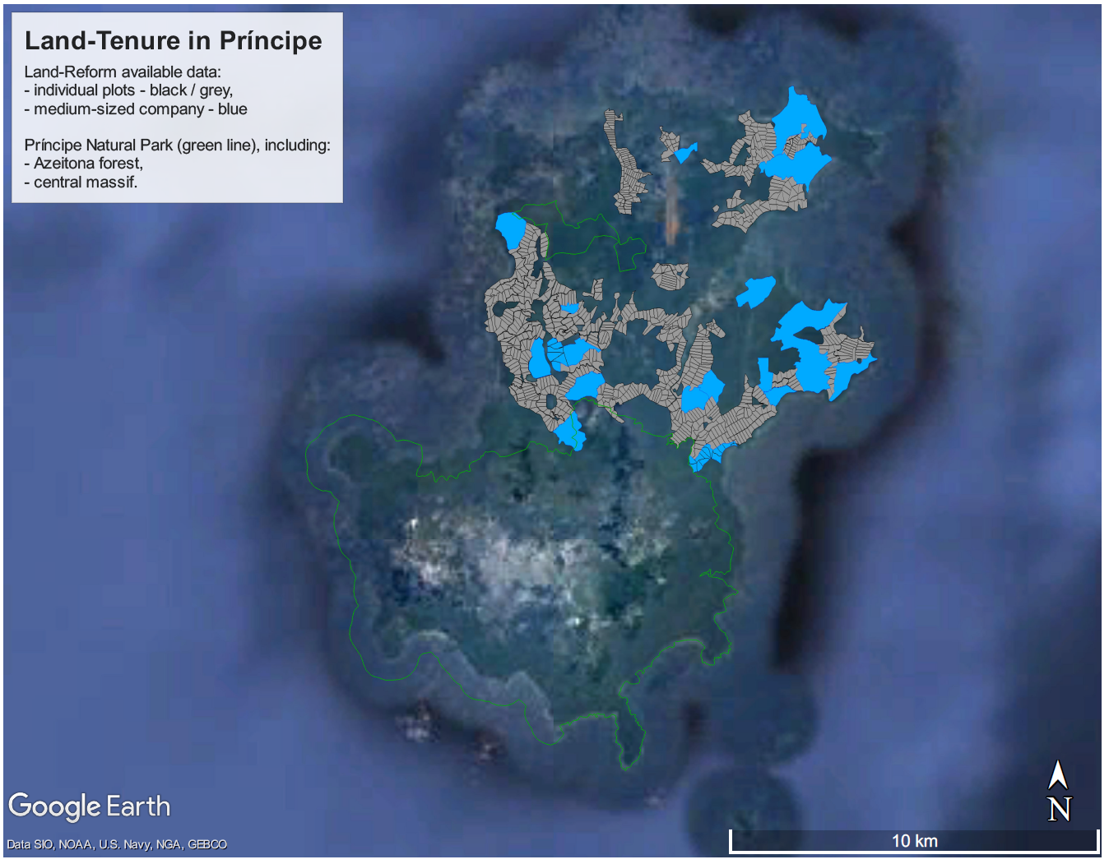

Figure 9: São Tomé land use and 2014 cadastre (individual 1.5 ha plots, medium-sized enterprises, glebas and palm oil concessions; NB: incomplete and somewhat erroneous but best available data/maps)
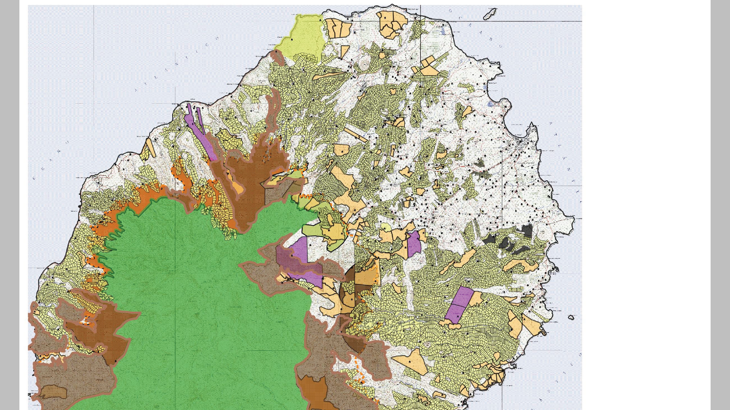
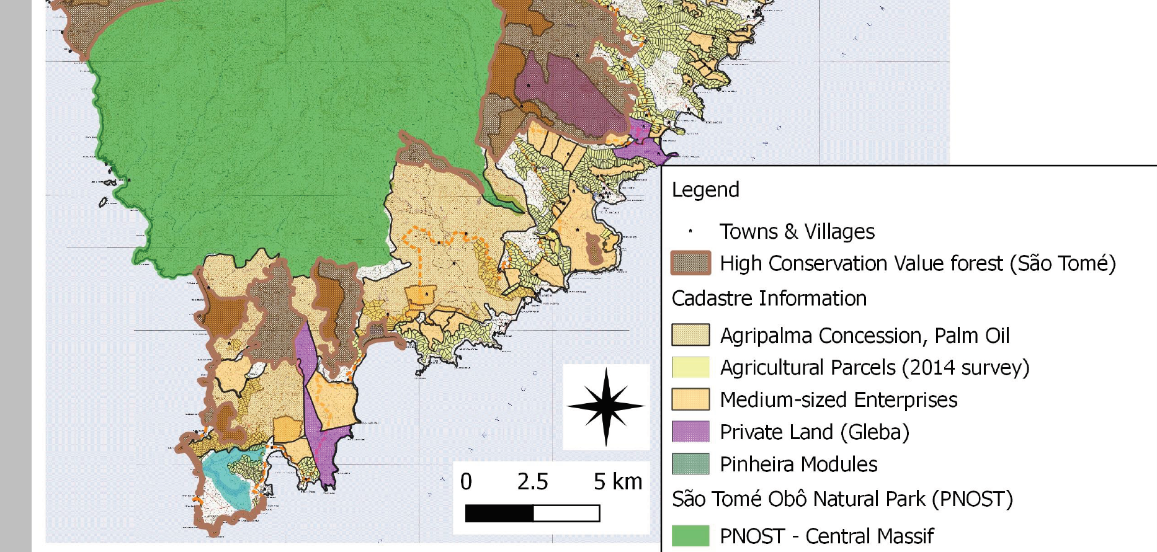
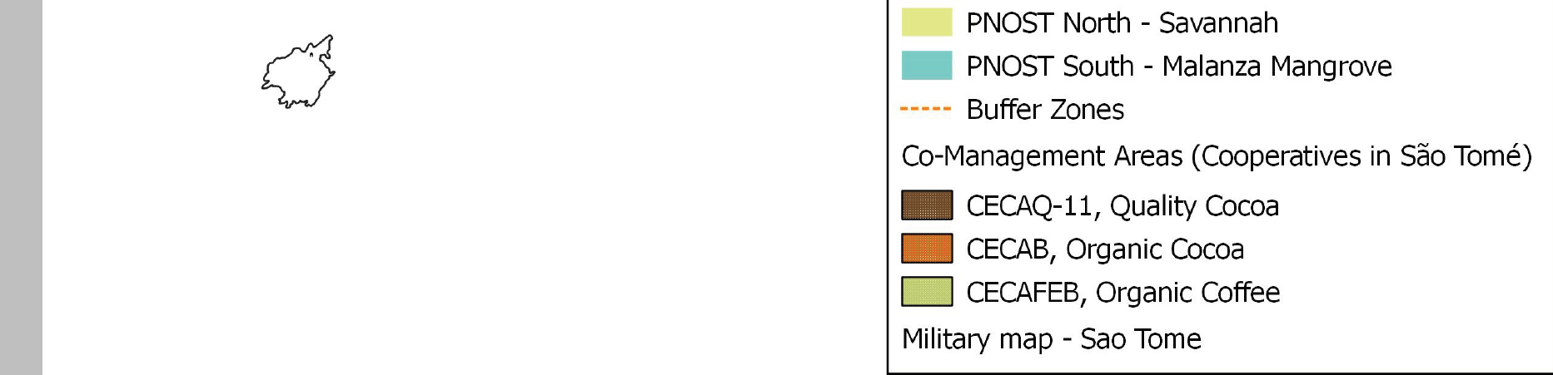

1.5 Threats to biodiversity and ecosystems
- Human activities are causing increasingly harmful impacts on the integrity and long-term outlook of the islands’ natural and productive ecosystems.
- The PPG prepared a comprehensive threat assessment that can be found in Annex 20. This is summarised in Table 3.
Table 3: Overview of direct drivers of ecosystem and biodiversity loss (expert opinion by PPG Lead)
Category | Current Urgency Ranking (L-M-H) | Threat / direct driver of loss and impact
Marine biodiversity and ecosystems
1. Habitat loss | L | Limited evidence but impacts can be expected from dynamite fishing and at specific locations from port construction and possibly sedimentation
2. Natural resource use and over-exploitation | H | Unsustainable and harmful fisheries and related impacts
2. Natural resource use and over-exploitation | H | Sea turtles: capture, egg collection and bycatch
3. Pollution | M-H | Chemical pollution including pesticides from rivers and urban waste emissaries
3. Pollution | M-H | Plastic pollution
3. Pollution | M | Noise pollution from shipping and seismic activities
3. Pollution | L | Pollution with hydrocarbons from oil & gas exploitation, not yet started
4. IAS | L | No reports yet
5. Climate change | L | Impacts on fish stocks and marine food chain expected, manage for resilience
Terrestrial biodiversity and ecosystems
1. Land-use change and habitat loss | H | Habitat loss from large-scale infrastructure developments
1. Land-use change and habitat loss | H | Forest habitat loss from large-scale agricultural developments
1. Land-use change and habitat loss | M-H | Forest, mangrove and savanna habitat loss for small-holder agriculture
1. Land-use change and habitat loss | M-H | Loss of sea turtle nesting beaches from sand mining
1. Land-use change and habitat loss | M-H | Habitat loss from urbanisation and related infrastructure, especially in coastal and rural areas
2. Natural resource use and over-exploitation | H | Forest degradation from unsustainable and illegal selective logging: Logging for timber
2. Natural resource use and over-exploitation | H | Forest degradation from unsustainable and illegal selective logging: Logging for charcoal-making
2. Natural resource use and over-exploitation | M | Unsustainable exploitation of NTFP
2. Natural resource use and over-exploitation | M-H | Wildlife hunting and collection
2. Natural resource use and over-exploitation | M | Disturbance from human presence in the forest
3. Pollution | M | Impacts of pesticides on freshwater species
4. IAS | M | Evidence for IAS animals and plants. No evidence yet for systemic and predation impacts yet these can be surmised, with risks for CR bird spp.
5. Climate change | L | Impacts on biodiversity and ecosystems expected, manage for resilience

- The PPG concluded that in terms of relative urgency for biodiversity and ecosystems, the current priory threats requiring interventions are
- For marine biodiversity and ecosystems, the over-exploitation of fisheries resources and sea turtles;
- For terrestrial biodiversity and ecosystems, the land conversion for large-scale infrastructure and agriculture developments, and the over-exploitation of forest resources from largely illegal timber logging and charcoal-making
- The priority threats identified above for terrestrial ecosystems respond also directly to the priority needs under the land degradation focal area, as evidenced by the country’s national voluntary targets towards Land Degradation Neutrality adopted in 2018, which commit the country to:
- Reduce the conversion of forests and savannas to other land uses to less than 5% by 2030;
- Reduce illegal logging from 85% to 15% by 2030;
- Improve the charcoal manufacturing process by 50%, by 2030, thereby improving productivity (efficiency) and reducing waste
- The maps in Figure 10 highlight the scale and distribution of the priority threats.
- Considering the baseline investments detailed in the following chapters and the fact that the project was at PIF stage conceived as a BD & LD MFA, the PPG concluded that the originally planned integration of the marine environment (marine biodiversity, marine protected areas) was an overreach and that the project should focus its attention on the priority threats on terrestrial ecosystems.
Figure 10: Above: Deforestation in Sao Tomé 2009-2012/13 (Source: GeoVille, 2013). Bottom: Heatmaps of timber logging and charcoal production in Sao Tomé and Príncipe
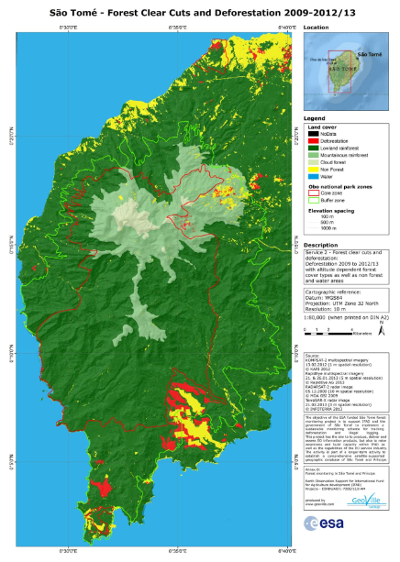 | Main causes of deforestation over the period (red):  North:  - Slash & burn agriculture,  - Unregulated fires,  - Charcoal production,  - Urbanization.  Center:  - Horticulture  South:  - Large red/yellow area: AgriPalma oil palm plantations (the survey period coinciding with the investment phase of the AgriPlama plantation)  - Malanza, Porto Alegre in the far south: firewood, urbanisation & construction (tourism), charcoal (in mangrove area)  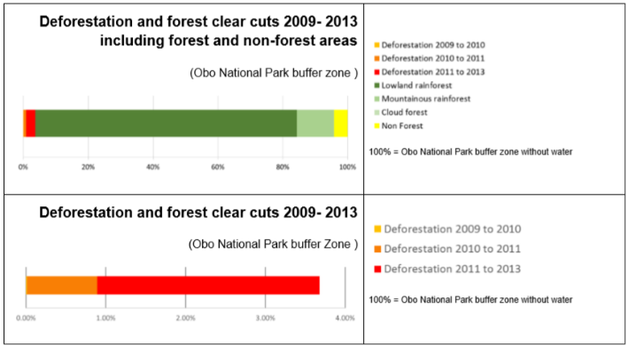
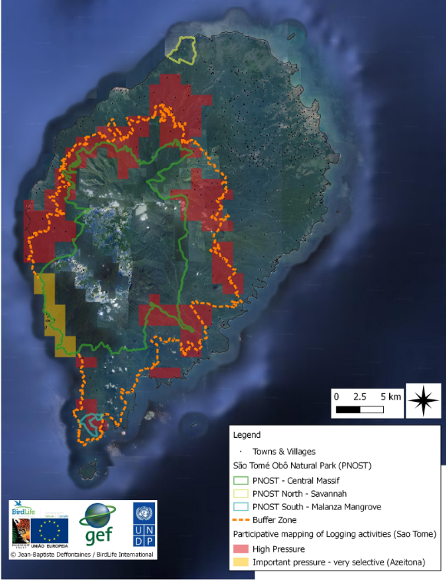 | 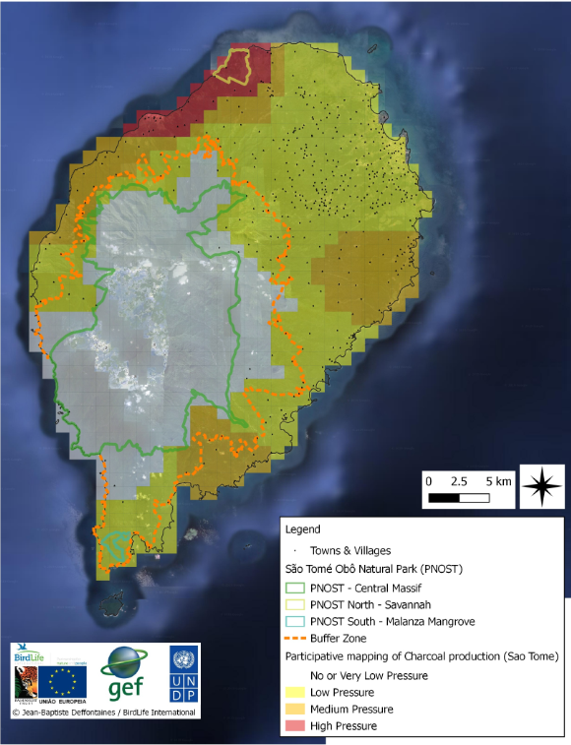

Strategy

2.1 The long-term solution
- The long-term solution to the above-described challenges and threats is that the terrestrial biodiversity and high conservation value forest ecosystems in São Tomé and Príncipe are effectively protected in adequately financed and managed protected areas, avoiding the loss of globally important species and habitats, and that forest ecosystem services and natural resources are maintained and sustainably managed in well-defined buffer zones and across the wider landscape through effective integrated land-use planning and management, compliance with environmental law, the successful establishment of a new sustainable coconut-based charcoal value chain, and the reorientation of high-impact traditional charcoal-makers to new livelihood activities.

2.2 Key past and ongoing interventions
- To determine how the project will contribute to the above long-term solution, the PPG conducted an exhaustive analysis of the situation and interventions that the government and its partners implemented in relation to the above challenges in the past, and those that are ongoing and planned for the coming years. Annex 1 provides details on recent and especially ongoing projects and investments. The following section will explain the situation with key recent interventions for different aspects.
Biodiversity science, protected areas, buffer zones and HCV forests
The National Protected Areas System
- In 2006, under the EU-funded ECOFAC-IV project, the greater parts of the best-preserved forests on the two main islands, São Tomé and Príncipe, were designated as two Natural Parks (Law n. º 06/2006 / Lei De Parque Natural, Obô, de São Tomé & Law n. º 07/2006 / Lei De Parque Natural, Obô, do Príncipe).
Table 4: Existing protected areas in São Tomé and Príncipe
Name | Type | Description | IUCN  Cat. | Size (ha) | Year Established
Obô Natural Park of São Tomé (PNOST) | Forest | Central massif, mountainous area in the southern-western centre of ST | II | 25,274 ha | 2006  (Law 6/2006)
Obô Natural Park of São Tomé (PNOST) | Savannah Littoral | Protected Landscape Area of Praia das Conchas / Lagoa Azul in northern ST | V | 25,274 ha | 2006  (Law 6/2006)
Obô Natural Park of São Tomé (PNOST) | Mangrove | Malanza Mangrove Natural Reserve, in southern ST | IV | 25,274 ha | 2006  (Law 6/2006)
Obô Natural Park of Príncipe (PNP) | Forest | Príncipe forests, in the south of the island | II | 6,500 | 2006  (Law 7/2006)
Obô Natural Park of Príncipe (PNP) | Forest | Azeitona forest, in the northwest of the island | IV | 6,500 | 2006  (Law 7/2006)
Príncipe Biosphere Reserve | Forest Coastal Marine | Príncipe and islets Bom Bom, Boné do Jóquei, Mosteiros, Santana, Pedra da Galei, Tinhosa Grande and Tinhosa Pequena, as well as the surrounding marine habitats |  | 71,593 ha | 2012, but it has no national legal statute

- The two Natural Parks each cover nearly one-third of the island on which they are located (see Fig. 14 and 15), and their boundaries are well defined in the respective laws (see Annex 22).
- In addition, these laws provided the delimitation of a transition area or “buffer zone” around the Parks, in which only specific low-impact activities would be allowed: “There shall also be a buffer zone that, except in situations of physical impossibility, extends beyond the limits of the Park, in a strip whose width may vary between 250 meters and 10 kilometres” (RDSTP 2006, Article 5 No. 2). However, the buffer zones were never formally decreed. Law 6/2006 indicated that the “boundaries of the PNOST, like also its protection zone, are indicated in the map annexed to the present document”, yet the annex was not included in the law journal upon publication. In consequence, the interpretation of the buffer zones has been arbitrary, based on projects and expert opinions and is also not adequately conveyed to stakeholders; buffer zone maps must therefore be treated with caution, as they do not reflect the reality in legal terms or on the ground.
- In addition, the smaller areas of the disjunct NPs are commonly interpreted as not having buffer zones (e.g. Savanna area in ST and Azeitona forest on Príncipe).
- A first set of PA management plans was developed in 2006, which were reviewed and updated in 2010 and again in 2015. The main objectives following the recommendations of the PA Management Plans are:
- Reduce illegal logging and its impacts on the forest ecosystem;
- Prevent the clearing of new forest areas;
- Control the negative impacts of invasive species;
- Protect areas of distribution of endemic and/or threatened species and improve the conservation of ecosystems and endemic species, in and around the Protected Areas, and the protection of important areas for Critically Endangered species;
- Reduce current collection levels and capture pressure on protected species (especially for endangered species);
- Control the use of Park facilities (trails, infrastructures), particularly for tourism purposes.
- However, the latest updates do i) not provide zoning for the diverse and vulnerable habitats/species in the NPs; ii) not support sustainable land-use in the buffer zone; and iii) not consider the current capacities of the PAs (de Lima, 2016).
- Obô Natural Park of São Tomé (PNOST). The PNOST presents a discontinuous territory, covering three distinct areas (see Table 4) comprising a total of 25,327 ha (or 25,274 ha). PNOST has no permanent human settlements and is uninhabited, due to the relief, high rainfall and difficult access. It is these factors that, in general, have ensured the absence of major negative impacts by human action.
- The sustainable management of the Park and the surrounding buffer zone should provide overall benefits in terms of biodiversity conservation and ecosystem services, as well as enable and provide socio-economic benefits to communities living near the forest, through co-management and sustainable production of raw materials and Non-Timber Forest Products.
- Although the STP government and other stakeholders have shared the aspiration to sustainably manage the Natural Park since its designation 13 years ago, the management is not yet operational. The regulation for PNOST was never decreed and enacted, and the resources and capacities of the authorities for the implementation of the Management Plan are far below needs. Deforestation and forest degradation have been increasing and natural resources are in decline in the NP and especially its buffer zone.
- While there is some awareness of the boundaries of the PA wherefore encroachment from agricultural conversion is not severe, no sustainable management rules or practices are applied in areas around the NP. There are no differences in terms of land use and resource exploitation between the buffer zone and the wider agricultural landscape, except for the gradient caused by ease of access. There are significant areas in the buffer zone where forest vegetation has been largely if not entirely removed for farming purposes, logging and charcoal-making; this includes most notably the oil palm plantations in southern São Tomé which converted important buffer zone areas to the border of the NP.
- Obô Natural Park of Príncipe (Príncipe Natural Park, PNP). The Príncipe Natural Park was created with the aim of protecting the most representative ecosystems of the southern zone of the island of Príncipe, occupying one third of the island's surface, including a marine part along the south-western coast of its boundaries.
- PNP is divided into two geographically distinct zones; the main section in the south covering the entire mountainous region of the island, including Picos do Príncipe, Agulha, João Dias Pai, João Dias Filho, Papagaio, Cariot and Mercone; and the significantly smaller Azeitona Forest in the north-western part of the island.
- The southern section of PNP has no permanent human settlements and is uninhabited (except for a semi-permanent fishing community at Praia Grande). This is partly due to the relief, high rainfall and difficult access. It is these factors that have ensured the absence of major negative impacts by human action (Albuquerque & Cesarini, 2009).
- The Azeitona forest is separated from the southern block of the PNP and surrounded by communities and private concessions. There is no respect of the park boundary, as it was never properly enforced, and there has been a continuous invasion of the area, with local communities constructing a growing number of houses. The invasion is happening on all sides but is highest on the road from Ponta do Sol to Sundy Roça (pers. com. Daniel Ramos, Technician of the PNP). Small-scale subsistence agriculture, firewood and charcoal production are encroaching on the PA area. The recent development of the project “Terra Prometida”, which will host more than 100 persons, relocated from Sundy Roça (led by UN-Habitat with funding from a private touristic investment from HBD), in 1 to 2 years (construction undergoing), is situated right at the border of the Azeitona forest, on the other side of the road. It will potentially increase drastically the threat on the northern part of the PNP by increasing pressure on forest resources.
- As in the case of PNOST, the buffer zone stipulated in the law was never decreed. The main PA area in the south of the island was meant to be surrounded on its landward northern border by a buffer zone of between 500 and 2000 m, mostly too narrow a strip. There were no plans for a buffer zone around Azeitona Forest.
- As in the case of PNOST, there are no differences in terms of land use and resource exploitation between the buffer zone and the wider agricultural landscape, except for the gradient caused by ease of access. There are areas in the buffer zone where forest vegetation is being reduced for farming purposes and charcoal-making.
- Príncipe Biosphere Reserve and Marine PAs. In 2012, the entire island of Príncipe, its islets Bom Bom, Boné do Jóquei, Mosteiros, Santana, Pedra da Galei, Tinhosa Grande and Tinhosa Pequena, as well as the surrounding marine habitats were classified as a UNESCO Biosphere Reserve with a total of 71,593 ha. The Biosphere Reserve aims to contribute to the protection, valuation and enhancement of the existing natural heritage, in a perspective of enlargement and dissemination of scientific knowledge; and promoting tourism and sustainable development. The designation, supported by UNESCO HQ, reflects a paradigm shift led by the regional autonomous government, as it intends to promote the Biosphere Reserve as an example of sustainable development in action. To date, the Biosphere reserve has no legal status in STP.
- There is a lack of clarity regarding the definition and interpretation of the different zones of the Biosphere Reserve. One source indicates the zoning being: core land area 6,044 ha; core marine area 11,199 ha; buffer zone land area 1,447 ha; buffer zone marine area 10,323 ha; terrestrial transition zone for economic use 6,499 ha; marine transition zone for economic use 36,082 ha. The management plan however stipulates that outside the NP, on the one hand, and outside the urban area of the capital Santo Antonio and the airport, on the other hand, the island should be entirely considered buffer zone (IUCN IV).
- The Tinhosas Islands to the south of Príncipe were declared a Ramsar wetland of international importance in 2006 (23 ha, Ramsar Site # 1632). There are presently no marine protected areas in STP. The Príncipe Biosphere Reserve includes a core marine area of 11,199 ha around the south of Príncipe and the Tinhosas Islands, but this was not yet transposed to national law.
- Other areas under permanent conservation regime. The Forest Law (RDSTP 2001) establishes the existence of the Forest Regime of Permanent Conservation or Non-Productive Protection. This includes forests located on the banks of rivers and watercourses, around lakes, ponds and springs, or any natural or artificial reservoirs, on the tops of hills, mountains and other areas at high altitudes. However, in many cases, these areas have been occupied for agricultural and human settlement purposes, factors that encourage illegal hunting and logging, the destruction of habitats and, consequently, forest degradation and impact fauna & flora in these areas (de Carvalho & al., 2018).
- Authorities responsible for the protected areas system. The current, exclusively terrestrial, protected areas system is presently overseen and managed through a Department for Natural Parks in the Directorate for Forests and Biodiversity under the Ministry of Agriculture, Fisheries and Rural Development – which delegates its functions on Príncipe to the Regional Secretariat for Environment and Sustainable Development with its Department for the Biosphere Reserve and Natural Park. The PNOST Department in DFB presently has 8 core staff, while the PNP Department in Príncipe has 7 core staff.
- However, DGA also has a Department for Nature Conservation and Biodiversity Management and there are structural overlaps. It is unclear who will become responsible once a set of marine PAs eventually becomes legally gazetted, noting that neither DFB, nor DGA, nor the Directorate for Fisheries would have the appropriate mandate and capacity.
- Please see the organigrammes for the DFB, DGA and RSESD in Annex 10.
High Conservation Value (HCV) forests in São Tomé
- In 2019, BirdLife International, SPEA and the CE3C Research Centre of the University of Lisbon in 2019 conducted a preliminary assessment of High Conservation Value forests in São Tomé – a detailed description of which is provided in Annex 21.
- Based primarily on an assessment of biodiversity values, 19 separate HCV forest areas were identified (Fig. 11), linked to species diversity (HCV1), to landscape-level ecosystems and mosaics (HCV2), to ecosystems and habitats (HCV3), to ecosystem services (HCV4), community needs (HCV5) and cultural value (HCV6).
- Most of these 19 HCV forest areas are in the PNOST and its buffer zone. However, six are outside the current interpretation of the buffer zone (which however is arbitrary and not legally decreed as explained above) – and their conservation can largely be attributed to the fact that other areas offered easier access and provided enough natural resources to meet demand.
- The lack of sustainable management of the buffer zones and the advanced stage of forest degradation or loss in some of the buffer zone areas, together with the existence of HCV forests outside of the buffer zone, asks for a slight redefinition and revision of the conservation areas on ST – especially the boundaries of the buffer zone, if not also for limited amendments of the NP boundary. In addition, (some of) the areas could be designated Special Reserves under Article 21 of the Law on the Conservation of Fauna, Flora and Protected Areas (RDSTP 1999), that provides for the “existence of restricted areas in size in which conservation and management are necessary to ensure the existence or reproduction of certain resident or migratory species, communities of flora or fauna”.
- The preliminary HCV forest area boundaries were drawn also to be easily identified on the ground and to avoid overlap with agricultural plots and concessions.
- More recent work on the flora and fauna of Príncipe Island indicates that a similar approach to the designation and management of the buffer zone that integrates HCV forest areas and criteria would be appropriate to ensure better protection of biodiversity (GTC, 2018).
Figure 11: HCV Areas of Sao Tomé

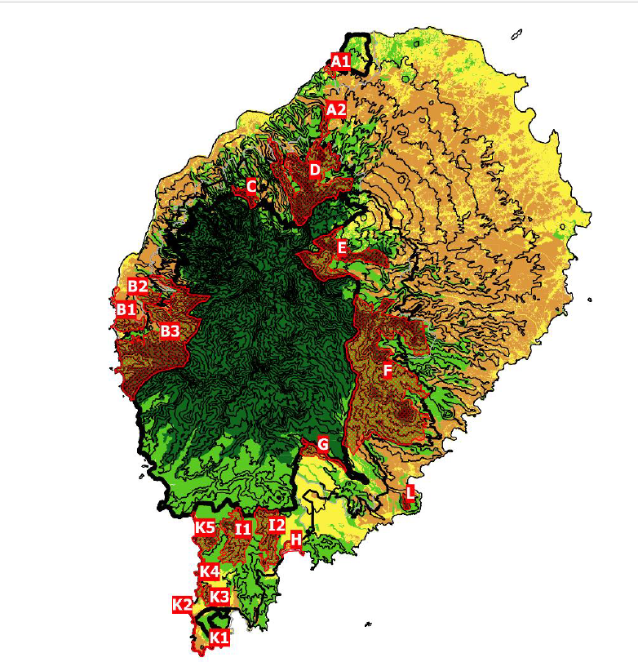 | The background shows the 100 m altitudinal isolines (thin black lines), over-imposed on São Tomé’s preliminary land-use (native forest – dark green; secondary forest – light green; agroforest – orange; non-forested – yellow). The Obô Natural Park is shown by the thick black line and the buffer zone by the intermediate black line (ECOFAC IV). In grey is a proposed alternative to the boundaries of the buffer zone.
  Code | Name | Area (ha)
  A1 | Praia de Plancas | 33.7
  A2 | Ribeira Funda | 110.3
  B1 | Ponta Furada | 254.9
  B2 | Claudina | 143.0
  B3 | Morros de Bindá | 2,165.6
  C | Contador | 100.4
  D | Chamiço | 1,498.8
  E | Zampalma | 846.4
  F | Maria Fernandes | 3,982.9
  G | Vila António | 152.9
  H | Praia Grande | 76.3
  I1 | Cão Pequeno | 506.3
  I2 | Sarcinda | 494.1
  K1 | Praias do Sul | 60.2
  K2 | Jalé | 45.5
  K3 | Cantagalo | 97.8
  K4 | Xixi | 62.3
  K5 | Mussacavú-Willy | 245.9
  L | Pico Macurú | 35.5

Recent and ongoing donor-funded projects
- Apart from the work by various local and international NGOs and universities – BirdLife International (most notably with EU/ECOFAC funding since 2018), Fundacao Príncipe, FFI, OIKOS, University of Coimbra, Missouri Botanical Gardens and others – the baseline situation on PA management was very weak, especially on São Tomé, wherefore much basic work remains necessary, while at the same time the presence of technically strong organisations introduces advanced elements such as on science and monitoring.

- The following details relevant projects that were recently been implemented and/or are planned for the near future:
- Projects under BirdLife International including ECOFAC-6. The EU-funded ECOFAC (Écosystèmes Forestiers en Afrique Centrale) programme is part of a regional initiative that focuses on the conservation of forest ecosystems. ECOFAC began its operations in São Tomé and Príncipe in 1995 under the responsibility of the then Directorate of Forestry, with the aim to establish protected areas on both islands and put systems in place for their management as well as sustainable utilisation of their buffer zones. The successive ECOFAC projects contributed to the establishment of the two Ôbo Nature Parks, initial development of ecotourism services including community-managed lodges, hiking trails and the establishment of the Botanical Garden at Ôbo Nature Park in São Tomé, promotion of agro-forestry practices in buffer zones, support to biodiversity-related research programmes, and under ECOFAC-5 the development of a protected area management plan for 2015-2020. From 1005 to the end of ECOFAC-5, the ECOFAC projects in STP were implemented by Government, with mixed success.
- The ECOFAC-6 project started in 2018 ($2,214,400, 2018-2022), and is for the first time in STP being implement through an NGO – BirdLife International. It is implemented via a consortium of NGOs that in addition includes OIKOS, SPEA, RSPB and the local NGO Fundação Príncipe. The project aims to reinforce the management of the two NPs, to mainstream biodiversity in development decision-making, to create new models for the management of the buffer zone involving communities, and to raise new sustainable finance for the PAs working focusing especially on tourists.
- BirdLife is leading on two further projects in STP:
- “Sao Tomé’s buffer zone hotspot: A unique landscape for people and nature”, with SPEA/University of Lisbon and funded by Rainforest Trust ($210,890, 2018-2022); under this project High Conservation Value forest areas were mapped on ST, to provide the evidence base for site prioritisation, protection and management, and developing Land-Use Models for these; it supports the Protected Area Management Committee and integration in existing forest management platforms.
- “Securing a sustainable future for the Guinean Forests - São Tomé and Príncipe Component”, expected to be funded by Fondation Prince Albert II de Monaco ($122,091); it aims to ensure the long-term sustainability of high conservation value forest and landscape connectivity through direct conservation action, holistic land-use management and a transition to forest-compatible livelihoods; ensuring alignment with BirdLife-led initiatives in cross-sector forest conservation efforts across the region, and contributing to the global dialogue on sustainable landscape strategies.
- These three projects led by BirdLife, most notably ECOFAC-6, taken together represent one of the two most important baselines for the present DGA/UNDP/GEF-6 project, and during the PPG a full integration and complementarity of the respective activities was achieved.
- Additional projects:
- Fundação Príncipe /FFI/University of Coimbra/Missouri Botanical Garden/Príncipe Forest Department project, funded by GTC - Global Tree Campaign ($127,270, 2019-) “Taking action for Príncipe’s threatened trees”, which aims to train and support capacity of local people to create and implement recovery plans for three threatened tree species (Chytranthus mannii, Strephonema sp. and Carapa gogo); understand social context and human pressures for the species; conduct research to understand their biology and reproduction; establish an experimental nursery for propagation and to develop a germination protocol aiming the reinforcement of the wild populations; support the government in implementing and reviewing existing legislations regarding forest use and to embed the action plan for the target species on the Management Plan of Ôbo National Park; conduct a pilot study on regeneration of Strephonema sp. inside the area of the Natural Park using reinforcement plantation; draft a participatory best practices guide for sustainable bark and fruit collection of Chytranthus mannii; support the Forest Department using the regional list of threatened species and recovery plans created by the project to improve the quality of the Forest Department's procedures and activities as law enforcement, permits and criteria for logging, especially for Carapa gogo.
- Univ of Coimbra/CIAT/PNOST project funded by CEPF ($45,460, 2017-2020) “National Herbarium: Reference for the Knowledge and Conservation of the Diversity of São Tomé and Príncipe Plants”, which aims to support the structure and technical capacities of the National Herbarium in São Tomé, and ultimately to safeguard the unique and still poorly assessed botanical knowledge of the Island. Activities include: capacitation of local human resources in herbarium techniques and identification at the University of Coimbra; the granting of specific equipment to the ST Herbarium to follow up with cataloguing activities; botanical collecting missions for the herbarium conducted with experts from UC in the three Key Biodiversity Areas of São Tomé, gathering data to fill gaps for poorly assessed plants; mentoring of local technicians; involve local users (traditional healers, field guides); promote botanical knowledge and biodiversity awareness. Expected outcomes of the proposed requalification of the National Herbarium of São Tomé and Príncipe, include 1) To document and conserve the flora diversity of São Tomé and Príncipe, constituting itself as a reference collection for future projects; (2) Fill gaps in the taxonomy of the flora of the archipelago, as well as their distribution, ecology and uses; (3) Support management measures and design strategies for the conservation of endangered habitats and species, (4) Act as a center of science education and communication
- Alisei/Monte Pico/PNOST/BirdLife project funded by CEPF ($24,840, 2018-2020) “Save the São Tomé Giant Snail: Learning and Teaching to Preserve”, which aims to safeguard the endemic Giant Land Snail, Archachatina bicarinate; it will create a conservation breeding Centre as a tool to involve, aware and educate local communities about the conservation of the PNOST; update the IUCN Red List status by obtaining fundamental knowledge about the species’ ecology and biology; investigate the threats affecting the species, including on factors that influence and/or favour the entrance of the introduced invasive West African Giant Land Snail inside the limits of the Natural Park and its interaction with the endemic species.
- Fundação Príncipe/FFI GFWA/COOPAPIP project funded by CEPF ($199,248, 2017-2019) “From Bee-burners to Beekeepers: Supporting Community Beekeeping Organization in Príncipe”, which aims to establish beekeeping and agroforestry as sustainable livelihood options in and around the Príncipe Natural Park to incentivise better management of forest habitat, threat reduction to the western honey bee and restoration of degraded areas.
- Fundação Príncipe/FFI GFWA/SPEA project funded by CEPF ($99,999, 2017-2020) “Implementing the Action Plan for the Critically Endangered Príncipe Thrush”, which aims to train and support capacity of local people to address knowledge gaps identified in the Action Plan for the Príncipe Thrush (Turdus xanthorhynchus); understand social context and human pressures on the bird; and support the government in implementing and reviewing existing legislations regarding forest use, the Príncipe Thrush Conservation Action Plan and the PNP Management.
- Fundação Príncipe/Missouri Botanical Garden/Univ of Coimbra/Herbarium of STP/BirdLife project funded by CEPF ($227,643, 2019-2020) “Characterization of the threatened flora of São Tomé and Príncipe”, which aims to identify the endangered plant species of São Tomé and Príncipe and rigorously evaluate their conservation status according to the criteria and categories of the IUCN Red List; document, and if necessary, improve the network of Key Biodiversity Areas in the archipelago; build local capacities by training two botanists and two para-taxonomists; disseminate relevant information to stakeholders involved in biodiversity management.
- OIKOS/PNOST project funded by CEPF ($206,906, 2019-2020) “Participatory management of Malanza and Praia das Conchas mangroves”, which aims to update and implement participative management plans for mangroves of Malanza and Praia das Conchas, in the São Tomé Natural Park, to conserve the last mangrove forests of São Tomé; increase scientific knowledge of ecosystems; implement mangrove conservation and enhancement measures; constitute, train and animate mangrove management committees.
- Fundação Príncipe/FFI/PNP project funded by FFEM ($31,795, 2018-2019) “Understanding the remarkable biodiversity of Príncipe Island”, which aims to collect valuable data and build local capacity for research and conservation through the implementation of field surveys for birds and molluscs, providing information for the update of the PNP Management Plan and the development of a Conservation Action Plan for the Obô Land Snail.
- Fundação Príncipe/FFI/OIKOS/MARAPA project funded by Blue Action Fund ($ 2,867,200, 2019-2023) “Establishing a network of marine protected areas across São Tomé and Príncipe through a co-management approach [Omali Vida Nón (Príncipe) and Kike da Mungu (São Tomé)]”, which aims to support the designation of the first Marine Protected Areas (MPAs) across the country and help to create effective marine protection through a network of participatory fisheries management and conservation zones; by promoting sustainable fishing practises and investment into the supply chain; facilitating participatory zoning of MPAs and sustainable use zones; supporting the development of monitoring protocols and building up patrolling skills to enable fishers to control co-management areas; developing local incentives to promote community support and buy-in to conservation measures through enhanced marine product value and increased participation in marine resource management; and a study assessing the feasibility of establishing long-term financing mechanisms to support MPA management.
- Fundação Príncipe/Governo Regional da Ilha do Príncipe/HBD Príncipe, funded by Kosmos/Arribada Intitiative/ Príncipe Government/Oak Foundation/Rufford/HBD Príncipe ($120,000, Ongoing) “Sea Turtle Project - PROTETUGA”, wich aims to enhance the conservation status of the three nesting sea turtle species on Príncipe by building the necessary local capacity to ensure their effective protection both on land and at sea; by i) protection and monitoring the sea turtle populations covering 80% of the nesting beaches and surrounding waters through nocturnal beach patrols, diurnal marine patrols and engaging focal points in the local coastal communities to map areas that turtles use to feed, rest or are interacting with trash around island’s coast. ii) education and awareness to promote and strengthen interdisciplinarity and transversality in all actions undertaken, raise awareness of the island's urgent environmental needs, focusing on the threats faced by sea turtles locally, thereby ensuring the integration and support of communities in specific protection and conservation actions. iii) research to better understand the biology and ecology of sea turtles that choose the beaches and waters of the island to feed and reproduce and to find the most effective conservation solutions to the problems and threats they face.
- Programa Tatô/MARAPA ($167,570 per year, ongoing) “Programa Tatô - Sea Turtle Conservation”, which promotes adequate protection, of sea turtles; monitoring and management of critical nesting areas of sea Turtles; strengthens the capacities of local communities and national technicians as future leaders for the management, protection, conservation and awareness of sea turtles; develops legal economic alternatives for former hunters and traders of sea turtles; increases communication, awareness and education on the social, economic and ecological value of sea turtles.
- Fundação Príncipe/UNESCO Príncipe Biosphere Reserve project funded by the Aga Khan Foundation ($45,000, 2018-2021) “COBIO-NET”, which focuses on coastal biodiversity and food security in peri-urban Sub-Saharan Africa: assessment, capacity building and regional networking in contrasting Indian and Atlantic Oceans.
Environmental mainstreaming and land use planning
- DGA is the government authority responsible for designing and implementing policies related to the environment and ecosystem preservation (see the DGA organigramme in Annex 1). It is therefore the lead agency on environmental mainstreaming. DGA’s specific attributions are to i) guarantee the effective application of laws and other environmental policy instruments, through evaluation and monitoring (most importantly through EIA); ii) collaborate in the elaboration of an integrated environmental policy, ensuring multisector coordination and oversight; iii) create and coordinate the National Environmental Information System and produce statistical indicators; iv) accreditation of companies in the environmental area; v) collaborate in the definition of a waste management policy; vi) encourage the development of new technologies in the environmental area; vii) coordinate the integration of environmental issues in international relations. DGA also has a Department for Nature Conservation and Biodiversity Management whose function overlaps with the one of DFB. The EIA process could be significantly strengthened in terms of process planning, conduct, consultations, formal criteria and transparency.
Integrated land-use planning and management
- A Law on Land-Use Planning was adopted in 1991 (Law 3/1991) yet it has not been applied except on limited urban planning aspects and no agency has a mandate on integrated land-use planing and management.
- Since 2016, however, MOPIRNA has been implementing a project funded by the African Development Bank (USD 2,435,840) that was tasked with preparing a first National Land Use and Management Plan (PNOT – Plano Nacional de Ordenamento do Território 2018) and related outputs. MOPIRNA as national partner responsible for project implementation created a temporary structure for this purpose that brought together a series of technicians from several relevant government departments. Draft products including a summary map (see Figure 6) are available, and the final products are expected in 2020. The project was divided into three subprojects to produce the following results:
- Legal: Law on Land-Use and Spatial Planning; Diplomas on territorial planning instruments and urban planning operations; Review/amendment of proposal for the general regulations on urbanism and urban construction.
- Cartography and Geographic Information Systems (GIS): Images resulting from the aerophotographic coverage; Digital Terrain Model; Ortofotomaps; Vector cartography at a scale of 1:10,00.
- Spatial Planning: Seven Master Plans for the Autonomous Region of Príncipe and Districts of Água Grande, Cantagalo, Caué, Lembá, Lobata, Mé-Zóchi.
- The draft products indicate a compilation of existing plans and maps from various sectors, yet without guidance on trade-offs and integration, and with no indication that environmental sustainability and biodiversity have been considered (e.g. the summary map shows all the hydro dams planned across the PNOST).
- Under the project high resolution aerial imagery was obtained and a LIDAR scan of the islands was conducted from which an expert should be able to extract significant information on forest quality and resources, however the data are not (yet) publicly available.
- The project implementation consortium produced eight recommendations for the government (see key extracts in Table 5). Mainly based on the finding that many uncoordinated stakeholders intervene in spatial planning within the government, the PNOT proposes the creation of a competent authority to structure implementation efforts, bringing together key authorities, particularly the Directorate of Geographic and Cadastral Services (MOPIRNA) and the Department of Land Affairs (MAPDR).
Table 5: Extract from the 8 recommendations formulated by the PNOT Unit to the Government of STP in 2019
# | Recommendations
3 | Land-Use and Spatial Planning Laws
Observation | The revision of the Land-Use Law is currently underway (Law n. ̊.3/91 of July 31st).  In the draft, there are obvious overlaps with the PNOT current work, namely, with regard to the classification of lands and the legal regime to which they are subject.  The construction of wooden buildings in rural areas, which do not require licensing, generates high demand for timber, which has serious consequences for deforestation.
Recommendation | Articulate the Land-Use Law with the proposals for Spatial Planning and Urbanism Laws that are part of the scope of the PNOT Project.  Ensure that all constructions are progressively subject to licensing.
4 | Building Licensing and Control
Observation | In the draft laws submitted under the PNOT, it is proposed to centralise the licensing and control of buildings in a single entity, regardless of their location in urban areas or on land with an agricultural purpose.  According to information provided by FAO, a project aiming at restructuring of the Ministry of Agriculture is being prepared.
Recommendation | Articulate this proposal for the centralisation of competences with the restructuring of the current competences attributed to MOPIRNA and MAPDR. Define in which entity the competencies for licensing should be centralized.
5 | Property Registration
Observation | There is no up-to-date property cadastre, supported by digital mapping, which impedes the effective management and control of property titles and transmissions, as well as the licensing of buildings.
Recommendation | Develop a national property cadastre, supported by the new cartography and orthophotomaps to be produced under the PNOT and managed through a GIS.
7 | Management of the PNOT after its Completion and Approval
Observation | It is of the utmost relevance to advance, at the earliest convenience, with due training of the authorities that would be responsible for deliverables implementation, legal, cartography, plans.  More specifically, with regard to the new legislative framework under preparation, given the absence of any previous regulatory framework relating to the instruments of spatial planning, specific training should be given to jurists, judges and technicians who will have to work in the future with the new legislative framework that will be approved.
Recommendation | Create an institutional structure, duly equipped with human and material resources and, if necessary, supported by consultants with international experience, to manage the implementation of the PNOT and ensure the training of local staff.
Mainstreaming of biodiversity into agriculture
- For several decades IFAD has been supporting the Government of STP in the agriculture and fisheries sector. This includes the USD 19.2m project “Participatory Smallholder Agriculture and Artisanal Fisheries Development Programme (PAPAFPA)” that was implemented between 2001 and 2015. From 2012 to 2017, this project was co-financed by a GEF-5 grant for the project “Integrated Ecosystem Approach to Biodiversity Mainstreaming and Conservation in the Buffer Zones of the Obo and Príncipe Natural Parks” (GEF # 4494, $2,418,182), implemented by IFAD/MOPIRNA/MAPRD. The project was conceived to face causes of biodiversity loss and ecosystem degradation by means of an integrated approach linking up a direct support to actors and stakeholders, implementation of investments for the sustainable development of target communities in rural, PA buffer areas and the deployment of monitoring actions making use of modern technologies and adequate know-how, and the implementation of a private-public tourist platform (tourist operators, eco-lodge and hotel owners, agricultural cooperatives and international certification bodies), to promote agritourism packages to international tourists. The project aimed to sustainably manage 7,200 ha of biodiversity-rich ecosystems; 5,000 ha of forests in buffer zones; 2,000 ha of marine ecosystems; and 200 ha of mangrove forests. The project prepared an environmental education manual that is presently being used to support school curricula, a baseline assessment of fisheries resources, training of 1,090 farmers in agroforestry methods, and the development of a management plan for mangrove forests.
- The successor project Smallholder Commercial Agriculture Project (PAPAC, $12.2m, 2015-2020) has as objectives to reduce rural poverty and food insecurity in STP, through 1. Development of three inclusive value chains for organic cacao, coffee, and pepper, 2. Development of family plantations, 3. Strengthening of producer associations.
- The latest successor project is presently under development that will seek co-financing under GEF-7. COMPRAN will focus on extending the practices and the cooperative approach to other farmers and commodities which support the national policies of MAPDR to gradually reduce food imports and replace them with local products and expand the production base by increasing and diversifying agricultural production, livestock and fisheries.
- These projects have brought important livelihood improvements to rural farmers in STP. The introduction of organic value chains is also a notable success with ecological and human health benefits. However, the returns for biodiversity and sustainable buffer zone management are less visible. The successful promotion of the pepper value chain may well have negative impacts on ecosystems, and there are important plans to expand production. Further biodiversity and environmental mainstreaming in the agriculture sector appears indicated.
Forest management and environmental law policing and enforcement
- The management of STP’s forests is led by DFB (MAPDR). In accordance with Law no. 5/2001 – Forestry Law in force, DFB is responsible for the establishment of the directives for the conservation and sustainable use of forest, timber and non-timber resources, i.e. the elaboration and implementation of forestry sector policies in the country.
- The legal basis includes (but is not limited to):
- Law n°5/2001 – Forestry Law: Establishes the general framework of forest conservation and exploitation in the country, creates the Directorate of Forests, details its attributions and competences;
- Decree-Law 19/2009 – Control of the import, acquisition and circulation of chainsaws in the country: Establishes the rules for the acquisition of chainsaws, equipment and accessories for forest exploitation and criteria for their circulation in the country;
- Decree-Law 20/2009 – Regulation for Timber Import Licensing.
- To date, environmental law policing and enforcement in STP in the terrestrial domain have been limited primarily to the actions of technicians and forest guards of DFB and RSESD on ST and Príncipe, respectively.
- The DFB’s Department for Monitoring, Enforcement and Control and the RSESD’s Department for Forests and Biodiversity (see organigrammes in Annex 10) issue the licenses requested for the exploitation of natural resources, especially timber, charcoal, NTFP and wildlife hunting. Some monitoring of timber and charcoal logging licenses issued takes place – very limited in ST and occasional on Príncipe. In addition, it is clear that at least on ST there is significant unlicensed illegal exploitation. As the Natural Parks Department is under DFB, there is no separate effort for the enforcement of PNOST.
- A meeting with DFB officials on this topic during the PPG highlighted the following:
- There is growing awareness of the risks associated with the lack of law enforcement, especially amongst technicians
- DFB is aware of the scale of illegal logging and of locations where it takes place, but lacks resources, capacity, technical and strategic training to intervene in the field, and is unable to monitor the use forest resources and the PA
- The DFB counts with 6 under-capacitated and under-motivated forest rangers
- DGB has 3 vehicles, one of which could be dedicated to surveillance; and 6 motorcycles (Yamaha DT 125), including 3 for the surveillance team. Agents decentralized at district level are not operational.
- There are no active community-based informants reporting illegal practices, due to threats from potential offenders.
- The Rural Development Support Centre (CADR) technicians aim to support public awareness raising and supply DFB with field information, but in practice, there is no coordination
- DFB applies a bonus payment system under which forest guards receive a fixed amount per day for each patrol, regardless of the result
- Law enforcement by DFB is currently reduced to a minimum; until April 2018, some irregular surveillance activities were undertaken involving technicians and police forces, yet following conflicts in a community, activities were ceased.
- A National Forest Monitoring System was under development in 2019 that would support surveillance efforts
- An MOU exists between DFB and Ministry of Defence to implement enforcement activities, but it is inactive
- The DFB through its Department for Silviculture oversees nurseries, distributes seedlings to farmers, and conducts planting. Most of the species grown in nurseries and distributed and planted are common exotic species sought by farmers to enrich their plantations, such as jack fruit.
- No complete mapping of the forestry-related economic infrastructure. A survey by DFB in 2011 identified the existence of 60 timber posts of sale in various parts of the country, most of them illegal. In 2018, there were two ‘official’ sawmills in operation in Sao Tomé: IEM (Victor Futuros, in Fruta-fruta) and Gravana (Vigilinho, in Almeirim, however it is widely known that the hotspot of timber logging and sawmilling and charcoal-making on ST are in Neves and Lobata in northwestern São Tomé. On Príncipe, there is only one wood processing centre in the city of Santo António.
- As for the nurseries, on the island of São Tomé there is the Central Nursery (Campo de Milho) and the Pinheira Nursery and on the island of Príncipe, the Nursery of the Regional Forestry Service Department (Sto. António) (PNOT, 2019).
- As regards the commercialized timber, the species most commonly sold are: African teak (Milicia excelsa), Spanish cedar (Cedrela odorata), Moluccan albizia (Paraserianthes falcataria), Pau-mole (Tetrorchidium didymostemon), Jackfruit (Artocarpus heterophyllus), Marapião (Zanthoxylum sp.), Carapa or ‘gôgo’ (Carapa procera). However, in recent years, there has been an increase in demand for lower quality wood such as Coral tree (Erythrina sp.), Breadfruit (Artocarpus altilis) and Sandpaper tree (Ficus exasperata) (do Espirito & al., 2015).
- Under the MOPIRNA/UNDP/GEF-5 project “Promotion of Environmentally Sustainable and Climate-Resilient Grid/Isolated Grid-Based Hydroelectric Electricity Through an Integrated Approach in São Tomé and Príncipe”, forest engineer technicians of DFB prepared a National Forest Development Plan for 2018-2030 (PNDF). The PNDF aims to formalise the sector and boost the forest economy and timber industry and has set ambitious targets, namely to increase the contribution of the forest sector to GDP by at least 25% by 2030 mainly through management measures to increase timber productivity; and to ensure that by 2030 at least 65% of timber used in STP is produced in sawmills. This appears a very production-oriented vision of the national forest resources that may need to be balanced with sustainable management measures especially in the PA buffer zones and HCV areas. Table 6 provides extracts from the PNFD with strategic and operational objectives that are more balanced.
Table 6: National Forest Development Plan 2018-2030 strategic & operational objectives (from de Carvalho & al. 2018)
Strategic objectives | Operational objective
1 - Coherence and Coordination in the Implementation of the National Forestry Policy

SO 1.1. Adopt a policy for the forest sector in São Tomé and Príncipe | OO 1.1.1 Adopt and apply the national guidelines of the Santomean forestry sector policy
 | OO 1.1.2 Update and harmonize the legal and institutional framework of the forest sector and biodiversity
 | OO 1.1.3 Strengthen the implementation of international and sub-regional conventions and agreements signed and/or ratified in the field of forestry and biodiversity
2 - Development of Sustainable Management of Forest and Agroforestry Resources
SO 2.1 Foster Sustainable Management of Secondary Forests | OO 2.1.1. Secondary forest land use planning
SO 2.1 Foster Sustainable Management of Secondary Forests | OO 2.1.2. Ensure sustainable management of secondary forests with productive potential
SO 2.1 Foster Sustainable Management of Secondary Forests | OO 2.1.3. Develop community management of secondary forest areas
SO 2.2 SO 2.2 Promote the sustainable management of shade forests in an agroforestry system perspective | OO 2.2.1 Create conditions that ensure the management of shade forests as agroforestry systems
 | OO 2.2.2 Restore the shading in shade forests (cocoa and coffee plantations)
SO 2.3 Develop conservation and sustainable management of Savannas, Dry and Open Tropical Forests, and Mangroves | OO 2.3.1 Ensure conservation and sustainable management of the mangroves of STP
 | OO 2.3.2 Sustainably manage the savannahs and dry and open tropical forests of the North-Northeast of STP
SO 2.4 Strengthen the participation of all stakeholders, especially vulnerable population groups, in forest management | OO 2.4.1 Strengthen the organizational and technical capacities of civil society organizations (CSOs), as well as the active participation of vulnerable populations, in forest resource management
3 - Forest monitoring and combating illegal logging
SO 3.1 Develop the Permanent Services for National Forest Inventory and Forest Monitoring | OO 3.1.1 Create and/or install a National Forest Monitoring System
 | OO 3.1.2 Carry out the 3rd National Forest Inventory
 | OO 3.1.3 Develop and implement a national REDD+ strategy
SO 3.2. Reduce the occurrence of illegal logging and the incidence of chainsaw use in forest timber processing | OO 3.2.1 Design and implement an Integrated Action Plan to Combat Illegal Logging
 | OO 3.2.2 Improve the effectiveness of forest control and enforcement activities
4 - Fostering the forest economy and the timber industry

SO 4.1. Improve the contribution of the forest sector to economic development and the well-being of the population | OO 4.1.1 Increase the contribution of the forestry sector to the economy of the State of Santomean
 | OO 4.1.2 Promote the creation of alternative activities that generate employment and income in rural areas
SO 4.2. To promote the wood sawmilling industry | OO 4.2.1 Install new sawmills and intelligent wood processing workshops

- The situation in Príncipe regarding forest management is more favourable, due to the much smaller population of only 10,000 people and greater political support and public awareness, but there is still a need to strengthen capacity and resources. A Regional Presidential Decree (2010) prevents all harvesting of timber during four months per year (March, June, September, & November). In terms of reforestation, about 30 ha of degraded areas have so far been replanted through partnerships between the regional DFB and private land owners, where the regional DFB provides seedlings of commercially valuable species.
Recent and ongoing donor-funded projects
- Several relevant projects have recently been implemented and are planned for the near the future by government with support from its international partners that respond to several of the priorities in the PNDF. This includes most notably:
- On Non-Timber Forest Products. The PPG team found an important baseline on NTFP that led to the conclusion to not include a dedicated output on NTFP in the project:
- The regional AfDB-funded project “Enhancing the contribution of non-wood forest products to food security in Central Africa”, led in STP by FAO/MAPDR (2014-2017, $845,000), which aimed to develop marketing circuits for selected NTFPs (all of which except the first were interestingly not native but exotic species: palm wine, jackfruit, tamarind, Chayote Sechium edule and the two invasive species West Indian Strawberry and West African Giant Land Snail), contributing also to sustainable forest management. The project supported the development of a National Strategy and Action Plan for the Development of the NTFP Sector; prepared an amendment of the Forestry Law 5/2001 in line with the COMIFAC Directives on NTFP (which however has not been adopted).
- The ongoing DFB/FAO (TCP/STP/3704) project “Support for the development of rural activities to improve food and nutrition security and value chains of NTFPs in São Tomé and Príncipe” ($200,000, 2019-2021), working on: capacity building and training; NTFP legislative framework; biological and economic characterization of existing NTFPs; development of business plans for the transformation and marketing of NTFPs; national and international marketing (value chain development) for transformed NTFPs.
- The African Union-funded DFB/Univ of Coimbra project ($700,000, 2018-2021) “Implementation of Agroforestry Systems in Sao Tomé and Príncipe degraded lands, and development of non-wood forest products (NWFP) in Angola and Sao Tomé & Príncipe to improve income-generation and food security”, which aims to develop more innovative NTFPs, by: i) analysing the options of farmers for the implementation of agroforestry management models, based on tradition and culture and the needs of existing local and regional markets; ii) finding ways to recreate an agroecological succession in degraded lands that, denying the need for forest clearance, meets the urgent needs of food and nutritional security (through Forest Agriculture and participatory tree domestication programs); iii) find commercially viable products and marketing strategies to develop non-timber forest products (food, medicinal plants and mushrooms), creating a successful and sustainable agroforestry system and creating opportunities in communities to process these products with added value.

- On NTFP and Sustainable Charcoal. The EU-funded project ($719,680, 2015-2018) “Inclusive development of the Lembà District (São Tomé)” implemented by the Italian NGO Alisei (Associazione per la cooperazione internazionale e l'aiuto umanitario) and the local government, which aimed to i) elaborate a development plan for the Lembà District; ii) build a plant for the processing of breadfruit and the production of flour to be used locally in the production of bread; iii) test new materials to replace charcoal; iv) implementation of a training course to coach local communities’ members to become eco-guides; and v) undertake awareness or educational activities for school pupils by using journalists working in local radios. The project tested charcoal briquette made from sawdust and recycled cooking and found these to be successful. There was no follow up.
- A Portuguese NGO Bo Energia is currently seeking funding to continue this activity.
- The PPG team was concerned about the promotion of a new value chain – charcoal briquettes from sawdust – where the waste stems largely from illegal logging operations that need to be curbed.
- No other relevant baseline initiative was found that tackles the threat from charcoal-making, despite the importance the issue receives in some key policy documents such as the national LDN targets (see Section 3.6 §241).
- On REDD+ Carbon Credits. The ongoing CEPF-funded project “OboCarbono - Participatory Management for Community-based Avoided Deforestation in São Tomé Obô Natural Park” (DFB, RSET, WayCarbon, PNOST, ADAPPA; $296,000, 2019-2020), which aims to strengthen participatory community-based management of PNOST and its buffer zone to improve governance through the integration of stakeholders in planning and decision-making, the production of data for management, and the access to financial flows for sustainability interventions via the implementation of a REDD + pilot project – by completing the first step towards offering verified REDD+ carbon credits on the voluntary carbon market, following the VERRA-VCS route.
- This appeared at first sight an interesting baseline project on which the present project could have built, and a budget and output to tackle the next step was prepared. However, there were concerns from the project team about baseline data, methodology and the fact that REDD+ in STP could be generated primarily by reforestation given the low baseline rate. This Output was hence again removed.
- On National Forest Monitoring. Two parallel attempts to develop an online, geo-referenced digital platform database, addressing OO 3.1.1. Firstly, the National Forest Monitoring System developed under DFB (MAPDR) with UNDP/GEF-5 support, meant to be available for implementation from 2019. Secondly, under the National Observatory for the Environment (MOPIRNA) developing a climate change monitoring system. There is a lack of coordination between the two developments, and there are concerns about their suitability, the former being set up by ESRI Portugal with the application not free of charge; wherefore they would better be streamlined. Both systems need to be benchmarked, ground-truthed and made available to the public. This may take place under the following DFB-FAO/GEF-6 project.
- On Illegal Timber Logging and Forest Landscape Restoration. One of the two most important baseline projects is the parallel GEF-6 project implemented by DFB/FAO “Landscape Restoration for Ecosystem Functionality and Climate Change Mitigation in the Republic of São Tomé e Príncipe” ($4,666,515, GEF # 9517, 2019-2023). Component 1 - Policy Development and Integration will create a coordination platform for forest and landscape restoration, empower DFB, establish a Forest Landscape Plan to inform and guide future forest management, conservation, and restoration initiatives. The component will also work towards the improvement of the policy framework for FLR, with the amendment of existing, and the adoption of new laws, regulations, and incentives. Component 2 - Implementation of Restoration Programs and Complementary Activities and complementary SLM initiatives (agroforestry, organic fair-trade products, sustainable use of NTFP, and engage rural communities and the private sector for a more sustainable and efficient exploitation of timber and wood, through improved and more regulated harvesting and utilization. Component 3 - Institutions, Finance and Upscaling, to develop the capacity of relevant actors – institutions, private sector, and civil society – to understand, develop and implement FLR initiatives, promote the establishment of partnerships and definition of arrangements to harness existing domestic public financing structures, design new financial products to support landscape restoration activities, and achieve a more conducive environment for FLR financing, triggering a new flow of public and private finance into restoration and sustainable land management through the promotion of bankable projects. Component 4 - Knowledge, Partnerships, Monitoring and Assessments, and linkages with GCP will focus on the set up of a monitoring & evaluation framework for FLR, and on the integration of the STP project into the wider TRI programmatic knowledge management system, inter alia to develop a GIS-based National Forest and Landscape Monitoring System.
- The National Platform for Forest Landscape Restoration was formally established in 2019 (MAPDR Dispatch 39/2019) and includes most of the actors related to forest management in STP.
- However, the PPG missions and discussions also revealed that this project is primarily focused on the illegal timber logging value chain (e.g. by introducing portable sawmills), which as described in the threat assessment in Annex 20, is separate from the charcoal value chain.
- The project decided to fill this gap with a targeted intervention on sustainable charcoal, to complement and work closely together with this DFB/FAO project. The National Platform for Forest Landscape Restoration will also be suitable for the discussions around the HCV Forest areas in STP and their relationship with the NP and buffer zone areas.
Environmental financing
- STP is a country with limited financial resources, and with 95% of the public sector budget stemming from ODA there are limited domestic sustainable revenue generating options. For instance, recent public budgets for the two NPs together have been around USD 17,000 per year.
- In consequence, financing for the environment and most notably for biodiversity and protected areas in STP comes almost exclusively from international grants – from ODA to Governments and NGOs, and from NGOs, foundations and philanthropists to NGOs. Both government agencies and NGOs focus their fundraising efforts on international grant fundraising.
- There have been no impactful recent interventions on mobilising sustainable financing. BirdLife/ECOFAC plans to develop a PA System Finance Plan and mobilise more resources from tourists by improving the park/visitor fee collection system. The Fundação Príncipe/Blue Action Fund project plans to assess opportunities for mobilising financing for marine PAs.
National Funds for Forestry, Biodiversity/PAs and Environment.
- The relevant environmental legislation created three relevant funds: Environment Fund, Forest Promotion Fund, and two Special Natural Park Funds (one per NP):
- Fund for Forest Promotion (Fundo de Fomento Florestal, created under Law 05/2001). A regulatory decree was prepared that stipulates that revenue shall come from: logging fees; fines and fees for logging permits; government fund from core budget of the state; state forest domain exploration; sales of seeds, seedlings, Non Timber Forest Products, among others; loans and grants from countries and international cooperation bodies, granted to the State and allocated to the Forest Promotion Fund; donations from any source; sales by public auction of seized forest products; renting of forest land or land for forestry purposes; revenues from the management of permanent preservation areas.
- The decree has not yet been approved by the Government and not been published in the Legal Journal, yet the Fund operates nevertheless through a bank account operational through the signature of the “Director of Forests” and the “Head of the Monitoring and Evaluation Department” (according to the Regulations). Revenue has been used for the reparation and maintenance of nurseries; subsidies for the production and distribution of seedlings; seed production; forest restoration & maintenance interventions; research & development (soil protection, irrigation, trees adaptation); development of community forest programs; loan payment & compliance with arrangements; Forestry Week activities; payment of subsidies to technicians. There are no financial reports.
- The Forest Promotion Fund will be more fully operationalised by the DFB/FAO/GEF-6 forest restoration project.
- Special Park Fund (Fundo Especial do Parque, one for each of the two Natural Park). The Special Park Funds are proposed in the Conservation of Fauna, Flora & Protected Area Act (Law 11/1999), for any protected area, and then created in the Laws 6/2006 and 7/2006 that established the Obô Natural Parks of São Tomé and Príncipe. The revenue shall come from fees and fines, resources from other activities developed in and around the Parks (e.g. permits & licensing), and donations from potential sponsors.
- In Sao Tomé, initially under a past EU-ECOFAC cycle and then reviewed under the IFAD/GEF-5/PAPAFPA project, a regulation was proposed, but so far, the Funds have not been legally established. There are two bank accounts handled by the (ex) Park Directorate (now Department of Forest & Biodiversity Directorate), but lack appropriate management.
- In Príncipe, for the Príncipe Natural Park, the regional government in 2018 created an additional separate fund. A regulation was approved regionally that allows the PNP to manage funds collected, mainly from fees from tourists visiting the NP (5€ per person).
- No work on establishing the Environment Fund is foreseen at present.
- Environment Fund (Fundo para o Ambiente, Law 10/1999), This fund proposed by the Environment Law in its article no. 53 was created implicitly with the adoption of the Environmental Law, but should be regulated by a specific text, which was never proposed. The revenue shall come from the general budget of the state, from fees collected for the use of natural resources, compensation, and indemnities (e.g. the Taxa de Impacto Ambiental (Decree-Law 47/2013) – fee to offset the environmental impact – is supposedly contributing to the fund.
- No work on establishing the Environment Fund is foreseen at present.
Some options for sustainable financing in STP
- Tourism. PNOST visitor fees/donations collected at the Bom Sucesso Botanical Gardens, from February 2018 to January 2019 amount to a total of 2804 Euros (726 registered donations, for an average of 1 donation in 4 visits, and to an average of 93 cents (22 Dobras) per visit (SPEA, 2019). Most donations are collected by rangers without receipts and not registered and used for personal benefit. But even with a mandatory payment for each visitor and a better recording system, numbers would remain limited (e.g. 3000 visitors @ $5 each: $15,000/yr)
- PNP visitor fees collected in the entire year May 2018 – April 2019 amount to c. USD 2000 (regional regulation fixing entrance fee to EUR 5 for foreign tourists)
- With only 30,000 tourists visiting STP (in 2018) the PPG concluded that the potential to capture significant additional revenue directly from tourists appeared limited and cumbersome or at least not very cost-efficient. Income from tourism could be leveraged through various further means, including i) the collection of voluntary contributions at (luxury) hotels, ii) levies on tourism companies, and iii) arrival/departure levies on tourists. However, none of these was judged to have considerable potential in terms of sustainable PA financing. The potential for i) was considered low because nature or wildlife do not stand out enough for mainstream nature tourists to come to STP in greater numbers. The potential for ii) was considered low because tourism companies are struggling because of poor infrastructure and services and low returns on investment. The half-philanthropic company HBD has invested heavily in infrastructure and hotels on the island of Príncipe but is yet to generate positive economic returns. It does not seem realistic to expect the government to impose levies on ailing tourism companies. The potential for iii) was considered very low because a tourism tax is already levied but go into national treasury desperate for revenue; only a fraction of this revenue is returned to the tourism sector for investment; there are no chances of it contributing to protected area management at this stage.
- Other private sector. The private sector is generally struggling due to the islands’ isolation, poor connectivity and infrastructure, and limited market access. Agricultural companies can be expected to adopt more biodiversity-friendly practices as they target premium price niche markets, but they cannot realistically be expected to finance PA management. Tourism is also too limited and hard to harness financially at larger scale, even though there is some potential in fee collection from tourists and the creation of tourism concessions. The oil & gas sector is not yet operational.
- Annex 23 offers a preliminary assessment matrix of potential financing sources.

2.3 The projected baseline scenario
- Considering the respective project durations and relevance of the interventions described above, the baseline investment for the project is estimated as follows: For the donor funded-projects, USD 5,862,515 for forest management and environmental law enforcement, and USD 7,217,119 for protected area management and environmental mainstreaming, for a total of USD 13,079,634. In addition, the baseline contributions by the three lead government agencies relevant to the project, DGA, DFB and RSESD, amount to an estimated USD 516,000, USD 306,000 and USD 282,000 over the duration of the project. The total project baseline scenario therefore is estimated to USD 14,183,634.

2.4 Barriers and theory of change
- Although the initiatives described above provide a baseline, there are several critical barriers that need to be addressed to tackle the threats and development challenges outlined in the preceding chapters. These are detailed in Table 7.
Table 7: Overview of direct drivers of ecosystem and biodiversity loss (expert opinion by PPG Lead)
Barrier | Description
Gaps in legal and regulatory framework and weaknesses in the poorly resourced institutional framework, regarding biodiversity conservation, PA management, land-use planning and charcoal | Significant gaps and barriers remain in the legal/regulatory and institutional frameworks, particularly those related to biodiversity and PA management, integrated land use planning and the use of natural resources most notably forests for charcoal-making. Several laws must be updated, and their implementation decrees must be (re)developed so they become more operational (PAs with integration of biosphere reserve, hunting, environment fund, EIA, charcoal licensing and value chains, etc.). The buffer zones are poorly defined and not legally decreed and must be appropriately redefined and properly decreed with the applicable sustainable management rules, all based on new biodiversity and land use data.  There are mandate conflicts regarding land-use and the management of forest resources and agricultural lands, especially between MOPIRNA and MAPDR and their directorates/agencies, and in extension with the Príncipe Regional Government. No mechanisms exist to ensure coordination among the key government institutions (DGA, DFB, NP Directorates, Directorate of Land Survey & Planning, RDESD, etc.) on biodiversity management land use planning (noting that a Forest Landscape Restoration Platform was recently created). These key agencies do also not have any of the autonomy that has proven to work in other countries, impeding for instance that they benefit from an activated Environment Fund.  In addition, there is limited capacity in government (DGA, DFB and beyond) to monitor sector impacts on biodiversity, forests and land use, and inform decision makers in a timely manner to prevent environmentally harmful development and investment decision-making.
Weak compliance with and enforcement of environmental laws including on PAs and natural resource extraction | There is limited awareness of most aspects of environmental law. While the existence of PAs is recognised, the boundaries on the ground are unclear, and there is limited to no awareness of the rules for resource extraction. There is limited to no awareness of the existence of a buffer zone and of the sustainable management requirements that should apply. This applies to charcoal-making, which is very informal and widespread amongst also opportunistic farmers. It also applies to (unsustainable/illegal) hunting and NTFP exploitation which are long-established livelihood activities targeting open-access resources.  Still, this does not apply to the logging for timber, sand mining, sea turtle poaching where stakeholders knowingly infringe the law – which reflects another aspect: limited proactive preventative community engagement and policing/surveillance and in consequence limited self-regulated/voluntary adherence to the law.  Then there is limited actual enforcement by the state in the case of infractions. There are too few control agents on the ground – primarily forest guards – and there may be collusion. In addition, when infractions are reported, many/most cases are dismissed without charges being made.
Weak national civil society in field of biodiversity and forest conservation and sustainable natural resource management | There are several local environmental NGOs in STP, in addition to a few international. However, international NGOs tend to be transient as are international personnel working in local NGOs; while local NGOs and NGO personnel are mostly weak in terms of strategic, management, fundraising and advocacy skills. Local NGOs are engaged in smaller-scale interventions but do not have the capacity to engage in larger projects or to assume systemic responsibilities.  In addition, there is still no local NGO devoted specifically to biodiversity and forest conservation – able to independently monitor threats to the status of STP’s natural ecosystems, provide technical and financial support, implement actions, and hold government and industry to account for their investment/development decisions (noting that CSOs successfully led opposition to the expansion of oil palm plantations, but this was largely led by international NGOs). A strong local NGO could assume systemic responsibilities such as co-managing a protected area, HCV forest area, or economic value chain but this will require significant strengthening.
Limited staffing and resources impede effective on-the-ground management of biodiversity and natural resources in protected areas and their buffer zones | The capacity of government authorities under both MOPIRNA/DFB and RSESD to manage STP’s two protected areas and their buffer zones continues to be very limited. The NP authorities have insufficient staff (PNOST 8 and PNP 7 including 2 rangers, some part-time) and incentive mechanisms and resources are limited, wherefore presence on the ground is weak.  Infrastructure to attract and accommodate visitors and park staff is mostly in a dilapidated state or entirely lacking, and there are few ranger outposts. PA governance does not integrate adjacent communities well-enough, and there are no systems in place to facilitate coordination between PA staff and other key stakeholders including the private sector. Surveillance of natural resource exploitation, land conversion and economic activities more widely in the PAs and buffer zones is limited, as is enforcement of the relevant laws. Boundaries are not well demarcated for the PAs and inexistent for the buffer zone. Buffer zones must be redefined and streamlined so they become meaningful on the ground, and sustainable use schemes must be defined for the buffer zones. In addition, there are limited technical skills and systems for ecosystem and threat monitoring. Some species require dedicated management that government agencies are not able to provide.  Much of this is caused by the chronic lack of financial resources available to the government. In 2017 the combined national budget for both parks was USD 16,484. Park fees are collected by individual rangers without receipts and there is no central deposit. Local and international NGOs have recently filled important gaps with international grants, and without these the PA Management Plans would not be implemented, in which case the maintenance of healthy ecosystems would depend on the remoteness of many of the areas of the two NPs.
Lack of incentives for technology transfer and alternative sourcing to make charcoal more sustainable | While there is a growing awareness that charcoal-making is leading to the degradation of forests and that high-quality wood resources are vanishing (as evidenced by the increasingly poor quality of charcoal on sale), there is very limited technical knowledge amongst government technicians, private companies, NGOs and communities about viable alternatives (discussions during the PPG were limited to efficient stoves and the manufacture of briquettes from sawdust waste stemming from largely illegal logging operations). Moreover, there are no resources and opportunities for subsidies and/or technology transfer – to i) demonstrate and establish more sustainable kiln technologies, ii) launch new value chains targeting alternative charcoal sources; and iii) replant trees for charcoal purposes. And finally, there are no discussions between the government and private sector regarding the need to find solutions on the supply side of the charcoal value chain.
Rural poverty and limited (sustainable) livelihood opportunities | Households in rural areas adjacent to NPs often do not have the skills and economic means to move away from their dependency on unsustainable natural resource exploitation – logging for timber and charcoal, hunting and encroaching into forest areas for agriculture. Interviews with communities in the PA buffer zones revealed that many would prefer to work in agriculture and agroforestry, on their own land plots if available or granted, or employed on commodity plantations, instead of depending on forest resource extraction, but that opportunities for developing these livelihoods are limited.
Limited individual technical capacity and results-orientation | This is a barrier that underpins many challenges in a horizontal manner. While there are well-trained technicians in the administration and amongst local NGOs, there are still major gaps in individual skills and capacity – on technical matters in different fields (integrated land use planning and management, mainstreaming of environment and biodiversity concerns, environmental law enforcement, biodiversity conservation and monitoring, PA management, forestry, biodiversity finance, sustainable charcoal, gender mainstreaming) but also in terms of project planning and implementation including results-orientation. This applies equally, albeit in a different manner, to members of local communities that depend on natural resources including charcoal-makers.
Weak knowledge management (use and sharing of information, best practices and lessons learnt) | This is a barrier that underpins many challenges in a horizontal manner. There is too little transfer of information between stakeholders, and too little public access to data on biodiversity, natural resources, forests, threats and sector impacts, management needs, results obtained from past interventions, lessons learnt and best practices, planned interventions, etc. This was manifest during the PPG in stakeholder meetings, workshops, and literature searches, needed especially for the situation analysis and baseline scenario. The country has no Clearing House Mechanism.  The limited amount of information available creates challenges for sharing and scaling-up of successes and lessons learned of efforts being supported by international, national and local actors.
Limited gender mainstreaming | This is a barrier that underpins many challenges in a horizontal manner. In the environment and natural resources sector, gender aspects are not routinely considered in government processes and decision-making, in the design and implementation, reducing the ability to effectively include and empower women.

- During the PPG, a project design prioritisation was applied that brought together the analyses of threats, baseline investment and barriers, to determine the best way move to the long-term solution. The resulting Theory of Change is included in Annex 8.

Results and Partnerships

3.1 Project Description and Expected Results
- To address the above-mentioned challenges, root causes and barriers and work towards the long-term solution in conjunction with the baseline scenario interventions, the project will work on the integrated components, outputs and activities outlined in the following.
- The project will take a comprehensive landscape approach, including aspects of biodiversity conservation through protected area management and sector mainstreaming, and tackling forest land degradation in and around the protected areas.
- Throughout the project, representatives from both São Tomé and Príncipe islands will routinely be targeted and involved in adequate proportion, and the means for inter-island travel will be made available where required and appropriate.
- This project will be implemented via two main channels: firstly, via the national implementing partner DGA, who will engage relevant government agencies as required most notably DFB and the Regional Government of Príncipe/RSESED; and secondly, via the Responsible Party Birdlife International, who again will mobilise local NGO partners as required and appropriate. This is to reflect the important BirdLife/ECOFAC funding baseline and the recognised roles and capacities of each, as well as to share the responsibility of delivering on the project’s expected outcomes.
- To facilitate capacity development on technical and project management aspects, the PMU office in São Tomé will bring together the IP-led project team with those of the BirdLife International Office in the country, to maximise coordination and reciprocal capacity exchanges, as well as coordinated engagement of the IP and RP staff in São Tomé. The same applies to the island and sub-office in Príncipe.
- Each of the Outputs described in the section below has been assigned either to the DGA PMU (with DFB/RSESD) or to BirdLife International, to define clear responsibilities. It is however also expected that each side proactively involves the other in planning and implementation, at least where this does not imply any unreasonable or unbudgeted costs. BirdLife International will thus be in the position to contribute inputs and technical expertise on the outputs led by DGA (DFB/RSESD, with the technical assistance procured for the PMU), and vice versa.
- Throughout the Components, activities implemented also with BirdLife co-financing, most notably under the principal baseline project, ECOFAC-6, are indicated by (*). Noting that the BirdLife/ECOFAC-6 and the present DGA/UNDP/GEF-6 projects were in their initial stages developed in parallel, the present project will reinforce many of the baseline activities on enhancing biodiversity conservation and PA management effectiveness on the ground. The DGA/UNDP/GEF-6 project will add resources and capacity, but also extend the lifetime of interventions to beyond the expected duration of ECOFAC-6, which will close at the end of 2022. The anticipated activities of the projects in the BirdLife pipeline will build on the achievements of the coming 1-2 years and remaining gaps.
Project Objective: Safeguard globally significant terrestrial biodiversity and ecosystems services by strengthening national capacities and frameworks for biodiversity and natural resource management, integrated land use planning and environmental law enforcement as well as enhancing protected area management and the sustainability of charcoal production.
Component 1: Enhancing capacities and frameworks for biodiversity and natural resource management, integrated land use planning and environmental law enforcement
- This Component will deliver the following Outcomes:
  - Outcome 1.1: Individual capacities and systemic frameworks enhanced for biodiversity and integrated land management
  - Outcome 1.2: Nationally adapted environmental law enforcement system agreed and emplaced
- To achieve this, the project will, under this Component, work on the following outputs and activities:
Output 1.1 Frameworks on biodiversity conservation, land-use planning and charcoal strengthened and streamlined
- Implementation primarily led by: DGA PMU with DFB and RSESD.
- Under this output the project will work to improve the legal and regulatory as well as institutional framework on several inter-related issues to advance biodiversity conservation and sustainable forest management. This will happen through a dedicated participatory process accompanied by technical assistance by an internal expert in environmental law. The laws and regulations for protected areas and buffer zones have gaps that need to be fixed, including on how they integrate Príncipe Biosphere Reserve and its zoning, and on the poorly framed and defunct CONFFAP; this will include the revision of the current PA/buffer zoning system (where the latter are not well defined or respected), and the definition of an improved, more practical and more science-based system, proposed to be focused on High Conservation Value forests in the NPs and adjacent areas to refocus on key areas while rescinding on other less valuable too-degraded ones (*). This will also entail the definition of new management models for PAs and HCV areas including concessions (tourism, etc.), co-management (with NGOs, PPP, etc.) and community-based management (e.g. for an innovative sustainable value chain on medicinal/aromatic plants); work with STP’s APCI could lead the way here. The regulatory goals will establish indicators for key performance areas, such as on biodiversity status and protection, tourism and income, infrastructure and equipment and community-based natural resource management. (*)
- Work under this Output will also prepare the ground for the much-anticipated future gazettement of marine protected areas in STP. Furthermore, the hunting law and related regulations must be significantly strengthened. And the national Environment Fund and Special PA Fund that are outlined in the PA law yet were never established through regulations and so forth, must be finally activated and in so doing connect with the proposed streamlining of the institutional framework – such that the Environment Fund can effectively support a strengthened or renewed institute for environment and land management, and the PA Special Fund become a conduit for nationally collected income for PA management (which links to above-mentioned work on concessions).
- The project will equally revise the legal and policy framework for land use planning and management, one of the action priorities identified under the PNOT to strengthen the hand of land planners in decisions on infrastructure and agricultural investments, and to ensure biodiversity matters are appropriately integrated; this will inter alia look at the Framework Law on Land Management and Urbanisation, the Legal Regime on Land Planning Instruments and the EIA framework, as these are presently weak especially on biodiversity aspects, and expand the latter to include Strategic Environmental Assessments. This outcome is immediately linked to the institutional strengthening on environment and land management that is another workstream under this output.
- Working closely with the parallel DFB/FAO/GEF-6 project and the National Forest Restoration Platform, the framework for the exploitation of forests for the purpose of charcoal-making will be revised, to strengthen regulations and best-practice requirements (licensing, oversight, replanting, sale) which are tightly linked with the workstreams under Component 3 on sustainable charcoal.
- As a key barrier in STP is the application/enforcement of laws, the effectiveness of the above results relies heavily on the environmental law surveillance and enforcement installed under Output 1.3.
- In parallel to the revision of the legal and regulatory framework, the project will under this Output also look at improving the institutional framework on nature conservation, forests and protected areas, on the one hand, and on environment and land use planning and management, on the other hand. Noting inter alia the overlap between the DFB with its Department for the Natural Parks, on the one hand, and the Department for Nature Conservation and Biodiversity Management under DGA, on the other hand. Several ideas and plans are under discussion in the two relevant ministries – MOPIRNA and MAPDR. A national discussion will ask fundamental questions on the adequacy and effectiveness of the current setup to come up with a nationally-owned consensus, informed by international expert assistance; presently this is expected to lead to the setup of two agencies/institutes with clearer mandates and at least some financial autonomy, one on Nature Conservation and PAs (possibly including Forests), and another on Environment and Land Management that would integrate currently dispersed units on land planning, land reform, cadastre, land conflict resolution, EIA, and so forth and provide a platform for the continuity of the recent work on the National Land Use Plan (PNOT). Regional delegations in Príncipe would need to be defined as appropriate. (*)
- In response to a PIF-stage request from GEF STAP, the above will entail a rigorous analysis of the regulatory requirements; define whether the regulatory agency should be a government agency and how it will be made effective and accountable to society and to achieve environmental benefits; explore whether and how the regulatory functions on these issues could be separated from implementing functions, considering alternatives to the standard model of state agencies as well as a delegation of implementation functions to non-government agencies. A further aspect to be considered is linked to staff incentives: the low salary levels of public servant technicians undermine dedication and effectiveness; and while the project cannot address this in a general manner, especially not in a situation where the IMF recently imposed cuts in public service spending, the project can attempt to find specific improvements if institutes are created with a greater degree of autonomy.
- This streamlined complementary setup is expected to be more empowered and operational by project-end given the parallel critical work on capacity and finance. To facilitate a smooth and immediate start-up of the new structures these will be provided with rehabilitated office space and basic equipment.
Figure 12: Agencies to involve in institutional streamlining for biodiversity and protected area management
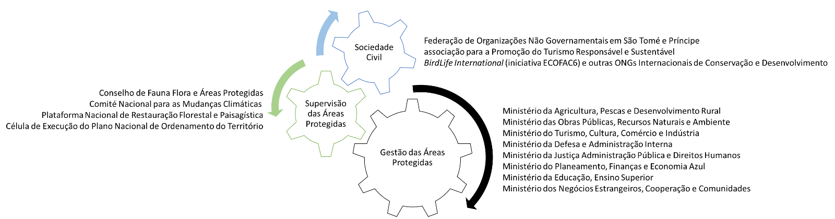

Output 1.2 Environmental sustainability and biodiversity considerations mainstreamed in land-use planning and investments
- Implementation led by: DGA PMU with RSESD.
- Building on the institutional realignment under Output 1.1 that will provide a streamlined platform for land use planning and management and related issues – continuing the work initiated on the National Land Use and Spatial Plan (PNOT) – the work under this output will work to further strengthen the integration of environmental and biodiversity concerns into land use planning and management and the related cross-sector oversight. This will happen by emplacing an Environment Mainstreaming Officer who will with technical assistance by the CTA and BirdLife International work to
- Environment/biodiversity-proof the current version of the PNOT to create an improved benchmark against which development proposals can be held against.
- Monitor sector compliance on the said land-use planning in general but especially on environment and biodiversity, to prevent large-scale developments and investments (in agriculture, tourism, infrastructure, energy, etc.) that could harm natural and productive ecosystems in an undue manner – several such projects have been proposed in the past and are still in the pipeline, such as the construction in the NPs of hydro-dams and of a road-stretch closing the circle around the island of São Tomé (crossing steep inaccessible parts of the NP in the SW), the creation of tax free zones in the mangroves in southern São Tomé, of large-scale tourism infrastructures potentially incompatible with the island’s marketing, etc. This workstream will engage closely with the country’s Agency for Commerce and Investment Promotion (APCI).
- Under this Output the project will also field a small team over one year to determine land use across forest and agricultural lands/plots, combining desk work using cadastre, satellite imagery, topographic maps with ground-truthing field work. Guided by the technical assistance provided by the DGA PMU and BirdLife, this will provide a new scientific baseline for future government decisions on land tenure and management.
Output 1.3 Framework and delivery system for integrated environmental surveillance and enforcement emplaced
- Implementation led by: DGA PMU with DFB and RSESD.
- Building on Output 1.1, the work under this output and Output 1.4 is to significantly strengthen environmental law enforcement in STP. In order to build and then emplace a realistic, nationally-owned and effective system that at the same time responds to social safeguards, the project will, with the support from international human rights, environmental law and law enforcement experts:
- Before the start of the main project activities, conduct a Human Rights Risk Assessment that looks at relevant risks such as increased violence and prepare a Human Rights Action Plan to define appropriate mitigation measures whose adequate implementation will be overseen by project staff, as required.
- Establish and convene a national platform for environmental law enforcement.
- Facilitate a comprehensive consensus-build process, bringing together current and potential further stakeholders – from forestry, biodiversity/PAs, environment, agriculture, coast guard, military, police, communities, etc. (*)
- Define the most appropriate national environmental law enforcement framework, and prepare a national environmental law enforcement strategy and action plan – considering inter alia, hosting agency/ies, scope, post-project financing, integration of existing officers/forest guards, role of police and military, community-based surveillance, income/health plans for environmental guard families for the case of accident in the performance of duties, etc.; and deciding on sector scope from amongst protected areas, forests, agriculture, land use, coastal management, etc.; and anticipating the future inclusion of the marine environment (marine protected areas, fisheries, oil & gas). (*)
- Working in conjunction with Output 1.1, adapt the legal and regulatory framework as required for the enforcement system (institutions, statutes, mandates, responsibilities, prevention, inspections, detentions, negotiations, responses civil and criminal legal/penalties, jurisprudence, etc.; balancing stringency and feasibility).
- Emplace the newly defined integrated environmental guard (or similar as appropriate) and equip and train it so it becomes operational. (*)
- Implementation of the national environmental law enforcement strategy and action plan, to include surveillance at key transit points. (*)
- The work on the environment funds under Output 2.4 is key for the system’s sustainability post-project.
Output 1.4 Capacity developed on environmental law surveillance and enforcement
- Implementation led by: DGA PMU with DFB and RSESD.
- This Output will provide the necessary capacity building and outreach to enable the discussions and results under Output 1.3. The project will, under the leadership of the international environmental law and law enforcement experts, provide a series of trainings: i) annual 3-day workshops for senior staff and technicians in relevant government agencies (forestry, biodiversity/PAs, environment, agriculture, land use planning, NGOs; in addition to lawyers, judges, police, military, coast guard); ii) annual 12-day field training for the newly defined integrated environmental guard; and iii) international distance evening courses in environmental law, providing up to 6 academic fees and guidance by the international experts to carefully selected key agents in government critical for the effective legal application of the system (prosecutors, judges, etc.).
- This will also entail regular outreach to communities, especially those most affected by the strengthening of the environmental law enforcement system, raising awareness and understanding, promoting compliance, and engaging on community-based surveillance. This will be conducted by the community organisers together with government staff and by the environmental guards once emplaced.
Output 1.5 Key environmental CSOs and CBOs strengthened
- Implementation led by: Responsible Party BirdLife International. (*)
- Under this Output, the project will aim to significantly strengthen the country’s civil society involved in biodiversity conservation, sustainable natural resource management and sustainable communities. This will involve the international NGOs represented in STP and their local staff, but especially national NGOs, local NGOs – and CBOs.
- Capacity development for NGOs will focus especially on strategic and operational aspects including planning, management, finance, human resources, results-based management, reporting, advocacy, communication, fundraising and so forth. It will take place in the form of
- two advanced 12-day workshops over the duration of the project facilitated by international organisational development experts (presumably from the BirdLife partnership), for an estimated 20 participants from both São Tomé and Príncipe;
- ten subsidised 6-month domestic internships, competitively selected from amongst Santomean NGO staff, in the actual project to be exposed to its day-to-day operations; and
- three subsidised 6-month internships, competitively selected from amongst Santomean NGO staff, in well-run foreign NGOs such as in Brazil or in anglophone countries (incl. to promote essential language skills).
- Capacity development for CBOs will touch on similar issues yet at lower levels, adding more focus on their role in community organising and governance, awareness, and sustainable development and livelihoods. The training events under the present Output for CBOs are proposed to be limited to 1 day only, twice a year throughout the duration of the project. The CBO capacitation is directly linked to the informal regular community engagement on sustainable charcoal and livelihoods under Component 3.
Component 2: Management, monitoring and financing of PAs and adjacent key biodiversity and forest areas
- This Component will deliver the following Outcomes:
  - Outcome 2.1: Protection of the two existing PAs and adjacent HCV forest areas enhanced
  - Outcome 2.2: Finance for biodiversity conservation and PA management increased
- To achieve this, the project will, under this Component, work on the following outputs and activities:
Output 2.1 Management effectiveness of protected areas and adjacent High Conservation Value areas enhanced
- Implementation led by: Responsible Party BirdLife International with DFB and RSESD.
- Under this Output – in which the integration of the critical BirdLife International co-financing is most prominent – the project will further operationalise the emerging governance structure for the national PA system, focusing on STP’s two existing PAs – Sao Tomé Obô Natural Park and Príncipe Natural Park – and considering regional specificities. This involves a multi-stakeholder coordination mechanism involving government, NGOs and CBOs, private sector, research institutions, and Government.), allowing information exchange, involving local communities adjacent to the NPs, and facilitating participatory decision-making on the implementation of the NP management plans. (*)
- In 2020, the project will prepare the next iteration of the 5-year PA Management Plans for the two existing NPs, which then will be updated again in 2025 during the project’s final year. The latter update will then be informed by a SMART Management Based Biodiversity Monitoring System, as explained under Output 2.2 below. (*)
- To provide adequate bases from which PA surveillance and management interventions can take place, and to provide better facilities for PA visitors, the project will support the rehabilitation/construction of key infrastructures, including the renovation of old park buildings and reopening and maintaining of nature trails. In Príncipe, the rehabilitation of the island nature conservation centre and PA headquarters in Porto Real, most of which was already financed under baseline investments, will be finalised, to provide a platform for PA visibility, scientific residence and ecotourism. A gate to the PA will be built next to the Porto Real centre, which is the main access road; two further entrance gates/outposts will be built in Barracão and Alto Camarão. In São Tomé, the Bom Sucesso Botanical Gardens at the existing PA entrance will be rehabilitated; and two new infrastructures will be built to expand the number of official park entrances from one to three, to increase access for park surveillance and monitoring; these are expected to be built uphill from Ponta Figo (north-western ST) and near Monte Carmo (southern ST). Simple infrastructures / base camps will be developed in Ponta Figo close to the boundary of the park near Rebordelo or Cascata, and possibly at Carvalho and Mesa. While the vast majority of these infrastructure investments will be financed by the ECOFAC-6 co-financing, USD 40,000 of GEF resources have been earmarked for the completion of the renovation of the Porto Real PA headquarters in Príncipe. (*)
- PA staff will be recruited by the project as well as capacitated and provided with the necessary field equipment to engage in PA management interventions, conducting patrols against illegal activities including hunting of endangered species and illegal logging. (*)
- A key objective will be to provide better access and services for local and foreign tourists visiting the park. Tourism activities will be developed, based around the rehabilitated park buildings, including development of multi-lingual visitor information and services. The project will hire and train local eco-guides to improve the trail network and provide nature-based guiding services. In doing so, the project will capitalise on efforts made on ecotourism in the Príncipe Biosphere Reserve and replicate this in São Tomé via the Platform for Responsible and Sustainable Tourism. The work on tourism will also allow the set-up of a clearer process for the collection, accounting and utilisation of park visitor fees. (*)
- The project will moreover design and implement a communication campaign for biodiversity, protected areas and ecotourism, bringing together several parallel attempts promoted by different stakeholders (DFB, UNDP CO, BLI) and working with the Ministry of Tourism, Culture, Commerce and Industry. (*)
- Enhanced on-the-ground PA management, like biodiversity conservation in STP more widely, will hinge on a better protection and management of forest areas inside and outside the two NPs. The latter is linked to the delineation and management of the PAs’ “buffer zones”, which as explained above are not adequately defined in legal terms, not scientifically delineated and not recognised on the ground in terms of awareness or livelihood practices. Working in conjunction with the revision of the legal and regulatory framework for PAs under Output 1.1 and the Park Authorities, the project will therefore devise a new zoning system that integrates emerging data on HCV Forests. The available data (São Tomé only) shows that i) most of the forests remaining in the “buffer zone” are HCV forests; ii) the remainder of the buffer zone are agricultural lands including under shade plantations but also open agriculture; iii) there are important HCV forests outside the buffer zone requiring conservation management (under a protection regime or under a sustainable management scheme) and these areas are larger than the (poorly defined) current buffer zone. The revised zonation could therefore i) exclude degraded agricultural areas with limited realistic recovery potential from the buffer zone, while ii) focusing more attention on HCV forest areas outside the NPs, whether these are included in the current buffer zones or not. The project/government may eventually decide to integrate some key HCV areas in the NP (e.g. areas near the AgriPalma oil palm plantation in southern São Tomé important for the 3 Critically Endangered bird species), but this isn’t defined as an objective of the project at this stage. (*)
- Given that the HCV assessment has so far only been concluded for the island of São Tomé, the project will therefore replicate this work on the Island of Príncipe, which will be a work package contracted to a competent provider working with the project team, to conduct the necessary desk review and develop the baseline field mapping of HCV and HCV forest classification together with competent authorities and local NGOs.
- In Príncipe, there is a potential conflict of usage of a zone located close to the Floresta da Azeitona and disconnected from the rest of the Park. This zone is located close to agricultural areas and used by communities. The zone is considered as a Type 1 Partial Protection zone in the current version of the Management Plan but is not clearly mentioned as such in the law of the Park. Stakeholders will need to be brought together to work on the mapping and legislation, in order to provide an addendum to the regulation.
- To complement the above new zonation system focused on HCV areas, the project will work to introduce and formalise internationally benchmarked innovative management/partnership models for PA and HCV areas, regarding concessions and the involvement of the private sector and NGOs, co-management, community-based management that can be linked to sustainable agroforestry (e.g. for new NTFP value chains), etc. (*)
Output 2.2 Capacity developed on biodiversity, zoology/botany, ecosystem services, conservation and PA management
- Implementation led by: DGA PMU with DFB and RSESD.
- Under this Output, the project will aim to raise awareness and technical capacity about biodiversity science, threats and conservation responses, across a variety of stakeholders in STP, with the content suitably adapted to each particular stakeholder group. As some technicians during the PPG requested advanced/specialised trainings (e.g. on remote sensing data), the project will at project start conduct a consensus-building training needs assessment guided by the CTA and prepare a capacity development plan for the project. The project will then, under the leadership of the CTA and working closely with BirdLife International, provide a series of trainings:
  - annual 5-day training workshops for technicians, NGOs and community staff working in biodiversity/PAs, forests, environment, land use planning, agriculture, enforcement, etc., for an estimated 40 participants on São Tomé and 20 participants on Príncipe;
  - annual one-day awareness/training seminars on key topics for decision-makers/parliamentarians/political parties, key business people, NGOs, etc., highlighting linkages to both global matters (sustainable development goals, climate change) and national well-being;
  - with the aim to build a small new cohort of competent national conservationists, four subsidised one-year post-graduate conservationist courses abroad such as in Brazil or in anglophone countries (incl. to promote essential language skills competitively selected from amongst Santomean graduates and/or young professionals (noting that a more basic diploma course should be considered if 1-2 candidates from Príncipe can be found that are bound to have less advanced formal education);
- regular training and one-day workshops and support missions to targeted communities (200+ pax)
- In addition, and at least as important to achieve impacts, PMU staff including the CTA and other experts, as well as the team of BirdLife International with its NGO partners will regularly engage these stakeholder groups to build awareness and capacity. (*)
Output 2.3 New technologies, systems and tools for information-based biodiversity and PA management emplaced
- Implementation led by: Responsible Party BirdLife International with DFB and RSESD.
- This Output will in a sequential manner emplace two systems for monitoring the status and threats to ecosystems and biodiversity in STP. The first, and already-planned under the BLI/ECOFAC project, is a transect-based system that was already piloted and provided some of the indicator data used in the GEF PA Management Effectiveness Tracking Tool; this will be done from the project’s first year. The second, more ambitious and complex and planned as a subsequent step once relevant capacity has been built, will set up a Management Oriented Biodiversity Monitoring System (MOBMS), based on a Spatial Monitoring and Reporting Tool (SMART) – that can be linked to the existing ESRI-based National Forest Monitoring System at DFB and other similar platforms. This will require support from an International IT Expert working with an experienced biodiversity expert in the development of the software, the definition of database format and content, and data collection protocols – where data can be contributed by project staff, government and NGO technicians, from community-based surveillance activities, etc. Once operational and proven, the second system can replace the former. (*)
- As both systems will provide information useful for the management of the NPs and adjacent areas, they are thus complementary to and directly support Output 2.1. It is expected that the MOBMS data can be integrated into the 2025 update of the two PA Management Plans.
- A further assessment and tool that will be prepared by the project under this Output is an economic valuation of the ecosystem services provided by the NPs and their importance to local communities and the national economy. It can inform the management of the NPs and biodiversity, such as on the cost/benefit of tourism concessions or NTFP exploitation, but if favourable, can be used to make a better case for a more sustainable management of natural capital on the islands more widely, especially given the existence of champions such as the President of the Príncipe Government who promotes his view also amongst national-level decision-makers. The economic valuation work with embedded cost-benefit analyses will be undertaken by BirdLife International under ECOFAC co-financing, and BirdLife intends to use the TESSA Toolkit for Ecosystem Service Site-Based Assessment (http://tessa.tools). The toolkit is designed to provide practical guidance on identifying those ecosystem services significant at a site of interest, what data are needed to measure them, what methods or sources can be used to obtain the data and how to communicate the results; the toolkit emphasizes the importance of comparing estimates for alternative states of a site (for example, before and after conversion to agriculture) so that decision-makers can assess the net consequences of such a change, and hence the benefits for human well-being that may be lost through the change or gained by conservation. (*)
Output 2.4 Proven structures and tools to capture and distribute new finance for the national system of protected areas and biodiversity created
- Implementation led by: Responsible Party BirdLife International.
- Under this Output, the project will advance the PA/biodiversity finance agenda in the country, complementing the work on the National Environment Fund and Special PA Fund under Output 1.1.
- However, with approximately 95% of the national budget coming from ODA and a weak private sector in the country, the government will likely continue to have only limited domestic resources available for its PA system and sustainable land/forest management and depend on external funding for another while as well as on continuing efforts to diversify sources further in the future.
- To take the next steps along this way, the project will:
- Prepare a Finance Plan for Biodiversity and Protected Areas for STP that that will include a PA System Finance Needs and Gap Assessment, considering the regional specificity for the Autonomous Region of Príncipe and including viability studies and a suitable revenue management model in line with the legislation. The project will then begin its implementation. (*)
- Create and maintain a database on biodiversity and PA financing in STP.
- Design, establish and legally register an international and independent Conservation Trust Fund for São Tomé and Príncipe, to diversify the funding available for the conservation of the country’s terrestrial and marine biodiversity and protected area management. The PPG concluded that this could be the most promising route for STP given the relatively limited potential of alternative sources at this point in time: the raising of additional PA-specific taxes or levies from the public or tourists, payments from tourism companies, REDD+ carbon credit sales, or oil & gas sector offset payments are not presently viable, and tourism numbers are still too low to generate significant revenue through PA fees. Responding to a comment from GEF STAP, a CTF once operationalized would also create a decentralised way to capture resources – and eventually to distribute them to a diversity of stakeholders offering biodiversity solutions including different government agencies, private sector, NGOs and CBOs – which will need to be reflected in the CTF’s objectives, statutes and manuals.
- Design and implement an international campaign to capitalise the CTF’s endowment fund, mobilising promotional support from national and international partners from government and the private sector (e.g. (e.g. tourism ministry, the tourism company HBD, oil & gas companies, leading agribusinesses, etc). No GEF resources will be used to capitalise the CTF.
- To advance the work under this Output, the project will procure the services of an experienced international expert with a proven track record in CTF creation and fundraising, as well as the services by a specialised lawyer for the cost/fees of its registration. It will also procure a national counterpart to support this at national level, receive on the job-training to build the national skills in this domain.
- There will be a need to follow up with additional support in the future should there be some initial success during the project in terms of endowment fund capitalisation.
Component 3: Reducing forest degradation and ecosystem services loss from unsustainable charcoal-making
- This Component will deliver the following Outcomes:
  - Outcome 3.1: Forest degradation from charcoal making reduced and compensated
  - Outcome 3.2: Prevalence of traditional high-impact charcoal-making livelihoods reduced in favour of more sustainable options
- To achieve this, the project will under this Component work on the following outputs and activities:
Output 3.1 Charcoal supply and value chain analysis prepared to identify further options for reducing wood-based charcoal extraction drivers
- Implementation led by: DGA PMU with DFB and RSESD.
- While the PPG compiled and reviewed much information on the threat from charcoal-making, as is presented in the preceding chapters, the project will under this Output prepare a more comprehensive assessment of the entire charcoal value chain on both São Tomé and Príncipe to further define and quantify the threat and its impact on different forest areas of the islands (inside and outside the NPs) – and to identify further solutions along the value chain. There are different opinions in the country about solutions both on the supply side and the demand side, yet no structured assessment. The project’s intervention on charcoal – improved kilns and coconut-based charcoal as explained under the following Outputs – is one obvious route that is in line with the BD and LD eligibility criteria, yet other routes may need to be followed in the future to complement this. The assessment could thus provide guidance to the project but also to future interventions – determining the viability of further supply-side solutions (e.g. charcoal briquettes based on wood shavings/sawdust (from largely illegal logging operations) as proposed during the PPG; importation of charcoal from nearby Africa, which only relocates the problem) and demand-side solutions (e.g. efficient charcoal-based cooking stoves, alternative energy sources such as gas/LPG/biogas or electricity).
- The value chain assessment will involve desk review but also comprehensive field surveys and interviews with stakeholders to provide quantitative data along the supply chain (see Fig. 10) considering inter alia, extraction rates, trees species, location, seasonality, other livelihoods and degree of dependency, role of men/women, cost, risk, transport, market access, sales price, income level, education, charcoal quality, type of end use, openness to substitutes, health impacts and so forth. It will be conducted in conjunction with the Human Rights and Economic Displacement Risk Assessments required under UNDP safeguards requirements.
Figure. 13: 5-step charcoal value chain: wood extraction/forest management; carbonisation; transport; distribution, warehousing and retail; and consumption.
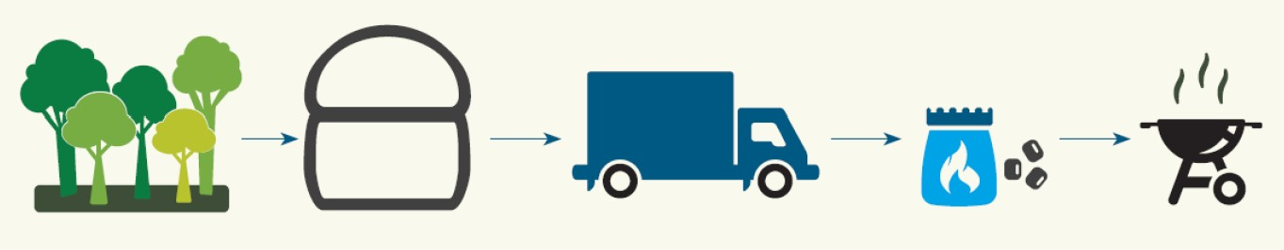
Output 3.2 More sustainable charcoal kilns and charcoal sources mobilised
- Implementation led by: DGA PMU with DFB and RSESD.
- Traditional charcoal production relies on a combination of rudimentary technology, involving virtually zero capital investment, and basic operator skills. The traditional charcoal kiln type is the earth mound built from local soil. Conversion efficiencies are very low (10% or lower) and process cycles (firing, pyrolysis and cooling down) are long. If the wood is wet or the kiln is improperly operated, large emissions of methane and of harmful smoke particles and volatile organic substances are released.
- Under this Output, the project will introduce and establish new approaches, technologies and value chains to reduce rampant forest degradation and ecosystem loss caused by traditional wood-based charcoal-making. It aims to achieve this by targeting the charcoal value chain’s supply side – the unsustainable and often illegal sourcing of wood. The project will introduce and demonstrate improved charcoal kilns to enhance the efficiency of traditional charcoal-making, which will be required during at least a transitional phase for social reasons. In addition, and more importantly for the medium and long term, the project will help establish a new value chain on coconut-based charcoal.
- To achieve these ambitious goals – which are judged realistic given the growing awareness about the problem both at government and community level, the political commitment by at least the President of the Príncipe Regional Government, and the interest by a key private sector company – the project will, with the support from the CTA who is expected to have experience in sustainable charcoal kilns:
  - Create and convene a National Sustainable Charcoal Platform, possibly under the recently constituted National Forest Landscape Restoration Platform, to create a multi-stakeholder consultation and coordination forum to guide actions by the project and other stakeholders on sustainable charcoal, identifying any emerging needs in terms of enabling framework, social intervention, reforestation, investments, linkages to the DFB/FAO/GEF-6 project, etc.;
  - Integrating the consultations with charcoal-makers conducted in the context of the charcoal-value chain assessment (Output 3.1), decide on the types of low-cost, improved charcoal kiln technology to be demonstrated; depending on the model, the improved kilns may be imported from mainland Africa and/or locally built wherefore locally available materials and construction capabilities will be considered; tentatively, the model will be individual portable Casamance kilns or drum kilns made from barrels – which in combination with proper operator skills and pre-treatment of wood resources can boost conversion rates from 10% to up to 25%, yet cost less than $50 with a lifetime of more than 3 years and can be produced by local welders.
  - Import and/or locally produce the selected kilns and demonstrate their functioning in selected centralised sites on both islands;
  - The project will facilitate the dissemination and initial operation of use of improved kilns by charcoal-makers in selected pilot communities on both São Tomé and Príncipe. To promote acceptance of the technology, emplace an interactive process to adjust the technology to match local needs and skills. Ongoing training and joint learning to identify and materialize benefits will be provided under Output 3.3. A total throughput time of 3-4 years is envisaged with recurrent training activities, monitoring and expert assistance.
  - In addition, under a parallel workstream, the project will work together with STP’s leading coconut-product manufacturing/trading company, Valudo, which expressed interest in entering the charcoal value-chain making use of its 20 tons of daily coconut plant waste (12,000 units @ 150g = 1.8 t/day of coconut shell, and 12,000 units @ 1500g = 18 tons/day of coconut fibre) to produce coconut-based charcoal briquettes, a well-established product in some countries in Africa (e.g. http://zaacoal.com). Coconut charcoal briquette is a compact block charcoal made from coconut waste that is carbonised, crushed and moulded using a natural binder/agglutinant. It is a high-quality charcoal, hotter and lasting longer than most traditional charcoal, and suitable for a variety of domestic and larger-scale utilisation. To this end, the project will facilitate the negotiation of a public-private partnership between the Government and Valudo, under which the project will provide technical and financial assistance to Valudo including for the procurement from abroad of at least one semi-industrial charcoal kiln (including pre and post carbonisation steps), while Valudo commits to providing the coconut plant waste, to ensuring their collection and transport to the kiln(s) (with the first based at its main plant in Favorita/ST), to producing and storing coconut-based charcoal briquettes, and to promoting and distributing it to national sales points. The contribution from Valudo moreover includes manpower, health, safety & security procedures, and insurance and maintenance of equipment. No GEF resources will be channelled through Valudo.
Output 3.3 Awareness raised and capacity developed on more sustainable charcoal production and alternatives
- Implementation led by: DGA PMU with DFB and RSESD.
- Under this Output, the project will aim to raise awareness and transfer relevant knowledge and technology skills enabling them to understand the causes and impact of unsustainable charcoal production; to understand the benefits of sustainable charcoal solutions achieved through improved production and consumption technologies and practices; and to take ownership of measures proposed to sustain a more sustainable charcoal value chain. A variety of stakeholder groups will be targeted, with the content suitably adapted to each. To this aim, the project will, under the leadership of the PMU and CTA:
  - Produce, print and disseminate information on sustainable charcoal and coconut-based charcoal manuals/posters;
  - Organise two 3-day training workshops for technicians, community staff and interested NGOs and private companies working in biodiversity/PA, forests, agriculture, enforcement, NGOs, energy, etc., for an estimated 40 participants from both São Tomé and Príncipe;
  - Organise regular trainings and one-day workshops and support missions to charcoal-makers and their communities throughout the duration of the project;
  - Demonstrate the value of sustainable charcoal for productive processes in rural areas, including institutional kitchens, laundries, and food processing.
Output 3.4 Fast-growing native charcoal tree species planted in degraded forests and shade plantations
- Implementation led by: DGA PMU with DFB and RSESD, with technical assistance and UNDP procurement support.
- To complement the above interventions on increasing the efficiency of traditional charcoal-making through improved kilns, better monitoring and law enforcement, the project will in addition counter the pressures on forests exerted by charcoal-makers by restocking the resource base.
- Working closely with the DFB/FAO/GEF-6 project that focuses primarily on reducing pressures from logging for construction timber purposes yet is expected to produce a Forest Landscape Restoration Plan, the project here will focus on the restocking with fast-growing native charcoal tree species. The native African Oil Bean (Moandi) Pentaclethra macrophylla and endemic and endangered Polyscias quintasii were already identified during the PPG, yet further species should be considered based on their growth rates, regeneration patterns, suitability for nursery reproduction, replanting survival rates, etc. To this end, the project will i) boost the seedling production capacity specifically for these species by providing basic construction, equipment and staffing to nurseries under DFB and RSESD, including for seed or seedling collection and treatment; and ii) field one itinerant tree planting team (each employing c. 8-10 selected professional charcoal-makers) on each São Tomé and Príncipe for the duration of the project to restock resources in areas that have suffered from forest degradation.
Output 3.5 Community stakeholders consulted and sustainable livelihoods introduced and adopted
- Implementation led by: Responsible Party BirdLife International with DGA, DFB and RSESD.
- This Output critically underpins the work under Components 1-3 on strengthening protected area management, environmental law enforcement and sustainable charcoal, where it seeks to positively engage and strengthen the targeted rural communities in terms of governance and organisation, and support sustainable livelihoods, particularly for charcoal-makers and others reliant on unsustainable if not illegal natural resource extraction in valuable forest areas.
- Before the start of the main project activities, the project will conduct an Economic Displacement Risk Assessment that looks at the related risk and prepare a Livelihood Action Plan to define appropriate mitigation measures whose adequate implementation will be overseen by project staff, as required.
- The project will provide regular engagement of rural community stakeholders by two gender-focused community organisers and other project staff and technical experts, aimed at community strengthening and sustainable / green livelihood capacity development, addressing gaps in entrepreneurial and administrative skills (e.g. book-keeping, budgeting, and implementing sales and revenue analysis and so forth. (*)
- Finally, the project will issue an estimated 40 micro-grants (30 in Sao Tomé and 10 in Príncipe, for an average of USD 5000, provided in equipment and material, in addition to technical support for identification, implementation and follow up) for catalysing sustainable livelihoods, to be carefully screened and distributed to individuals/ communities/ associations/ companies; this will entail local-level sustainable charcoal and alternative energy initiatives (e.g. rural biogas pilots), sustainable extraction of new NTFP value chains (medicinal and aromatic plants), apiculture, sustainable forestry, etc.; grants may also be issued to boost already-existing low-impact livelihoods where these allow a professional reorientation of high-impact charcoal-makers. It is hoped that by project end, at least 80 key actors of the charcoal value chain (20 in Príncipe and 60 in Sao Tomé) are engaged in alternative income generating activities, from green enterprise and other sustainable livelihood initiatives. In São Tomé, the project will primarily target communities that are important charcoal production or trade hotspots (Praia das Conchas, Plancas 1&2, Ribeira Funda, Ponta Figa; Neves, Guadalupe). In Príncipe, the project will target São Joaquim, Gaspar and Azeitona, all known to be important charcoal production centres. Other communities may be included upon further research on the value chain. (*)
Component 4: M&E, Knowledge Management and Gender
- This Component will deliver the following Outcomes:
  - Outcome 4.1: M&E, knowledge management and gender work fully and successfully implemented
- To achieve this, the project will under this Component work on the following outputs and activities:
Output 4.1: M&E and knowledge management plans implemented
- Implementation led by: DGA PMU with DFB and RSESD.
- The project will employ a full-time M&E & KM and Safeguards Officer to oversee the implementation of this Output.
- It will work to fully implement the stipulated M&E requirements that are spread across the Project Results Framework (Section IV), M&E Plan (Section V), Monitoring Plan (Annex 5), Risk Log (Annex 4), and also the Gender Action Plan (Annex 11). The project will equally fully implement its Knowledge Management Plan (Section XX). Both together will provide the basis to guide adaptive management, and promote the uptake of knowledge, good practices and successful approaches. The project will promote a participatory approach to monitoring, evaluation and learning, involving all relevant stakeholders, including local communities. To boost its visibility and impact potential, the project will also set up a project website.
- In addition, the project will support the government in meeting one of its outstanding international KM commitments, namely the establishment of a national biodiversity clearing-house mechanism for STP – such that important information about biodiversity and its management can become more publicly accessible and also provide a repository for information from international organisations and academia working in STP that currently have no reliable platform.
Output 4.2: Gender strategy and action plan operationalised to guide project implementation, monitoring and reporting
- Implementation led by: DGA PMU with DFB and RSESD, with technical assistance and UNDP procurement support.
- The project will work to fully implement its Gender Strategy and Action Plan with its 54 indicator targets (Annex 11). Every PMU team member will be sensitised about gender aspects such that this aspect is considered throughout implementation. To achieve its stipulated results and indicator targets the NPC and CTA will be responsible for ensuring this is met in dealings with government, NGO and private sector stakeholders; while the work on gender with communities is handled by the two “gender-focused community organisers”. The project will ensure good participation by women in decision-making platforms, employment by project and government (including also for environmental law enforcement which has proven successful in other countries in Africa), trainings, and as direct beneficiaries in sustainable livelihood diversification.

3.2 Project area and sites with map and geospatial coordinates
- Through a systemic national level approach that includes work on the enabling framework, environmental law enforcement and on land use planning with an integration of environment and biodiversity concerns, the project will at the highest level target the entirety of the two main islands of STP – Sao Tomé Island and Príncipe Island.
- At lower levels, the project will support the consolidation of achievements relating to the island’s two protected areas (Sao Tomé Obô Natural Park and Príncipe Natural Park) and work on a more sustainable management of the surrounding landscapes. The project will thus support a conservation gradient from the parks in the highest and remotest areas of the islands to the coast – crossing the main forest formations, native forest, secondary forest and productive shade/agro-forests – including the important areas forests (HCV) these contain.
- Table 8 below summarises the degree of direct and indirect support to STP by the project across the different landscapes. The extent of the NPs and of the HCV areas (defined on São Tomé, pending for Príncipe) as well as the communities targeted by the project are shown in the maps in Figures 14 and 15 below. The communities are listed in detail in Table 9 with their geographic coordinates.
Table 8: Direct and indirect project support to landscapes of STP, by Component
Project Area | Component 1 | Component 2 | Component 3
Sao Tomé Obô Natural Park | Review of legal / regulatory framework, institutional framework for nature conservation and protected areas, law-enforcement (direct) | Direct Support / PA management effectiveness, sustainable finance | Reduction of threats related to the extraction of natural resources (indirect)
Príncipe Natural Park
High Conservation Value areas |  | Direct support / Identification & management/partnership innovative management models
STP landscapes (island wide) | Review of legal / regulatory framework, institutional framework, mainstreaming in Land-Use and Spatial planning / capacity-development, surveillance & law enforcement (direct) | capacity-development, monitoring, sustainable finance | Adopted Sustainable Forest Management Practices / charcoal production, alternative livelihood, capacity-development (direct)
Secondary lowland forest |  | Habitats & Species conservation (HCV approach), monitoring (direct)
Shade/agro-forests & Agricultural lands | Review of legal / regulatory framework, land use and spatial planning, monitoring & integrated law-enforcement, mainstreaming (direct) | None | Charcoal improved production,
Local Communities | Community-based surveillance and capacity development (direct) | Inclusion in PA/HCV governance mechanisms and capacity-development (direct) | Communication and capacity-development & planting, low value grants mechanisms – sustainable alternatives to NR dependency (direct)
Coastal areas | Review of legal / regulatory framework, including Coastal and MPA related issues (indirect) | Sustainable finance (indirect) | Indirect support (natural and assisted) for the regeneration of coconut groves (mitigation to coastal erosion)

Figure 14: Main direct beneficiary communities of the project on Príncipe Island
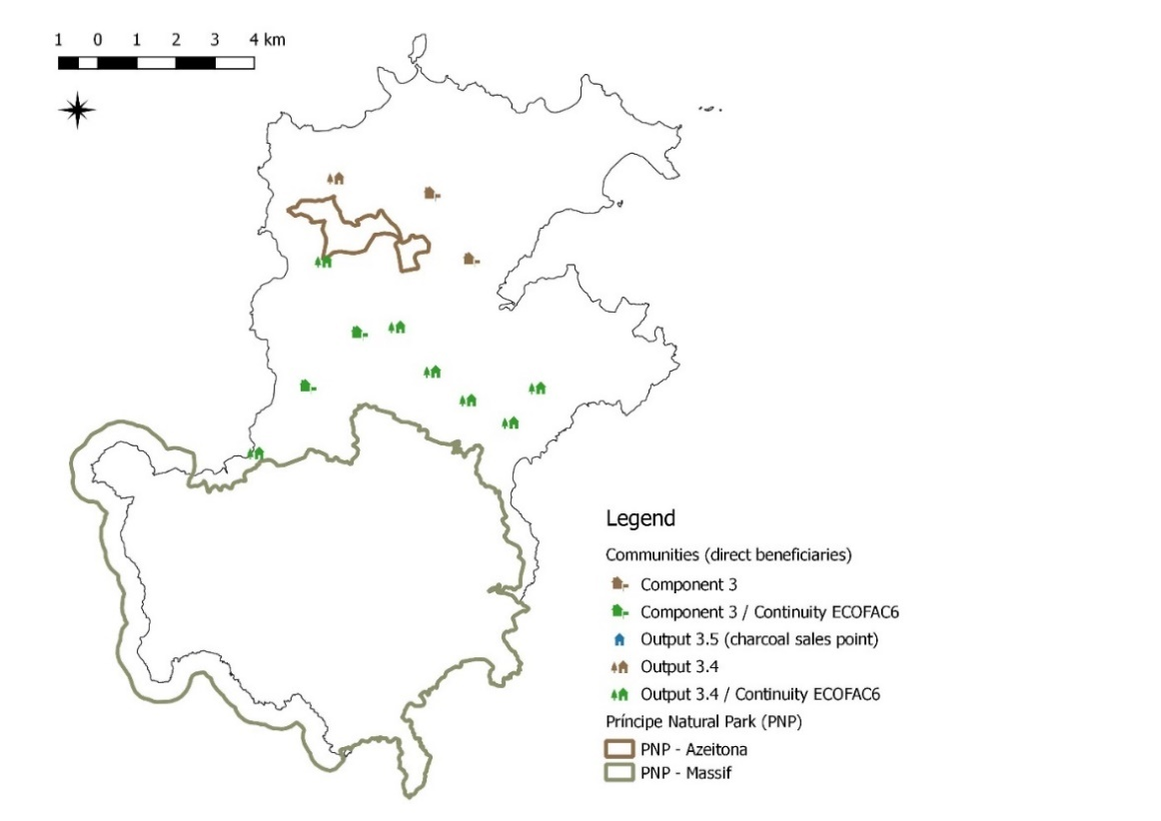

Figure 15: Main direct beneficiary communities of the project on Sao Tomé Island
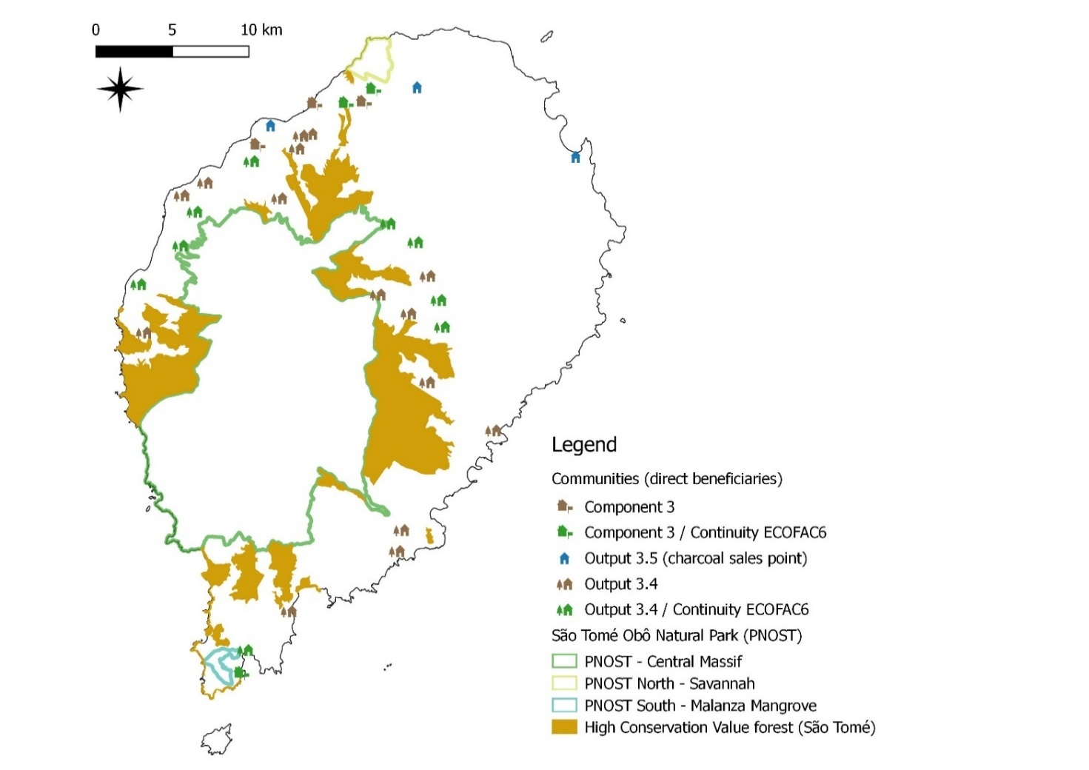

Table 9: Local Communities targeted by the project
District | Location | GPS Position | Activities
Água Grande | São Tomé | Point (6.7312065580903413 0.33861214518610777) | Output 3.5 (charcoal sales point)
Cantagalo | Claudino Faro | Point (6.65253286187526083 0.23863200349928199) | Output 3.4 / Continuity ECOFAC6  [under TRI project]
Cantagalo | Colónia Açoreana | Point (6.68259936546443445 0.17772437748855599) | Output 3.4
Cantagalo | São Paulo | Point (6.64380302554107427 0.20607284974924606) | Output 3.4
Caué | Dona Agusta | Point (6.6259843838359247 0.10678125658731107) | Output 3.4
Caué | Manuel Caroça | Point (6.6286342436664949 0.11910651388875432) | Output 3.4
Caué | Monte Mário | Point (6.5624229336183264 0.07134882742885543) | Output 3.4
Caué | Porto Alegre | Point (6.53439622477866067 0.03461326582165716) | Component 3 / Continuity ECOFAC6
Caué | Vila Malanza | Point (6.53676604687529483 0.04853458725577392) | Output 3.4 / Continuity ECOFAC6
Lembá | Diogo Vaz | Point (6.4994358392343079 0.31592336724292663) | Output 3.4
Lembá | Generosa | Point (6.54040733956711406 0.3360547973316671) | Output 3.4 / Continuity ECOFAC6  [under TRI project]
Lembá | Manuel Morais | Point (6.55676626856501077 0.31420722935461071) | Output 3.4
Lembá | Maria Luisa | Point (6.51319068814081081 0.32337137288772783) | Output 3.4  [under TRI project]
Lembá | Mulundo | Point (6.50702712468673639 0.3063331085125679) | Output 3.4 / Continuity ECOFAC6
Lembá | Neves | Point (6.55181060197040299 0.35706319533355468) | Output 3.5 (charcoal sales point)
Lembá | Ponta Figo | Point (6.54387171190998274 0.34529641109898568) | Component 3
Lembá | Ponta Furada | Point (6.47719720658669829 0.23523749872700306) | Output 3.4
Lembá | Ribeira Funda | Point (6.57738659277267246 0.36948971288039517) | Component 3
Lembá | Ribeira Palma | Point (6.57465245797777964 0.35206760745907839) | Output 3.4  [under TRI project]
Lembá | Rosema | Point (6.56942432977204405 0.35097641896600801) | Output 3.4
Lembá | Santa Catarina | Point (6.47401240696067592 0.26373289751300261) | Output 3.4 / Continuity ECOFAC6
Lembá | Santa Jenny | Point (6.49864676145055054 0.28641618844467709) | Output 3.4 / Continuity ECOFAC6  [under TRI project]
Lembá | Santa Teresa | Point (6.5671549490918073 0.34340169625949113) | Output 3.4
Lobata | Guadalupe | Point (6.63795296178312455 0.37947106268972514) | Output 3.5 (charcoal sales point)
Lobata | Plancas I | Point (6.59584721294681042 0.36972215480456821) | Component 3 / Continuity ECOFAC6
Lobata | Plancas II | Point (6.60634164064590745 0.37046889746172096) | Component 3
Lobata | Pr. Conchas (Roça) | Point (6.61199329542969139 0.37798114559790624) | Component 3 / Continuity ECOFAC6
Mé zóchi | Abade | Point (6.65044666716233301 0.25440294280470732) | Output 3.4 / Continuity ECOFAC6
Mé zóchi | Água das Belas | Point (6.6148269191979594 0.25762965426558243) | Output 3.4  [under TRI project]
Mé zóchi | Bombain | Point (6.63281946860896277 0.24642991907656242) | Output 3.4
Mé zóchi | Santa Adelaide | Point (6.6440919807684109 0.26849711084550348) | Output 3.4  [under TRI project]
Mé zóchi | São Carlos (M.Z.) | Point (6.62070866506553912 0.29939621285576923) | Output 3.4 / Continuity ECOFAC6
Mé zóchi | Saudade | Point (6.6368228634148565 0.28843059303071827) | Output 3.4 / Continuity ECOFAC6
Região Autónoma do Príncipe | Azeitona | Point (7.4054761420453854 1.66497724469128272) | Component 3  [under TRI project]
Região Autónoma do Príncipe | Bela Vista | Point (7.4137677627790266 1.617787822442319) | Output 3.4 / Continuity ECOFAC6
Região Autónoma do Príncipe | Gaspar | Point (7.41452463959799069 1.64985510273067004) | Component 3
Região Autónoma do Príncipe | Montalegre | Point (7.38875196651463995 1.63303219030671753) | Component 3 / Continuity ECOFAC6
Região Autónoma do Príncipe | Nova Estrela | Point (7.42969331195015226 1.62058301470096811) | Output 3.4 / Continuity ECOFAC6
Região Autónoma do Príncipe | Pincate | Point (7.39744687615952934 1.63457229941336912) | Output 3.4 / Continuity ECOFAC6
Região Autónoma do Príncipe | Ponta do Sol | Point (7.38055603175724606 1.64967037094354674) | Output 3.4 / Continuity ECOFAC6
Região Autónoma do Príncipe | Porto Real | Point (7.40557009808769173 1.62435300089855894) | Output 3.4 / Continuity ECOFAC6
Região Autónoma do Príncipe | Praia da Lapa | Point (7.36499853196318544 1.60560932259214351) | Output 3.4 / Continuity ECOFAC6
Região Autónoma do Príncipe | São Joaquim | Point (7.376935650865172 1.62070513088389778) | Component 3 / Continuity ECOFAC6
Região Autónoma do Príncipe | Sundy | Point (7.38334914353330785 1.66872929125609759) | Output 3.4
Região Autónoma do Príncipe | Terreiro Velho | Point (7.42350867978787399 1.61258182614928214) | Output 3.4 / Continuity ECOFAC6

3.3 Alignment with GEF focal area strategy
- The project is resourced with GEF-TF funding from the BD and LD focal areas. The project is therefore aligned with the eligibility criteria of these two focal areas:
- Objective BD-1: Improve sustainability of protected area system, Programme 1-1: Improving financial sustainability and effective management of the national ecological infrastructure, Outcome 1.2: Improved management effectiveness of protected areas, USD 2,410,958. The project responds to this GEF focal area strategy programme and outcome, as follows:
  - Under Component 1, by revising the legal and regulatory framework relevant to PA management including also ancillary laws such as on hunting and the National Environment Fund and Special PA Fund (Output 1.1); by revising the institutional framework with the expected establishment of a more dedicated unit or department if not autonomous institute for nature conservation and protected areas (Output 1.1); by emplacing and capacitating a national system for environmental law enforcement that will to a large part tackle threats to biodiversity/ecosystems in PAs (forests, beaches, wildlife, etc.) (Outputs 1.3-1.4); and to a good degree also indirectly by strengthening NGOs active in PA-related work in STP (Outputs 1.3-1.4).
  - Under Component 2, by enhancing management effectiveness of PAs and adjacent HCV areas by strengthening PA governance, consultations, management planning, rehabilitation of PA facilities, revision of PA buffer zonation with greater focus on HCV areas, and the introduction of innovative management models for these such as concessions, co-management and community-based models (Output 2.1); enhancing capacity on biodiversity, conservation and PA management (Output 2.2); emplacing a Management Oriented Biodiversity Monitoring System (Output 2.3); and by dedicated work on PA financing through the preparation of a PA finance needs and gap assessment, PA finance plan and the setup of a Conservation Trust Fund for STP.
  - Under Component 3, by addressing traditional unsustainable charcoal-making, one of the key pressures increasingly threatening forest integrity and therefore globally threatened fauna and flora inside the NPs (especially on São Tomé) (Outputs 3.1-3.5).
  - Under Component 4, by sharing lessons from past projects and disseminating activities and results on PA management and financing emerging from the present project including through a project website and a national clearing house mechanism, and by engaging women in the project’s activities linked to PA management and finance (Outputs 4.1-4.2).
- Objective BD-4: Mainstream biodiversity conservation and sustainable use into production landscapes and seascapes and sectors, Programme 4-9: Managing the human-biodiversity interface, Outcome 9.2: Sector policies and regulatory frameworks incorporate biodiversity considerations, USD 937,458. The project responds to this GEF focal area strategy programme and outcome, as follows:
  - Under Component 1, by revising the institutional framework with the expected establishment of a more dedicated unit or department if not autonomous institute for environment and land management that would represent a key vehicle for biodiversity mainstreaming and ensure that land and resource use is appropriately situated to maximize production without unduly threatening important biodiversity (Output 1.1); by placing an environment/biodiversity mainstreaming officer in the unit in charge of land management, to biodiversity-proof its policies and plans and add environmental/biodiversity elements to the oversight provided by the unit to the decisions, practices and investments by relevant sectors (agriculture, tourism, infrastructure, energy, etc.) (Output 1.2); by emplacing and capacitating a national system for environmental law enforcement that will support the said sector oversight to achieve enhanced compliance (Outputs 1.3-1.4); and to a good degree also indirectly by strengthening NGOs active in monitoring the impacts of different sectors on biodiversity across the landscape in STP (which has proven effective e.g. when the oil palm expansion plans were halted due to public pressure) (Outputs 1.3-1.4).
  - Under Component 3, by mainstreaming biodiversity into the charcoal value chain, one of the key pressures increasingly threatening forest integrity and cover across the landscape including in HCV areas outside the (poorly framed) buffer zone (Outputs 3.1-3.5).
  - Under Component 4, by sharing lessons from past projects and disseminating activities and results on sector mainstreaming of biodiversity emerging from the present project including through a project website and a national clearing house mechanism, and by engaging women in the project’s activities linked to sector mainstreaming of biodiversity (Outputs 4.1-4.2).
- Objective LD-2: Forest landscapes: generate sustainable flows of forest ecosystem services, including sustaining livelihoods of forest dependent people, Programme 2-3: Landscape management and restoration, Outcome 2.2: Improved forest management and/or restoration, USD 758,321
  - Under Component 1, by revising the legal and regulatory framework relevant to the charcoal value chain (Output 1.1); by emplacing and capacitating a national system for environmental law enforcement that will inter alia tackle the degradation of forests and their provisioning ecosystem services caused by illegal selective logging and poorly controlled conversion for agriculture (Outputs 1.3-1.4); and indirectly by strengthening NGOs active in forest conservation and rehabilitation (Outputs 1.3-1.4).
  - Under Component 3, aimed at improving management of forest landscapes through innovative practices, the project will address traditional unsustainable charcoal-making, one of the key pressures increasingly threatening forest integrity and thereby undermining the sustainable provision of ecosystem goods and services important for local well-being and livelihoods; the project will tackle one aspect of the supply side, rather than the demand side (efficient stoves, different energy source) or an international approach to the supply side (importation of charcoal from nearby Africa, which only relocates the problem); this involves a precise definition of the charcoal supply and value chain to identify further options for reducing wood-based charcoal extraction drivers (including for any future project looking more at the demand-side) (Outputs 3.1); awareness raising and capacity development on sustainable charcoal directed at technicians, private sector, communities and charcoal-makers as well as the creation of a national sustainable charcoal platform, (Output 3.3); the demonstration of improved charcoal kilns in selected pilot sites and communities and the negotiation of a prospective PPP between Government and the private company Valudo leading to the establishment of a new coconut-based charcoal value chain with the introduction of a semi-industrial kiln (Output 3.2); supplementary planting of fast-growing native charcoal tree species (Output 3.4); and sustainable livelihood diversification in targeted communities facilitated also through a micro-grant scheme (Output 3.5).
  - Under Component 4, by sharing lessons from past projects and experiences from other countries as well as by disseminating activities and results on sustainable charcoal solutions from the present project including through a project website, and by engaging women in the project’s activities linked to PA management and finance (Outputs 4.1-4.2).
- Objective LD-3: Integrated landscapes: reduce pressures on natural resources from competing land uses in the wider landscape, Programme 3-4: Scaling up SLM through the Landscape Approach, Outcome 3.1: Support mechanisms for SLM in wider landscapes established, USD 155,824.
  - Under Component 1, by revising the institutional framework with the expected establishment of a more dedicated unit or department if not autonomous institute for environment and land management that is expected to facilitate integrated land-use planning and management (with co-benefits for biodiversity and climate change mitigation and adaptation); and by emplacing and capacitating a national system for environmental law enforcement that will support the implementation and compliance with the resulting land use and management instructions (Outputs 1.3-1.4);
  - Under Component 4, by sharing lessons from past projects and experiences from other countries as well as by disseminating activities and results on sustainable charcoal solutions from the present project including through a project website, and by engaging women in the project’s activities linked to PA management and finance (Outputs 4.1-4.2).
- The project contributes directly to the STP’s National Voluntary Targets towards Land Degradation Neutrality adopted in 2018, which inter alia commits the country to:
- By 2030, reduce to less than 5% the conversion of forests and savannas to other land uses;
- Reduce illegal logging from 85% to 15% by 2030;
- By 2025, restore about 32,000 ha of degraded forests and landscapes;
- By 2030, improve the charcoal manufacturing process by 50%, thereby improving productivity (efficiency) and reducing waste.

3.4 Incremental Cost Analysis (Baseline vs Alternative Scenario) and Global Environmental Benefits
- The project is timely as the increased investments that took place in the past two decades contributed to establishing a foundation on which this project aims to build in synergy with ongoing interventions to facilitate enhanced environmental sustainability through enhanced biodiversity conservation and sustainable management of forest lands.
- The baseline and alternative scenarios are juxtaposed in the following table. The principal baseline interventions that can be considered here are the activities that the relevant Government agencies (most notably DGA, DGF and RSESD) are able to implement with their own limited domestic resources; the activities by the DFB/FAO-GEF-6 project relating forest landscape restoration; and the interventions by BirdLife International with their projects financed by EU/ECOFAC, CEPF, etc.
Baseline Scenario | Alternative Scenario
Component 1
There would be some work on the legal framework proposed by BirdLife who recently prepared a legal assessment that concluded that the legal and institutional setup for biodiversity and PAs is largely incomplete and dysfunctional; however, there is some hesitation by government to consider proposals from NGOs on legal framework improvements, which would also be limited to these topics. There would be no work on the environmental funds, no work on the regulatory framework for charcoal and no work on improving the framework for land-use related development investments.  Some work is expected on the institutional framework, namely ad hoc plans to give DGA in its current form more institutional autonomy, which would however not look at the functions and improvement potential that could result from a streamlined and more empowered institute. There would be no attempt to create an upgraded unit/institute for Nature Conservation and PAs.  There would be a downgraded unit left after the land use planning project (PNOT) ends in 2020, with no attempts to integrate environment and biodiversity into the currently available land use plan, with limited capacity to monitor sector compliance, and without capacity or ambition to proactively mainstream environment and biodiversity in sector activities; noting that the conservation NGOs in STP engage key sector stakeholders and monitor developments, but they often become aware of plans late in the process and do not offer a government-internal process.  There would be no serious attempt to agree on and much less to emplace and capacitate a consolidated environmental law enforcement system, with DFB & RSESD and their c. six Forest Guards remaining the sole official agents, poorly resourced, rarely in the field and with questionable effectiveness.  There would be some, but limited capacity development opportunities provided by BirdLife and FFI for the NGOs they are working with most importantly OIKOS and Fundacao Príncipe. But there would be no internship opportunities and advanced dedicated training opportunities aimed, and no work on strengthening CBOs. | The revision of the legal and regulatory framework will be more comprehensive in scope, as it will include the National Environment Fund and the Special PA Fund, the frameworks for charcoal and land-use related development investments. Work on those issues already planned by BirdLife regarding the biodiversity and PA framework would be more impactful because conducted under a project led by government agencies – the reason why the work under this component here remains almost exclusively (except NGO training) under the national implementing partner/executing agency.  The revision of the institutional framework will ask more fundamental questions on the effectiveness of the current system on biodiversity and PAs on the one hand, and on land use planning and management on the other hand. The national consensus discussion is expected to lead to the setup of two agencies/institutes with clearer mandates and at least some financial autonomy, one on Nature Conservation and PAs (possibly including Forests), and another on Environment and Land Management. This streamlined complementary setup is expected to be more empowered and operational by project-end given the parallel critical work on capacity and finance.  The project provides a platform under which the land use planning unit will be maintained after mid-2020 and capacitated (via the Environment Mainstreaming Officer) to integrate environment and biodiversity into the currently available land use plan and to monitor sector compliance including on environment and biodiversity, to prevent in early stages large scale developments and investments that could harm natural and productive ecosystems in an undue manner – several such projects are have been proposed in the past and are still in the pipeline and not clearly assessed: the construction of hydro-dams in the NPs and of a road around the entire island of São Tomé crossing steep inaccessible parts of the NP in the SW, the creation of tax free zones in the mangroves in southern São Tomé etc.  The project aims to significantly strengthen if not transform environmental law enforcement in STP. It will establish a national platform and consensus-building process informed by international technical assistance to define a national system bringing together the current and potential further stakeholders – from forestry, environment and PAs, coast guard, military, police, communities, etc. It will then emplace the newly created guard and equip and train it so it becomes operational. The work on the environment funds is key for the system’s sustainability post-project.  The project will significantly strengthen NGOs in STP, reaching a far wider range of beneficiaries than under the baseline; this will include CBOs, which is linked to the community work under Component 3. Capacity development will take place via a regular series of workshops but also through subsidised internships in the project and well-run foreign NGOs such as in Brazil, Guinea Bissau or in English speaking countries to promote essential language skills.
Component 2
There would be good progress on PA strengthening: rehabilitating PA infrastructure and tourism trails, training and fielding eco-guides, management presence in the NPs, setting up participatory governance and consultation platforms for the NPs, finalising the HCV studies for São Tomé, updating the management plans in 2020 and 2025, preparing an economic valuation of ecosystem services, tourism flow management, defining basic PA finance and business plans, collection of tourist park fees, and establishing a transect-based PA and biodiversity threat monitoring system. There would also be a National Forest Monitoring System prepared by DFB and others. | The project reinforces many of the baseline activities on enhancing biodiversity conservation and PA management effectiveness on the ground by adding resources and capacity, but also extends their lifetime to beyond the expected duration of the current principal baseline project, ECOFAC-6, which will close at the end of 2022; noting that activities of the project(s) in the BirdLife pipeline (investment mobilised) will build on the achievements of the coming 1-2 years and remaining gaps. The project will extend the HCV work on enhanced recognition and conservation of recently defined HCV forest areas, as a better focus for sustainable management outside the NP areas than buffer zones that are poorly defined and implemented; to further this goal, the project will work on introducing management models new for STP and their formalisation, regarding concessions and the involvement of the private sector and NGOs, co-management, community-based management that can be linked to sustainable agroforestry (e.g. for new NTFP value chains), etc.; the project proponents may eventually decide to integrate some of the HCV areas in the NP, but this isn’t defined as an objective of the project at this stage.  Emplacing a SMART Management Oriented Biodiversity Monitoring System to monitor status and threats to ecosystems and biodiversity is another complementary component supporting enhanced management.  Another key additional result under this Component is the raising of awareness and technical capacity about biodiversity and PA management, across a variety of stakeholders in STP: technicians, decision-maker, politicians, parliamentarians, NGOs, communities etc. Technicians have requested advanced trainings (e.g. on remote sensing) rather than beginner or intermediate level content. The project will conduct a consensus building training needs assessment to orient these. This will also include an attempt to build a small new cohort of competent national conservationists by subsidising four undergraduate or diploma studies abroad.  The work on PA/biodiversity financing will be significantly upgraded under the alternative scenario, following the conclusions of the PPG missions that questioned. The project will conduct a PA finance needs and gap assessment to inform future financial planning and fundraising, and then focus on the setup of an international independent Conservation Trust Fund for STP and a campaign to capitalise its endowment fund, as the currently most promising new option for raising sustainable income.  Several of the workstreams/outputs under this component will be led by the Responsible Party BirdLife International given the ECOFAC funding baseline the existing technical capacity – but close engagement of government agencies is expected.
Component 3
Although the DFB/FAO/GEF-6 project could be expected to cover some of what is proposed here, the interpretation on the ground leaves specific gaps that are being addressed by the here-proposed parallel GEF-6 project.  The DFB/FAO/GEF-6 project clearly targets the one most important driver for forest degradation in STP: selective logging for timber (the vast majority of which is illegal); this project therefore focuses its interventions on the timber value chain, engaging loggers; it provides more efficient portable saws to reduce waste, and its work on replanting and livelihoods is focused on agroforestry and already-established NTFP; the National Platform for Forest Landscape Restoration would be created and a National Forest Landscape Plan prepared. There are however no plans to address the 2nd-most important driver, charcoal-making. Charcoal is a lead bioenergy source in urban households especially, and there would be no sufficiently relevant work on making this value chain more sustainable – except a small-scale proposal by Bo Energy to use wood shavings (from illegal logging operations!) to create charcoal briquettes, which appears misguided. Further baseline work would entail the ongoing issuing of extraction licenses and occasional field monitoring by DGB/RSESD technicians. There would be no training of sustainable charcoal, no demonstration of improved kilns, and no attempts to use more sustainably sourced plant materials to produce charcoal. There would also be no livelihood work for charcoal-makers and no combination with the legal enforcement (Comp 1) that is judged critical in shifting behaviours. | Under this Component, the project will introduce and establish new approaches, technologies and value chains to reduce rampant forest degradation and ecosystem loss by charcoal-making. It will achieve this by targeting the supply side – the unsustainable and often illegal sourcing of wood. This workstream is almost entirely incremental to a weak baseline on this topic.  The project will introduce, demonstrate and provide training on improved charcoal kilns to enhance the efficiency of traditional charcoal making, which will be required during at least a transitional phase for social reasons. In addition, and more importantly for the medium and long term, the project will establish a new value chain on coconut-based charcoal, working together with STP’s dominant coconut-product manufacturer/trader Valudo, who will enter a PPP with Government, receiving technical assistance and technology in return for providing and collecting the plant waste material, producing and selling the charcoal on the national market.  This workstream will be accompanied by essential dedicated livelihood work for charcoal-maker households and communities in combination with environmental law enforcement (Comp 1) to initiate a transition period away from unsustainable practices.
Component 4
While STP has a good gender strategy and also a dedicated National Institute for the Promotion of Gender Equity, there is little awareness amongst the government agencies relevant to this project and no structured approach to engaging and empowering women.  The DFB/FAO/GEF-6 project itself will implement its gender strategy that focuses especially on livelihoods and NTFP. There would also be some implicit ad-hoc work on gender by international NGOs.  There would be no structured sharing of international experience and lessons on the topics proposed by the project amongst relevant stakeholders, except for what BirdLife and related NGOs provide in terms of technical assistance on biodiversity and PA management. | The project will fully implement its gender strategy working with national counterparts, ensuring good participation by women in decision-making platforms, employment by project and government, trainings, and sustainable livelihood diversification.  Besides the KM and M&E work internal to the project in terms of lessons sharing and result disssemination, the project will create a project website to communicate its results and establish a biodiversity clearing house mechanism for STP.

- The global environmental benefits generated under the above incremental alternative scenario are linked to the project’s indicator framework outlined (see IV Project Results Framework and Annex 6 GEF Core Indicators at Baseline with GEF PA Management Effectiveness Tacking Tool).
- Regarding the BD focal area, the project will deliver an improved management of 32,454 ha of terrestrial protected areas, which will maintain or enhance the conservation status of significant number of endemic and/or globally threatened species of STP (see Section 1.2 for details on these).
- Regarding the LD focal area, the project is expected to achieve improved practices and avoided loss in the 12,414 ha of HCV areas on STP, considered a better reference for the areas outside the PAs to be protected than the often used but poorly delineated buffer zones; this will allow the maintenance of ecosystem services provided by these forests that are important for nearby communities but also for other purposes such as waterflow provisioning for agriculture and water extraction for households and urban areas, and also potentially for any of the micro-hydro energy projects being planned.

3.5 Local and national project beneficiaries and benefits
- National project beneficiaries can be segregated into several groups/levels as follows:
- Government staff (senior including politicians and parliamentarians, but especially technicians) in both the national central government and the regional government in Príncipe, which will benefit from technical training and on-the-job exposure to new approaches, methodologies and technologies/equipment regarding the legal and institutional framework, environmental law enforcement, land use planning and biodiversity mainstreaming, biodiversity and ecosystem service science, biodiversity and threat monitoring (MOBMS), PA management, PA/biodiversity financing, improved charcoal kilns, sustainable charcoal sourcing based on coconut, as well as an access to experience from past project and experience in other countries. The economic benefits can accrue by salary increases and/or better employability post-project including in consultancy roles. The benefits to these technicians translate into benefits to all the GEB by the project, during the project itself and especially also post-project. Gender issues will be respected by ensuring that training and employment involves women in an equitable if not preferential manner.
- NGO staff and young academics, because the project aims to help build a new cohort of national biodiversity conservation specialists, through subsidised post-graduate courses, subsidised internships in the project and NGOs abroad, trainings in STP. The GEB targeted here are not bound to materialise during the project but through a project legacy that will have a favourable impact on the management of STP’s globally relevant biodiversity in the long-term. Gender issues will be respected by ensuring that training opportunities are provided to women in an equitable if not preferential manner.
- At the local community level, where stakeholders will benefit from support provided by one gender-focused community organiser per island in addition to technical assistance by the wider team made up of the DGA-hosted PMU, the government agencies involved (DFB, RSESD) and the Responsible Party BirdLife International. This this support will involve i) strengthening of communities and CBOs; ii) demonstration and acquisition of improved model charcoal kilns; iv) employment as eco-guides and in supplementary planting of fast-growing charcoal trees; iii) capacity development on issues relating to environmental law enforcement including community-based surveillance, PA governance and biodiversity, sustainable charcoal and sustainable livelihood diversification; and iv) the issuance of micro-grants by the project for sustainable livelihood diversification (sustainable charcoal initiatives such as improved kilns, briquettes, biogas, sustainable exploitation of NTFP, ecotourism, apiculture, sustainable forestry, agroforestry, etc.). Special attention will also be given to community-level gender issues and women empowerment. These beneficiaries will be targeted in such a manner that the benefits will lead to a reduction of unsustainable natural resource exploitation most especially selective logging for charcoal-making and thereby improve the outlook for natural forests of STP and the globally important biodiversity they contain, inside and outside the 2 islands’ two NPs.
Table 10: Number of direct and indirect beneficiaries disaggregated by gender expected from GEF investment
Direct project beneficiaries disaggregated by gender (individual people) | 2,000 (1,000 men, 1,000 women)  [Guarda Ambiental 20; Community surveillance 20; capacity-building and direct engagement: 100 govt technicians; 40 politicians, 60 technicians, 500 community members + charcoal makers; 17 academics/interns; 30+ eco-guides; 10 Valudo employment; 20 tree planting; c. 1200 incl. co-beneficiaries through c. 30 household livelihood and value chain micro-grants @ avge household size of 4. Total estimate c. 2000.]
Indirect project beneficiaries disaggregated by gender (individual people) | 55,000 (27,500 men, 27,500 women)  [half of population of Príncipe of 10,000 + quarter of population on ST of 200,000 benefitting from more sustainable and healthier coconut-based charcoal]

3.6 Alignment with national convention strategies/plans/reports/assessments and priorities
- The project is consistent and fully in line with various national plans, priorities and policies. First and foremost, it is aligned with the National Commitments towards the Sustainable Development Goals 1, 5, 12, 13 and 15 (please see Section 3.7 for more detail).
- The project is consistent with the current Second National Poverty Reduction Strategy (SNPR) 2012-2016, which focuses on achieving sustainable economic growth and making the economy more competitive by promoting agriculture, fisheries and tourism as key sectors for growth and employment, through a rational use of natural resources. In particular, the project is aligned with one of the targets from the Second Pillar of the SNPR Strategy Promoting sustainable and integrated economic growth, Objective 1 Improving the primary sector, Target 4. Promoting a healthy environment and rational use of natural resources, Policy measures: protect and preserve ecosystems; promote sustainable economic development; strengthen the capacity of environmental institutions; implement actions consistent with international conventions for the protection of flora, fauna, water resources, biodiversity, soils, and inherent ecosystems; implement the management plan for the national parks of São Tomé and Príncipe.
- The general sustainable development approach of the project is aligned with all the strategic direction documents developed for the 2015-2030 period, which aim to transform São Tomé and Príncipe into a united society based on cultural values, establishing public policies that incorporate ethical precepts and respect for others and the environment, through the prioritization of sustainable development as a broad, strategic, integrated and inclusive commitment to all groups and sectors of society: National Consultation Report for the Post-2015 Development Agenda (2015); General Points of the Country’s Development Agenda 2030 (2015); São Tomé and Príncipe 2030 Strategy (2010); São Tomé and Príncipe 2030, the Country We Want (2015); and 2030 Sustainable Development Plan for the Autonomous Region of Príncipe (2019).
- The project is aligned with the Nationally Determined Contributions submitted to UNFCCC, which focuses not only on mitigation (to reduce national GHG emissions of 24% by 2030, and maintain the country status of a “carbon sink” according to BAU scenario), but also on the adaptation to climate change of the agriculture and forest sectors. The project activities are aligned with different targets of the NDCs, reflected also in the National Forest Development Plan 2018-2030, as both ask for a reduction of illegal logging by 15% by 2030;
- The project is aligned with the National Forest Development Plan 2018-2030, which promotes the contribution of the forest sector and biodiversity to the sustainable development of the country, through the preservation, conservation, development and use of forests and their resources for the benefit of present and future generations, in particular outside of the PAs. Most axes and objectives of the National Forest Development Plan are echoing the project activities:
- Axis 1 - Coherence and Coordination in the Implementation of the National Forestry Policy
  - Target 1.1 By 2022, Sao Tomé and Príncipe will have a policy for the forest sector, integrating COMIFAC guidelines and other regional and international agreements, as well as an appropriate legal and institutional framework.
- Axis 2 - Development of Sustainable Management of Forest and Agroforestry Resources, for planning and zoning of forest territories; Promotion of community management of forests and other private interventions in forest production; and Rehabilitation and restoration of degraded forest areas.
  - Taget 2.1 By 2030, the integrity of secondary forests as a productive forest protection domain will be maintained and their productivity increased; The spatial planning of secondary forests is performed, with unique and relevant ecological values identified and subject to the permanent preservation regime.
  - Target 2.3: By 2025, existing resources in mangroves and savannas will be exploited in accordance with sustainable management and management rules and regulations.
  - Target 2.4: By 2030, the number of young people, women and local populations participating in the development and implementation of forest policy increased by 25%.
- Axis 3 - Forest monitoring and combating illegal logging: Strengthening and/or installing the National Forest Monitoring System; Strengthening the control and monitoring capacity of the Directorate for Forests and Biodiversity; Reducing illegal logging and chainsaw sawing to a minimum; Rationalizing the production and consumption of firewood and coal.
  - Target 3.1 By 2030, the integrity of São Tomé and Príncipe's forest ecosystems will be maintained and its resource exploitation and conservation activities known and monitored.
  - Target 3.2 By 2030, illegal logging and chainsaw sawing have been reduced to 15%.
- Axis 4 - Promotion of the forest economy and the timber industry: Promotion and economic valorization of the sectors (Non-Timber Forest Product, Tourism);
  - Target 4.1 By 2030 the forest sector's contribution to Gross Domestic Product (GDP) will have increased by at least 25%.
- Transversal Axis 1 – Conservation and Sustainable Use of Biological Diversity.
  - By 2030, together with other institutions involved: i) The territorial integrity of Protected Areas (PA) is fully maintained (100%); ii) The ecotourism sector contribution to GDP increased by 25%; iii) The populations of threatened species of flora and fauna is stable.
- Transversal Axis 2 – Training, Research and Knowledge Development
  - Target 2.1 By 2030, the number of technicians trained in forestry and biodiversity to meet the requirements of the sector will be satisfactory
  - Target 2.2 By 2030, the knowledge gap on forest ecosystems, on the most exploited species and on the most important social aspects linked to the São Toméan forest sector has been overcome.
- Transversal Axis 3 – Information, Education, Communication and Sensitization
  - Target 3.1 By 2030, the understanding and attitude of the broader São Toméan public, especially rural residents, regarding the conservation and sustainable use of forest resources will be improved.
- The project is aligned with the Strategy on Desertification and Land Degradation (2005), which prioritizes prevention of erosion through the extension and protection of forests. More specifically the project will help the implementation of the following key actions planned under this Strategy: i) improvement of administrative structures; ii) protection of national resources; iii) reforestation of key areas. The project does respond to the strategic guidelines (SG) of the elaboration document, by including the civil society in the implementation process as well as by developing Public-Private Partnerships to limit deforestation:
- SG1: Strengthening of legal and institutional capacities in the fight against land degradation and deforestation;
- SG2: Consider non-governmental organisations, associations and civil society as fundamental to the fight against desertification; creating partnership with NGOs in the areas of awareness, training, information and reinforcement of technical and financial assistance;
- SG3: Involve private sector as a partner of the Government to relaunch economic growth and provide capacity building interventions, to promote awareness-raising and mobilisation actions so that interventions in productive systems do not affect soil degradation and deforestation; Engage the private sector (agriculture) to undertake appropriate technologies to combat soil degradation and deforestation.
- The project contributes directly to the STP’s National Voluntary Targets towards Land Degradation Neutrality adopted in 2018, which inter alia commits the country to:
- By 2030, reduce to less than 5% the conversion of forests and savannas to other land uses;
- Reduce illegal logging from 85% to 15% by 2030;
- By 2025, restore about 32,000 ha of degraded forests and landscapes;
- By 2030, improve the charcoal manufacturing process by 50%, thereby improving productivity (efficiency) and reducing waste.
- The project responds strongly to a range of elements of the National Biodiversity Strategy & Action Plan 2015-2020 – NBSAP II, including most importantly:
- NBSAP Strategic Objective A Address the root causes of biodiversity loss, approaching biodiversity together with the government and society, most notably with:
  - Target 2 In 2020, at the latest, biodiversity values had been integrated into national and local development, poverty reduction strategies and planning processes, and had being incorporated into national accounting, as appropriate, and into information systems, which asks specifically for i) The Government has recognized the need to strengthen aspects relating to biodiversity in government action, to ratify the CBD and to implement Projects ECOFAC, GEF-5, etc.; ii) Definition of about 30% of the territory of the country as “important area for biodiversity”; and iii) of Administration and Management Plans of the Obô Parks of São Tomé Island and Príncipe Island.
  - Target 4 In 2020, at the latest, governments, companies and stakeholders, at all levels, had taken steps to achieve, or have plans in place for, sustainable production and consumption, and had kept the natural resource use impacts well within safe ecological limits, which asks specifically for i) adoption of legislation on the conservation of flora and fauna and protected areas; and ii) Training on the best techniques for the production of honey and charcoal firewood and other natural resources.
- Strategic Objective B: Reduce direct pressures on biodiversity and promote its sustainable use, most notably with:
  - Target 5 In 2020, at the latest, the rate of loss of all natural habitats, including forests, will be at least half, and possibly brought close to zero, and their degradation and fragmentation had been significantly reduced, which asks specifically for i) Enforcement of the Forest Act;
  - Target 7 By 2020, at the latest, the areas of agriculture, aquaculture and forestry will be managed sustainably, ensuring conservation of biodiversity, which asks specifically for i) Implementation of various projects of reforestation with tree species of commercial value; ii) projects in the fields of agriculture, aquaculture and forestry will be submitted to EIA.
- Strategic Objective C: Improve the status of biodiversity by protecting ecosystems, species and genetic diversity, most notably with:
  - Target 11 In 2020, at least 17% of inland water areas, and 10% of coastal and marine areas – especially areas of particular importance for biodiversity and services of the ecosystem – will be adequately preserved, in a broad perspective of the whole country environment, under an approach of continuity, which takes into account the sustainability of the transition zones.
  - Target 12 By 2020, at the latest, the extinction of known threatened species is prevented, and their conservation status will be improved, especially of those most endangered.
- Strategic Objective D: Increase the benefits of biodiversity and ecosystem services for everyone, most notably with:
  - Target 14 By 2020, ecosystems that provide essential services, including water-related services, and contribute to the health, living conditions and welfare, are restored and protected, taking into account the needs of indigenous and local communities, particularly the women and the poor and vulnerable.
  - Target 19 By 2020, knowledge, science and technologies relating to biodiversity, its values, functioning, status and trends, and its preservation will be improved and as widely shared, transferred or applied as convenient, which asks specifically for In 2015, establishment of the CHM (information exchange centre on biodiversity).
  - Target 20 Until 2020, at the latest, the mobilization, from all sources, of financial resources for the effective implementation of the “Strategic Plan for Biodiversity 2011-2020”, in accordance with the agreed and consolidated process for the Resource Mobilization Strategy, should increase substantially from current levels.
- The project will directly contribute to Aichi Targets 1, 2, 5, 7, 9, 11, 12, 14 and 20.
- The project responds also to the São Tomé and Príncipe International Species Action Plans for Critically Endangered Bird Species (Dwarf Olive Ibis Bostrychia bocagei, São Tomé Fiscal Lanius newtoni and São Tomé Grosbeak Neospiza concolor) and Single Species Action Plan for the conservation of the Príncipe Thrush Turdus xanthorhynchus (BirdLife International, 2014), which aim to guide the improvement of the conservation status and knowledge on the ecology and distribution of Critically Endangered bird species through undertaking a set of actions that contribute to the following objectives: i) habitat degradation and human disturbance reduced in targeted species’ areas of occurrence; ii) priority areas of forest habitat are preserved. The project will build on and extend the approach to all recognized CR species, birds as well as other taxa, in both islands; through High Conservation Value (HCV) areas assessment and management.
- Finally, the project is aligned with the vision defined in the Strategic and Marketing Plan for Tourism in São Tomé and Príncipe 2018: In 2025, São Tomé and Príncipe is the most preserved island tourist destination in Equatorial Africa, with a unique nature and biodiversity, which aims to promote natural capital and its preservation for local development and growth of the country.

3.7 Relevance to SDGs
- This project will contribute to the following Sustainable Development Goals:
- SDG 15: Protect, restore and promote sustainable use of terrestrial ecosystems, sustainably manage forests, combat desertification, and halt and reverse land degradation and halt biodiversity loss. The project delivers major benefits on this SDG by strengthening terrestrial ecosystem/biodiversity and forest conservation, forest management, through enhanced PA management, better biodiversity mainstreaming and land use planning, and environmental law enforcement.
- SDG 12: Ensure sustainable consumption and production patterns. Charcoal is a common biomass energy commodity across Africa whose production (and consumption) is often unsustainable, contributing to forest degradation and loss. Introducing a new value chain based on coconut and other plant waste and introducing more efficient kilns for traditional wood-based charcoal-making renders the product supply chain more sustainable.
- SDG 13: Take urgent action to combat climate change and its impacts. Reducing forest degradation and restoring forests maintains and restores carbon sinks. The introduction of more sustainable charcoal kilns is a common element of CCM projects in Africa to reduce emissions per charcoal energy unit because fewer emissions occur during charcoal carbonisation.
- SDG 5: Achieve gender equality and empower all women and girls. The project has an ambitious Gender Action Plan that will be implemented, to raise awareness about gender issues in STP, engage women in decision making and consultation platforms, and empower women through recruitment and livelihoods.
- SDG 1: End poverty in all its forms everywhere. The project will work with some of the most marginal communities in the country engaging often engaging in activities that are not in accordance with the law. The project will pilot and provide support for them to move into more sustainable and legal livelihoods.

3.8 Stakeholder engagement and partnerships
- Throughout the design of the project, extensive efforts were made to engage all relevant stakeholders. This was done through several international missions of altogether nearly two months to the country (to both São Tomé and Príncipe islands), working directly with different government agencies, the UNDP country office, several national and international NGOs and private sector companies and further partners present in the country. Several consultation meetings and workshops were held with key government agencies and partners, and communities and rural stakeholders, to identify needs and priorities and align these through the project with GEF eligibility criteria. The most important baseline projects were engaged several times to ensure additionality.
- The same participatory approach applied during project design will be carried forward during implementation. This includes a host of engagement strategies that are fully embedded in each of the project components. One of the objectives of this project is to improve cross-sector coordination and streamline existing structures to enhance efficiencies and informed management decision-making.
- A list of the stakeholders consulted during the project design phase with records of community consultations are provided in Annex 9, and a dedicated Stakeholder Engagement Plan is provided in Annex 10.

3.9 Gender equality and empowering women
- The project will adopt a participatory approach for maximum impact through the inclusion of all relevant social groups, including marginalized people (e.g. unemployed youth), with attention to the participation and inclusion of women whilst respecting the norms, values and customs of targeted communities. A Gender Analysis and an ambitious Gender Action plan were prepared during the PPG that are included in Annex 11. There are two gender indicators in the project results framework, one of which is a summary indicator rating the achievement of the 54 gender micro-indicators listed in the Gender Action Plan. The project will employ 2 gender-focused community organisers to ensure that especially the work with communities involves women effectively. In addition, the project will train all project staff on gender issues and ensure gender mainstreaming throughout the different workstreams wherever appropriate – in recruitment, the setup of consultation platforms, the streamlining of government agencies, engagement of decision-makers, training, empowerment, risk assessments, livelihood activities, etc. The project will endeavour to provide direct and indirect benefits to men and women in an equitable manner, wherever possible given the existing prevailing bias (e.g., there are fewer women in lead government roles). Please see Annex 3 for the detailed S&E Screening.

3.10 Social/environmental risks and risks to project success
- The Risk Log in Annex 4 details the social and environmental impacts the project may inadvertently cause, on the one hand, and the risks that could undermine a successful implementation of the project, on the other hand. Altogether 42 risks were identified in an exhaustive analysis, including three Critical Risks to project success, and mitigation measures were identified that have been mainstreamed across the project.
- The social and environmental risks are based on a Social and Environmental Screening (Annex 3) conducted during the PPG that involved community stakeholder consultations. The project was rated of Moderate Risk. The greatest risks are connected to the introduction of new charcoal value chains and enhanced environmental law enforcement, that could impact rural stakeholders that depend on natural resources for their livelihoods (charcoal, logging, etc.) whether these are legally or illegally exploited or not. To control for the risks assessed and enable appropriate risk management during the implementation of the project, an Economic Displacement Risk Assessment and a Human Rights Risk Assessment will be undertaken prior to the launch of project activities, that will produce a Livelihood Action Plan and Human Rights Action Plan, respectively, for the project, and will also define an appropriate project-level Grievance Redress Mechanism, if required. The project will engage one staff (the M&E, KM and Safeguards Officer) with a dedicated part-time responsibility to oversee that social and environmental risks are continuously monitored, and adaptive management conducted when required.

3.11 Innovativeness, sustainability and potential for scaling up
Innovation
- The design of this project is innovative in the STP context in several respects. Innovations in technology will be realized through activities such as the demonstration of improved charcoal kilns that are more efficient, and the introduction of charcoal briquettes made from coconut shells and fiber and thus reduce the reliance on wood.
- Innovations in finance are reflected in activities such as the creation and campaign for capitalization of a Conservation Trust Fund for STP to diversify the funding available for the conservation of the country’s terrestrial and marine biodiversity and protected area management. The services of an experienced international expert with a proven track record in CTF creation and fundraising will be procured. While there is some risk associated with this, discussions with stakeholders in the PPG phase confirm that this is an acceptable risk to secure transformational change in STP’s capacities to secure PAs given limitations and uncertainties in terms of other alternatives (e.g., too limited potential from tourism, from REDD+ carbon credit sales, or from oil & gas sector offset payments). There will be a need to follow up with additional support in the future should there be some initial success during the project in terms of endowment fund capitalisation.
- Innovations in business models will be realized through the establishment of a PPP between Government and Valudo (the largest private company in STP involved in coconut-based products) to make the charcoal value chain more sustainable through a greater reliance on coconut-based inputs in the manufacture of charcoal briquettes. This new business model involving the government and a private sector company is expected to help realize a more sustainable charcoal value chain with the latter contributing through collection and transport of coconut and other plant waste material to the charcoal production facilities, including manpower, health, safety & security procedures; insurance and maintenance of equipment; production of plant-based charcoal briquettes especially from coconut shells and fiber (all costs of productions and storage); and the promotion, distribution/transport to sales point(s) and sale of more sustainable charcoal.
- The project will also lead to innovations in policy specifically in policy frameworks related to land use planning and environmental law enforcement: environmental sustainability and biodiversity considerations will be integrated into STP’s National Land Use and Management Plan that was recently completed, and an internationally benchmarked but nationally adapted national environmental law enforcement strategy and action plan will be implemented. An additional innovation will be the carrying out of a Human Rights Risk Assessment and implementation of a Human Rights Action Plan to ensure the respect of human rights in the implementation of the policy framework for environmental law enforcement.
- The project also promotes institutional innovation insofar as it will work to streamline the existing institutional framework for biodiversity, forests, and land-use planning and management by creating suitable autonomous agencies/institutes for i) nature conservation and protected areas, and ii) environment and land management. In addition, the project will promote innovative institutional management/ partnership models in PAs and HCV areas such as concessions (tourism concessions, biodiversity-friendly farming concessions, etc.) and NGO co-management, as well as mixed government-NGO implementation arrangements for the project. It will strengthen PA institutions by emplacing a Management Oriented Biodiversity Monitoring System, based on a Spatial Monitoring and Reporting Tool, and this will help to provide institutions with a better basis for environmental M&E.
Sustainability
- With c. 95% of the national budget coming from ODA, the government will continue to have only limited domestic resources available for its PA system and sustainable land/forest management, and related efforts will presumably continue to depend on external funding for another while. That said, the project will take important strides towards sustainability by focusing on the inter-related factors of building stakeholder trust and motivation, putting in place important measures that can help with sustaining capacity and financing after the project, and building resilience in outcomes, as noted in the GEF-STAP paper on durability. The design of the project has also been based on extensive stakeholder engagement (please see Annex 9 Stakeholders consultations during project design and Annex 10 Stakeholder Engagement Plan). This was done through several international missions of altogether nearly two months to the country (to both São Tomé and Príncipe islands), working directly with different government agencies, the UNDP country office, several national and international NGOs and private sector companies and further partners present in the country. Several consultation meetings and workshops were held with key government agencies and partners, and communities and rural stakeholders, to identify needs and priorities and align these through the project with GEF eligibility criteria. The same participatory approach applied during project design will be carried forward during implementation. This includes a host of engagement strategies that are fully embedded in each of the project components.
- Further, in addition to emphasizing stakeholder engagement, the project invests significantly in capacity building of stakeholders ranging from communities (e.g., those involved in the charcoal value chain, reforestation, PA work), government staff, technicians, private sector operators (Valudo), NGOs and CBOs. This includes activities such as demonstrations of more efficient charcoal kilns at the community level, as well as specialized workshops for capacity building and knowledge exchange arranged at the community level and national level covering environmental law enforcement, planning/ management of NGOs and CBOs, biodiversity/ PAs, sustainable forest management, sustainable agriculture, land use planning, sustainable charcoal value chains, etc. Together with the development and implementation of a knowledge management strategy, these efforts will help sustain capacity beyond the lifetime of the project.
- In terms of sustaining financing for the actions initiated under the project, the project will establish a Conservation Trust Fund as a sustainable financing mechanism for biodiversity conservation and PA management; will establish a PPP to carry this work on coconut-based charcoal forward; and will provide low-value grants to communities to help them in establishing financially viable, sustainable, alternative livelihood ventures; will pilot new models for HCV forest areas that could introduce sustainability though concessions and co-management schemes.
- To build resilience into project outcomes, and for increasing the opportunities for scaling up project successes, the project dedicates significant resources to monitoring and evaluation and knowledge management through a dedicated M&E, KM and Safeguards Officer, an M&E plan and a KM plan. The project team will ensure extraction and dissemination of lessons learned and good practices to (i) promote learning and adaptive management within the project, and (ii) facilitate upscaling or replication at local and global scales.
Upscaling
- In terms of specific opportunities for scaling project actions, the partnership between the project and Valudo, the dominant coconut-product manufacturer/trader in STP, is a case in point. Through this PPP, the project will introduce and establish a coconut-charcoal (briquette) value chain. Valudo will provide co-finance but will also benefit from technical assistance on charcoal kiln technology and subsidies for the purchase of a semi-industrial kiln to launch production at scale. The project’s experience with innovative institutional management/ partnership models in PAs and HCV areas such as concessions and NGO co-management also offer the potential for scaling. For supporting transfer of project successes and potential replication in other areas, results and case studies or stories from project activities that could facilitate the design and implementation of similar interventions will be codified and disseminated nationally and regionally through existing information sharing networks and forums. Equally, mutual exchange of information will be maintained between this project and other projects of a similar focus. The project has a vast amount of capacity development activities that will be a key avenue for sharing lessons and experience under the wider KM objectives (see KM Plan in PRODOC Annex 15).

3.12 Knowledge Management
- This project includes a dedicated component (Component 4) 4 on M&E, KM and Gender. The project has also been informed by numerous other related initiatives and will coordinate with these as already described, especially given that this is inherent in the cross-sector nature of the project. The socio-economic and environmental/ecological impacts of the project’s interventions in the targeted regions and project sites will be regularly monitored following the project’s M&E framework. The project will integrate important work on M&E/KM to reflect the project’s multi-pronged undertaking and the need to constantly monitor the project’s activities in relation to its goals and react through careful adaptive management.
- Under Component 2 the project will introduce an innovative Management Oriented Biodiversity Monitoring System, based on a Spatial Monitoring and Reporting Tool. The project will thus provide a better basis for environmental M&E. Results and case studies or stories from project activities that could facilitate the design and implementation of similar interventions will be codified and disseminated nationally and regionally through existing information sharing networks and forums. The project will identify and participate, as relevant and appropriate, in scientific, policy-based and any other network that could be beneficial to the project implementation in terms of teachings. Equally, mutual exchange of information will be maintained between this project and other projects of a similar focus. The project has a vast amount of capacity development activities that will be a key avenue for sharing lessons and experience under the wider KM objectives.
- Under KM, the project will arrange for short workshops disseminating project results to a wider interested audience at least on an annual basis. In addition, the project will assess and share experience gained in the mixed Govt / NGO implementation arrangements.
- A dedicated Knowledge Management Plan is included in Annex 15.

3.13 South-South and Triangular Cooperation
- The project will contribute to UNDP’s South-South Triangular Cooperation platform. The project through the knowledge portal and other learning tools will make information, lessons learned, and practical experiences available for uptake to the UNDP’s solution provider mechanism designed to leverage south-south exchange. The project will also facilitate south-south exchanges with experts linked to the project’s capacity building efforts, particularly under Components 1 and 3 – on charcoal and law enforcement, where considerable capacity exists in countries on the African continent. The project will provide São Tomé & Príncipe experts and stakeholders with access to and integrated lessons from UNDP’s South-South initiative. Under Components 1 and 2, a number of national professionals and students will be given opportunities to spend time abroad and train and intern in foreign organisations/NGOs e.g. in Brazil. Further learning opportunities and transfer from peer countries will be further explored during project implementation. In addition, to bring the voice of São Tomé & Príncipe to global and regional fora, the project will explore opportunities for meaningful participation by STP representatives in specific events on land use planning, environmental law enforcement, protected area management, forest conservation and sustainable forest management, environmental management, etc.

Project Results Framework
This project will contribute to the following Sustainable Development Goals: 15 Protect, restore and promote sustainable use of terrestrial ecosystems, sustainably manage forests, combat desertification, and halt and reverse land degradation and halt biodiversity loss; 12 Ensure sustainable consumption and production patterns; 13 Take urgent action to combat climate change and its impacts; 5 Achieve gender equality and empower all women and girls; 1 End poverty in all its forms everywhere.
This project will contribute to the following country outcome (UNDAF/CPD, RPD, GPD): “Employment and competitiveness are assured by diversifying the economy and resilience to climate Change, improving the quality of life of poor and vulnerable populations and access to financial aid and markets by youth and women”, OUTPUT 3.3 “Public and private institutions and rural communities are able to apply sustainability principles for better use of natural resources, biodiversity conservation and protection for inclusive growth”.
 | Objective and Outcome Indicators | Baseline | Mid-term Target | End of Project Target
Objective:  Safeguard globally significant terrestrial biodiversity and ecosystems services by strengthening national capacities and frameworks for biodiversity and natural resource management, integrated land use planning and environmental law enforcement as well as enhancing protected area management and the sustainability of charcoal production | Indicator 1: # direct project beneficiaries disaggregated by gender (individual people) | 0 | 1,000 (500 men, 500 women) | 2,000 (1,000 men, 1,000 women)  [Guarda Ambiental 20; Community surveillance 20; capacity-building and direct engagement: 100 govt technicians; 40 politicians, 60 technicians, 500 community members + charcoal makers; 17 academics/interns; 30+ eco-guides; 10 Valudo employment; 20 tree planting; c. 1200 incl. co-beneficiaries through c. 30 household livelihood and value chain micro-grants @ avge household size of 4. Total estimate c. 2000.]
 | Indicator 2: # indirect project beneficiaries disaggregated by gender (individual people) | 0 | 11,000 (5,500 men, 5,500 women)  [20% of project end target because charcoal value chain emerging only] | 55,000 (27,500 men, 27,500 women)  [half of population of Príncipe of 10,000 + quarter of population on ST of 200,000 benefitting from more sustainable and healthier coconut-based charcoal]
 | Indicator 3 - GEF Core Indicator 4.1: Area of landscapes under improved management to benefit biodiversity | 0 ha | 2,000 ha | 6,207 ha  [estimated to 50% of 10,913 ha of HCV in São Tomé (the half not under avoided loss below) + 50% of the HCV areas to be identified on Príncipe (1,500 ha estimated before studies, so 50%=750 ha; the half not under avoided loss below]
 | Indicator 4 - GEF Core Indicator 4.4: – Area of High Conservation Value Forest (HCVF) loss avoided | 0 ha | 2,000 ha | 6,207  [estimated to 50% of 10,913 ha of HCV in São Tomé (the half not under better management above) + 50% of the HCV areas to be identified on Príncipe (1,500 ha estimated before studies, so 50%=750 ha; the half not under better management above; the objective is not to avoid wholesale conversion but to avoid HCV trigger status loss from forest degradation by unsustainable selective logging and natural resource exploitation].
 | Indicator 5: Red List Index of endangered species of birds, mammals and terrestrial amphibians (STP Official SDG Indicator) | Total species: 150, Critically endangered species (CR): 4 / 2.7%, Endangered species (EN): 9 / 6%, Vulnerable endemic species (VU): 5 / 3.3%, Near threatened species (NT): 12 / 8%, Species of little concern (LC): 117 / 78%, Species with insufficient data (DA): 3 / 2%. | Index maintained or improved | Index maintained or improved
Component 1 | Enhancing capacities and frameworks for biodiversity and natural resource management, integrated land management and environmental law enforcement
Outcome 1.1  Individual capacities and systemic frameworks enhanced for biodiversity and integrated land management | Indicator 6: Scores obtained from the UNDP Capacity Developing Scorecard | CR1 – SCORE 0.42  CR2 – SCORE 0.48  CR3 – SCORE 0.31  CR4 – SCORE 0.45  CR5 – SCORE 0.12 | +10% each | +30% each
 | Indicator 7: Emplacement of new streamlined and effective institutes for i) nature conservation and protected area management, and ii) environment and integrated land use planning and management | i) There are structures/teams for biodiversity management at DFB and for environment under DGA, yet there are problems with the legal frameworks and mandates and effectiveness; ii) there is no permanent dedicated structure or team for land use planning and management | Existing structures/teams under review with alternatives for strengthening under discussion, for i) nature conservation and protected areas; ii) environment and land use planning and management | New streamlined and effective institutes agreed and legally created for i) nature conservation and protected areas; ii) environment and land use planning and management
Outputs to achieve Outcome 1.1 | - Output 1.1 Frameworks on biodiversity conservation, land-use planning and charcoal strengthened and streamlined  - Output 1.2 1.2 Environmental sustainability and biodiversity considerations mainstreamed in land-use planning and investments  - Output 1.5 Key environmental CSOs and CBOs strengthened
Outcome 1.2  Nationally adapted environmental law enforcement system agreed and emplaced | Indicator 8: Environmental patrolling effort: # patrol days/yr & total patrol km/yr | 0 in 2019 | 400 patrol /yr avge  (3 teams*3x/wk) | 400 patrol /yr avge  (3 teams*3x/wk)
 | Indicator 9: % of reported cases of environmental infractions leading to due legal prosecutions | 0 | 20% | 40%
Outputs to achieve Outcome 1.2 | - Output 1.3 Framework and delivery system for integrated environmental surveillance and enforcement emplaced  - Output 1.4 Capacity developed on environmental law surveillance and enforcement
Component 2 | Management, monitoring and financing of PAs and adjacent key biodiversity and forest areas
Outcome 2.1  Protection of the two existing PAs and adjacent HCV forest areas enhanced | Indicator 10: GEF Core Indicators 2: METT Scores for Parque Natural Obô de São Tomé and Parque Natural do Príncipe | PNOST Score 35  PNP Score 46 | PNOST Score 42  PNP Score 53  Based on a full detailed analysis of the anticipated end state for each METT criterion, including after considering other parallel interventions | PNOST Score 57 (range 57-72)  PNP Score 68 (68-72)  Based on a full detailed analysis of the anticipated end state for each METT criterion, including after considering other parallel interventions
Outputs to achieve Outcome 2.1 | - Output 2.1 Management effectiveness of protected areas and adjacent High Conservation Value areas enhanced  - Output 2.2 Capacity developed on biodiversity, zoology/botany, ecosystem services, conservation and PA management  - Output 2.3 New technologies, systems and tools for information-based biodiversity and PA management emplaced
Outcome 2.2  Finance for biodiversity conservation and PA management increased | Indicator 11: Status of Conservation Trust Fund for STP | CTF does not exist | CTF legally established in a European Country following CFA best practices | CTF legally established in a European Country following CFA best practices
 | Indicator 12: Financing made available for biodiversity and protected areas from sources beyond traditional external grants to governments or NGOs, and capitalisation of STP CTF endowment fund | USD 5000/yr non-grant income from tourism, 0 other sources, 0 CTF endowment capital | USD 10,000/yr non-grant income from tourism, 0 other sources, 0 CTF endowment capital | USD 50,000/yr non-grant income from tourism and related concessions, and USD 2 million launch capital attracted into the CTF endowment capital or sinking fund with resulting income distributed to biodiversity conservation interventions in STP
Outputs to achieve Outcome 2.2 | - Output 2.4 Proven structures and tools to capture and distribute new finance for the national system of protected areas and biodiversity created
Component 3 | Reducing forest degradation and ecosystem services loss from unsustainable charcoal-making
Outcome 3.1  Forest degradation from charcoal making reduced and compensated | Indicator 13: Native fast-growing charcoal-making trees planted and surviving across the forest landscape | Approx. 25 ha restored so far by DFB under different pilot actions = between 2,500-25,000 trees for low (100/ha) and high (1000/ha) planting density estimates; Príncipe plans to reforest 5,000 trees/year but is far from achieving this goal | 10 per day/pax * 8 pax * 2 teams * 100 days/yr =16,000/yr in the mid-term year, with at least 60% surviving | Effort maintained throughout final years for a total of 4*16,000/yr = 64,000 planted by project end, with at least 60% surviving
 | Indicator 14: Number of improved charcoal kilns effectively in use | 0 improved charcoal kilns | 1 semi-industrial improved kiln (ST) producing coconut-based charcoal and 10 improved traditional wood-based kilns in operation | 2 semi-industrial kilns (1 ST, 1 Príncipe) producing coconut-based charcoal and 40 improved traditional wood-based kilns in operation
Outputs to achieve Outcome 3.1 | - Output 3.1 Charcoal supply and value chain analysis prepared to identify further options for reducing wood-based charcoal extraction drivers  - Output 3.2 More sustainable charcoal kilns and charcoal sources mobilised  - Output 3.3 Awareness raised and capacity developed on more sustainable charcoal production and alternatives  - Output 3.4 Fast-growing native charcoal tree species planted in degraded forests and shade plantations
Outcome 3.2  Prevalence of traditional high-impact charcoal-making livelihoods reduced in favour of more sustainable options | Indicator 15: Number of fully-dedicated professional traditional charcoal-makers harvesting unsustainably | 500 ST, 50 Príncipe | 400 ST, 40 Príncipe | 300 ST, 30 Príncipe
 | Indicator 16: Share of household incomes based on newly adopted sustainable livelihood activities in targeted priority communities | 0% | At least 30% in directly targeted households; at least 10% overall in targeted communities | At least 60% in directly targeted households; at least 20% overall in targeted communities
Outputs to achieve Outcome 3.2 | - Output 3.5 Community stakeholders consulted and sustainable livelihoods introduced and adopted
Component 4 | M&E, Knowledge Management and Gender
Outcome 4.1  M&E, knowledge management and gender work fully and successfully implemented | Indicator 17: % of female members i) in platforms and decision-making forums emplaced by the project, and ii) amongst staff recruited by and for the project | 0 | i) At least 30%; ii) At least 50% (esp. in enforcement, community work but also beyond) | i) At least 30%; ii) At least 50% (esp. in enforcement, community work but also beyond)
 | Indicator 18: % of 52 sub-indicator targets in Gender Action Plan met | 0 | 40% | 80%
 | Indicator 19: Quality of PIR completed annually by national project staff | N/A | PIRs are completed reliably but with major support from international project staff and UNDP CO | PIRs are completed reliably by national project staff
Outputs to achieve Outcome 4.1 | - Output 4.2 Gender strategy and action plan operationalised to guide project implementation, monitoring and reporting  - Output 4.1: M&E and knowledge management plans implemented

Monitoring and Evaluation (M&E) Plan
- The project results, corresponding indicators and mid-term and end-of-project targets in the project results framework will be monitored annually and evaluated periodically during project implementation. If baseline data for some of the results indicators is not yet available, it will be collected during the first year of project implementation. The Monitoring Plan included in Annex 5 details the responsibilities, frequency and sources of project monitoring.
- Project-level monitoring and evaluation will be undertaken in compliance with UNDP requirements as outlined in the UNDP POPP and UNDP Evaluation Policy. The UNDP Country Office is responsible for ensuring full compliance with all UNDP project monitoring, quality assurance, risk management, and evaluation requirements.
- Additional mandatory GEF-specific M&E requirements will be undertaken in accordance with the GEF Monitoring Policy and the GEF Evaluation Policy and other relevant GEF policies. The costed M&E plan included below, and the Monitoring plan in Annex 5, will guide the GEF-specific M&E activities to be undertaken by this project.
- In addition to these mandatory UNDP and GEF M&E requirements, other M&E activities deemed necessary to support project-level adaptive management will be agreed during the Project Inception Workshop and will be detailed in the Inception Report.
Additional GEF monitoring and reporting requirements
Inception Workshop and Report
- A project inception workshop will be held within 60 days of project CEO endorsement, with the aim to:
- Familiarize key stakeholders with the detailed project strategy and discuss any changes that may have taken place in the overall context since the project idea was initially conceptualized that may influence its strategy and implementation.
- Discuss the roles and responsibilities of the project team, including reporting lines, stakeholder engagement strategies and conflict resolution mechanisms.
- Review the results framework and monitoring plan.
- Discuss reporting, monitoring and evaluation roles and responsibilities and finalize the M&E budget; identify national/regional institutes to be involved in project-level M&E; discuss the role of the GEF OFP and other stakeholders in project-level M&E.
- Update and review responsibilities for monitoring project strategies, including the risk log; SESP report, Social and Environmental Management Framework and other safeguard requirements; project grievance mechanisms; gender strategy; knowledge management strategy, and other relevant management strategies.
- Review financial reporting procedures and budget monitoring and other mandatory requirements and agree on the arrangements for the annual audit.
- Plan and schedule Project Board meetings and finalize the first-year annual work plan.
- Formally launch the Project.
GEF Project Implementation Report (PIR)
- The annual GEF PIR covering the reporting period July (previous year) to June (current year) will be completed for each year of project implementation. Any environmental and social risks and related management plans will be monitored regularly, and progress will be reported in the PIR. The PIR submitted to the GEF will be shared with the Project Board. The quality rating of the previous year’s PIR will be used to inform the preparation of the subsequent PIR.
Knowledge management
- The project team will ensure extraction and dissemination of lessons learned and good practices to enable adaptive management and upscaling or replication at local and global scales. Results will be disseminated to targeted audiences through relevant information sharing fora and networks. The project will contribute to scientific, policy-based and/or any other networks as appropriate (e.g. by providing content, and/or enabling participation of stakeholders/beneficiaries)
- Results from the project will be disseminated within and beyond the project intervention area through existing information sharing networks and forums. The project will identify and participate, as relevant and appropriate, in scientific, policy-based and/or any other networks, which may be of benefit to the project. The project will identify, analyse and share lessons learned that might be beneficial to the design and implementation of similar projects and disseminate these lessons widely. There will be continuous information exchange between this project and other projects of similar focus in the same country, region and globally.
GEF Core Indicators
- The GEF Core indicators included in Annex 6 will be used to monitor global environmental benefits and will be updated for reporting to the GEF prior to MTR and TE. Note that the project team is responsible for updating the indicator status. The updated monitoring data should be shared with MTR/TE consultants prior to required evaluation missions, so these can be used for subsequent ground-truthing. The methodologies to be used in data collection have been defined by the GEF and are available on the GEF website.
- The required Protected Area Management Effectiveness Tracking Tool (METTs) have been prepared and the scores include in the GEF Core Indicators.
Independent Mid-term Review (MTR)
- An independent Mid-Term Review (MTR) will take place half-way through the project implementation period. The terms of reference, the review process and the final MTR report will follow the standard templates and guidance prepared by the UNDP IEO for GEF-financed projects available on the UNDP Evaluation Resource Center (ERC).
- The evaluation will be ‘independent, impartial and rigorous’. The consultants that will be hired by UNDP evaluation specialists to undertake the assignment will be independent from organizations that were involved in designing, executing or advising on the project to be evaluated. Equally, the consultants should not be in a position where there may be the possibility of future contracts regarding the project under review.
- The GEF Operational Focal Point and other stakeholders will be actively involved and consulted during the evaluation process. Additional quality assurance support is available from the UNDP-GEF Directorate.
- The final MTR report and MTR TOR will be completed, made publicly available in English and posted on the UNDP ERC by project mid-term – 33 months after GEF CEO Endorsement – i.e. tentatively by 31 March 2023. A management response to MTR recommendations will be posted in the ERC within six weeks of the MTR report’s completion.
Independent Terminal Evaluation (TE)
- An independent Terminal Evaluation (TE) will take place upon completion of all major project outputs and activities. The terms of reference, the evaluation process and the final TE report will follow the standard templates and guidance prepared by the UNDP IEO for GEF-financed projects available on the UNDP Evaluation Resource Center.
- The evaluation will be ‘independent, impartial and rigorous’. The consultants that will be hired by UNDP evaluation specialists to undertake the assignment will be independent from organizations that were involved in designing, executing or advising on the project to be evaluated. Equally, the consultants should not be in a position where there may be the possibility of future contracts regarding the project being evaluated.
- The GEF Operational Focal Point and other stakeholders will be actively involved and consulted during the terminal evaluation process. Additional quality assurance support is available from the UNDP-GEF Directorate.
- The final TE report and TE TOR will be completed, made publicly available in English and posted on the UNDP ERC by by 30 November 2025. A management response to the TE recommendations will be posted to the ERC within six weeks of the TE report’s completion.
Final Report
- The project’s terminal GEF PIR along with the Terminal Evaluation (TE) report and corresponding management response will serve as the final project report package. The final project report package shall be discussed with the Project Board during an end-of-project review meeting to discuss lesson learned and opportunities for scaling up.
Agreement on intellectual property rights and use of logo on the project’s deliverables and disclosure of information
- To accord proper acknowledgement to the GEF for providing grant funding, the GEF logo will appear together with the UNDP logo on all promotional materials, other written materials like publications developed by the project, and project hardware. Any citation on publications regarding projects funded by the GEF will also accord proper acknowledgement to the GEF. Information will be disclosed in accordance with relevant policies notably the UNDP Disclosure Policy and the GEF policy on public involvement.
Monitoring and Evaluation Plan and Budget:
GEF M&E requirements | Responsible Parties | Indicative costs (USD) | Time frame
Inception Workshop | Implementing Partner  Project Manager/National Project Coordinator | Total: 5,000 | Within 60 days of CEO endorsement of this project.
Inception Report | PM/NPC, CTA, RP | None | Within 90 days of CEO endorsement of this project.
Monitoring of indicators in project results framework | PM/NPC and CTA will oversee TA/institutions/ agencies charged with collecting results data. | No extra cost, in TA and RP TORs | Annually prior to GEF PIR. This will include GEF core indicators.
GEF Project Implementation Report (PIR) | Regional Technical Advisor  UNDP Country Office  PM/NPC and CTA | None | Annually typically between June-August
Monitoring all risks  (Atlas risk log) | PM/NPC and CTA | No extra cost, in PM/NPC & CTA TORs | On-going
Monitoring of: Livelihood Action Plan; Human Rights Action Plan | National M&E, KM and Safeguards Officer | 1/3 of 60,000=20,000 | On-going
Monitoring of stakeholder engagement plan | PM/NPC & Gender-focused conservationists-community organisers | No extra cost, in PM/NPC & Community Organiser TORs | On-going
Monitoring of gender action plan | PM/NPC & Gender-focused conservationists-community organisers | No extra cost, in PM/NPC & Community Organiser TORs | On-going
Lessons learned and knowledge generation | PM/NPC | No extra cost, in M&E/KM Officer TORS | Annually
Supervision missions | UNDP Country Office | None | Annually
Oversight missions | UNDP-GEF RTA and UNDP-GEF Directorate | None24 | Troubleshooting as needed
Mid-term GEF Core indicators and METT or other required Tracking Tools | BirdLife, DFB, DGA | None, covered by existing budgets under Outputs 2.3 and 4.1 | Before mid-term review mission takes place.
Independent Mid-term Review (MTR) and management response | UNDP Evaluation Specialists and independent evaluation consultants | 42,000 | 01 March 2023
Terminal GEF Core indicators and METT or other required Tracking Tools | BirdLife, DFB, DGA | None, covered by existing budgets under Outputs 2.3 and 4.1 | Before terminal evaluation mission takes place
Independent Terminal Evaluation (TE) and management response | UNDP Evaluation Specialists and independent evaluation consultants. | 42,000 | 30 November 2025
TOTAL indicative COST |  | USD 109,000 | Noting this does not entirely reflect the M&E costs in the TBWP which are higher but cannot be easily transposed to this table

Governance and Management Arrangements
Roles and responsibilities of the project’s governance mechanism
Implementing Partner
- The Implementing Partner (per GEF terminology: Executing Partner) for this project is Ministry of Infrastructure, Public Works, Natural Resources and Environment / General Directorate for Environment (DGA). The Implementing Partner is the entity to which the UNDP Administrator has entrusted the implementation of UNDP assistance specified in this signed project document along with the assumption of full responsibility and accountability for the effective use of UNDP resources and the delivery of outputs, as set forth in this document.
- The Implementing Partner is responsible for executing this project. Specific tasks include:
- Project planning, coordination, management, monitoring, evaluation and reporting. This includes providing all required information and data necessary for timely, comprehensive and evidence-based project reporting, including results and financial data, as necessary. The Implementing Partner will strive to ensure project-level M&E is undertaken by national institutes and is aligned with national systems so that the data used and generated by the project supports national systems.
- Risk management as outlined in this Project Document;
- Procurement of goods and services, including human resources;
- Financial management, including overseeing financial expenditures against project budgets;
- Approving and signing the multiyear workplan;
- Approving and signing the combined delivery report at the end of the year; and,
- Signing the financial report or the funding authorization and certificate of expenditures.
UNDP:
- UNDP is the GEF Implementing Agency and therefore accountable to the GEF for the implementation of this project. This includes oversight of project execution to ensure that the project is being carried out in accordance with agreed standards and provisions. UNDP is responsible for delivering GEF project cycle management services comprising project approval and start-up, project supervision and oversight, and project completion and evaluation. UNDP is responsible for the Project Assurance role of the Project Board/Steering Committee.
Figure 16: Project Organisation Structure
Implementing Partner: MOPIRNA/DGA with Project Management Unit:
Project Coordinator, Project HR & Procurement Officer, Project Finance & Admin Officer, M&E + KM Officer, Environment Mainstreaming Officer, PA & Biodiversity Finance Officer, Gender-focused conservationists-community organisers, Chief Technical Advisor Biodiversity-Charcoal-Enforcement, International Expert in Environmental Law, International Expert in Environmental Law Enforcement
Project Board/Steering Committee
Executive

Minister of Infrastructure, Public Works, Natural Resources and Environment
Beneficiary Representatives

Director General for Environment; Secretary for Environment and Sustainable Development, Regional Government of Príncipe; Director for Forests and Biodiversity; Head of Project Office BirdLife International São Tomé & Príncipe.

Development Partners

National Project Coordinator, GEF-6 DFB/FAO/TRI Forest Landscape Restoration
Project Assurance: UNDP

ARR Programme, UNDP STP; RTA, UNDP-GEF Istanbul; PTA & Head of Biodiversity, UNDP NYC

NIM Support
UNDP Responsible Party:
BirdLife International São Tomé & Príncipe Project Office
Govt Lead Agency or Responsible Party:
Secretariat for Environment and Sustainable Development, Regional Government of Príncipe
Govt Lead Agency or Responsible Party:
Directorate of Forests and Biodiversity, MAPDR

Project Board
- The Project Board (also called Project Steering Committee) is responsible for taking corrective action as needed to ensure the project achieves the desired results. In order to ensure UNDP’s ultimate accountability, Project Board decisions should be made in accordance with standards that shall ensure management for development results, best value money, fairness, integrity, transparency and effective international competition. In case consensus cannot be reached within the Board, the UNDP Resident Representative (or their designate) will mediate to find consensus and, if this cannot be found, will take the final decision to ensure project implementation is not unduly delayed.
- Specific responsibilities of the Project Board include:
- Provide overall guidance and direction to the project, ensuring it remains within any specified constraints;
- Address project issues as raised by the project manager;
- Provide guidance on new project risks, and agree on possible mitigation and management actions to address specific risks;
- Agree on project manager’s tolerances as required, within the parameters set by UNDP-GEF, and provide direction and advice for exceptional situations when the project manager’s tolerances are exceeded;
- Advise on major and minor amendments to the project within the parameters set by UNDP-GEF;
- Ensure coordination between various donor and government-funded projects and programmes;
- Ensure coordination with various government agencies and their participation in project activities;
- Track and monitor co-financing for this project;
- Review the project progress, assess performance, and appraise the Annual Work Plan for the following year;
- Appraise the annual project implementation report, including the quality assessment rating report;
- Ensure commitment of human resources to support project implementation, arbitrating any issues within the project;
- Review combined delivery reports prior to certification by the implementing partner;
- Provide direction and recommendations to ensure that the agreed deliverables are produced satisfactorily according to plans;
- Address project-level grievances;
- Approve the project Inception Report, Mid-term Review and Terminal Evaluation reports and corresponding management responses;
- Review the final project report package during an end-of-project review meeting to discuss lesson learned and opportunities for scaling up.
- The composition of the Project Board must include the following roles:
- Project Executive: Is an individual who represents ownership of the project and chairs the Project Board. The Executive is normally the national counterpart for nationally implemented projects. The Project Executive is: Minister of Infrastructure, Public Works, Natural Resources and Environment (Osvaldo Abreu).
- Beneficiary Representatives: Individuals or groups representing the interests of those who will ultimately benefit from the project. Their primary function within the board is to ensure the realization of project results from the perspective of project beneficiaries. Often civil society representative(s) can fulfil this role. The Beneficiary representatives are: Director General for Environment MOPIRNA (Lourenço Monteiro de Jesus); Secretary for Environment and Sustainable Development of Regional Government of Príncipe (Ana Alice de Pina); Director for Forests and Biodiversity MAPDR (João José D’Alva); Head of Project Office BirdLife International São Tomé & Príncipe (Jean-Baptiste Deffontaines).
- Development Partner(s): Individuals or groups representing the interests of the parties concerned that provide funding and/or technical expertise to the project. The Development Partner(s) is/are: National Project Coordinator, GEF-6 DFB/FAO/TRI Forest Landscape Restoration Project (Faustino Oliveira).
- Project Assurance: UNDP performs the quality assurance role and supports the Project Board and Project Management Unit by carrying out objective and independent project oversight and monitoring functions. This role ensures appropriate project management milestones are managed and completed. The Project Board cannot delegate any of its quality assurance responsibilities to the Project Manager. UNDP provides a three – tier oversight services involving the UNDP Country Offices and UNDP at regional and headquarters levels. Project assurance is totally independent of the Project Management function.
Responsible Parties
- The project will have one Responsible Party (per GEF terminology: Technical Executing Partner) designated by UNDP following a request by the Government/IP:
Table 11: Responsible Parties, Engagement Modalities, Roles and Responsibilities
Name of RP | Engagement Modality | Role and Responsibility
BirdLife International - São Tomé Office | Responsible Party Agreement with UNDP (see Annex 19) | BirdLife International, as the executing agency for the STP component of the regional EU-funded ECOFAC project, is a major co-financier and executing agency also of the present project – in charge of delivery of several Output packages (1.5, 2.1, 2.3, 2.4 and 3.4), providing additional technical assistance to government, and liaising with other conservation and community NGOs in STP. BirdLife will be directly responsible for the work on the island of São Tomé but will deliver the work packages under its auspices on the island of Príncipe through the locally established NGO Fundacao Príncipe (in coordination with the Regional Secretariat for Environment & SD).

- Two government agencies will take additional lead roles in the execution of the project, upon delegation by the primary national implementing partner/executing agency DGA:
- Directorate of Forests and Biodiversity, MAPDR. DFB will be responsible for co-delivering several Output packages related to the charcoal/forest management interface (2.2, 3.1, 3.2, 3.3 and 3.5), and ensure that the project’s activities are well coordinated with its own activities including especially those of the GEF-6 DFB/FAO/TRI Forest Landscape Restoration Project that it leads on. The national implementing partner DGA will decide if it wishes to formally designate DFB a Responsible Party under its own rules.
- Secretariat for Environment & Sustainable Development, Regional Government of Príncipe. The RSESD will be responsible for co-delivering the Government/IP-led work packages (1.1, 1.2, 13, 1.4, 2.2, 3.1, 3.2, 3.3 and 3.5, 4.1, 4.2) on the island of Príncipe. It will do so working through its technical services, in close mutual coordination also with Fundação Príncipe. The national implementing partner DGA will decide if it wishes to formally designate RSESD a Responsible Party under its own rules.
- UNDP Partnership Capacity Assessment Tools as well as HACT Micro-Assessments under the were conducted to assess and determine the respective implementation capacities. The risk ratings were as follows:
Table 12: HACT and PCAT Capacity Assessment ratings of Responsible Party BirdLife International, and of DFB and RSESD
 | HACT Micro Assessment Risk | UNDP PCAT Risk
BirdLife International - São Tomé Office | Moderate | Low
Directorate of Forests and Biodiversity, MAPDR | Significant | Moderate
Secretariat for Environment & Sustainable Development, Regional Government of Príncipe | Significant | Low
Project stakeholders and target groups
- Please refer to Section 3.8 Stakeholder engagement and partnerships, Annex 9 Stakeholders consultations during project design and Annex 10 Stakeholder Engagement Plan.
Project Manager
- The Project Manager has the authority to run the project on a day-to-day basis on behalf of the Implementing Partner within the constraints laid down by the Project Board. The Implementing Partner appoints the Project Manager, who must be different from the Implementing Partner’s representative in the Project Board.
- The Project Manager’s primary responsibility is to ensure that the project produces the results specified in the project document, to the required standard of quality and within the specified constraints of time and cost. The Project Manager will inform the Project Board and the Project Assurance roles of any delays or difficulties as they arise during implementation so that appropriate support and corrective measures can be adopted. The Project Manager will remain on contract until the Terminal Evaluation report and the corresponding management response have been finalized and the required tasks for operational closure and transfer of assets are fully completed.
- The overall and specific responsibilities of the PM are detailed in Annex 13 Terms of References.
Project extensions
- The UNDP-GEF Executive Coordinator must approve all project extension requests. Note that all extensions incur costs and the GEF project budget cannot be increased. A single extension may be granted on an exceptional basis and only if the following conditions are met: one extension only for a project for a maximum of six months; the project management costs during the extension period must remain within the originally approved amount, and any increase in PMC costs will be covered by non-GEF resources; the UNDP Country Office oversight costs during the extension period must be covered by non-GEF resources.

Financial Planning and Management
- The total cost of the project is USD 10,486,559. This is financed through a GEF grant of USD 4,262,559 and USD 6,224,000 in co-financing. UNDP, as the GEF Implementing Agency, is responsible for the oversight of the GEF resources and the cash co-financing transferred to UNDP bank account only.
- Confirmed Co-financing: The actual realization of project co-financing will be monitored during the mid-term review and terminal evaluation process and will be reported to the GEF. Table 13 provides details on the co-financing sources, use and risks.:
Table 13: Co-financing – sources, use and risks
Co-financing source | Co-financing amount & type | Use of co-financing | Risks to co-financing being realized | Risk Mitigation Measures
UNDP | USD 20,000 | Purchase of vehicle | Low risk as confirmed by UNDP CO Resident Representative | Annual budget planning confirmed
General Directorate for Environment / MOPIRNA | USD 516,000  in-kind | Technical assistance, senior staff oversight, training workshop logistics, community mobilisation and awareness through field staff, use of premises and equipment | Low risk and low potential impact. These are basic confirmed/ expected annual operational budgets | Mobilise Minister of MOPIRNA to ensure the pledged co-finance/ recurrent budget is obtained from treasury
Directorate for Forests and Biodiversity / MAPDR | USD 306,000  in-kind | Cost of technicians and senior officials - field work, PA management, biodiversity monitoring, forest surveillance, forest product regulation, community engagement, nursery, reforestation | Low risk and low potential impact. These are basic confirmed/ expected annual operational budgets | Mobilise Minister of MAPDR to ensure the pledged co-finance/ recurrent budget is obtained from treasury
Regional Government of Príncipe | USD 282,000  in-kind | Cost of technicians and senior officials (nursery, reforestation, monitoring, etc.), training workshop logistics and venues, community outreach activities, local national and international visibility | Low risk and low potential impact. The departure of the President of the Regional Government could lead to a downsizing of the environment work in Príncipe | The share in the overall project budget is small, wherefore project activities could proceed without this co-finance; IP and RP would deploy capacity and means to compensate.
Birdlife International (Responsible Party) | USD 4,750,000 grant  USD 250,000  in-kind | Technical assistance, travels, supplies, publications, studies, research, training workshops, community mobilisation and awareness, sustainable financing market assessment, stakeholder identification and finance plan development, parks and ecotourism infrastructure, local empowerment and support to micro-projects to improve local livelihoods and community engagement in natural resources management, use of vehicles and equipment | High potential impact, if proposals to secure $2.3m of the pledged co-financing are not approved/secured, because this would undermine the field presence and workstreams on protected areas and livelihoods as well as the technical assistance provided to government, NGOs and local stakeholders.  However, the risk is low given the concrete outcomes obtained by the ongoing Govt/ BirdLife collaboration (also reflected in the present project), and donors have already expressed preliminary interest. | The GEF grant resources assigned to BirdLife International under the Responsible Party Agreement are large enough to allow the maintenance of sufficient capacities to keep the project share executed by the RP afloat.
Valudo | 300,000 (225,000 grant, 75,000 in-kind) | Provision of raw material for more sustainable alternative charcoal as per business plan; collection and transport of coconut and other plant waste material to the charcoal  production facilities including manpower, health, safety & security procedures, and  insurance and maintenance of equipment; production of plant-based charcoal briquettes especially from coconut shells and fiber (all  costs of productions and storage); promotion, distribution/transport to sales point(s) and sale of more sustainable charcoal. | Low risk but high potential impact. If Value changes management or objectives, or if the business model is not considered viable then this PPP would not be realised, and there is no better centralised alternative in the country as Valudo is the largest company working in coconut | Other private companies interested in sustainability and/or business model would be approached, such as HBD or SATOCAO, to organise transport and transform the idea into a viable business. Alternatively, a community-based cooperative could be created bringing together interested individuals/ entrepreneurs that could supplant the centralised approach proposed so far and create this value and supply chain in a more fragmented manner

Designation of BirdLife International as on grant-making (on-granting) institution
- The UNDP-appointed Responsible Party BirdLife International was designated a (low-value) grant-making institution. On-granting was hence included in the scope of the Responsible Party Agreement between UNDP and BirdLife International. Please see Annex 19 for the RP Agreement that includes the “On-Granting Provisions applicable to a Responsible Party under Supported NIM”. BirdLife International was subjected to a HACT Micro-Assessment that identified a manageable Moderate Risk, and a PCAT analysis that identified a Low Risk including for on-granting (see Table 12 also).
Implementing Partner (IP) request for UNDP to provide country support services:
- The Implementing Partner and GEF OFP have requested UNDP to provide support services for the full duration of the project. The Request Letter signed by the IP/GEF OFP and the signed Letter of Agreement between UNDP and IP detailing these support services are included in Annexes 17a and 17b. To ensure the strict independence required by the GEF and in accordance with the UNDP Internal Control Framework, these execution services should be delivered independent from the GEF-specific oversight and quality assurance services (i.e. not done by same person to avoid conflict of interest).
- The following execution functions and support services are being requested: recruitment of project personnel and contract management; procurement of goods and services including consultancy services travel arrangements and ICT support; and processing of direct payments associated with procurement. The details and associated costs to be charged to the GEF project grant (USD 43,075) are outlined in the above-mentioned Letter of Agreement signed by DGA and UNDP.
- The request for these support services is based on the following rationale:
- São Tomé & Príncipe being an LDC SIDS, government institutions including the national implementing partner/executing agency DGA still face a range of capacity-related challenges, especially for large projects such as this requiring accurate and timely reporting.
- Technical capacity available at the DGA is limited and insufficient to draft accurate ToR and procurement notices. UNDP support is judged critical to produce quality ToR, which are the basis for robust, low risk procurement results with international standards.
- DGA does not have a specialized, staffed and resourced procurement unit that manages quality procurement in the local markets; the exiguous local market is very fragmented, making procuring a burdensome and resource-consuming responsibility.
- Suppliers including travel agencies do not accept delivery of goods or services without pre-payment from government institutions – but are normally willing to accept delivery after a UNDP requisition; government institutions therefore often request UNDP to issue requisitions in order to obtain a timely delivery of goods.
- Government institutions including DGA do not have the expertise, language skills and access to international platforms to engage adequately in international bidding and procurement processes. DGA does not have a supplier database or formal guidelines and procedures to facilitate the identification, monitoring and management of contracts and there are potential conflicts of interest with potential suppliers/agents.
- Because STP is dependent on imported fuel to produce 93% of electricity and available financial resources are insufficient to guarantee a steady supply, electricity supply and internet in the country are very fragile, leading to regular periods of blackouts several times per day. Most private or public institutions are then forced to operate without electricity and internet. The UN House in contrast is in the position to guarantee 24h electricity and internet on its premises given its generator capacity and fuel tanks. Staff of ongoing projects therefore often use UNDP premises during office hours to access power and internet during blackout periods.
- An independent third-party Harmonized Approach to Cash Transfers (HACT) Micro-Assessment of DGA was conducted during the PPG in 2019 that gave a Significant risk rating, with weaknesses identified especially in the areas of i) organizational structure and staffing numbers (High), programme management (Significant), accounting policies and procedures (Significant) and financial reports and oversight (High). In consequence, UNDP is required to apply Direct Payments as cash transfer modality. In addition, the HACT analysis also determined that DGA does not have an adequate Internal Control Framework, a requirement for Direct Payments to be applied to good and services procured by DGA. While we will work with UNDP to set up such an ICF, this is another reason why we will rely on UNDP’s procurement services for the project.
- And finally, with approximately 95% of the country’s national budget being provided by official development assistance, the government is not in the position to cover the cost of UNDP implementation support from its own budgetary resources.
- The Government agreed to direct a significant portion of the GEF grant resources through the NGO BirdLife International, which is expected to work closely with the Project Management Unit, DGA and other government agencies for technical capacity development and delivery. The Government did however not consider management support services from an NGO as an appropriate solution. There is a fiduciary government agency that could serve as service provider in the country, yet it is more focused on procurement services for infrastructure projects and has exhausted its capacity as a reliable provider.
- The Government/DGA and UNDP are committed to building programme, administrative and financial management capacity through this project, such that DGA can gradually become more autonomous in project management. The project has assigned staff time and budgets to this purpose. This will look inter alia at elements captured by the HACT-MA – including emplacing a financial accounting software and internal control framework at the IP, to allow precise recording of financial transactions, allowing audit trails and financial reporting.
- In addition, to facilitate especially capacity development on technical and project management aspects, the PMU office in São Tomé will bring together the IP-led project team with those of the BirdLife International Office in the country, to maximise coordination and reciprocal capacity exchanges, as well as coordinated engagement of the IP and RP staff in São Tomé. The same applies to the island and sub-office in Príncipe.
- Budget Revision and Tolerance: As per UNDP requirements outlined in the UNDP POPP, the project board will agree on a budget tolerance level for each plan under the overall annual work plan allowing the project manager to expend up to the tolerance level beyond the approved project budget amount for the year without requiring a revision from the Project Board. Should the following deviations occur, the Project Manager and UNDP Country Office will seek the approval of the UNDP-GEF team to ensure accurate reporting to the GEF: a) Budget re-allocations among components in the project with amounts involving 10% of the total project grant or more; b) Introduction of new budget items/or components that exceed 5% of original GEF allocation.
- Any over expenditure incurred beyond the available GEF grant amount will be absorbed by non-GEF resources (e.g. UNDP TRAC or cash co-financing).
- Audit: The project will be audited as per UNDP Financial Regulations and Rules and applicable audit policies. Audit cycle and process must be discussed during the Inception workshop. If the Implementing Partner is an UN Agency, the project will be audited according to that Agencies applicable audit policies.
- Project Closure: Project closure will be conducted as per UNDP requirements outlined in the UNDP POPP. On an exceptional basis only, and if there is no increase of the project budget, one extension of the operational closure date beyond the initial duration of the project may be approved by the UNDP-GEF Directorate. However, all costs incurred to close the project must be included in the project closure budget and reported as final project commitments presented to the Project Board during the final project review. The only costs a project may incur following the final project review are those included in the project closure budget.
- Operational completion: The project will be operationally completed when the last UNDP-financed inputs have been provided and the related activities have been completed. This includes the final clearance of the Terminal Evaluation Report (that will be available in English) and the corresponding management response, and the end-of-project review Project Board meeting. Operational closure must happen with 3 months of posting the TE report to the UNDP ERC. The Implementing Partner through a Project Board decision will notify the UNDP Country Office when operational closure has been completed. At this time, the relevant parties will have already agreed and confirmed in writing on the arrangements for the disposal of any equipment that is still the property of UNDP.
- Transfer or disposal of assets: In consultation with the Implementing Partner and other parties of the project, UNDP is responsible for deciding on the transfer or other disposal of assets. Transfer or disposal of assets is recommended to be reviewed and endorsed by the project board following UNDP rules and regulations. Assets may be transferred to the government for project activities managed by a national institution at any time during the life of a project. In all cases of transfer, a transfer document must be prepared and kept on file. The transfer should be done before Project management Unit (team) complete their assignments.
- Financial completion (closure): The project will be financially closed when the following conditions have been met: a) the project is operationally completed or has been cancelled; b) the Implementing Partner has reported all financial transactions to UNDP; c) UNDP has closed the accounts for the project; d) UNDP and the Implementing Partner have certified a final Combined Delivery Report (which serves as final budget revision).
- The project will be financially completed within 6 months of operational closure or after the date of cancellation. Between operational and financial closure, the implementing partner will identify and settle all financial obligations and prepare a final expenditure report. The UNDP Country Office will send the final signed closure documents including confirmation of final cumulative expenditure and unspent balance to the UNDP-GEF Unit for confirmation before the project will be financially closed in Atlas by the UNDP Country Office.
- Refund to GEF: Should a refund of unspent funds to the GEF be necessary, this will be managed directly by the UNDP-GEF Directorate in New York. No action is required at CO level on the actual refund from UNDP project to the GEF Trustee.

Total Budget and Work Plan
Total Budget and Work Plan
Atlas Award ID: | 00112508 | Atlas Project/Output ID: | 00118062
Atlas Proposal or Award Title: | Biodiversity Resilience Degradation Land
Atlas Business Unit | STP10
Atlas Primary Output Project Title | Biodiversity Resilience Degradation Land
UNDP-GEF Project ID (PIMS) | 5881
GEF Project ID | 10007
Implementing Partner | Ministry of Infrastructure, Public Works, Natural Resources and Environment / General Directorate for Environment

Atlas Activity  (GEF Component) | Atlas Impl Agent  (IP, RP, UNDP) | Atlas Fund ID | Donor Name | Atlas  Budgetary  Account  Code | ATLAS Budget  Account Description | Amount Year 1  2020-2021  (USD) | Amount Year 2  2021-2022  (USD) | Amount Year 3  2022-2023  (USD) | Amount Year 4  2023-2024  (USD) | Amount Year 5  2024-2025  (USD) | Amount Year 6  2025-2026  (USD) | Total (USD) | See Budget Note:
COMP 1 | IP DGA | 62000 | GEFTF | 61300 | Salary & Post Adj Cst-IP Staff | 30,000 | 60,000 | 60,000 | 30,000 | 30,000 | 30,000 | 240,000 | 1
COMP 1 | IP DGA | 62000 | GEFTF | 71200 | International Consultants | 70,000 | 20,000 | 20,000 |  |  |  | 110,000 | 2
COMP 1 | IP DGA | 62000 | GEFTF | 71300 | Local Consultants |  | 24,000 |  |  |  |  | 24,000 | 3
COMP 1 | IP DGA | 62000 | GEFTF | 71400 | Contractual Services - Individ | 6,600 | 13,200 | 13,200 | 13,200 | 13,200 | 6,600 | 66,000 | 4a
COMP 1 | IP DGA | 62000 | GEFTF | 71400 | Contractual Services - Individ |  | 38,400 | 38,400 | 38,400 | 38,400 | 19,200 | 172,800 | 4b
COMP 1 | IP DGA | 62000 | GEFTF | 71600 | Travel | 2,930 | 3,860 | 3,860 | 3,860 | 3,860 | 2,930 | 21,300 | 5
COMP 1 | IP DGA | 62000 | GEFTF | 72100 | Contractual Services-Companies | 12,000 | 12,000 | 20,000 |  |  |  | 44,000 | 6
COMP 1 | IP DGA | 62000 | GEFTF | 72200 | Equipment and Furniture | 33,000 |  | 5,000 |  |  |  | 38,000 | 7a
COMP 1 | IP DGA | 62000 | GEFTF | 72300 | Materials & Goods |  | 1,000 |  |  |  |  | 1,000 | 8a
COMP 1 | IP DGA | 62000 | GEFTF | 72300 | Materials & Goods | 20,000 |  |  |  |  |  | 20,000 | 8b
COMP 1 | IP DGA | 62000 | GEFTF | 72800 | Information Technology Equipmt |  |  | 5,000 |  |  |  | 5,000 | 9
COMP 1 | IP DGA | 62000 | GEFTF | 73400 | Maint, Oper of Transport Equip | 4,800 | 9,600 | 9,600 | 9,600 | 9,600 | 4,800 | 48,000 | 10
COMP 1 | IP DGA | 62000 | GEFTF | 74500 | Miscellanous Expenses (Insurance) | 900 | 1,800 | 1,800 | 1,800 | 1,800 | 900 | 9,000 | 11
COMP 1 | IP DGA | 62000 | GEFTF | 75700 | Training, Workshops and Confer | 8,900 | 8,900 | 8,900 | 8,900 |  |  | 35,600 | 12a
COMP 1 | IP DGA | 62000 | GEFTF | 75700 | Training, Workshops and Confer | 7,900 | 16,900 | 7,900 | 7,900 |  |  | 40,600 | 12b
COMP 1 | RP BLI | 62000 | GEFTF | 71800 | Contractual services - Indiv ImpPtnr | 2,600 | 5,100 | 5,100 | 5,100 | 5,100 | 2,700 | 25,700 | 13
COMP 1 | RP BLI | 62000 | GEFTF | 75700 | Training, Workshops and Confer | 1,400 | 22,700 | 8,800 | 22,700 | 2,800 | 1,400 | 59,800 | 14
COMP 1 | IP DGA | 40000 | UNDP | 72200 | Equipment and Furniture | 6,000 |  |  |  |  |  | 6,000 | 7b
COMP 1 |  | 62000 | GEFTF |  | Subtotal Component 1 GEF | 201,030 | 237,460 | 207,560 | 141,460 | 104,760 | 68,530 | 960,800
COMP 1 |  | 40000 | UNDP |  | Subtotal Component 1 UNDP | 6,000 | 0 | 0 | 0 | 0 | 0 | 6,000
COMP 1 |  |  |  |  | Total Component 1 | 207,030 | 237,460 | 207,560 | 141,460 | 104,760 | 68,530 | 966,800
COMP 2
COMP 2 | IP DGA | 62000 | GEFTF | 61300 | Salary & Post Adj Cst-IP Staff | 30,000 | 60,000 | 60,000 | 30,000 | 30,000 | 30,000 | 240,000 | 15
COMP 2 | IP DGA | 62000 | GEFTF | 71400 | Contractual Services - Individ | 9,600 | 19,200 | 19,200 | 19,200 | 19,200 | 9,600 | 96,000 | 16
COMP 2 | IP DGA | 62000 | GEFTF | 71600 | Travel | 2,930 | 3,860 | 3,860 | 3,860 | 3,860 | 2,930 | 21,300 | 17
COMP 2 | IP DGA | 62000 | GEFTF | 72100 | Contractual Services-Companies | 30,000 | 40,000 |  |  |  |  | 70,000 | 18
COMP 2 | IP DGA | 62000 | GEFTF | 72200 | Equipment and Furniture | 33,000 |  |  |  |  |  | 33,000 | 19a
COMP 2 | IP DGA | 62000 | GEFTF | 73400 | Maint, Oper of Transport Equip | 4,800 | 9,600 | 9,600 | 9,600 | 9,600 | 4,800 | 48,000 | 20
COMP 2 | IP DGA | 62000 | GEFTF | 74500 | Miscellanous Expenses (Insurance) | 900 | 1,800 | 1,800 | 1,800 | 1,800 | 900 | 9,000 | 21
COMP 2 | IP DGA | 62000 | GEFTF | 75700 | Training, Workshops and Confer |  | 112,000 |  |  |  |  | 112,000 | 22a
COMP 2 | IP DGA | 62000 | GEFTF | 75700 | Training, Workshops and Confer | 8,000 | 8,000 | 8,000 | 8,000 | 8,000 | 8,000 | 48,000 | 22b
COMP 2 | RP BLI | 62000 | GEFTF | 71200 | International Consultants | 20,000 | 30,000 | 40,000 | 40,000 | 30,000 | 20,000 | 180,000 | 23
COMP 2 | RP BLI | 62000 | GEFTF | 71800 | Contractual services - Indiv ImpPtnr | 33,200 | 65,700 | 65,700 | 65,700 | 65,700 | 33,900 | 329,900 | 24
COMP 2 | RP BLI | 62000 | GEFTF | 71600 | Travel | 9,240 | 12,480 | 12,480 | 12,480 | 12,480 | 9,240 | 68,400 | 25
COMP 2 | RP BLI | 62000 | GEFTF | 72100 | Contractual Services-Companies |  | 35,000 |  | 2,500 | 2,500 | 2,500 | 42,500 | 26
COMP 2 | RP BLI | 62000 | GEFTF | 72200 | Equipment and Furniture | 72,000 |  |  |  |  |  | 72,000 | 27
COMP 2 | RP BLI | 62000 | GEFTF | 72800 | Information Technology Equipmt | 12,000 |  |  |  |  |  | 12,000 | 28
COMP 2 | RP BLI | 62000 | GEFTF | 73100 | Rental & Maintenance-Premises | 2,400 | 4,800 | 4,800 | 4,800 | 4,800 | 2,400 | 24,000 | 29
COMP 2 | RP BLI | 62000 | GEFTF | 73400 | Maint, Oper of Transport Equip | 6,240 | 12,480 | 12,480 | 12,480 | 12,480 | 6,240 | 62,400 | 30
COMP 2 | RP BLI | 62000 | GEFTF | 74100 | Professional Services |  | 10,000 |  |  |  |  | 10,000 | 31
COMP 2 | RP BLI | 62000 | GEFTF | 74500 | Miscellanous Expenses (Insurance) | 1,300 | 2,600 | 2,600 | 2,600 | 2,600 | 1,300 | 13,000 | 32
COMP 2 | IP DGA | 40000 | UNDP | 72200 | Equipment and Furniture | 6,000 |  |  |  |  |  | 6,000 | 19b
COMP 2 |  | 62000 | GEFTF |  | Subtotal Component 2 GEF | 275,610 | 427,520 | 240,520 | 213,020 | 203,020 | 131,810 | 1,491,500
COMP 2 |  | 40000 | UNDP |  | Subtotal Component 2 UNDP | 6,000 | 0 | 0 | 0 | 0 | 0 | 6,000
COMP 2 |  |  |  |  | Total Component 2 | 281,610 | 427,520 | 240,520 | 213,020 | 203,020 | 131,810 | 1,497,500
COMP 3 | IP DGA | 62000 | GEFTF | 61300 | Salary & Post Adj Cst-IP Staff | 30,000 | 60,000 | 60,000 | 30,000 | 30,000 | 30,000 | 240,000 | 33
COMP 3 | IP DGA | 62000 | GEFTF | 71400 | Contractual Services - Individ | 3,300 | 6,600 | 6,600 | 6,600 | 6,600 | 3,300 | 33,000 | 34a
COMP 3 | IP DGA | 62000 | GEFTF | 71400 | Contractual Services - Individ | 20,400 | 40,800 | 40,800 | 40,800 | 40,800 | 20,400 | 204,000 | 34b
COMP 3 | IP DGA | 62000 | GEFTF | 71600 | Travel | 2,930 | 3,860 | 3,860 | 3,860 | 3,860 | 2,930 | 21,300 | 35
COMP 3 | IP DGA | 62000 | GEFTF | 72100 | Contractual Services-Companies | 10,000 | 20,000 |  |  |  |  | 30,000 | 36
COMP 3 | IP DGA | 62000 | GEFTF | 72200 | Equipment and Furniture | 173,000 | 115,000 |  |  |  |  | 288,000 | 37a
COMP 3 | IP DGA | 62000 | GEFTF | 72300 | Materials & Goods |  | 1,000 |  |  |  |  | 1,000 | 38
COMP 3 | IP DGA | 62000 | GEFTF | 73400 | Maint, Oper of Transport Equip | 4,800 | 9,600 | 9,600 | 9,600 | 9,600 | 4,800 | 48,000 | 39
COMP 3 | IP DGA | 62000 | GEFTF | 74200 | Audio Visual&Print Prod Costs | 5,000 | 5,000 |  |  |  |  | 10,000 | 40
COMP 3 | IP DGA | 62000 | GEFTF | 74500 | Miscellanous Expenses (Insurance) | 900 | 1,800 | 1,800 | 1,800 | 1,800 | 900 | 9,000 | 41
COMP 3 | IP DGA | 62000 | GEFTF | 75700 | Training, Workshops and Confer |  | 1,200 | 1,200 | 1,200 |  |  | 3,600 | 42
COMP 3 | RP BLI | 62000 | GEFTF | 71200 | International Consultants | 30,000 |  |  |  |  |  | 30,000 | 43
COMP 3 | RP BLI | 62000 | GEFTF | 71800 | Contractual services - Indiv ImpPtnr | 11,100 | 22,050 | 22,050 | 22,050 | 22,050 | 11,250 | 110,550 | 44
COMP 3 | RP BLI | 62000 | GEFTF | 72600 | Grants | 20,000 | 40,000 | 50,000 | 40,000 | 30,000 | 20,000 | 200,000 | 45
COMP 3 | RP BLI | 62000 | GEFTF | 73100 | Rental & Maintenance-Premises | 2,400 | 4,800 | 4,800 | 4,800 | 4,800 | 2,400 | 24,000 | 46
COMP 3 | IP DGA | 40000 | UNDP | 72200 | Equipment and Furniture | 6,000 |  |  |  |  |  | 6,000 | 37b
COMP 3 |  | 62000 | GEFTF |  | Subtotal Component 3 GEF | 313,830 | 331,710 | 200,710 | 160,710 | 149,510 | 95,980 | 1,252,450
COMP 3 |  | 40000 | UNDP |  | Subtotal Component 3 UNDP | 6,000 | 0 | 0 | 0 | 0 | 0 | 6,000
COMP 3 |  |  |  |  | Total Component 3 | 319,830 | 331,710 | 200,710 | 160,710 | 149,510 | 95,980 | 1,258,450
COMP 4 | IP DGA | 62000 | GEFTF | 61300 | Salary & Post Adj Cst-IP Staff | 10,000 | 20,000 | 20,000 | 10,000 | 10,000 | 10,000 | 80,000 | 47
COMP 4 | IP DGA | 62000 | GEFTF | 71200 | International Consultants |  |  | 37,000 |  |  | 37,000 | 74,000 | 48
COMP 4 | IP DGA | 62000 | GEFTF | 71300 | Local Consultants |  |  | 5,000 |  |  | 5,000 | 10,000 | 49
COMP 4 | IP DGA | 62000 | GEFTF | 71400 | Contractual Services - Individ | 7,500 | 15,000 | 15,000 | 15,000 | 15,000 | 7,500 | 75,000 | 50
COMP 4 | IP DGA | 62000 | GEFTF | 71600 | Travel | 930 | 1,860 | 1,860 | 1,860 | 1,860 | 930 | 9,300 | 51
COMP 4 | IP DGA | 62000 | GEFTF | 72100 | Contractual Services-Companies |  |  | 17,180 |  |  |  | 17,180 | 52
COMP 4 | IP DGA | 62000 | GEFTF | 72200 | Equipment and Furniture | 11,000 |  |  |  |  |  | 11,000 | 53a
COMP 4 | IP DGA | 62000 | GEFTF | 72800 | Information Technology Equipmt | 12,500 |  |  |  |  |  | 12,500 | 54
COMP 4 | IP DGA | 62000 | GEFTF | 73400 | Maint, Oper of Transport Equip | 1,600 | 3,200 | 3,200 | 3,200 | 3,200 | 1,600 | 16,000 | 55
COMP 4 | IP DGA | 62000 | GEFTF | 74100 | Professional Services | 4,000 | 4,000 | 4,000 | 4,000 | 4,000 | 4,000 | 24,000 | 56
COMP 4 | IP DGA | 62000 | GEFTF | 74500 | Miscellanous Expenses (Insurance) | 300 | 600 | 600 | 600 | 600 | 300 | 3,000 | 57
COMP 4 | IP DGA | 62000 | GEFTF | 75700 | Training, Workshops and Confer | 10,000 |  |  |  |  |  | 10,000 | 58
COMP 4 | RP BLI | 62000 | GEFTF | 71800 | Contractual services - Indiv ImpPtnr | 1,300 | 2,550 | 2,550 | 2,550 | 2,550 | 1,350 | 12,850 | 59
COMP 4 | IP DGA | 40000 | UNDP | 72200 | Equipment and Furniture | 2,000 |  |  |  |  |  | 2,000 | 53b
COMP 4 |  | 62000 | GEFTF |  | Subtotal Component 4 GEF | 59,130 | 47,210 | 106,390 | 37,210 | 37,210 | 67,680 | 354,830
COMP 4 |  | 40000 | UNDP |  | Subtotal Component 4 UNDP | 2,000 | 0 | 0 | 0 | 0 | 0 | 2,000
COMP 4 |  |  |  |  | Total Component 4 | 61,130 | 47,210 | 106,390 | 37,210 | 37,210 | 67,680 | 356,830
PMC | IP DGA | 62000 | GEFTF | 71400 | Contractual Services - Individ | 15,000 | 30,000 | 30,000 | 30,000 | 30,000 | 15,000 | 150,000 | 60
PMC | IP DGA | 62000 | GEFTF | 72500 | Supplies | 2,000 | 2,000 | 2,000 | 2,000 | 1,000 | 904 | 9,904 | 61
PMC | UNDP | 62000 | GEFTF | 64397 | Services to Projects - CO staff | 574 | 574 | 574 | 574 | 574 | 574 | 3,446 | 62
PMC | UNDP | 62000 | GEFTF | 74596 | Services to Projects - GoE | 6,605 | 6,605 | 6,605 | 6,605 | 6,605 | 6,605 | 39,629 | 63
PMC |  | 62000 | GEFTF |  | Subtotal PMC GEF | 24,179 | 39,179 | 39,179 | 39,179 | 38,179 | 23,083 | 202,979
PMC |  | 40000 | UNDP |  | Subtotal PMC UNDP | 0 | 0 | 0 | 0 | 0 | 0 | 0
PMC |  |  |  |  | TOTAL PMC | 24,179 | 39,179 | 39,179 | 39,179 | 38,179 | 23,083 | 202,979
 |  |  |  |  | Total GEF Grant | 873,779 | 1,083,079 | 794,359 | 591,579 | 532,679 | 387,083 | 4,262,559
 |  |  |  |  | Total UNDP Co-finance | 20,000 | 0 | 0 | 0 | 0 | 0 | 20,000
Summary of Funds
 | Amount Year 1  2020-2021  (USD) | Amount Year 2  2021-2022  (USD) | Amount Year 3  2022-2023  (USD) | Amount Year 4  2023-2024  (USD) | Amount Year 5  2024-2025  (USD) | Amount Year 6  2025-2026  (USD) | Total
GEF | 873,779 | 1,083,079 | 794,359 | 591,579 | 532,679 | 387,083 | 4,262,559
UNDP | 20,000 |  |  |  |  |  | 20,000
Directorate General for Environment / MOPIRNA | 86,000 | 86,000 | 86,000 | 86,000 | 86,000 | 86,000 | 516,000
Regional Government of Príncipe | 47,000 | 47,000 | 47,000 | 47,000 | 47,000 | 47,000 | 282,000
Directorate for Forests and Biodiversity / MAPDR | 51,000 | 51,000 | 51,000 | 51,000 | 51,000 | 51,000 | 306,000
Birdlife International | 800,000 | 800,000 | 800,000 | 800,000 | 800,000 | 800,000 | 4,800,000
Valudo | 30,000 | 60,000 | 60,000 | 60,000 | 60,000 | 30,000 | 300,000
Subtotal Co-finance | 1,034,000 | 1,044,000 | 1,044,000 | 1,044,000 | 1,044,000 | 1,014,000 | 6,224,000
TOTAL | 1,907,779 | 2,127,079 | 1,838,359 | 1,635,579 | 1,576,679 | 1,401,083 | 10,486,559

Please see also the co-financing letters in Annex 18.
Budget notes
# | Budget Note Description
1 | CTA - International Chief Technical Advisor (Biodiversity-Charcoal-Enforcement) @ pro rata of $200,000/yr: 50% in Yr 1, 100% in Yrs 2-3, 50% in Yrs 4-6. [30% C1, 30% C2, 30%C3, 10%C4]
2 | IC LTA International Expert in Environmental Law (Outputs 1.1, 1.2, 1.3, 1.4 @$20,000 each); IC International Expert in Human Rights Risk Assessment, 10 weeks @ $3,000/wk
3 | 2 land use / forester field officers @ 1000 * 12 months: Conduct assessment of land use in forest and agricultural lands/plots, combining desk work using cadaster, satellite imagery, topo maps etc. and field work (12 months)
4a | National Environment Mainstreaming Officer in PNOT, 1000/m*12mths*5yrs. (Outputs 1.1, 1.2, (1.3), (1.4), 2.2) (60,000); Principe Technical Lead, 500/m*12mth*5yrs. (All of IP in Principe) [20% C1, 40% C2, 30% C3, 10% C4] (6,000)
4b | Emplace Guarda Ambiental [20 * 80/m + 80/m incentives * 4.5yrs = 172,800]
5 | Inter-island travel: 1 trip/mth (@ 300 USD + Domestic Per Diems 4 days/m @ 80) * 12m *5yrs [25% C1-4] (9,300); International Travel & Per Diem for TA missions [1/3 each C1-3] (12,000)
6 | National Service Contract Company Legal Expert, 1000/m*12mths*2yrs. (Outputs 1.1, 1.2, 1.3, 1.4, 2.1 new land management models) (24,000); New central government structures for Biodiversity-Forests-PAs & Land-Use-Envt in Sao Tome: renovation of office space (20,000)
7a | Vehicles: 2 lifted HiLux @ USD 35,000 (1 ST Govt, 1 Principe Govt) [30% C1-3, 10%C4] (21,000); New central government structures for Biodiversity-Forests-PAs & Land-Use-Envt in Sao Tome: equip office space: 5 * 1000 Office Furniture incl. for Environment Mainstreaming and Safeguards Officer (5,000); Motor bikes: 10 Yamaha @ 4000, 7 ST, 3 P (Enforcement 5 in ST, 1 in P) [30% C1-3, 10%C4] (12,000)
7b | UNDP Co-finance: Vehicles: 1 small 4x4 @ USD 20,000 ST Gov [30% C1-3, 10%C4] (6,000)
8a | Equipment/GPS: Conduct assessment of land use in forest and agricultural lands/plots, combining desk work using cadaster, satellite imagery, top maps etc. and field work (1,000)
8b | Field Equipment for Guardas Ambientais: 20 @ 1000: uniforms, boots, monitoring gear (binos, tents, tablet, mobile trackers) + camera traps (20,000)
9 | New central government structures for Biodiversity-Forests-PAs & Land-Use-Envt in Sao Tome: equip office space: 5 * 1000 IT incl. for Environment Mainstreaming and Safeguards Officer
10 | Motor bike maintenance: 10*200/y*5y [30% C1-3, 10%C4] (3,000); Motor bike fuel: 10*30/wk*52w*5y [30% C1-3, 10%C4] (23,400); Vehicle maintenance: 4*1000/y*5y [30% C1-3, 10%C4] (6,000); Vehicle fuel: 4*50/wk/veh*52w*5y [30% C1-3, 10%C4] (15,600)
11 | Motor bike insurance: 200/yr*10*5y [30% C1-3, 10%C4] (3,000); Vehicle insurance: 1000/yr*4*5y [30% C1-3, 10%C4] (6,000)
12a | Cap Dev Envt Enforcement - Guardas Ambientais training (20 pax): (15 ST *12-day training*incentive10 + 5P*([12-day training + 2 travel days]*80perdiem+local flights 300)) * 4 times altogether (35,600)
12b | Cap Dev Envt Enforcement - Technicians and legal/enforcement cadre (40 pax): (30 ST *3-day training*incentive10 + 10P*([3-day training + 2 travel days]*80perdiem+local flights 300)) * 4 times altogether (31,600); Cap Dev Envt Enfor - distance evening course in international environmental law, 6 course fees, accompanied by CTA (9,000)
13 | RP: Junior International TA for Principe @2000/m*12*5yrs + relocation fee@1000 + 5*flights@1500). (All of RP share of project in Principe + TA to IP) [20% C1, 40% C2, 30% C3, 10% C4]
14 | RP: Cap Dev NGOs - 6-month subsidised foreign internships in well-run conservation NGOs abroad, competitively selected from amongst Sao Tome & Principe nationals, 1000/m*6m * 1x/y * 3yrs incl. flight cost (18,000); 6-month subsidised domestic internships in the project, competitively selected from amongst Sao Tome & Principe nationals, 200/m * 2/yr * 5y (12,000); Training workshops for local CBOs: 20 pax * 1-day trainings *incentive10) * 10 times altogether (2,000); Training workshops for staff of national and international NGOs [organisational and programme management, fundraising, etc.] (20pax): 15 ST * 12-day training * incentive 10 + 5P * ([12-day training + 2 travel days] * incentive 80 + local flights 300) + logistics 1000 + 3000 BLI TA + 1000 BLI flight) * 2 times altogether (27,800)
15 | CTA - SEE ABOVE
16 | National PA & Biodiversity Finance Officer, 1000/m*12mths*5yrs. (Output 1.1, 1.5, 2.4) (60,000); Principe Technical Lead, 500/m*12mth*5yrs. (All of IP in Principe) [20% C1, 40% C2, 30% C3, 10% C4] (12,000); 2 * National gender-focused conservationists-community organisers for local/community work on PAs, charcoal, livelihoods and gender, 1ST+1P@500/m*12*5yrs. (Outputs 2.1, 2.2, 3.1, 3.2, 3.3, 3.4, 3.5, 4.2) [40% C2-3, 20% C4] (24,000)
17 | Inter-island travel: 1 trip/mth (@ 300 USD + Domestic Per Diems 4 days/m @ 80) * 12m *5yrs [25% C1-4] (9,300); International Travel & Per Diem for TA missions [1/3 each C1-3] (12,000)
18 | Further improvement of the already-rehabilitated island nature conservation headquarters in Porto Real (Principe), to provide a platform for PA visibility, scientific residence and ecotourism
19a | Vehicles: 2 lifted HiLux @ USD 35,000 (1 ST Govt, 1 Principe Govt) [30% C1-3, 10%C4] (21,000); Motor bikes: 10 Yamaha @ 4000, 7 ST, 3 P (Enforcement 5 in ST, 1 in P) [30% C1-3, 10%C4] (12,000)
19b | UNDP Co-finance: Vehicles: 1 small 4x4 @ USD 20,000 ST Gov [30% C1-3, 10%C4] (6,000)
20 | Motor bike maintenance: 10*200/y*5y [30% C1-3, 10%C4] (3,000); Motor bike fuel: 10*30/wk*52w*5y [30% C1-3, 10%C4] (23,400); Vehicle maintenance: 4*1000/y*5y [30% C1-3, 10%C4] (6,000); Vehicle fuel: 4*50/wk/veh*52w*5y [30% C1-3, 10%C4] (15,600)
21 | Motor bike insurance: 200/yr*10*5y [30% C1-3, 10%C4] (3,000); Vehicle insurance: 1000/yr*4*5y [30% C1-3, 10%C4] (6,000)
22a | Cap Dev Biodiversity - Create a new cohort of conservation professionals: conservationist postgraduate training abroad: [4 competitively selected biologists * 1 yr post graduate trainings in Brazil or similar, $15,000 course, $12,000 stipend, $1000 flight] (112,000)
22b | Cap Dev Biodiversity - One-day awareness/training workshops on key topics for politicians: 100pax@10perdiem +10*travel from P@400 incl. per diem * 1/yr * 6 altogether (30,000); Training workshop for Technicians & Community Staff (pax: biodiversity/PA, forests, agriculture, land use planning, enforcement, NGOs). ST: 40pax*5-day training events*incentive10*1/y*6yrs. Principe: 20pax*5-day training events*incentive10*1/y * 6 altogether (18,000)
23 | RP: IC International Expert PA Finance and Conservation Trust Fund part time on pro rata of 100,000/yr (BD Finance Framework, BD & PA Finance Needs Assessment accompanied, CTF Establishment & Manuals, CTF Campaign, Training Workshops)
24 | RP: Biodiversity and Environmental Law Enforcement Advisor @ 3500/m*12mths*5 yrs + relocation fee@1000 + 5*flights@1500). (All of RP share of project - notably Outputs 1.3, 1.4, 2.1, 2.3) (218,500); National Procurement Officer 700/m*12mths*5yrs. (All of RP share of project) (42,000); 2 Field Officers 300/m*12mths*5yrs*2. (Outputs 2.1, 2.3, 3.4) [50% C2, 50% C3] (18,000); Junior International TA for Principe @2000/m*12*5yrs + relocation fee@1000 + 5*flights@1500). (All of RP share of project in Principe + TA to IP) [20% C1, 40% C2, 30% C3, 10% C4] (51,400)
25 | RP: Inter-island travel: 1 trip/mth (@ 300 USD + Domestic Per Diems 3 days/m @ 80) * 12m *5yrs (32,400); International Travel & Per Diem for TA missions (36,000)
26 | RP: Emplace a transect-based monitoring of threats and biodiversity (7,500); RP: Emplace a Management Oriented Biodiversity Monitoring System (15,000); RP: Extend HCV studies to Principe: studies, lit review, baseline field mapping of HCV, development of HCV forest classification through competent authorities and local NGOs, workshop dissemination, field visits (20,000)
27 | RP: Motor bikes. 3 * Yamaha @ 4000 * - 2*ST 1*P (12,000); Vehicles: 2 * 4x4 @ USD 30,000. 1 ST NGO, 1 P NGO (60,000)
28 | RP: IT: 6 pax with PC @ 1000, 500 screens, 500 Office Equipment
29 | RP: Rent to integrate Government and NGO-led workstreams on ST. (On Principe already colocated in the refurbished building. $800/m [50% C2, 50% C3] (24,000)
30 | RP: Motor bike maintenance: 3*200/y*5y (3,000); Motor bike fuel: 3*30/wk*52w*5y (23,400); Vehicle maintenance: 2*1000/y*5y (10,000); Vehicle fuel: 2*50/wk/veh*52w*5y (26,000)
31 | RP: Professional Services by a specialised lawyer for the registration of an international autonomous conservation trust fund + related legal/processing fees. [Output 2.4. An independent Sao Tome & Principe Conservation Trust Fund designed, created, legally registered and equipped with a set of legal and operational manuals]
32 | RP: Motorbike insurance: 3*200/yr*5y (3,000); Vehicle insurance: 2*1000/yr*5y (10,000)
33 | CTA - SEE ABOVE
34a | Principe Technical Lead, 500/m*12mth*5yrs. (All of IP in Principe) [20% C1, 40% C2, 30% C3, 10% C4] (9,000); 2 * National gender-focused conservationists-community organisers for local/community work on PAs, charcoal, livelihoods and gender, 1ST+1P@500/m*12*5yrs. (Outputs 2.1, 2.2, 3.1, 3.2, 3.3, 3.4, 3.5, 4.2) [40% C2-3, 20% C4] (24,000)
34b | Expansion of nursery and seedling production capacity: 4+2 community staff @ 100/m*12m*5yrs (36,000); Planting of fast-growing charcoal tree species across the landscape (community-based, private sector, PPP) [(employing itinerant teams made from selected charcoal-makers under supervision by technicians: 8@100/m*12*5 + 1 supervisor@600/m*12*5) * 2 altogether in ST/P)] (168,000)
35 | Inter-island travel: 1 trip/mth (@ 300 USD + Domestic Per Diems 4 days/m @ 80) * 12m *5yrs [25% C1-4] (9,300); International Travel & Per Diem for TA missions [1/3 each C1-3] (12,000)
36 | Expansion of nursery and seedling production capacity: equipment, basic construction
37a | Purchase of two semi-industrial charcoal kilns (including pre and post carbonisation steps) under a selected public-private partnership with Valúdo in two pilot sites in ST & P (225,000); Motor bikes: 10 Yamaha @ 4000, 7 ST, 3 P (Enforcement 5 in ST, 1 in P) [30% C1-3, 10%C4] (12,000); Vehicles: 2 lifted HiLux @ USD 35,000 (1 ST Govt, 1 Principe Govt) [30% C1-3, 10%C4] (21,000); Demonstration of improved charcoal kilns in selected pilot sites and communities in ST & P (30,000)
37b | UNDP Co-finance: Vehicles: 1 small 4x4 @ USD 20,000 ST Gov [30% C1-3, 10%C4] (6,000)
38 | Equipment/GPS: Conduct assessment of land use in forest and agricultural lands/plots, combining desk work using cadaster, satellite imagery, top maps etc. and field work
39 | Motor bike maintenance: 10*200/y*5y [30% C1-3, 10%C4] (3,000); Motor bike fuel: 10*30/wk*52w*5y [30% C1-3, 10%C4] (23,400); Vehicle maintenance: 4*1000/y*5y [30% C1-3, 10%C4] (6,000); Vehicle fuel: 4*50/wk/veh*52w*5y [30% C1-3, 10%C4] (15,600)
40 | Cap Dev Charcoal - Produce, print and disseminate information on sustainable charcoal and coconut-based charcoal manuals/posters (5,000 copies)
41 | Motor bike insurance: 200/yr*10*5y [30% C1-3, 10%C4] (3,000); Vehicle insurance: 1000/yr*4*5y [30% C1-3, 10%C4] (6,000)
42 | Cap Dev Charcoal - Training workshop for technicians & community staff (pax: biodiversity/PA, forests, agriculture, enforcement, NGOs, private companies). ST 40pax 2-day training*incentive10*3. Principe P 20pax 2-day training*incentive10*3.
43 | RP: IC International Expert in Economic Displacement Risk Assessment, 10 weeks @ $3,000/wk
44 | RP: Junior International TA for Principe @2000/m*12*5yrs + relocation fee@1000 + 5*flights@1500). (All of RP share of project in Principe + TA to IP) [20% C1, 40% C2, 30% C3, 10% C4] (38,550); Small Grant Community Officer ST 900/m*12mths*5yrs. (Outputs 3.1, 3.4) (54,000); 2 Field Officers 300/m*12mths*5yrs*2. (Outputs 2.1, 2.3, 3.4) [50% C2, 50% C3] (18,000)
45 | RP: Low-value grants for sustainable livelihood diversification screened and distributed to individuals/ communities/ associations/ companies, accompanied by TA [sustainable charcoal initiatives such as improved kilns, briquettes, biogas, as sustainable exploitation of NTFP, ecotourism, apiculture, sustainable forestry, agroforestry];
46 | RP: Rent to integrate Government and NGO-led workstreams on ST. (On Principe already colocated in the refurbished building. $800/m [50% C2, 50% C3] (24,000)
47 | CTA - SEE ABOVE
48 | MTR + TE Evaluations International Consultant
49 | MTR + TE Evaluations Local Consultant
50 | National M&E, KM and Safeguards Officer, 1000/m*12mths*5yrs. (PMU – All of IP) (60,000); Principe Technical Lead, 500/m*12mth*5yrs. (All of IP in Principe) [20% C1, 40% C2, 30% C3, 10% C4] (3,000); 2 * National gender-focused conservationists-community organisers for local/community work on PAs, charcoal, livelihoods and gender, 1ST+1P@500/m*12*5yrs. (Outputs 2.1, 2.2, 3.1, 3.2, 3.3, 3.4, 3.5, 4.2) [40% C2-3, 20% C4] (12,000)
51 | Inter-island travel: 1 trip/mth (@ 300 USD + Domestic Per Diems 4 days/m @ 80) * 12m *5yrs [25% C1-4] (9,300)
52 | Project website and national biodiversity clearing house mechanism
53a | Vehicles: 2 lifted HiLux @ USD 35,000 (1 ST Govt, 1 Principe Govt) [30% C1-3, 10%C4] (7,000); Motor bikes: 10 Yamaha @ 4000, 7 ST, 3 P (Enforcement 5 in ST, 1 in P) [30% C1-3, 10%C4] (4,000)
53b | UNDP Co-finance: Vehicles: 1 small 4x4 @ USD 20,000 ST Gov [30% C1-3, 10%C4] (2,000)
54 | 8 * (PC@1000 + Office Equipment@500) + Printer @500
55 | Motor bike maintenance: 10*200/y*5y [30% C1-3, 10%C4] (1,000); Motor bike fuel: 10*30/wk*52w*5y [30% C1-3, 10%C4] (7,800); Vehicle maintenance: 4*1000/y*5y [30% C1-3, 10%C4] (2,000); Vehicle fuel: 4*50/wk/veh*52w*5y [30% C1-3, 10%C4] (5,200)
56 | Annual Audit Fee
57 | Motor bike insurance: 200/yr*10*5y [30% C1-3, 10%C4] (1,000); Vehicle insurance: 1000/yr*4*5y [30% C1-3, 10%C4] (2,000)
58 | Inception Workshop (5,000); DGA: Adoption of and training on Accounting Software taken from Ministry of Finance/AFAP or similar, in response to HACT for DGA (5,000) [HACT: The partner should implement accounting software that will allow accurate recording of financial transactions of UNDP and other donors. This software should include the ability to sort expenditures by donor, project, type and budget item. The accounting system should be able to provide an audit trail linking the costs reported in financial reports to donors to the individual transactions recorded in the system. In addition, it will need to ensure that the system can automatically generate all its financial reports, including those prepared for donor-funded projects]
59 | RP: Junior International TA for Principe @2000/m*12*5yrs + relocation fee@1000 + 5*flights@1500). (All of RP share of project in Principe + TA to IP) [20% C1, 40% C2, 30% C3, 10% C4]
60 | National Project Coordinator, 1600/m*12mth*5yrs. (PMU – All of IP) (96,000); Driver / Logistics Support @200/m*12m*5y (12,000); National Project Procurement, Admin and Finance Officer, 700/m*12mths*5yrs (PMU – All of IP) (42,000) [HACT: Project Finance Officer / Accountant. As the DGA does not have accounting staff, it is imperative to recruit specialised staff if the volume of work recommends it and if the financial resources are available in projects with sufficiently large budgets] [HACT DGA: DGA needs technical and financial assistance for the development of such a manual. This could be done within the framework of the implementation of the project]
61 | Supplies
62 | Estimated direct project services as requested by the Government of Sao Tome & Principe: Payments, disbursements and other financial transactions; identification and/or recruitment of project and programme personnel; identification and facilitation of activities; procurement of goods and services. Please refer to PRODOC Annex 17.
63 | Estimated direct project services as requested by the Government of Sao Tome & Principe: Payments, disbursements and other financial transactions; identification and/or recruitment of project and programme personnel; identification and facilitation of activities; procurement of goods and services. Please refer to PRODOC Annex 17.

Legal Context
- This project document shall be the instrument referred to as such in Article 1 of the Standard Basic Assistance Agreement between the Government of (country) and UNDP, signed on 26 March 1976. All references in the SBAA to “Executing Agency” shall be deemed to refer to “Implementing Partner.”
- This project will be implemented by Ministry of Infrastructure, Public Works, Natural Resources and Environment / General Directorate for Environment (“Implementing Partner”) in accordance with its financial regulations, rules, practices and procedures only to the extent that they do not contravene the principles of the Financial Regulations and Rules of UNDP. Where the financial governance of an Implementing Partner does not provide the required guidance to ensure best value for money, fairness, integrity, transparency, and effective international competition, the financial governance of UNDP shall apply.
- Any designations on maps or other references employed in this project document do not imply the expression of any opinion whatsoever on the part of the Secretariat of the United Nations or UNDP concerning the legal status of any country, territory, city or area or its authorities, or concerning the delimitation of its frontiers or boundaries.

Risk Management
Implementing Partner is a Government Entity (NIM)
- Consistent with the Article III of the SBAA, the responsibility for the safety and security of the Implementing Partner and its personnel and property, and of UNDP’s property in the Implementing Partner’s custody, rests with the Implementing Partner. To this end, the Implementing Partner shall:
- put in place an appropriate security plan and maintain the security plan, taking into account the security situation in the country where the project is being carried;
- assume all risks and liabilities related to the Implementing Partner’s security, and the full implementation of the security plan.
- UNDP reserves the right to verify whether such a plan is in place, and to suggest modifications to the plan when necessary. Failure to maintain and implement an appropriate security plan as required hereunder shall be deemed a breach of the Implementing Partner’s obligations under this Project Document.
- The Implementing Partner agrees to undertake all reasonable efforts to ensure that no UNDP funds received pursuant to the Project Document are used to provide support to individuals or entities associated with terrorism and that the recipients of any amounts provided by UNDP hereunder do not appear on the list maintained by the Security Council Committee established pursuant to resolution 1267 (1999). The list can be accessed via http://www.un.org/sc/committees/1267/aq_sanctions_list.shtml.
- The Implementing Partner acknowledges and agrees that UNDP will not tolerate sexual harassment and sexual exploitation and abuse of anyone by the Implementing Partner, and each of its responsible parties, their respective sub-recipients and other entities involved in Project implementation, either as contractors or subcontractors and their personnel, and any individuals performing services for them under the Project Document.
- In the implementation of the activities under this Project Document, the Implementing Partner, and each of its sub-parties referred to above, shall comply with the standards of conduct set forth in the Secretary General’s Bulletin ST/SGB/2003/13 of 9 October 2003, concerning “Special measures for protection from sexual exploitation and sexual abuse” (“SEA”).
- Moreover, and without limitation to the application of other regulations, rules, policies and procedures bearing upon the performance of the activities under this Project Document, in the implementation of activities, the Implementing Partner, and each of its sub-parties referred to above, shall not engage in any form of sexual harassment (“SH”). SH is defined as any unwelcome conduct of a sexual nature that might reasonably be expected or be perceived to cause offense or humiliation, when such conduct interferes with work, is made a condition of employment or creates an intimidating, hostile or offensive work environment.
- In the performance of the activities under this Project Document, the Implementing Partner shall (with respect to its own activities), and shall require from its sub-parties referred to in paragraph 4 (with respect to their activities) that they, have minimum standards and procedures in place, or a plan to develop and/or improve such standards and procedures in order to be able to take effective preventive and investigative action. These should include: policies on sexual harassment and sexual exploitation and abuse; policies on whistleblowing/protection against retaliation; and complaints, disciplinary and investigative mechanisms. In line with this, the Implementing Partner will and will require that such sub-parties will take all appropriate measures to:
- Prevent its employees, agents or any other persons engaged to perform any services under this Project Document, from engaging in SH or SEA;
- Offer employees and associated personnel training on prevention and response to SH and SEA, where the Implementing Partner and its sub-parties referred to in paragraph 4 have not put in place its own training regarding the prevention of SH and SEA, the Implementing Partner and its sub-parties may use the training material available at UNDP;
- Report and monitor allegations of SH and SEA of which the Implementing Partner and its sub-parties referred to in paragraph 4 have been informed or have otherwise become aware, and status thereof;
- Refer victims/survivors of SH and SEA to safe and confidential victim assistance; and
- Promptly and confidentially record and investigate any allegations credible enough to warrant an investigation of SH or SEA. The Implementing Partner shall advise UNDP of any such allegations received and investigations being conducted by itself or any of its sub-parties referred to in paragraph 4 with respect to their activities under the Project Document, and shall keep UNDP informed during the investigation by it or any of such sub-parties, to the extent that such notification (i) does not jeopardize the conduct of the investigation, including but not limited to the safety or security of persons, and/or (ii) is not in contravention of any laws applicable to it. Following the investigation, the Implementing Partner shall advise UNDP of any actions taken by it or any of the other entities further to the investigation.
- The Implementing Partner shall establish that it has complied with the foregoing, to the satisfaction of UNDP, when requested by UNDP or any party acting on its behalf to provide such confirmation. Failure of the Implementing Partner, and each of its sub-parties referred to in paragraph 4, to comply of the foregoing, as determined by UNDP, shall be considered grounds for suspension or termination of the Project.
- Social and environmental sustainability will be enhanced through application of the UNDP Social and Environmental Standards (http://www.undp.org/ses) and related Accountability Mechanism (http://www.undp.org/secu-srm).
- The Implementing Partner shall: (a) conduct project and programme-related activities in a manner consistent with the UNDP Social and Environmental Standards, (b) implement any management or mitigation plan prepared for the project or programme to comply with such standards, and (c) engage in a constructive and timely manner to address any concerns and complaints raised through the Accountability Mechanism. UNDP will seek to ensure that communities and other project stakeholders are informed of and have access to the Accountability Mechanism.
- All signatories to the Project Document shall cooperate in good faith with any exercise to evaluate any programme or project-related commitments or compliance with the UNDP Social and Environmental Standards. This includes providing access to project sites, relevant personnel, information, and documentation.
- The Implementing Partner will take appropriate steps to prevent misuse of funds, fraud or corruption, by its officials, consultants, responsible parties, subcontractors and sub-recipients in implementing the project or using UNDP funds. The Implementing Partner will ensure that its financial management, anti-corruption and anti-fraud policies are in place and enforced for all funding received from or through UNDP.
- The requirements of the following documents, then in force at the time of signature of the Project Document, apply to the Implementing Partner: (a) UNDP Policy on Fraud and other Corrupt Practices and (b) UNDP Office of Audit and Investigations Investigation Guidelines. The Implementing Partner agrees to the requirements of the above documents, which are an integral part of this Project Document and are available online at www.undp.org.
- In the event that an investigation is required, UNDP has the obligation to conduct investigations relating to any aspect of UNDP projects and programmes in accordance with UNDP’s regulations, rules, policies and procedures. The Implementing Partner shall provide its full cooperation, including making available personnel, relevant documentation, and granting access to the Implementing Partner’s (and its consultants’, responsible parties’, subcontractors’ and sub-recipients’) premises, for such purposes at reasonable times and on reasonable conditions as may be required for the purpose of an investigation. Should there be a limitation in meeting this obligation, UNDP shall consult with the Implementing Partner to find a solution.
- The signatories to this Project Document will promptly inform one another in case of any incidence of inappropriate use of funds, or credible allegation of fraud or corruption with due confidentiality.
- Where the Implementing Partner becomes aware that a UNDP project or activity, in whole or in part, is the focus of investigation for alleged fraud/corruption, the Implementing Partner will inform the UNDP Resident Representative/Head of Office, who will promptly inform UNDP’s Office of Audit and Investigations (OAI). The Implementing Partner shall provide regular updates to the head of UNDP in the country and OAI of the status of, and actions relating to, such investigation.
- UNDP shall be entitled to a refund from the Implementing Partner of any funds provided that have been used inappropriately, including through fraud or corruption, or otherwise paid other than in accordance with the terms and conditions of the Project Document. Such amount may be deducted by UNDP from any payment due to the Implementing Partner under this or any other agreement. Recovery of such amount by UNDP shall not diminish or curtail the Implementing Partner’s obligations under this Project Document.
- Where such funds have not been refunded to UNDP, the Implementing Partner agrees that donors to UNDP (including the Government) whose funding is the source, in whole or in part, of the funds for the activities under this Project Document, may seek recourse to the Implementing Partner for the recovery of any funds determined by UNDP to have been used inappropriately, including through fraud or corruption, or otherwise paid other than in accordance with the terms and conditions of the Project Document.
- Note: The term “Project Document” as used in this clause shall be deemed to include any relevant subsidiary agreement further to the Project Document, including those with responsible parties, subcontractors and sub-recipients.
- Each contract issued by the Implementing Partner in connection with this Project Document shall include a provision representing that no fees, gratuities, rebates, gifts, commissions or other payments, other than those shown in the proposal, have been given, received, or promised in connection with the selection process or in contract execution, and that the recipient of funds from the Implementing Partner shall cooperate with any and all investigations and post-payment audits.
- Should UNDP refer to the relevant national authorities for appropriate legal action any alleged wrongdoing relating to the project, the Government will ensure that the relevant national authorities shall actively investigate the same and take appropriate legal action against all individuals found to have participated in the wrongdoing, recover and return any recovered funds to UNDP.
- The Implementing Partner shall ensure that all of its obligations set forth under this section entitled “Risk Management” are passed on to each responsible party, subcontractor and sub-recipient and that all the clauses under this section entitled “Risk Management Standard Clauses” are included, mutatis mutandis, in all sub-contracts or sub-agreements entered into further to this Project Document.

Annexes

Annex 1: Recent and ongoing investments relevant in project design
Project(s) or Organization name | Description / Main Components  Lessons learnt & Synergies with UNDP-GEF Project | Lead & Implementation Partners | Donor(s) | Budget (USD) | Status | Timeframe |  | Location
 |  |  |  |  |  | Start Date | End Date | Location
CLOSED, CLOSING OR IRRELEVANT PROJECTS
São Tomé and Príncipe Adaptation to Climate Change  (in coastal areas) | Set up infrastructures meant to protect coasts in four areas considered as the most vulnerable countrywide to climatic changes. | World Bank  MOPIRNA | GEF-4  LDCF  #4018 | $4,147,800 | Finished | 2012 | 2016 | São Tomé
Strengthening Climate Information and Early Warning Systems in São Tomé and Príncipe for Climate Resilient Development and Adaptation to Climate Change | Strengthening the capacity of national and sub-national entities to monitor climate change, generate reliable hydro-meteorological information (including forecasts) and to be able to combine this information with other environmental and socio-economic data to improve evidence-based decision-making for early warning and adaptation responses as well as planning. | UNDP  National Institute of Meteorology  National Council for Climate Change / DRR | GEF-5  LDCF  #5004 | $4,000,000 | Finished | 2014 | 2018 | São Tomé & Príncipe
Participatory Smallholder Agriculture and Artisanal Fisheries Development Programme PAPAFPA | Empower smallholders to improve their incomes by developing new products and activities and enable grass-roots organizations to lead value chain development activities, including exports  Support a pool of professional service providers who can respond to the needs and demands of smallholder farmers and fishers  Economic infrastructure such as small irrigation schemes and access road rehabilitation  Social infrastructure such as housing and potable water  Environmentally friendly technologies such as solar panels and energy derived from windmills | IFAD  DGA / MOPIRNA  Directorate of Agriculture and Rural Development / MAPDR | IFAD  AFD  Govt  +  GEF-5 #4494 | $19.2m  incl. 2.42m GEF #4494 | Finished | 2001 | 2015 | São Tomé & Príncipe
Integrated Ecosystem Approach to Biodiversity Mainstreaming and Conservation in the Buffer Zones of the Obo and Príncipe Natural Parks | The project was conceived to face causes of biodiversity loss and ecosystem degradation by means of an integrated approach linking up a direct support to actors and stakeholders, implementation of investments for the sustainable development of target communities in rural, Parks’ buffer areas and the deployment of monitoring actions making use of modern technologies and adequate know-how. Among the interventions undertaken, the implementation of a private-public tourist platform (tourist operators, eco-lodge and hotel owners, agricultural cooperatives and international certification bodies), to promote sustainable agro-tourism. The platform aimed primarily at establishing and managing agro-tourism packages to satisfy the growing request from international tourists. | IFAD  DGA / MOPIRNA  Directorate of Agriculture and Rural Development / MAPDR | GEF-5  TF  #4494 | $2,418,182 | Finished | 2012 | 2017 | São Tomé & Príncipe
Projeto de Apoio à Pequena Agricultura Comercial (PAPAC) | Smallholder Commercial Agriculture Project - to reduce rural poverty and food insecurity in São Tomé and Príncipe  1. Development of three inclusive value chains for organic cacao, coffee, and pepper  2. Development of family plantations  3. Strengthening of producer associations | IFAD / PAPAC  MAPDR | IFAD  AFD | $12,800,000 | On-Going | 2015 | 2020 | São Tomé & Príncipe
Commercialization, Productivity and Nutrition Project (COMPRAN) | 3 technical and 1 coordination and management component:  (i) support for productivity and increased agricultural production;  (ii) support for the development of value chains and the processing and marketing of agricultural products;  (iii) the strengthening of actors' capacities and innovation.  Component 1: Support for productivity and increased production: (i) Consolidation and enhancement of PAPAC achievements, (ii) New and innovative interventions, (iii) Improving the availability of agricultural water and sustainable land management, (iv) Improving availability and access to safe and nutritious foods  Component 2: Support for the development of value chains and the processing and marketing of agricultural products: (i) facilitating dialogue among economic actors in the value chains, (ii) forging partnerships with the private sector and (iii) supporting agribusiness, processing, packaging and marketing.  Component 3: Strengthening of actors' capacities and innovation: (i) dialogue on public strategies and policies for the development of the agriculture sector with a multi-sectoral approach; (ii) institutional capacity building; and (ii) strengthening and building farmers’ organisations and providing support to cooperatives.  Component 4: Project coordination, Monitoring, Evaluation and Knowledge Management: (i) managing human and financial resources of the Project, and developing the required partnerships for effective, results-based implementation of the Project; (ii) the M&E system that will be in continuity with the PAPAC M&E system. | IFAD / COMPRAN  MAPDR | GEF-7 $4.5m tbc  AFD $1m tbc  Adaptation Fund $5m tbc  GCF tbc | $10,300,000 | Fundraising | 2020 | 2025
Promotion of Environmentally Sustainable and Climate-Resilient Grid Isolated Grid Based Hydroelectric Electricity Through an Integrated Approach in São Tomé and Príncipe | Issues related to access to energy, deforestation and land use. Legislation to increase production of renewable energy by private investors will be supported, as much as the creation of a guarantee fund c/o local Central Bank to ensure that protocols to produce, distribute and sell energy will be associated to a sustainable management of degraded agricultural lands and forests. | UNDP  MOPIRNA  Empresa da Agua e Electricidade (EMAE)  Central Bank of STP | GEF-5  TF  #5334 | $5,274,544 | On-Going | 2016 | 2020 | São Tomé & Príncipe
Enhancing Capacities of Rural Communities to Pursue Climate Resilient Livelihood Options in the São Tomé and Príncipe Districts of Caué, Me-Zochi, Príncipe, Lemba, Cantagalo, and Lobata (CMPLCL) | i) The capacity of the CATAP, CIAT, district governments and assemblies, district councils, CSOs and CBOs strengthened to support the enhancement of climate resilience of rural community livelihoods.  ii) Vulnerability of rural livelihoods reduced through climate risks supportive infrastructures and mechanisms.  iii) Adaptation strategies are designed and transferred to strengthen communities’ climate resilience in the 30 most vulnerable villages of 6 districts in São Tomé and Príncipe. | UNDP  MOPIRNA | GEF-5  LDCF  #5184 | $4,000,000 | Closing soon | 2015 | 2019 | São Tomé & Príncipe
Strategic Program to Promote Renewable Energy and Energy Efficiency Investments in the Electricity Sector of São Tomé and Príncipe | Strengthening the policy, legal and regulatory framework for sustainable energy solutions  Promoting investments in sustainable energy solutions  Strengthening capacities on sustainable energy island solutions | UNIDO  MOPIRNA  Agência Fiduciária de Administração de Projeto (AFAP)  ECOWAS Centre for Renewable Energy and Energy Efficiency (ECREEE) | GEF-6  TF  #9897 | $1,575,571 | Approved 2019 |  |  | São Tomé & Príncipe
West Africa Coastal Area Resilience Investment Project | Strengthen Regional Integration  Strengthen National Policy and Institutional Framework  Strengthen National Physical and Social Investments | World Bank  MOPIRNA | GEF-6  LDCF  #9113 | $6,000,000 | On-Going | 2016/ 2019? |  | Regional
Strengthening Resilience and Adaptive Capacity to Climate Change in São Tomé and Príncipe’s Agricultural and Fisheries Sectors | Strengthening resilience of the agricultural and fisheries sectors, natural systems and communities to climate change and variability  Enhancing technical and institutional capacities for adaptation to climate change at all levels  Monitoring, evaluation and knowledge management for effective adaptation | AfDB  MAPDR | GEF-6  LDCF  #9364 | $3,502,968 | On-Going  Approved Mar 2019 | 2019 | 2023 | São Tomé & Príncipe
Reducing climatic vulnerability in STP | Engage the country in an effective and sustainable process to adapt to climate changes. The project was structured around two components aiming at:  (i) attaining tangible advantages for the most vulnerable groups leaving in two districts (Mé Zochi et Lembâ) particularly exposed to climate change, and  (ii) strengthening national institutional capacity to face CC challenges. | MOPIRNA | EU | $3,321,600 | Finished | Jan-14 | Jun-19 | São Tomé & Príncipe
Inclusive development of the Lembà District | (i) elaboration of a development plan for the Lembà District, jointly with a specialist from Italy;  (ii) construction of a plant for the processing of breadfruits and the production of flour to be used locally in the production of bread;  (iii) testing of new materials (“briquette”) to replace charcoal;  (iv) implementation of a training course to coach local communities’ members to become eco-guides; and  (v) undertaking of several awareness or educational activities for school pupils by using journalists working in local radios. | Alisei  Lembà District | EU | $719,680 | Finished | Apr-15 | Mar-18 | São Tomé & Príncipe
FORBIO - Strengthening of civic society organizations on biodiversity issues | (1) Strengthening of civil society actors interested in the preservation of the environment and biodiversity in particular, through the strengthening of the network of environmental NGOs (Rede Bio) in São Tomé and the associative support to the RAP NGOs and the constitution of a regional network;  (2) Awareness and advocacy for better governance of biodiversity, through the review and formulation of proposals for the improvement of public policies and national legislation;  (3) Carrying out specific studies aimed at identifying and promoting new opportunities for the development of the Green Economy on the island of Príncipe, based on the valorisation of traditional knowledge associated with natural resources, and ecosystem services.  Support trainings / capacity-building  Include Rede Bio & Rede Voz do Príncipe in biodiversity related decision making  Medicinal Plants / NTFP | OIKOS  ADAPPA – Associação para o Desenvolvimento Agro-Pecuário e Proteção do Ambiente  ACTUAR – Associação para o a Cooperação e o Desenvolvimento | EU | $553,600 | Finished | Mar-15 | Aug-17 | São Tomé & Príncipe
Bioenergy in São Tomé and Príncipe - Energetic Use of Biogas | Application of the anaerobic digestion process to the treatment of organic waste produced by households, with a view to use in small stoves adapted for biogas produced;  Promotion of the use of a renewable energy source as a measure to combat climate change;  Training of local and institutional technicians, preparing them for the monitoring and implementation of projects to reduce greenhouse gas emissions (GHG);  Training of national and institutional technicians as well as households directly involved in the project in the operationalization of biogas solutions;  Raising public awareness of climate change issues. | Ecovisão  DGA / MOPIRNA | Fundo Português de Carbono | $729,385 | Finished | Dec-14 | Jul-16 | São Tomé & Príncipe
Enhancing the contribution of non-wood forest products to food security in Central Africa | Regional project aiming to contribute to food security and sustainable forest management in Equatorial Guinea, Chad, Rwanda, Burundi and Sao Tomé & Príncipe, through the valorisation of NWFP by local people.  The project carried out, amongst other things:  (i) proposed amendment of the Forestry Law no. 05/2001 in accordance with the COMIFAC Directives on NTFPs of plant origin, in order to include articles related to NTFPs;  (ii) The study of the political, institutional and political framework governing NTFPs;  (iii) development of marketing circuits of the following priority NTFPs in two pilot communities: Búzio (Archachatina marginata), palm wine, jackfruit, tamarind, pimpinela (Sechium edule), and strawberry (Rubus rosifolius).  Promotion of suitable NTFP | FAO  MAPDR | AfDB | $845,000 | Finished | 2014 | 2017 | São Tomé
Support structural change for the resilience to climate change in SIDS of Africa | The project aims to support STP and five other African small island developing states in their efforts to make their agriculture more resilient to climate shocks and boost economic development. The project will focus on activities to mitigate and adapt production to CC conditions and make farming practices overall more efficient. Farmers will benefit from training and knowledge exchanges on climate-smart agriculture and food production practices that will make production more resilient to adverse conditions. The project includes activities to help smallholders identify ways to create viable market opportunities for nutritious food, and opportunities to enter high-value niche markets through Fair Trade or Organic labelling. To promote regional agricultural trade initiatives, the project will focus on strengthening regulations and agreements between importers and exporters. The project will also identify policy opportunities, including ways to stimulate healthy nutrition trough food-based dietary guidelines and nutrition education programming. | FAO | Africa Solidarity Trust Fund | $1,500,000 | Approved 2017 |  |  | Regional
Infrastructure Rehabilitation for Food Security Support Project (PRIASA II) | Aims to provide communities with appropriate infrastructure and support them so they can regularly produce and sell agricultural and fishery products in sufficient quantities and with better quality. So far, PRIASA has achieved several visible results, including the rehabilitation of 23 km of road sections and of 6 gravity-fed irrigation networks to serve 330 ha of agricultural land, the installation of 14 greenhouse shelters for nurseries on a pilot basis, and the creation of 6 solar dryers. PRIASA is also engaged in the modernization and equipping of the Agricultural Research and Technology Centre (CIAT) and the Advanced Agro-Pastoral Training Centre (CATAP), and in the financing of training for producers’ associations, technicians and officials of the Ministry for Rural Development, and students. | PRIASA  MAPDR | AfDB, GEF | $27,000,000 | On-Going |  |  | São Tomé & Príncipe
Apoio às fileiras agrícolas de exportação de São Tomé-e-Príncipe | (1) Strengthening government support structures (research, training and extension) so that they can provide effective and sustainable services to the various actors working in the main agricultural export sectors;  (2) Improving the capacity of the Ministry of Agriculture and Rural Development (MADR) to develop the legal framework and information systems;  (3) Increasing the productivity of agricultural export chains and the profitability of production units; and  (4) Consolidating the integration of the country's products into external markets by improving their quality and international recognition. | MAPDR  National Intellectual Property Service (SENAPI) | EU | $7,473,600 | Approved | 2014 | 2020 | São Tomé & Príncipe
Plano Nacional de Ordeamento do Território de São Tomé e Príncipe | Elaboration of a National Policy for Spatial Planning and Urbanism, which aims to contribute to the development and reduction of poverty, through better use, occupation and transformation of the territory, allowing a more inclusive and sustainable socio-economic development. | MOPIRNA  NRV I Norvia, Ofek (Israel)  Sociedade de Advogados PLMJ (Portugal) & Equatorial (São Tomé e Príncipe) | AfDB | $2,435,840 | On-Going | 2016 | 2020 | São Tomé & Príncipe
RELEVANT INVESTMENT BY GOVERNMENT AND PARTNERS
DGA / MOPIRNA | Effective application of laws and other environmental policy instruments, through evaluation and monitoring  EIA and sector oversight  Ecosystem conservation, sector engagement, land use planning  Elaboration of integrated environmental policy, ensuring multisector coordination  Create and coordinate the National Environmental Information System  Accreditation of companies in the environmental area  Promote new technologies in the environmental area |  |  | Estimated to $86,000/yr  => 516,000 in-kind co-financing
DFB / MAPDR | National Forest Landscape Restoration Platform  National Forest Monitoring System  Charcoal licensing and monitoring  Nurseries and planting  NP management and monitoring (50% of $16,484 annual budget for 2 NPs)  Law enforcement by forest guards |  |  | Estimated to $51,000/yr  => 306,000 in-kind co-financing
Regional Government of Príncipe | The Regional Government of Príncipe normally executes about $4m annually. This includes:  Regional Secretariat for Environment and SD: c. $300,000 ($296,740) per year, incl. for staff and operations  Charcoal licensing and monitoring  Nurseries and planting  NP and Biosphere Reserve management and monitoring (50% of $16,484 annual budget for 2 NPs)  Law enforcement by forest guards |  |  | Estimated to $47,000/yr  => 282,000 in-kind co-financing
Landscape Restoration for Ecosystem Functionality and Climate Change Mitigation in the Republic of São Tomé e Príncipe | Component 1 - Policy Development and Integration will create a coordination platform for forest and landscape restoration, including all main concerned members of the national society, which will become the “engine” spearheading future FLR work in the country. It will also empower the Directorate of Forest through training and the establishment of a Forest Landscape Plan to inform and guide future forest management, conservation, and restoration initiatives. The component will also work towards the improvement of the policy framework for FLR, with the amendment of existing, and the adoption of new laws, regulations, and incentives.  Component 2 - Implementation of Restoration Programs and Complementary Activities will support the implementation of FLR interventions in priority areas of both islands, as well as complementary sustainable land management initiatives. It will target a wide range of ecosystem and management practices. In total, approximately 35,500 hectares of forest landscapes will be directly targeted with a broad range of interventions. For instance, the component will help strengthen agroforestry practices that have yielded demonstrated economic benefits to rural communities, namely the value chains of high quality (organic, fair trade) products, and diversified income generation through the sustainable use of Non-Wood Forest Products. It will also initiate pilot actions to engage rural communities and the private sector in a more sustainable and efficient exploitation of timber and wood, through improved and more regulated harvesting and utilization of this commodity.  Component 3- Institutions, Finance and Upscaling is designed to develop the capacity of all relevant actors– institutions, private sector, and civil society – to understand, develop and implement FLR initiatives. It will also promote the establishment of partnerships and definition of arrangements to harness existing domestic public financing structures, design new financial products to support landscape restoration activities, and achieve a more conducive environment for FLR financing, triggering a new flow of public and private finance into restoration and sustainable land management through the promotion of bankable projects.  Component 4 - Knowledge, Partnerships, Monitoring and Assessments, and linkages with GCP will focus on the set up of a monitoring &evaluation framework for FLR, and on the integration of the STP project into the wider TRI programmatic knowledge management system, with mutual benefits and in close interaction with the Global Learning, Finance, and Partnerships Child project (GCP). Through this component, the project will help the Directorate of Forest build a National Forest and Landscape Monitoring System - a GIS platform to monitor deforestation and forest degradation, take actions and respond to aspects related to forest use, reforestation and cartography, in addition to facilitating administrative processes and technical procedures related to all these aspects.  Does not include preparation of a new national forest inventory (last one in 1999)  Reviewing land distribution: potential plantations – abandoned areas / mediu sized and smallholder agricultural plots  National Platform for Landscape and Forest Restauration  This project includes important legal aspect including consultancy to review use and functionality of the Fundo de Fomento Florestal (Fund for Forest Promotion) but limited planning in implementation: Need to align the initiatives (additional activities: incentivising timber import through the Fundo de Fomento Florestal – 1st import by gov. would be supported through project, and sells would then cover working capital).  The TRI project is working with banks in STP sales develop a ‘code of conduct and ethics’ that shall guide banks in funding environment-friendly project; seeking for bankable project from major agro-industry (i.e. AgriPlama) to co-finance (up to 20%) alternative activities to logging, timber importation. | FAO  DFB / MAPDR | GEF-6  TF  #9517 | $4,666,515 | On-Going | Jan-19 | Jan-23 | São Tomé & Príncipe
Support for the development of rural activities to improve food and nutrition security and value chains of NTFPs in São Tomé and Príncipe. | Product  1. Capacity building and training: recruitment of 2 national and international consultants for capacity building community and public officials.  2. Development of the business plan for the transformation and marketing of NTFPs.  Results  1. Characterization of existing NTFPs.  2. Economic characterization and legislative framework for NTFPs.  3. Preparation and implementation of business plans.  4. National and international marketing (value chain development) of the transformed NTFPs. | FAO  DFB / MAPDR | FAO | $200,000 | On-Going | Sep-19 | Sep-21 | São Tomé
COMIFAC – Sustainable Management of Forests in the Congo Basin | It is a regional support programme for the Central African Forest Commission (COMIFAC) funded by the German Ministry for Cooperation (BMZ). It consists of two technical cooperation projects implemented by GIZ and three financial cooperation projects financed by KFW. The two technical cooperation projects implemented by GIZ are: Regional Support to the Central African Forest Commission (since 2005), and “Support Project for the Sena Oura - Bouba Ndjida Binational Complex (BSB Yamoussa) (since 2014)”. The three financial cooperation projects implemented by KFW are: Project for the Promotion of Certified Exploitation of Forests (PPECF) (Since 2011); Foundation for Tri-national Sangha (FTNS) (since 2012); Support Project for the Sena Oura - Bouba Ndjida Binational Complex (BSB Yamoussa) (since 2014).  The objective of this programme is "the biological diversity and forest resources of the Congo Basin and surrounding savannah are better protected and are being exploited in an increasingly sustainable manner". Through collaboration with COMIFAC and its partner institutions, the programme intervenes in themes such as ABS, protected areas, organizational development, international dialogue, knowledge management, participation of indigenous peoples and local communities and civil society, forestry training through support to RIFFEAC, and forest certification. | GIZ / COMIFAC | BMZ / KFW |  | On-Going |  |  | Regional
ECOFAC6 - Biodiversity & Ecosystems (Parques Naturais Obô de São Tomé e Príncipe) | The socio-economic and sectorial activities in the Obô Natural Parks of São Tomé and Príncipe and surrounding buffer zones are coordinated in an integrated manner, using a landscape approach and ensuring the sustainable availability of ecological services to stakeholders.  Effective Protected Areas management systems developed and implemented in São Tomé and Príncipe  The neighbouring communities are engaged in, and benefit from the sustainable management of natural resources.  Ensure the longer term provision of forest & derivated products surveillance for the NPs ECOFAC6 aims to establish throughout the 5-year project (including not only relevant government departments but also a community forest monitoring mechanism)  Ensure the longer term NPs financing strategies defined throughout the 5-year project | BirdLife International  OIKOS  SPEA  RSPB  Fundação Príncipe | EU | $2,214,400 | On-Going | Dec-17 | Mar-22 | São Tomé & Príncipe
Sao Tomé’s buffer zone hotspot: A unique landscape for people and nature | High Conservation Value forest areas mapped in the Obô Natural Park Buffer Zone, to provide the evidence base for site prioritisation, protection and management.  Through a participatory process, develop government-endorsed Land-Use Models for management of site-based conservation areas, identified based on criteria for High Conservation Value (HCV) forests around the Obô Natural Park in accordance with relevant IUCN protection category (IV, V or VI).  Support development of the Fauna & Flora Conservation and Protected Areas Council, Protected Area Management Committee and integration in existing forest management platforms.  Support endorsement of HCVs & Management Model through adapted land-use of BZs | BirdLife International  SPEA  Univ of Lisbon | Rainforest Trust | $210,890 | On-Going | Jan-18 | Feb-22 | São Tomé
Securing a sustainable future for the Guinean Forests - São Tomé and Príncipe Component | While core blocks of forest are legally protected at these sites, the challenge remains to ensure the long-term sustainability of high conservation value forest and landscape connectivity. The solution entails direct conservation action, holistic land-use management and a transition to forest-compatible livelihoods. Through development and refinement of landscape-scale sustainability models, this project will contribute to the long-term protection of these forests, build capacity and alignment of BirdLife-led initiatives in cross-sector forest conservation efforts across the region, and contribute to the global dialogue on sustainable landscape strategies.  Training & capacitation of government focal points to integrate biodiversity considerations in agriculture and development actions & policies | BirdLife International | Fondation Prince Albert II de Monaco | $122,091 | Fundraising |  |  | São Tomé
Taking action for Príncipe’s threatened trees | Train and support capacity of local people to create and implement recovery plans for three threatened tree species (Chytranthus mannii, Strephonema sp. and Carapa gogo).  Understand social context and human pressures for the species.  Conduct research to understand the biology and reproduction of the species.  Establish an experimental nursery for propagation and to develop a germination protocol aiming the reinforcement of the wild populations.  Conduct a Support the government in implementing and reviewing existing legislations regarding forest use and to embed the action plan for the target species on the Management Plan of Ôbo National Park.  Conduct a pilot study on regeneration of Strephonema sp. inside the area of the Natural Park using reinforcement plantation.  Draft a participatory best practices guide for sustainable bark and fruit collection of Chytranthus mannii.  Support the Forest Department using the regional list of threatened species and recovery plans created by the project to improve the quality of the Forest Department's procedures and activities as law enforcement, permits and criteria for logging, especially for Carapa gogo. | Fundação Príncipe  Fauna & Flora International  Univ of Coimbra  Missouri Botanical Garden  Príncipe Forest Department | GTC - Global Tree Campaign | $127,270 | Approved | Oct-19 |  | Príncipe
OboCarbono – Participatory Management for Community-based Avoided Deforestation in São Tomé Obô Natural Park | Strengthen participatory community-based management of Obô National Park and its buffer zone to improve governance through the integration of stakeholders in planning and decision-making, the production of data for management, and the access to financial flows for sustainability interventions via the implementation of a REDD + pilot project. | RSET  WayCarbon  DFB  PNOST  ADAPPA | CEPF | $296,000 | On-Going | Jul-19 | Dec-20 | São Tomé
National Herbarium: Reference for the Knowledge and Conservation of the Diversity of São Tomé and Príncipe Plants | This project aims to support the structure and technical capacities of the National Herbarium in São Tomé, and ultimately to safeguard the unique and still poorly assessed botanical knowledge of the Island. Activities include the capacitation of local human resources in herbarium techniques and identification at the University of Coimbra, and the granting of specific equipment to the ST Herbarium to follow up with cataloging activities. Botanical collecting missions for the herbarium are to be conducted with experts from UC in the three Key Biodiversity Areas of São Tomé Island, gathering data to fill gaps for poorly assessed plants. Mentoring is to be provided for the duration and beyond the extent of the project. It also aims to involve and the local users (traditional healers, field guides), and to promote botanical knowledge and biodiversity awareness. Expected outcomes of the proposed requalification of the National Herbarium of São Tomé and Príncipe, include (1) To document and conserve the flora diversity of São Tomé and Príncipe, constituting itself as a reference collection for future projects; (2) Fill gaps in the taxonomy of the flora of the archipelago, as well as their distribution, ecology and uses; (3) Support management measures and design strategies for the conservation of endangered habitats and species, (4) Act as a center of science education and communication. | Univ of Coimbra  CIAT  PNOST | CEPF | $45,460 | On-Going | Sep-17 | Jul-20 | São Tomé
Implementation of Agroforestry Systems in S. Tomé and Príncipe degraded lands, and development of non-wood forest products (NWFP) in Angola and S. Tomé e Príncipe to improve income-generation and food security | Understand the options of farmers for the implementation of agroforestry management models, based on tradition and culture and the needs of existing local and regional markets.  Finding ways to recreate an agroecological succession in degraded lands that, denying the need for forest clearance, meets the urgent needs of food and nutritional security (through Forest Agriculture and participatory tree domestication programs).  Find commercially viable products and marketing strategies to develop non-timber forest products (food, medicinal plants and mushrooms), create a successful and sustainable agroforestry system and create opportunities in communities to process these products with added value. | Univ of Coimbra  DFB / MAPDR | African Union | $700,000 | On-Going | Jun-18 | May-21 | São Tomé
Save the São Tomé Giant Snail: Learning and Teaching to Preserve | The São Tomé Obô Natural Park (STONP), home to a remarkable unique biodiversity, hosts at least 30 species of endemic molluscs, including the iconic Giant Land Snail, Archachatina bicarinata. This species is herbivorous and substrate decomposer, indicator of well-preserved native and secondary forest, widely known by local inhabitants for its medicinal and food uses. This species, endemic to São Tomé and Príncipe, has suffered a rapid decline in the last decades, due to a combination of habitat loss and indirect competition with the introduced West African Giant Snail, Archachatina marginata, an invasive species in many countries outside the native distribution range in West continental Africa. The project is aimed at creating a São Tomé Giant Snail conservation breeding Centre as a tool to involve, aware and educate local communities about the conservation of the Obô Natural Park. Update the IUCN Red List status by obtaining fundamental knowledge about the ecology and biology of the endemic threatened São Tomé Giant Snail, through the breeding Centre. Investigate the major threats affecting the species. Specifically, investigate on factors that influence and/or favour the entrance of the invasive species inside the limits of the Natural Park and its interaction with the endemic species. | Alisei ONG  Monte Pico  PNOST  BirdLife/Ecofac | CEPF | $24,840 | On-Going | Aug-18 | Jan-20 | São Tomé
From Bee-burners to Beekeepers: Supporting Community Beekeeping Organization in Príncipe | Establish beekeeping and agroforestry as sustainable livelihood options on Príncipe in and around the Obô Natural Park (Parque Natural Obô do Príncipe) to incentivize better management of forest habitat, threat reduction to the western honey bee and restoration of degraded areas. | Fundação Príncipe  Fauna & Flora International GFWA  COOPAPIP | CEPF | $199,248 | On-Going | Jul-17 | Sep-19 | Príncipe
Implementing the Action Plan for the Critically Endangered Príncipe Thrush | Train and support capacity of local people to address knowledge gaps identified in the Action Plan for the Príncipe Thrush (Turdus xanthorhynchus). Understand social context and human pressures on the bird. Support the government in implementing and reviewing existing legislations regarding forest use, the Príncipe Thrush Conservation Action Plan as well as the Management Plan of Ôbo National Park. | Fundação Príncipe  Fauna & Flora International GFWA  SPEA | CEPF | $99,999 | On-Going | Jul-17 | Dec-20 | Príncipe
Characterization of the threatened flora of São Tomé and Príncipe | Identify the endangered plant species of São Tomé and Príncipe and rigorously evaluate their conservation status according to the criteria and categories of the IUCN Red List. Document, and if necessary, improve the network of Key Biodiversity Areas in the archipelago. Build local capacities by training two botanists and two parataxonomists. Disseminate relevant information to stakeholders involved in biodiversity management. | Fundação Príncipe  Missouri Botanical Garden  Univ of Coimbra  Herbarium of STP  BirdLife | CEPF | $227,643 | On-Going | May-19 | Dec-20 | São Tomé & Príncipe
Participatory management of Malanza and Praia das Conchas mangroves | Update and implement participative management plans for mangroves of Malanza and Praia das Conchas, in the São Tomé Natural Park, to conserve the last mangrove forests of São Tomé. Increase scientific knowledge of ecosystems. Implement mangrove conservation and enhancement measures. Constitute, train and animate mangrove management committees, which will include representatives of communities and other stakeholders. | OIKOS  PNOST | CEPF | $206,906 | On-Going | May-19 | Dec-20 | São Tomé
Understanding the remarkable biodiversity of Príncipe Island | Collect valuable data and build local capacity for research and conservation through the implementation of field surveys for birds and molluscs. Information will support the update of the management plan for the Parque Natural Obô do Príncipe, and the development of a Conservation Action Plan for the Obô Land Snail. | Fundação Príncipe  Fauna & Flora International  Parque Natural do Príncipe | FFEM | $31,795 | On-Going | Apr-18 | Nov-19 | Príncipe
Establishing a network of marine protected areas across São Tomé and Príncipe through a co-management approach  [Omali Vida Nón (Príncipe) and Kike da Mungu (São Tomé)] | This project will support the designation of the first Marine Protected Areas (MPAs) across the Small Island Developing State of São Tomé and Príncipe. It helps to create effective marine protection though a network of participatory fisheries management and conservation zones. The project will contribute to enhanced local livelihoods through the promotion of sustainable fishing practises and investment into the supply chain. The project will facilitate participatory zoning of MPAs and sustainable use zones. It will also support the development of monitoring protocols and build up patrolling skills to enable fishers to control co-management areas. It will further develop local incentives to promote community support and buy in to conservation measures through enhanced marine product value and increased participation in marine resource management. Lastly, the feasibility of establishing long-term financing mechanisms to support MPA management beyond the duration of the project will be assessed.  Ensure the longer term provision of maritime surveillance for the MPAs the Blue Action project aims to establish throughout the 5-year project (including not only relevant government departments but also a community fisheries monitoring mechanism)  Ensure the longer term MPA financing strategies defined throughout the 5-year project | Fundação Príncipe  Fauna & Flora International  OIKOS  MARAPA | Blue Action Fund | $ 2,867,200 | On-Going | Oct-18 | Oct-23 | São Tomé & Príncipe
Sea Turtle Project - PROTETUGA | The PROTETUGA project aims to enhance the conservation status of the three nesting sea turtle species on Príncipe by building the necessary local capacity to ensure effective protection of sea turtles both on land and at sea. In order to reach this goal, the project consists of the following 3 pillars; i) Protection and monitoring the sea turtle populations covering 80% of the nesting beaches and surrounding waters through nocturnal beach patrols, diurnal marine patrols and engaging focal points in the local coastal communities to map areas that turtles use to feed, rest or are interacting with trash around island’s coast. ii) Education and awareness promote and strengthen interdisciplinarity and transversality in all actions undertaken, raise awareness of the island's urgent environmental needs, focusing on the threats faced by sea turtles locally, thereby ensuring the integration and support of communities in specific protection and conservation actions. iii) Research To better understand the biology and ecology of sea turtles that choose the beaches and waters of the island to feed and reproduce and to find the most effective conservation solutions to the problems and threats they face. | Fundação Príncipe  Governo Regional da Ilha do Príncipe  HBD Príncipe | Kosmos  Arribada Intitiative  Governo Regional do Príncipe  Oak Foundation  Rufford  HBD Príncipe | $120,000 | On-Going |  |  | Príncipe
Programa Tatô - Sea Turtle Conservation | Promote adequate protection of Sea Turtles;  Monitoring and management of critical nesting areas of Sea Turtles;  Strengthen the capacities of local communities and national technicians as future leaders for the management, protection, conservation and awareness of Sea Turtles;  Develop legal economic alternatives for former hunters and traders of sea turtle;  Increase communication, awareness and education on the social, economic and ecological value of sea turtles;  Strengthen coordination and carry out monitoring and evaluation of the results and impacts of the initiative. | Programa Tatô  MARAPA |  | $167,570 per year | On-Going |  |  | São Tomé
COBIO-NET | Coastal biodiversity and food security in peri-urban Sub-Saharan Africa: Assessment, capacity building and regional networking in contrasting Indian and Atlantic Oceans (39K EUR) | Fundação Príncipe  UNESCO - Reserva da Biosfera Ilha do Príncipe | Aga Khan Foundation | $45,000 | On-Going | 2018 | 2021 | Príncipe

Annex 2: Multi-Year Work Plan
TBD at Inception

Annex 3: UNDP Social and Environmental Screening Procedure (SESP)
06 December 2019

Project Information
Project Title | Enhancing Biodiversity Conservation and Sustainable Land and Natural Resource Management
Project Number | UNDP # 5881, GEF# 10007
Location (Global/Region/Country) | Sao Tomé & Príncipe / Africa

Part A. Integrating Overarching Principles to Strengthen Social and Environmental Sustainability
QUESTION 1: How Does the Project Integrate the Overarching Principles in order to Strengthen Social and Environmental Sustainability?
Briefly describe in the space below how the Project mainstreams the human-rights based approach
A fundamental principle in the human-rights based approach is the right for any group to have a say in the decisions that are made that affect them. A gradient exists in the level of participation in decision-making, from simple ‘consultation’ to active partnership of stakeholders in project conception, design, implementation, monitoring and evaluation; and from ‘limited’ participation to ‘full and effective participation’ of ‘all relevant stakeholders’ with special attention given to the most vulnerable groups, minorities and those sectors of society that are underrepresented. The project will attempt to achieve full and effective participation of all direct beneficiaries and directly affected stakeholders in all project activities, including through establishment and effective implementation of participatory platforms designed to enable community participation in natural resources and land use management decision-making.
These principles are duly reflected in the project and adapted to the national context of São Tomé and Príncipe.
By strengthening the institutional & legal framework, the project will ensure that the socio-economic and sector activities in the landscapes of São Tomé and Príncipe are coordinated in an integrated manner, using a landscape approach and ensuring a sustained availability of ecological services to stakeholders. The project will conduct a cross-sectoral review of environment considerations in national and sub-national policies and national plans e.g. biodiversity mainstreaming in the National Land Use and Management Plan. The project will respect the best practices regarding human rights by emphasizing the importance of community rights over resources and land.
The project includes elements that will ensure that relevant stakeholders are adequately capacitated to perform their roles. To facilitate access to information and education, the project will implement an important series of capacity building actions at several levels, in addition to the information and communication actions that already exist within the framework of ongoing projects in the country (e.g. Information HUB proposed by GEF6-funded DFB/FAO/TRI project). The project will (i) offer opportunities for graduate biologists to study abroad, (ii) organise capacity building activities to a wide range of stakeholders, from state workers, to private sector, NGOs, communities and user groups (especially charcoal makers) to promote biodiversity safeguards in policies and development planning, (iii) regular training on site and continuous monitoring of community activities based on an adapted approach to the target audience.
The project will emplace suitable platforms – such as a national platform for environmental law enforcement and a national sustainable charcoal platform – where all stakeholders, including communities and user groups (e.g. charcoal makers, farmers), can express themselves. The project will also build on existing national tools to ensure continuity such as by working with the National Platform for Forest & Landscape Restauration (Despatch No. 39/2019, from the Minister of Agriculture, Fisheries and Rural Development) that includes most of the actors related to forest management in STP.
The institutional set-up of the project, involving the Government, mainly through two ministries, the Ministry of Public Work, Infrastructures, Natural Resources and Environment (General Directorate for Environment) and the Ministry of Agriculture, Fisheries and Rural Development (Directorate for Forest and Biodiversity), and an international NGO (BirdLife International), whose intrinsic objective is the participation and strengthening of civil society for sustainable environmental management for the benefit of nature and people, and the United Nations Development Programme agency, will also guarantee integration of the overarching principles in order to strengthen social and environmental sustainability.
BirdLife International, leading a consortium of NGOs, is currently working through a network of community promotors and focal groups in relevant communities in the framework of the EU-funded ECOFAC VI project. BirdLife International objective is to continue in line with the ECOFAC project, which has already shown significant results in terms of community participation; with, in the context of the project, a special focus on charcoal makers.
The project mainstreams the human rights-based approach through interventions that address poverty, social equity and equality. It works to uphold human rights and improve the living conditions and general well-being of people living in Sao Tomé and Príncipe, as well as contributing to improved ecosystem services and natural resource-based livelihoods, through the provision of technical assistance throughout the project and low-value grants for sustainable livelihood and sustainable charcoal initiatives.
The project will also promote the development of community-based management model in the appropriate situation(s) or when human rights go beyond the common interest e.g. adapted management model for High Conservation Value areas.
Briefly describe in the space below how the Project is likely to improve gender equality and women’s empowerment
In the context of the project development phase, a gender analysis was carried out and a gender action plan was developed, in order to make the proposed project interventions more gender-centered and inclusive and ensure a close fit with local contexts and culture.
The project will review and streamline legal and regulatory frameworks relevant for biodiversity and natural resource management and will include gender considerations and ensure that the institutional framework is inclusive and equitable in all domains of application of biodiversity conservation measures, and land management/use, using the existent but underused gender equity juridical framework. The project will also promote awareness raising and make sure that project staff and beneficiaries are aware of gender equity issues and integration.
The project will apply gender-based principles in the selection and contracting of their local technical and administrative personnel as well as per any specific capacity-building activity e.g. accompanied distance evening course in international environmental law, opportunities for on the job learning and cross exchanges, domestic internships in project, internships in well-run conservation NGOs abroad. This principle will indiscriminately apply to all recruitment, particularly while emplacing integrated environmental surveillance and enforcement both at central and community level. Also, the project will purchase field equipment e.g. uniforms; the project will source the equipment from local communities and women owned small businesses whenever possible (at least 10% of field equipment).
The project will adopt a participatory approach for maximum impact through the inclusion of all relevant social groups, including marginalized people (e.g. unemployed youth), with attention to the participation and inclusion of women whilst respecting the norms, values and customs of targeted communities. The project will pursue the engagement of women and youth in decision-making, training, participatory mapping, and ensure that direct and indirect beneficiaries equally benefits from the project (see Question 1). At the community level, women’s participation in community forestry and decision-making processes is quite healthy: the project will sustain this and will work to improve it. This will be guaranteed by two (one on each island) national gender-focused community organizers for community work on protected areas, charcoal, livelihoods and gender. The project will aim to achieve a minimum quota of 30% of female members in decision-making platforms to be established by the project.
Also, the project will mobilise more-sustainable charcoal kilns and charcoal sources; women generally play important roles in the charcoal value chain but earn less than their male counterparts. This is mainly because the participation of women is rarely in the middle of the value chain (mostly at the end, sales of the final product), where profits are concentrated. Gender equitability criteria will also be paramount in the selection of the low-value grants for sustainable livelihoods and sustainable charcoal initiatives and aim to involve at least 50% of female beneficiaries. Moreover, women and children are disproportionally affected by the health impacts of charcoal production because of their primary roles in household cooking; indeed, the smoke produced by wood fuel poses a considerable health risk, especially indoors. The project will support production of plant-based charcoal briquettes especially from coconut shells and fibres, of very low volatile matter content. The impact will be extremely significant in this sense, with a positive effect on public health at the national level, in particular for women and children. In this sense, the project will secure that at least 50% of women participate in the consultations to identify drivers of charcoal extraction and potential community vouched for alternatives.
The project Monitoring and Evaluation Plan will include gender-specific indicators to assess concrete progress on gender mainstreaming, also ensuring participation of women in the Management Oriented Monitoring System of threats and biodiversity in Sao Tomé and Príncipe.
Briefly describe in the space below how the Project mainstreams environmental sustainability
The project as a whole is meant to benefit biodiversity conservation. The project has been built to strengthen national approach to development and the objectives set within the framework of international conventions.
In particular, as a Party to the Convention on Biological Diversity (CBD), Sao Tomé and Príncipe has agreed to the Strategic Plan for Biodiversity and its accompanying ‘Aichi Biodiversity Targets’. STP national target focus on five Strategic Axis (SA), three of which were pillars along the project development process:
(SA-3) Conservation of the Forest Ecosystems
(SA-4) Conservation of the Agrarian Ecosystems
(SA-5) Strengthening Institutional, Legal, and Socioeconomic Framework
The project is specifically designed to have a positive impact on biodiversity conservation, on landscapes scale, land management in critical habitats, improved management of Protected Areas and High Conservation Value areas. All activities were designed and will be implemented in the most risk-averse way possible, integrating biodiversity in all decision-making; with special regard to Sustainable Land & Forest Management. Biodiversity and Natural Capital are widely recognized by the government of Sao Tomé and Príncipe. Public policies and strategies, and international agreements systematically include environmental safeguards and/or preoccupations; however, there are significant inconsistencies, mainly due to capacity deficiencies. The country is going through a major phase of accelerated development where environmental integration is key to ensure greater sustainability.
The environment-related baseline information is disparate and incomplete. Therefore, during the PPG phase, a comprehensive study report, collating relevant existing information on ecosystems and biodiversity (e.g. socio-economics, demography, private sector, biodiversity, ecosystem services, threats, policies, relevant government departments and structure etc.) through desk studies and meetings with relevant stakeholders, and associated remote and field mapping, was developed to ensure an exhaustive and adapted consideration of the current state of knowledge in Sao Tomé and Príncipe. Also, the project built on past, ongoing or expected initiatives to ensure synergies and complementarity, learn from successes and challenges (lessons learnt) and identifies in a participatory way the niche of action on which local, national, and global benefits can be optimized. In this context, for instance, the project strategically addresses the issues of indiscriminate felling of trees for charcoal making; by developing and providing a substitute, culturally accepted, fuel (plant-based charcoal briquettes especially from coconut shells and fibre) while supporting alternative income-generating activities and green micro-businesses of charcoal makers. An important component of capacity building will support long-term sustainability of environment considerations nationally (i.e. capacity development on biodiversity, zoology/botany, ecosystem services, conservation and Protected Areas management). Capacity building activities may be ad hoc (workshop) but will also be considered internships and post-graduate studies for instance.

Part B. Identifying and Managing Social and Environmental Risks
QUESTION 2: What are the Potential Social and Environmental Risks? | QUESTION 3: What is the level of significance of the potential social and environmental risks? |  |  | QUESTION 6: What social and environmental assessment and management measures have been conducted and/or are required to address potential risks (for Risks with Moderate and High Significance)?
Risk Description | Impact and Probability (1-5) | Significance  (Low, Moderate, High) | Comments | Description of assessment and management measures as reflected in the Project design. If ESIA or SESA is required note that the assessment should consider all potential impacts and risks.
Risk A: The emplacement of systems for integrated environmental surveillance and enforcement (forests, agriculture, PAs, land use, coastal, etc.) could impinge on the livelihoods of rural communities, potentially restricting access to some resources; possibly resulting in economic displacement for specific user groups such as loggers and charcoal makers.  (SES Principle 1 Human Rights, q1, 2, 3; and SES Standard 5 Displacement, q5.2) | I = 3  P = 3 | Moderate | All stakeholders consulted acknowledge that there is a need for Law Enforcement. The PPG phase confirmed that there is insufficient capacity and resources for STP institutions to respond to pressures on natural resources and enforce existing environmental protection mechanisms. Inadequate regulation and enforcement of environmental measures in rural communities as well as in major private plantations/concessions threatens the remaining native and secondary forests in the PAs’ buffer zones.  It is a real concern, and awareness of the risks associated with the non-implementation of a surveillance policy is growing; also, there is a lack of capacity and resources for Law Enforcement of Natural Resources in São Tomé and Príncipe; for now exist several government bodies in charge of monitoring and surveillance of Natural Resources (forests, agriculture, Protected Areas, land use) but they are not operational. The project will support the government to operationalize implementation of law enforcement, surveillance and monitoring. However, even if this corresponds to a transversal demand, it is clear that this support could result in limitation of access to natural resources (land, timber), particularly for marginalized groups including people living in poverty that have few alternative livelihood opportunities.  While the specifics of the Environmental Guard and underpinning framework to be created are meant to emerge from a national consultation process, enforcement of environmental law is an objective the government of São Tomé and Príncipe shared with other donors and organizations in the country such as the European Union and its ECOFAC programme. | The project includes a comprehensive set of measures allowing greater capacity and resources for effective law enforcement; while minimizing the associated risks for vulnerable populations, namely by (a) informing why law enforcement is critical and how it will be done, (b) capacitate and support alternative activities and compensation measures.  This includes:  (i) Preparation of an internationally benchmarked but nationally adapted national environmental law enforcement strategy and action plan, process that will be supported throughout the project by a Biodiversity and Law Enforcement Advisor;  (ii) Strengthening of legal and regulatory framework on environmental protection and related enforcement;  (iii) Human rights awareness raising and capacity building for the environmental guards recruited under the project, for politicians (government, MPs), for state officials and for target audiences;  (iv) Consultation of all stakeholders (comprehensive Stakeholder Action Plan has been developed under the PPG and is included in the PRODOC Annexes); especially target groups that are potentially at risk (e.g., charcoal makers and loggers). An inclusive participatory platform will be proposed to facilitate the debate on law enforcement strategies.  (v) Direct involvement of communities and user groups in law enforcement, through the development of a community-based surveillance.  The project will conduct risk assessments on Economic Displacement and Human Rights (to include the risk of Violent Conflict) - and develop a Livelihood Action Plan and a Human Rights Action Plan before the implementation stage, to avoid, mitigate and/or compensate for any impacts from these risks.
Risk B: While the project does not propose the gazettement of new formal protected areas, restrictions on natural resource access in newly identified HCV Forests could impinge on the livelihoods of nearby communities.  (SES Principle 1 Human Rights, q1, 2, 3; and SES Standard 5 Displacement, q5.2) | I = 3  P = 3 | Moderate | Some communities and user groups (e.g. charcoal makers & loggers), lives from extraction of natural resources. A small number of users live solely on these resources (Non-Timber Forest Products – medicinal plans, professional charcoal makers, chainsaw operators, palm wine extractors) and others are opportunistic collectors (African Giant Land Snails, NTFP, firewood, hunters).  The project will support follow-up of the current BirdLife initiative that identified High Conservation Value (HCV) forests on the island of São Tomé. The project will support further advancement, management and expansion of internationally benchmarked innovative management/partnership models in HCV areas (Public-Private Partnerships, concessions, community-based, co-management, work with APCI).  The HCV studies will be extended to Príncipe island, through studies, literature review, baseline field mapping of HCV, development of HCV forest classification through competent authorities and local NGOs, workshop dissemination and field visits. | HCV identification takes into account management issues such as access to and use of natural resources by local populations and groups of users within HCV. Evidence based ToRs will be defined for each of the HCVs, to ensure due protection of specific species and habitats; not limiting, or partially limiting destructive activities, towards a sustainable management model, in constant consultation with all stakeholders (i.e., Output 2.1 - Internationally benchmarked innovative management/partnership models in HCV areas (PPP, concessions, community-based, co-management, work with APCI)).  Most stakeholders recognize that the zoning of the country is anarchic and carried out by various state institutions without coordination. Although the Government is currently working on a National Land Use and Management Plan (PNOT), there is no coherent approach yet to land-use. There is a need for greater coordination to allow spatial and land use planning compatible with current laws, sustainable development initiatives and conservation efforts; in particular for the Natural Parks, as described in the Law nº6/2006 and 7/2006, as well as their buffer zones, for the PNOT, etc. The HCV model used by the project will make it possible to coordinate the land use model by integrating biodiversity and habitat protection practices.  As mentioned under Risk A, the project will also conduct risk assessments on Economic Displacement - and develop a Livelihood Action to address this risk before the start of the activities.
Risk C: Support for the establishment of a structure to facilitate the spatial & land use plan could have an intrusive effect on local populations regarding access to land and resources.  (SES Principle 1 Human Rights, q1, 2, 3) | I = 3  P = 2 | Moderate | Through the review of the institutional framework on biodiversity, forests, environment and spatial & land-use planning and management, the project could logically facilitate the creation of a suitable autonomous agency for environment and land management [merging land reform department and geography and cadastre directorate, potentially adding up to the equation a land conflict resolution cell and an appropriate department dealing with Environmental Impact Assessment and Strategic Environmental Assessment]; with delegations in Príncipe as appropriate. In this case, the project could potentially affect access to land and resources through indirect facilitation for the implementation of the National Land Use and Management Plan. | This action results from a direct recommendation of the execution cell of the PNOT under development because the government wishes to ensure the continuity of the actions carried out.  The project will ensure that biodiversity and wider environmental considerations are embedded in land planning and land use initiative by recruiting an Environment Mainstreaming and Safeguards Officer.  The ToRs of the EMS Officer include the responsibility to ensure that any social risks to local populations arising from land planning and land use interventions are avoided or mitigated for.
Risk D: Mobilization of more sustainable charcoal kilns and charcoal sources could lead to significant competition for charcoal producers, marginalized groups, who are economically dependent on this activity.  (SES Principle 1 Human Rights, q1, 2, 3; and SES Standard 5 Displacement, q5.2) | I = 2  P = 4 | Moderate | The project will implement an integrated program aiming to value more sustainable charcoal kilns and charcoal sources, alternative to the informal production of charcoal through tree felling by valuing coconut and other plant waste material widely available in the country.  This includes the negotiation and finalisation of a prospective Public-Private Partnership between the Government and an already identified private company (Valudo), purchase of two semi-industrial charcoal kilns in two pilot sites in STP. Although similar experiences are already underway in STP, it will then turn into an industrial production aiming at reducing the demand for charcoal from logging and could lead to significant competition for charcoal producers, marginalized groups, who are economically dependent on this activity.  If it is realistic to expect that the regional government of Príncipe would impose a complete tree-based charcoal ban, this issue is more sensitive in Sao Tomé. There will always be opportunistic charcoal making (opening field for agriculture, etc.) for individual consumption – low degradation impact (reuse of trees felt on agricultural land e.g. CECAFEB coffee cooperative subsiding planting in Chamisso area in 2019). The populations most affected by the concurrence would then be professionalized charcoal makers (estimated at less than 500 individuals on the island of Sao Tomé). If it can be admitted that some of them, sensitized and capable of reorienting themselves professionally, will go through this transition without much difficulty; the others are likely to find themselves in financial difficulty. | An obvious trend in Sao Tomé and Príncipe is the reduction of tree stocks for charcoal production. As population is growing, the demand is increasing, and charcoal is being produced more and more in-land due to lack of wooden resources thus increasing its costs (transport, effort). Most of the production is opportunistic (agricultural expansion and plot cleaning) and only a few producers are oriented towards this trade (evaluate a maximum of 500 individuals). There are no traditions of charcoal production, its primary use is for cooking. And charcoal buyers are mostly peri-urban and urban populations.  To address the social risks, rural charcoal production will first be improved, giving producers an opportunity to adopt more sustainable production methods, through improved charcoal kilns in selected pilot sites and communities in Sao Tomé and Príncipe. Second, the project will introduce sustainable alternatives to charcoal makers. These measures include:  (i) Involvement of communities and users groups (i.e., charcoal makers) in the establishment of law enforcement and monitoring, through development of a community-based surveillance.  (ii) Screening and distribution of low-value grants for sustainable livelihoods and sustainable charcoal initiatives, to individuals and/or group of individuals (e.g. charcoal makers), including vulnerable groups (e.g. women) for sustainable kilns, briquettes, biogas, NTFP, apiculture, sustainable forestry;  (iii) Involvement of charcoal makers in planting of fast-growing charcoal tree species;  (iv) Direct employment through project and Public Private Partnership between Government and Valudo.  By convening a National Sustainable Charcoal Platform, the project will give continuity to the in-depth consultations undertaken during the PPG, and optimize the consultation process, by giving the most at-risk populations the opportunity to share their opinions and propose alternatives. The project field team permanently on the ground, will allow for a continuous capacitation and communication flow between community / users and decision makers / implementation parties. Coconut-based charcoal manuals will also be produced and disseminated to facilitate self-learning.  As mentioned under Risk A, the project will before the start of activities conduct risk assessments on Economic Displacement and Human Rights (to include the risk of Violent Conflict) - and develop a Livelihood Action Plan and a Human Rights Action Plan to avoid, mitigate and/or compensate for any impacts from these risks.
Risk E: Industrial charcoal production could lead to competition involving prices decrease of charcoal on national market while maintaining the levels of charcoal production produced by tree felling, resulting in a decrease in producers' incomes and the economic non-viability of the proposed PPP. In the worst-case scenario, the implementation of more sustainable charcoal kilns could lead to increased pressure on native forests with, on one side, export of coconut and other plant waste material produced coal, and, on the other side, decrease in the income of small producers, which could increase their production to reach their usual economic profitability level.  (SES Principle 1 Human Rights, q1, 2, 3; SES Standard 1 Sustainable Natural Resource Management, q1.1) | I = 4  P = 2 | Moderate | If there is no ownership of the project approach and active participation of stakeholders and surveillance, competition between charcoal making by the indiscriminate felling of trees and the proposed industrial product, based on plant waste and coconut, could lead to a decrease in prices due to the increase in production; having as an impact:  (i) The economic devaluation of the industrial process, and a non-profitability of the proposed PPP, with the risk of exporting the finished product which would no longer contribute to reducing the threat on a national scale, and;  (ii) The decrease in the income of small producers, which could increase their production to reach their usual economic profitability level. | It is very unlikely that the approach, following the recommendations of the main stakeholders consulted during the PPG, will not lead to a significant reduction in charcoal production through indiscriminate logging. However, increased monitoring and evaluation work and ongoing consultation of stakeholders (platform) will minimize this risk. Alternative income-generating activities must be entirely oriented towards producers (see above).  An economic viability study will be conducted pre-project, following the value chain study, to ensure the economic sustainability of the initiative by focusing on the inclusion of charcoal makers and environmental benefits at a landscape level. The project will also support a charcoal supply and value chain analysis to identify further options for reducing wood-based charcoal extraction drivers that will guarantee efficiency of intervention.  As for the risks linked to the unprofitable nature of the PPP, it was confirmed during the PPG that (i) the government is particularly favorable to PPPs, that they are promoting and facilitating in the sectors of agriculture (e.g. medium-sized enterprises) and energy (e.g. small hydroelectric power plants). (ii) the largest charcoal buyers are large retailers (e.g. Super CKDO, Coconut) and hotels (e.g. Pestana group, Club Santana, HBD), and that they are seeking for alternative to charcoal produced by indiscriminate tree felling, mainly image reasons, at regional, national and international level for hotels. The “clean” coal proposed under the PPP has thus great demand potential.  Implementation of this specific PPP, pilot for the country, will be based on the in-depth review and streamline legal and regulatory framework for exploitation of charcoal, licensing regulations, taxation, production and trade [complementing emerging work by DFB-FAO], proposed in output 1.1. This package will strengthen that no export of coal is allowed; therefore, obligating Valudo to stick to the national market. Valudo sees coconut clean coal as a non-profit product; this approach offers them an opportunity to value waste, create green jobs (a must for certification processes; e.g., fair-trade, ecocert).  The transparent management of the PPP, regularly monitored by the above-mentioned platform, will additionally ensure the economic, environmental and social sustainability of the proposed PPP.
Risk F: Project could exclude potentially affected stakeholders, in particular charcoal makers and communities, from fully participating in decisions that may affect them, duty-bearers do not have the capacity to meet their obligations.  (SES Principle 1 Human Rights, q1, 2, 3, 6 & 8; SES Standard 1 Biodiversity, q1.1) | I = 3  P = 2 | Moderate | There is some risk that the government, leading the action, could take decision without fully consulting the population. Stakeholder capacity has proven to be generally weak in previous projects, both within Government and at the local community level. In addition, there is a risk of insufficient political-will to improve the enabling environment for enhanced biodiversity protection and sustainable land management. | STP political-investment into participatory planning for natural resource is growing, due to an increasing recognition of its unique natural patrimony as a source of income. With the resulting extensive donor support that the country is receiving (see baseline investment), it is anticipated that the risk will be addressed – also with support from this proposed project, which aims to ensure that policy and corresponding capacities, enforcement and communication mechanisms are adequately strengthened.  Mechanisms will be put in place to secure integration of all stakeholders into the decision-making process while offering study-based information to guide the discussions. The project will have a strong focus on enhancing capacity of targeted stakeholders to ensure that they have the required knowledge and skills to actively participate in project interventions, incorporate lessons learned, and uptake good practices.  The set-up of the project involved various stakeholders including the Government - mainly through the Ministry of Public Work, Infrastructures, Natural Resources and Environment (General Directorate for Environment) and the Ministry of Agriculture, Fisheries and Rural Development (Directorate for Forest and Biodiversity) - an international conservation NGO (BirdLife International), whose intrinsic objective is strengthening greater participation of civil society in sustainable environmental management, and the development focused United Nations Development Programme agency, will guarantee the legitimacy of the decision-making processes with adequate integration of local communities consultation.  BirdLife International, leading a consortium of NGOs, will bring its expertise with community participation gained through its current positive experience working with a network of community promotors and focal groups in relevant communities in the framework of the EU-funded ECOFAC VI project.  A comprehensive Stakeholder Action Plan has been developed under the PPG and is included in the PRODOC Annexes.  As mentioned under Risk A, an Economic Displacement Risk Assessment and a Human Rights Risk Assessment will be undertaken prior to the launch of project activities, that will produce a Livelihood Action Plan and Human Rights Action Plan, respectively, for the project, and will also define an appropriate project-level Grievance Redress Mechanism, if required.
Risk G: The Project could potentially cause adverse impacts to habitats, ecosystems, ecosystem services, environmentally sensitive areas, legally protected areas, areas proposed for protection, to critical habitats, including legally protected areas (Sao Tomé Obô Natural Park – PNOST and Príncipe Natural Park – PNP), as well as areas proposed for protection. The project could potentially pose risks to endangered species and promote the distribution of already-introduced taxa through activities related to land-use planning, planting, or harvesting of Natural Resources.  (SES Standard 1 Biodiversity Conservation and Sustainable Natural Resource Management q1.1, 1.2, 1.3, 1.4, 1.5 & 1.6) | I = 2  P = 5 | Moderate | While the project is meant to benefit biodiversity conservation, several activities if not conducted appropriately could lead to inadvertent adverse effects:  i) Reforestation activities that would promote and use non-native and especially exotic invasive or otherwise biodiversity-harmful species;  ii) Review of park boundaries and zoning that would facilitate increased exploitation or conversion;  iii) Changes in land planning and land use could facilitate increased exploitation, degradation (land slide) or conversion for agriculture, forest exploitation, harmful tourism or hydro-dam infrastructure developments, etc. | The project is specifically designed to have a positive impact on biodiversity conservation and land management in critical habitats, improved management of existing PAs & HCVs. All activities will be designed and implemented in the most risk-averse way possible, integrating biodiversity in all decision-making.  The project will streamline the institutional framework and create a suitable autonomous agency for environment and land management (Output 1.1). The project will further integrate environmental sustainability and biodiversity considerations in the recently concluded PNOT (Output 1.2). Considering that the PNOT does not yet take into account environmental aspects, the project by its only existence will have a positive impact.  The project will, among others:  (i) Provide with resources, technical assistance and NGO engagement, involving key agencies (e.g., APCI - Agencia de Promoção do Comercio & Investimento whose role is to guide investment) and the Protected Areas responsible agencies.  (ii) Support, through a multi-sectoral approach, integration of environmental sustainability and biodiversity considerations, land-use planning, land allocation, land management and investment decisions, ensuring these are aligned with the National Land Use and Management Plan; specifically including the APCI, attending and supporting investors, and guiding them to line up investment with national expectations. The support will be all the more important in terms of further advancement, management and expansion of internationally benchmarked innovative management/partnership models in PAs and HCV areas (PPP, concessions, community-based, co-management),  This will be facilitated especially by the Environment Mainstreaming and Safeguards Officer hired by the project, who will have a key role in preventing/managing harmful impacts from larger-scale changes such as infrastructure developments or agricultural rezoning.  Biodiversity mainstreaming and adaptive integration will also be promoted through:  (iii) Development of a Management Oriented System and further implementation of the annual transects surveys will secure regular monitoring, improvement of knowledge and adaptability of actions;  (iv) Supporting long-term sustainability of evidence-based environment considerations nationally through capacity building - on biodiversity, zoology/botany, ecosystem services, conservation and Protected Areas management – and integration of scientific knowledge in policy making  Reviews of the Parks management plan fall into BirdLife International co-finance to the action; this will include scientific evidence-based zoning, to ensure appropriate and realistic management of protected areas, in line with existing management plans.  There is no risk of introducing new species to the islands, but there is a risk that any reforestation or livelihood activities could promote and further areas the distribution of already-introduced taxa. Building up on lessons learnt through, among others initiatives, DFB/TRI/FAO GEF6-funded project [the planting activities have been designed to complement this project], the Missouri Botanical Garden [historical partner of the ECOFAC EU-funded programme] CEPF-funded ‘Characterization of the Threatened Flora of São Tomé and Príncipe’ (2019-2020), and; the FFI [working closely with BirdLife International, globally and nationally] Global Tree Campaign project (Príncipe Island), the project will only consider native or endemic trees species, in particular in development of the activities:  (i) seedling and planting of time-sequenced fast-growing charcoal tree species (e.g. native Pentaclethra macrophylla; endemic Polyscias quintasii) and;  (ii) low-value grants for sustainable livelihoods.  An internal study allowing identification of the most suitable sequence of fast-growing candidate species will inform this process before the launch of the activities.  Proximity and easy-access of the selected plots will secure sustainability of the planting activities, both ecologically and economically, and allow due monitoring by the authorities (supported by the project team). Biodiversity improvement will be a key criterion for selection of the low-value grants for sustainable livelihoods.  A communication campaign will be developed to limit the introduction of alien plants through tourism activities.  The TORs of the Environment Mainstreaming and Safeguards Officer include the responsibility to ensure that any unwanted environmental risk from reforestation are avoided or mitigated. The risk is hence managed through project design.
Risk H: The expected outcomes of the project could be sensitive to potential impacts of climate change.  (SES Standard 2 Climate Change, q2.2) | I = 3  P = 4 | Moderate | Like many other small island states São Tomé and Príncipe is prone to natural hazards, which make it highly vulnerable to the effects of climate change, such as sea-level rise and extreme events. Because of its reduced size, STP is more prone to environmental crises, with a high degree of dependency on limited natural resources, mainly within the agricultural sectors of crop production, livestock and forestry. Higher and increasingly competing demands for food, energy, and space are accelerating the degradation of natural resources and ecosystems, which reduces their resilience to climate change. This situation increases the vulnerability of smallholders and creates a vicious cycle of low adaptive capacity, poverty, further degradation and hunger. According to the National Biodiversity Strategy and Action Plan 2015-2020, human actions are having a negative impact on all the ecosystems, leading to a degradation of biological diversity, and a reduction of the functionality of ecosystem services. To date, there are no studies that clearly demonstrate the effects of climate change on forests in São Tomé and Príncipe. However, the country is exposed to the consequences of climate change, especially extreme climatic phenomena, which often affect the most vulnerable sectors to climate, namely agriculture, forests, livestock, fisheries, water resources, infrastructure, health and food security. Due to the lack of quantitative data by area, it is difficult to quantitatively assess the impact.  As all biodiversity conservation achievements can be undermined medium to long term by impacts of climate change; on a small island like STP, there are no means go mitigate against these. | The project will work to address anticipated impacts of climate change by increasing resilience of the target landscape, through improving management of protected areas and ecosystem functioning and securing sustainable flow of ecosystem services. By protecting coastal PAs and mangrove forests, through sustainable livelihoods, the project will directly contribute to enhancing socio-ecological resilience to the impacts of climate change.  In any SFM/SLM activities, climate adapted species (native) should be incorporated in the project (see Risk G).  The project will support mobilization of more sustainable charcoal kilns through production of plant-based charcoal briquettes especially from coconut shells and fibers. Coconuts are well known for their nutrition qualities and the trees are resistant to climate change, limit coastal erosion, and act as a carbon sinkThe project will indirectly incentivize the development of coconut crops and and ageing coconut groves in the archipelago; which have an important role in the socio-environmental balance of the islands. Even if the interest in terms of biodiversity is low, there is no risk of extension of the actual land coverage by coconuts but rather an opportunity for renewing the existing plantations, favoring their mixture with attractive plants for local biodiversity, thus developing a value chain and jobs, while mitigating climate change.
Risk I: The project could indirectly increase social and environmental vulnerability to climate change.  (SES Standard 2 Climate Change, q2.3) | I = 4  P = 2 | Moderate | By facilitating the implementation of the STP National Land Use and Management Plan (see Risk C), there potentially could be a risks that impacts from climate change are disregarded e.g. by assigning roads or urbanization in areas exposed to sea level rise or floods/extreme weather events, by placing agricultural zones in areas exposed to seasonal droughts, by assigning hydro dams in areas important for watersheds exposed to water scarcity or so on. | In the process of biodiversity mainstreaming (see Risk C), the project will consider all relevant aspects of climate change and will advocate for integrative and adapted interpretation of the National Land Use and Management Plan; especially while planning on SLM and SFM interventions.  Many initiatives have been and are still addressing the issue of climate change in Sao Tomé and Príncipe and strong linkages will be established with past, ongoing and future efforts to improve climate information and resilience, including the GEF5-funded, UNDP-supported project ‘Enhancing Capacities of Rural Communities to Pursue Climate Resilient Livelihood Options in the Sao Tomé and Príncipe Districts of Caué, Me-Zochi, Príncipe, Lemba, Cantagalo, and Lobata (CMPLCL)’;the GEF5-funded, UNDP-supported project ‘Strengthening Climate Information and Early Warning Systems in São Tomé and Príncipe for Climate Resilient Development and Adaptation to Climate Change’ and; the EU-funded ‘Reducing climatic vulnerability in STP’.  Adaptation and Mitigation to Climate Change Action Plans have been or are being developed nationally and at district level, through the institutionalized National Committee on Climate Change (http://cnmc.gov.st/). These documents, freely available and of public use, are/will offer specific guidance that will be implemented while interpreting the National Land Use and Management Plan.  The TORs of the Environment Mainstreaming and Safeguards Officer include the requirement to ensure climate-proof interventions, and to not inadvertently increase social and environmental vulnerability to climate change.
Risk J: The project could affect land tenure arrangements.  (SES Standard 5 Displacement, q5.4) | I = 2  P = 3 | Moderate | Current informal arrangement over land tenure could be affected through activities related to High Conservation Value & Protected Areas management, National Land Use and Management Plan facilitation and plots identification for planting activities (see Risks C & B) | While this risk is judged moderate and a Stakeholder Engagement Plan, as mentioned under Risk C and G, has been prepared (PRODOC Annexes) it is potentially serious therefore special assessments, as mentioned under Risk A, will be undertaken before the start of activities and regularly updated during project implementation as follows:  (i) Conduct a Human Rights Risk Assessment and prepare a Human Rights Action Plan and oversee adequate implementation of the Human Rights Action Plan by project staff and stakeholders;  (ii) Conduct an Economic Displacement Risk Assessment and prepare a Livelihood Action Plan (if not yet completed by project start) and oversee adequate implementation of the Livelihood Action Plan by project staff and stakeholders.
Risk K: The project could potentially exacerbate conflicts among and/or the risk of violence to project-affected communities and individuals.  (SES Principle 1 Human Rights, q8) | I = 3  P = 2 | Moderate | Conflicts might arise if access to PAs is denied to individuals or communities that are presently exploiting forest resources. For instance, powerful individuals involved in illegal felling of trees, charcoal producers, traditional healers collecting plans, bird traders, etc. In particular, the project will emplace integrated environmental police/ guards (or similar). Involvement of police / guards / military in the project (e.g. output 1.3, 2.1) could exacerbate the risk of conflict and therefore requires additional risk management measures. | In line with the proposed management measures for risks A, C, G and J, the project will, before the start of activities, conduct risk assessments on Economic Displacement and Human Rights (to include the risk of Violent Conflict) - and develop a Livelihood Action Plan and a Human Rights Action Plan to avoid, mitigate and/or compensate for any impacts from these risks. Awareness raising and capacity building activities on human rights will be provided to the environmental guards recruited under the project and will facilitate implementation of above-mentioned plans, with the support of ongoing technical assistance.  The project will attempt to mitigate this risk to the best extent possible by increasing awareness about PAs/HCVs boundaries, while simultaneously reducing the need for illegally sourced resources thus minimizing risks for vulnerable populations (see Risks A, B, D and F).
Risk L: The project could affect women, generally playing important roles at the end of the charcoal value chain, for sales of the final product.  (SES Principle 2 Gender Equality and Women’s Empowerment, q4; SES Standard 5 Displacement, q5.4) | I = 2  P = 3 | Moderate | The project will mobilize more-sustainable charcoal kilns and charcoal sources (plant waste material) and could lead to significant competition with current charcoal value chain from indiscriminate felling of trees. The participation of women in the charcoal value chain, mostly at the end (sales of the final product), would then be impacted. | At the project development phase, a gender analysis was carried out and a comprehensive gender action plan has been developed under the PPG, included in the PRODOC Annexes.  The project Monitoring and Evaluation Plan will include gender-specific indicators to assess concrete progress on transversal gender inclusion and mainstreaming. E.g., gender equitability criteria will be paramount in the selection of the low-value grants for sustainable livelihoods and sustainable charcoal initiatives and aim to involve at least 50% of female beneficiaries. The risk assessment on Economic Displacement will consider gender equality, roles and how the project would affect these; the action plans, will then promote cross-cutting gender equal opportunities.
Risk M: The emplacement of environmental guards recruited under the project; pose a potential risk to safety of communities and/or individuals (including the guards themselves).  (SES Standard 3 Safety and Working Conditions, q3.9) | I = 3  P = 2 | Moderate | Even though there is limited risks of physical aggression, emplacement of environmental police/ guards could lead to violence and therefore risk of safety, especially for the environmental police/ guards; but also, in very few cases, to an abuse of power from the guards themselves. | A Human Rights Risk Assessment will be conducted and lead to a Human Rights Action Plan (including risks of violence).  This will be associated to the direct activities support and supervision by a highly experienced International Expert in Environmental Law Enforcement:  (i) development of internationally benchmarked but nationally adapted national environmental law enforcement strategy and action plan;  (ii)Advanced training of the guards, capacity development efforts for environmental law surveillance and enforcement.  A family/health benefit/pension plan will be developed to secure environmental guards’ family’s income (in case of illness, injury or death of a guard in the performance of his duties).
Risk N: The project could potentially result in the release of pollutants to the environment following potential application of pesticides on trees during forest restauration.  (SES Standard 7 Pollution Prevention, q7.1 & 7.4) | I = 3  P = 1 | Low | The project will support supplementary planting of fast-growing native charcoal tree species. There could be a risk that pests affect the nursery, which would then need plant protection treatment(s). | Nursery technicians will be trained accordingly by NPC, RP and CTA.
QUESTION 4: What is the overall Project risk categorization?
Select one (see SESP for guidance) |  | Comments
Low Risk |  | The E&S risks associated to the projects are:  (i) The emplacement of systems for integrated environmental surveillance and enforcement, the identification and designation of High Conservation Value Forest & protected areas management, valuing investment and national development through green economy, can potentially restrict access to natural resources and lands to communities and users (while considering that the areas described above are not inhabited except by temporary camps for the specific extraction of resources, which, without being prohibited, must be controlled);  (ii) The establishment of a structure to facilitate interpretation of the National Land Use and Management Plan, ensuring biodiversity mainstreaming, may raise issues related to access to land and resources;  (iii) Development of alternative to charcoal produced by the indiscriminate felling of trees could affect economically dependent charcoal makers;  (iv) Even if the whole project has been designed to avoid antagonistic impacts on ecosystems, habitats and species, activities if not conducted appropriately could lead to inadvertent adverse effects;  (v) Sensibility / vulnerability to climate-change is a global issue all the more important in small islands country;  (vi) planting activities could lead to the use of plant protection treatment;  (vii) Low capacitated, STP government, leading the action, could take decision without fully consulting the population.
Moderate Risk | X
High Risk
QUESTION 5: Based on the identified risks and risk categorization, what requirements of the SES are relevant?
Check all that apply |  | Comments
Principle 1: Human Rights | YES | SES Principle 1 Human Rights, q1, 2, 3, 6 & 8  The emplacement of systems for integrated environmental surveillance and enforcement, the identification & designation of High Conservation Value and Protected Areas, the establishment of a structure to facilitate the National Land Use and Management Plan could impinge on the livelihoods of rural communities, potentially restricting access to some natural resources and lands.  The government, main implementation party, could overcome decision-making mechanisms set by the project and hamper charcoal makers and communities, from fully participating in decisions that may affect them.
Principle 2: Gender Equality and Women’s Empowerment | YES | SES Principle 2 Gender Equality and Women’s Empowerment, q4  The project could affect women, generally playing important roles at the end of the charcoal value chain, for sales of the final product.
1. Biodiversity Conservation and Natural Resource Management | YES | SES Standard 1 Biodiversity Conservation and Sustainable Natural Resource Management, q1.1, 1.2, 1.3, 1.4, 1.5 & 1.6  Even if the whole project has been designed to avoid antagonistic impacts on ecosystems, habitats and species, activities, if not conducted appropriately, could lead to inadvertent adverse effects.
2. Climate Change Mitigation and Adaptation | YES | SES Standard 2 Climate Change, q2.3  STP is particularly vulnerable to climate change as being a small island country.
3. Community Health, Safety and Working Conditions | YES | SES Standard 3 Safety and Working Conditions, q3.9  The emplacement of environmental guards pose a potential risk to safety, mainly for the guards themselves.
4. Cultural Heritage | NO
5. Displacement and Resettlement | YES | SES Standard 5 Displacement, q5.2 & 5.4  The project could affect charcoal makers through economic displacement by developing an alternative to the production of charcoal through illegal felling of trees. The project could indirectly affect land tenure by establishing / facilitating the structure responsible for interpreting the National Land Use and Management Plan.
6. Indigenous Peoples | NO
7. Pollution Prevention and Resource Efficiency | NO

Final Sign Off

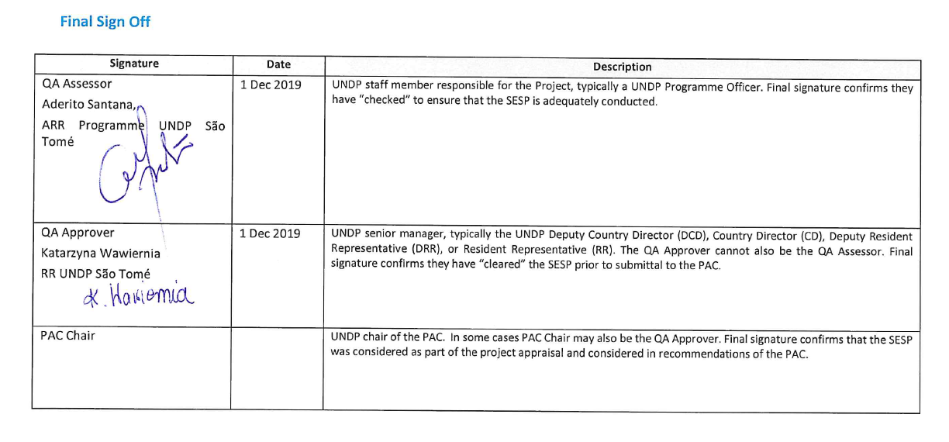
SESP Attachment 1. Social and Environmental Risk Screening Checklist
Checklist Potential Social and Environmental Risks
Principles 1: Human Rights | Answer  (Yes/No)
1. Could the Project lead to adverse impacts on enjoyment of the human rights (civil, political, economic, social or cultural) of the affected population and particularly of marginalized groups? | Yes
2. Is there a likelihood that the Project would have inequitable or discriminatory adverse impacts on affected populations, particularly people living in poverty or marginalized or excluded individuals or groups? | Yes
3. Could the Project potentially restrict availability, quality of and access to resources or basic services, in particular to marginalized individuals or groups? | Yes
4. Is there a likelihood that the Project would exclude any potentially affected stakeholders, in particular marginalized groups, from fully participating in decisions that may affect them? | Yes
5. Is there a risk that duty-bearers do not have the capacity to meet their obligations in the Project? | Yes
6. Is there a risk that rights-holders do not have the capacity to claim their rights? | Yes
7. Have local communities or individuals, given the opportunity, raised human rights concerns regarding the Project during the stakeholder engagement process? | No
8. Is there a risk that the Project would exacerbate conflicts among and/or the risk of violence to project-affected communities and individuals? | Yes
Principle 2: Gender Equality and Women’s Empowerment
1. Is there a likelihood that the proposed Project would have adverse impacts on gender equality and/or the situation of women and girls? | No
2. Would the Project potentially reproduce discriminations against women based on gender, especially regarding participation in design and implementation or access to opportunities and benefits? | No
3. Have women’s groups/leaders raised gender equality concerns regarding the Project during the stakeholder engagement process and has this been included in the overall Project proposal and in the risk assessment? | No
4. Would the Project potentially limit women’s ability to use, develop and protect natural resources, taking into account different roles and positions of women and men in accessing environmental goods and services? | Yes
Principle 3: Environmental Sustainability: Screening questions regarding environmental risks are encompassed by the specific Standard-related questions below
Standard 1: Biodiversity Conservation and Sustainable Natural Resource Management
1.1 Would the Project potentially cause adverse impacts to habitats (e.g. modified, natural, and critical habitats) and/or ecosystems and ecosystem services? | Yes
1.2 Are any Project activities proposed within or adjacent to critical habitats and/or environmentally sensitive areas, including legally protected areas (e.g. nature reserve, national park), areas proposed for protection, or recognized as such by authoritative sources and/or indigenous peoples or local communities? | Yes
1.3 Does the Project involve changes to the use of lands and resources that may have adverse impacts on habitats, ecosystems, and/or livelihoods? | Yes
1.4 Would Project activities pose risks to endangered species? | Yes
1.5 Would the Project pose a risk of introducing invasive alien species? | Yes
1.6 Does the Project involve harvesting of natural forests, plantation development, or reforestation? | Yes
1.7 Does the Project involve the production and/or harvesting of fish populations or other aquatic species? | No
1.8 Does the Project involve significant extraction, diversion or containment of surface or ground water? | No
1.9 Does the Project involve utilization of genetic resources? (e.g. collection and/or harvesting, commercial development) | No
1.10 Would the Project generate potential adverse transboundary or global environmental concerns? | N0
1.11 Would the Project result in secondary or consequential development activities which could lead to adverse social and environmental effects, or would it generate cumulative impacts with other known existing or planned activities in the area? | Yes
Standard 2: Climate Change Mitigation and Adaptation
2.1 Will the proposed Project result in significant greenhouse gas emissions or may exacerbate climate change? | No
2.2 Would the potential outcomes of the Project be sensitive or vulnerable to potential impacts of climate change? | Yes
2.3 Is the proposed Project likely to directly or indirectly increase social and environmental vulnerability to climate change now or in the future (also known as maladaptive practices)? | Yes
Standard 3: Community Health, Safety and Working Conditions
3.1 Would elements of Project construction, operation, or decommissioning pose potential safety risks to local communities? | No
3.2 Would the Project pose potential risks to community health and safety due to the transport, storage, and use and/or disposal of hazardous or dangerous materials (e.g. explosives, fuel and other chemicals during construction and operation)? | No
3.3 Does the Project involve large-scale infrastructure development (e.g. dams, roads, buildings)? | No
3.4 Would failure of structural elements of the Project pose risks to communities? (e.g. collapse of buildings or infrastructure) | No
3.5 Would the proposed Project be susceptible to or lead to increased vulnerability to earthquakes, subsidence, landslides, erosion, flooding or extreme climatic conditions? | No
3.6 Would the Project result in potential increased health risks (e.g. from water-borne or other vector-borne diseases or communicable infections such as HIV/AIDS)? | No
3.7 Does the Project pose potential risks and vulnerabilities related to occupational health and safety due to physical, chemical, biological, and radiological hazards during Project construction, operation, or decommissioning? | No
3.8 Does the Project involve support for employment or livelihoods that may fail to comply with national and international labor standards (i.e. principles and standards of ILO fundamental conventions)? | No
3.9 Does the Project engage security personnel that may pose a potential risk to health and safety of communities and/or individuals (e.g. due to a lack of adequate training or accountability)? | Yes
Standard 4: Cultural Heritage
4.1 Will the proposed Project result in interventions that would potentially adversely impact sites, structures, or objects with historical, cultural, artistic, traditional or religious values or intangible forms of culture (e.g. knowledge, innovations, practices)? | No
4.2 Does the Project propose utilizing tangible and/or intangible forms of cultural heritage for commercial or other purposes? | No
Standard 5: Displacement and Resettlement
5.1 Would the Project potentially involve temporary or permanent and full or partial physical displacement? | No
5.2 Would the Project possibly result in economic displacement (e.g. loss of assets or access to resources due to land acquisition or access restrictions – even in the absence of physical relocation)? | Yes
5.3 Is there a risk that the Project would lead to forced evictions? | No
5.4 Would the proposed Project possibly affect land tenure arrangements and/or community-based property rights/customary rights to land, territories and/or resources? | Yes
Standard 6: Indigenous Peoples
6.1 Are indigenous peoples present in the Project area (including Project area of influence)? | No
6.2 Is it likely that the Project or portions of the Project will be located on lands and territories claimed by indigenous peoples? | No
6.3 Would the proposed Project potentially affect the human rights, lands, natural resources, territories, and traditional livelihoods of indigenous peoples (regardless of whether indigenous peoples possess the legal titles to such areas, whether the Project is located within or outside of the lands and territories inhabited by the affected peoples, or whether the indigenous peoples are recognized as indigenous peoples by the country in question)? | No
6.4 Has there been an absence of culturally appropriate consultations carried out with the objective of achieving FPIC on matters that may affect the rights and interests, lands, resources, territories and traditional livelihoods of the indigenous peoples concerned? | No
6.5 Does the proposed Project involve the utilization and/or commercial development of natural resources on lands and territories claimed by indigenous peoples? | No
6.6 Is there a potential for forced eviction or the whole or partial physical or economic displacement of indigenous peoples, including through access restrictions to lands, territories, and resources? | No
6.7 Would the Project adversely affect the development priorities of indigenous peoples as defined by them? | No
6.8 Would the Project potentially affect the physical and cultural survival of indigenous peoples? | No
6.9 Would the Project potentially affect the Cultural Heritage of indigenous peoples, including through the commercialization or use of their traditional knowledge and practices? | No
Standard 7: Pollution Prevention and Resource Efficiency
7.1 Would the Project potentially result in the release of pollutants to the environment due to routine or non-routine circumstances with the potential for adverse local, regional, and/or transboundary impacts? | Yes
7.2 Would the proposed Project potentially result in the generation of waste (both hazardous and non-hazardous)? | No
7.3 Will the proposed Project potentially involve the manufacture, trade, release, and/or use of hazardous chemicals and/or materials? Does the Project propose use of chemicals or materials subject to international bans or phase-outs? | No
7.4 Will the proposed Project involve the application of pesticides that may have a negative effect on the environment or human health? | Yes
7.5 Does the Project include activities that require significant consumption of raw materials, energy, and/or water? | No

Annex 4: UNDP Risk Log
*: Social / Environmental, Financial, Operational, Organizational, Political, Regulatory, Strategic, Other
# | Risk Description | Date Identified | Risk Category* | Impact &  Probability | Countermeasures / Mgmt. response | Risk Owner | Status
Social and Environmental Risks and Mitigation Measures
1 | SES Risk A: The emplacement of systems for integrated environmental surveillance and enforcement (forests, agriculture, PAs, land use, coastal, etc.) could impinge on the livelihoods of rural communities, potentially restricting access to some resources; possibly resulting in economic displacement for specific user groups such as loggers and charcoal makers. | PPG Nov 2019 | Social / Environmental | I = 3  P = 3 | The project includes a comprehensive set of measures allowing greater capacity and resources for effective law enforcement; while minimizing the associated risks for vulnerable populations, namely by (a) informing why law enforcement is critical and how it will be done, (b) capacitate and support alternative activities and compensation measures. This includes:  (i) Preparation of an internationally benchmarked but nationally adapted national environmental law enforcement strategy and action plan, process that will be supported throughout the project by a Biodiversity and Law Enforcement Advisor;  (ii) Strengthening of legal and regulatory framework on environmental protection, compensation measures and related enforcement;  (iii) Human rights awareness raising and capacity building for the environmental guards recruited under the project, for politicians (government, MPs), for state officials and for target audiences;  (iv) Consultation of all stakeholders (comprehensive Stakeholder Action Plan has been developed under the PPG and is included in the PRODOC Annexes); especially target groups that are potentially at rist (e.g., charcoal makers and loggers). An inclusive participatory platform will be proposed to facilitate the debate on law enforcement strategies.  (v) Communication on sustainable forest management, biodiversity and protected areas. Several comprehensive national campaigns will be launched in 2020, following the development of the strategy on sustainable management, preservation and conservation of forests, biodiversity, PA and ecosystems (e.g., Information HUB proposed by GEF6-funded FAO-led TRI project). The project will capitalize on and support these initiatives, by endorsing environmental education programs and providing expertise on the issues addressed by the project (e.g., integrated environmental surveillance and enforcement);  (vi) Direct involvement of communities and user groups in law enforcement, through the development of a community-based surveillance.  The project will conduct risk assessments on Economic Displacement and Human Rights (to include the risk of Violent Conflict) - and develop a Livelihood Action Plan and a Human Rights Action Plan before the implementation stage, to avoid, mitigate and/or compensate for any impacts from these risks. | NPD, NPC, RP, CTA, UNDP CO
2 | SES Risk B: While the project does not propose the gazettement of new formal protected areas, restrictions on natural resource access in newly identified HCV Forests could impinge on the livelihoods of nearby communities. | PPG Nov 2019 | Social / Environmental | I = 3  P = 3 | HCV identification takes into account management issues such as access to and use of natural resources by local populations and groups of users within HCV. Evidence based ToRs will be defined for each of the HCVs, to ensure due protection of specific species and habitats; not limiting, or partially limiting destructive activities, towards a sustainable management model, in constant consultation with all stakeholders (i.e., Output 2.1 - Internationally benchmarked innovative management/partnership models in HCV areas (PPP, concessions, community-based, co-management, work with APCI))  Most stakeholders recognize that the zoning of the country is anarchic and carried out by various state institutions without coordination. If the Government is currently working on a National Land Use and Management Plan (Plano Nacional de Ordenamento do Território - PNOT), there is no coherent approach yet to land-use. There is a need for greater coordination to allow spatial and land use planning compatible with current laws, sustainable development initiatives and conservation efforts; in particular for the Natural Parks, as described in the Law nº6/2006 and 7/2006, as well as their buffer zones, for the PNOT, etc. The HCV model used by the project will make it possible to coordinate the land use model by integrating biodiversity and habitat protection practices.  As mentioned under Risk A, the project will also conduct risk assessments on Economic Displacement - and develop a Livelihood Action to address this risk before the start of the activities. | NPD, NPC, RP, CTA, UNDP CO
3 | SES Risk C: Support for the establishment of a structure to facilitate the spatial & land use plan could have an intrusive effect on local populations regarding access to land and resources. | PPG Nov 2019 | Social / Environmental | I = 3  P = 2 | This action results from a direct recommendation of the execution cell of the PNOT under development because the government wishes to ensure the continuity of the actions carried out.  The project will ensure that biodiversity and wider environmental considerations are embedded in land planning and land use initiative by recruiting an Environment Mainstreaming and Safeguards Officer.  The ToRs of the EMS Officer include the responsibility to ensure that any social risks to local populations arising from land planning and land use interventions are avoided or mitigated for. | NPD, NPC, RP, CTA, UNDP CO
4 | SES Risk D: Mobilization of more sustainable charcoal kilns and charcoal sources could lead to significant competition for charcoal producers, marginalized groups, who are economically dependent on this activity. | PPG Nov 2019 | Social / Environmental | I = 2  P = 4 | An obvious trend in Sao Tomé and Príncipe is the reduction of tree stocks for charcoal production. As population is growing, the demand is increasing, and charcoal is being produced more and more in-land due to lack of wooden resources thus increasing its costs (transport, effort). Most of the production is opportunistic (agricultural expansion and plot cleaning) and only a few producers are oriented towards this trade (evaluate a maximum of 500 individuals). There are no traditions of charcoal production, its primary use is for cooking. And charcoal buyers are mostly peri-urban and urban populations.  To address the social risks, rural charcoal production will first be improved, giving producers an opportunity to adopt more sustainable production methods, through improved charcoal kilns in selected pilot sites and communities in Sao Tomé and Príncipe. Second, the project will introduce sustainable alternatives to charcoal makers. These measures include:  (i) Involvement of communities and user groups (i.e., charcoal makers) in the establishment of law enforcement and monitoring, through development of a community-based surveillance.  (ii) Screening and distribution of low-value grants for sustainable livelihoods and sustainable charcoal initiatives, to individuals and/or group of individuals (e.g. charcoal makers), including vulnerable groups (e.g. women) for sustainable kilns, briquettes, biogas, NTFP, apiculture, sustainable forestry;  (iii) Involvement of charcoal makers in planting of fast-growing charcoal tree species;  (iv) Direct employment through project and Public Private Partnership between Government and Valudo.  By convening a National Sustainable Charcoal Platform, the project will give continuity to the in-depth consultations undertaken during the PPG, and optimize the consultation process, by giving the most at-risk population the opportunity to share their opinions and propose alternatives. The project field team permanently on the ground, will allow for a continuous capacitation and communication flow between community / users and decision makers / implementation parties. Coconut-based charcoal manuals will also be produced and disseminated to facilitate self-learning.  As mentioned under Risk A, the project will before the start of activities conduct risk assessments on Economic Displacement and Human Rights (to include the risk of Violent Conflict) - and develop a Livelihood Action Plan and a Human Rights Action Plan to avoid, mitigate and/or compensate for any impacts from these risks. | NPD, NPC, RP, CTA, UNDP CO
5 | SES Risk E: Industrial charcoal production could lead to competition involving prices decrease of charcoal on national market while maintaining the levels of charcoal production produced by tree felling, resulting in a decrease in producers' incomes and the economic non-viability of the proposed PPP. In the worst-case scenario, the implementation of more sustainable charcoal kilns could lead to increased pressure on native forests with, on one side, export of coconut and other plant waste material produced coal, and, on the other side, decrease in the income of small producers, which could increase their production to reach their usual economic profitability level. | PPG Nov 2019 | Social / Environmental | I = 4  P = 2 | It is very unlikely that the approach, following the recommendations of the main stakeholders consulted during the PPG, will not lead to a significant reduction in charcoal production through indiscriminate logging. However, increased monitoring and evaluation work and ongoing consultation of stakeholders (platform) will minimize this risk. Alternative income-generating activities must be entirely oriented towards producers (see above).  An economic viability study will be conducted pre-project, following the value chain study, to ensure the economic sustainability of the initiative by focusing on the inclusion of charcoal makers and environmental benefits at a landscape level. The project will also support a charcoal supply and value chain analysis to identify further options for reducing wood-based charcoal extraction drivers that will guarantee efficiency of intervention.  As for the risks linked to the unprofitable nature of the PPP, it was confirmed during the PPG that (i) the government is particularly favorable to PPPs, that they are promoting and facilitating in the sectors of agriculture (e.g. medium-sized enterprises) and energy (e.g. small hydroelectric power plants). (ii) that the largest charcoal buyers are large retailers (e.g. Super CKDO, Coconut) and hotels (e.g. Pestana group, Club Santana, HBD), and that they are seeking for alternative to charcoal produced by indiscriminate tree felling, mainly image reasons, at regional, national and international level for hotels. The “clean” coal proposed under the PPP has thus great demand potential.  Implementation of this specific PPP, pilot for the country, will be based on the in-depth review and streamline legal and regulatory framework for exploitation of charcoal, licensing regulations, taxation, production and trade [complementing emerging work by DFB-FAO], proposed in output 1.1. This package will strengthen that no export of coal is allowed; therefore, obligating Valudo to stick to the national market. Valudo sees coconut clean coal as a non-profit product; this approach offers them an opportunity to value waste, create green jobs (a must for certification processes; e.g., fair-trade, ecocert).  The transparent management of the PPP, regularly monitored by the above-mentioned platform, will additionally ensure the economic, environmental and social sustainability of the proposed PPP. | NPD, NPC, RP, CTA, UNDP CO
6 | SES Risk F: Project could exclude potentially affected stakeholders, in particular charcoal makers and communities, from fully participating in decisions that may affect them duty-bearers do not have the capacity to meet their obligations. | PPG Nov 2019 | Social / Environmental | I = 3  P = 2 | STP political-investment into participatory planning for natural resource is growing, due to an increasing recognition of its unique natural patrimony as a source of income. With the resulting extensive donor support that the country is receiving (see baseline investment), it is anticipated that the risk will be addressed – also with support from this proposed project, which aims to ensure that policy and corresponding capacities, enforcement and communication mechanisms are adequately strengthened.  Mechanisms will be put in place to secure integration of all stakeholders into the decision-making process while offering study-based information to guide the discussions. The project will have a strong focus on enhancing capacity of targeted stakeholders to ensure that they have the required knowledge and skills to actively participate in project interventions, incorporate lessons learned, and uptake good practices.  The set-up of the project involved various stakeholders including the Government - mainly through the Ministry of Public Work, Infrastructures, Natural Resources and Environment (General Directorate for Environment) and the Ministry of Agriculture, Fisheries and Rural Development (Directorate for Forest and Biodiversity) - an international conservation NGO (BirdLife International), whose intrinsic objective is strengthening greater participation of civil society in sustainable environmental management, and the development focused United Nations Development Programme agency, will guarantee the legitimacy of the decision-making processes with adequate integration of local communities consultation.  BirdLife International, leading a consortium of NGOs, will bring its expertise with community participation gained through its current positive experience working with a network of community promotors and focal groups in relevant communities in the framework of the EU-funded ECOFAC VI project.  A comprehensive Stakeholder Action Plan has been developed under the PPG and is included in the PRODOC Annexes.  As mentioned under Risk A, an Economic Displacement Risk Assessment and a Human Rights Risk Assessment will be undertaken prior to the launch of project activities, that will produce a Livelihood Action Plan and Human Rights Action Plan, respectively, for the project, and will also define an appropriate project-level Grievance Redress Mechanism, if required. | NPD, NPC, RP, CTA, UNDP CO
7 | SES Risk G: The Project could potentially cause adverse impacts to habitats, ecosystems, ecosystem services, environmentally sensitive areas, legally protected areas, areas proposed for protection, to critical habitats, including legally protected areas (Sao Tomé Obô Natural Park – PNOST and Príncipe Natural Park – PNP), as well as areas proposed for protection. The project could potentially pose risks to endangered species and promote the distribution of already-introduced taxa through activities related to land-use planning, planting, or harvesting of Natural Resources. | PPG Nov 2019 | Social / Environmental | I = 2  P = 5 | The project is specifically designed to have a positive impact on biodiversity conservation and land management in critical habitats, improved management of existing PAs & HCVs. All activities will be designed and implemented in the most risk-averse way possible, integrating biodiversity in all decision-making.  The project will streamline the institutional framework and create a suitable autonomous agency for environment and land management (Output 1.1). The project will further integrate environmental sustainability and biodiversity considerations in the recently concluded PNOT (Output 1.2). Considering that the PNOT does not yet take into account environmental aspects, the project by its only existence will have a positive impact.  The project will, among others:  (i) Provide with resources, technical assistance and NGO engagement, involving key agencies (e.g., APCI - Agencia de Promoção do Comercio & Investimento whose role is to guide investment) and the Protected Areas responsible agencies.  (ii) Support, through a multi-sectoral approach, integration of environmental sustainability and biodiversity considerations, land-use planning, land allocation, land management and investment decisions, ensuring these are aligned with the National Land Use and Management Plan; specifically including the APCI, attending and supporting investors, and guiding them to line up investment with national expectations. The support will be all the more important in terms of further advancement, management and expansion of internationally benchmarked innovative management/partnership models in PAs and HCV areas (PPP, concessions, community-based, co-management),  This will be facilitated especially by the Environment Mainstreaming and Safeguards Officer hired by the project, who will have a key role in preventing/managing harmful impacts from larger-scale changes such as infrastructure developments or agricultural rezoning.  Biodiversity mainstreaming and adaptive integration will also be promoted through:  (iii) Development of a Management Oriented System and further implementation of the annual transects surveys will secure regular monitoring, improvement of knowledge and adaptability of actions;  (iv) Supporting long-term sustainability of evidence-based environment considerations nationally through capacity building - on biodiversity, zoology/botany, ecosystem services, conservation and Protected Areas management – and integration of scientific knowledge in policy making  Reviews of the Parks management plan fall into BirdLife International co-finance to the action; this will include scientific evidence-based zoning, to ensure appropriate and realistic management of protected areas, in line with existing management plans.  There is low risk of introducing new species to the islands, but there is a risk that any reforestation or livelihood activities could promote and further areas the distribution of already-introduced taxa. Building up on lessons learnt through, among others initiatives, DFB/TRI/FAO GEF6-funded project [the planting activities have been designed to complement this project], the Missouri Botanical Garden [historical partner of the ECOFAC EU-funded programme] CEPF-funded ‘Characterization of the Threatened Flora of São Tomé and Príncipe’ (2019-2020), and; the FFI [working closely with BirdLife International, globally and nationally] Global Tree Campaign project (Príncipe Island), the project will only consider native or endemic trees species, in particular in development of the activities:  (i) seedling and planting of time-sequenced fast-growing charcoal tree species (e.g. native Pentaclethra macrophylla; endemic Polyscias quintasii) and;  (ii) low-value grants for sustainable livelihoods.  An internal study allowing identification of the most suitable sequence of fast-growing candidate species will inform this process before the launch of the activities.  The project will secure that no expansion of the planted plots can overcome the high diversity and protection status of High Conservation Value areas and the Natural Parks during the identification and preparation of dedicated land plots.  Proximity and easy-access of the selected plots will secure sustainability of the planting activities, both ecologically and economically, and allow due monitoring by the authorities (supported by the project team). Biodiversity improvement will be a key criterion for selection of the low-value grants for sustainable livelihoods.  A communication campaign will be developed to limit the introduction of alien plants through tourism activities.  The TORs of the Environment Mainstreaming and Safeguards Officer include the responsibility to ensure that any unwanted environmental risk from reforestation are avoided or mitigated. The risk is hence managed through project design. | NPD, NPC, RP, CTA, UNDP CO
8 | SES Risk H: The expected outcomes of the project could be sensitive to potential impacts of climate change. | PPG Nov 2019 | Social / Environmental | I = 3  P = 4 | The project will work to address anticipated impacts of climate change by increasing resilience of the target landscape, through improving management of protected areas and ecosystem functioning and secure a sustainable flow of ecosystem services. By protecting coastal PAs and mangrove forests, through sustainable livelihoods, the project will directly contribute to enhancing socio-ecological resilience to the impacts of climate change.  In any SFM/SLM activities, climate adapted species (native) should be incorporated in the project (see Risk G).  The project will support mobilization of more sustainable charcoal kilns through production of plant-based charcoal briquettes especially from coconut shells and fibers. Coconuts are well known for their nutrition qualities and the trees are resistant to climate change, limit coastal erosion, and act as a carbon sink. The project will indirectly incentivize the development of coconut crops and ageing coconut groves in the archipelago; which have an important role in the socio-environmental balance of the islands. Even if the interest in terms of biodiversity is low, there is no risk of extension of the actual land coverage by coconuts but rather an opportunity for renewing the existing plantations, favoring their mixture with attractive plants for local biodiversity, thus developing a value chain and jobs, while mitigating climate change. | NPD, NPC, RP, CTA, UNDP CO
9 | SES Risk I: The project could indirectly increase social and environmental vulnerability to climate change | PPG Nov 2019 | Social / Environmental | I = 4  P = 2 | In the process of biodiversity mainstreaming (see Risk C), the project will consider all relevant aspects of climate change and will advocate for integrative and adapted interpretation of the National Land Use and Management Plan; especially while planning on SLM and SFM interventions.  Many initiatives have been and are still addressing the issue of climate change in Sao Tomé and Príncipe and strong linkages will be established with past, ongoing and future efforts to improve climate information and resilience, including the GEF5-funded, UNDP-supported project ‘Enhancing Capacities of Rural Communities to Pursue Climate Resilient Livelihood Options in the Sao Tomé and Príncipe Districts of Caué, Me-Zochi, Príncipe, Lemba, Cantagalo, and Lobata (CMPLCL)’;the GEF5-funded, UNDP-supported project ‘Strengthening Climate Information and Early Warning Systems in São Tomé and Príncipe for Climate Resilient Development and Adaptation to Climate Change’ and; the EU-funded ‘Reducing climatic vulnerability in STP’.  Adaptation and Mitigation to Climate Change Action Plans have been or are being developed nationally and at district level, through the institutionalized National Committee on Climate Change (http://cnmc.gov.st/). These documents, freely available and of public use, are/will offer specific guidance that will be implemented while interpreting the National Land Use and Management Plan.  The TORs of the Environment Mainstreaming and Safeguards Officer include the requirement to ensure climate-proof interventions, and to not inadvertently increase social and environmental vulnerability to climate change. | NPD, NPC, RP, CTA, UNDP CO
10 | SES Risk J: The project could affect land tenure arrangements | PPG Nov 2019 | Social / Environmental | I = 2  P = 3 | While this risk is judged moderate and a Stakeholder Engagement Plan, as mentioned under Risk C and G, has been prepared (PRODOC Annexes) it is potentially serious therefore special assessments, as mentioned under Risk A, will be undertaken before the start of activities and regularly updated during project implementation as follows:  (i) Conduct a Human Rights Risk Assessment and prepare a Human Rights Action Plan and oversee adequate implementation of the Human Rights Action Plan by project staff and stakeholders;  (ii) Conduct an Economic Displacement Risk Assessment and prepare a Livelihood Action Plan (if not yet completed by project start) and oversee adequate implementation of the Livelihood Action Plan by project staff and stakeholders. | NPD, NPC, RP, CTA, UNDP CO
11 | SES Risk K: The project could potentially exacerbate conflicts among and/or the risk of violence to project-affected communities and individuals. | PPG Nov 2019 | Social / Environmental | I = 3  P = 2 | In line with the proposed management measures for risks A, C, G and J, the project will, before the start of activities, conduct risk assessments on Economic Displacement and Human Rights (to include the risk of Violent Conflict) - and develop a Livelihood Action Plan and a Human Rights Action Plan to avoid, mitigate and/or compensate for any impacts from these risks. Awareness raising and capacity building activities on human rights will be provided to the environmental guards recruited under the project and will facilitate implementation of above-mentioned plans, with the support of ongoing technical assistance.  The project will attempt to mitigate this risk to the best extent possible by increasing awareness about Pas/HCVs boundaries, while simultaneously reducing the need for illegally sourced resources thus minimizing risks for vulnerable populations (see Risks A, B, D and F). | NPD, NPC, RP, CTA, UNDP CO
12 | SES Risk L: The project could affect women, generally playing important roles at the end of the charcoal value chain, for sales of the final product. | PPG Nov 2019 | Social / Environmental | I = 2  P = 3 | At the project development phase, a gender analysis was carried out and a comprehensive gender action plan has been developed under the PPG, included in the PRODOC Annexes.  The project Monitoring and Evaluation Plan will include gender-specific indicators to assess concrete progress on transversal gender inclusion and mainstreaming. E.g., gender equitability criteria will be paramount in the selection of the low-value grants for sustainable livelihoods and sustainable charcoal initiatives and aim to involve at least 50% of female beneficiaries. The risk assessment on Economic Displacement will consider gender equality, roles and how the project would affect these; the action plans, will then promote cross-cutting gender equal opportunities. | NPD, NPC, RP, CTA, UNDP CO
13 | SES Risk M: The emplacement of environmental guards recruited under the project; pose a potential risk to safety of communities and/or individuals (including the guards themselves). | PPG Nov 2019 | Social / Environmental | I = 3  P = 2 | A Human Rights Risk Assessment will be conducted and lead to a Human Rights Action Plan (including risks of violence).  This will be associated to the direct activities support and supervision by an highly experienced International Expert in Environmental Law Enforcement:  (i) development of internationally benchmarked but nationally adapted national environmental law enforcement strategy and action plan;  (ii) Advanced training of the guards, capacity development efforts for environmental law surveillance and enforcement.  A family/health benefit/pension plan will be developed to secure environmental guards’ family’s income (in case of illness, injury or death of a guard in the performance of his duties). | NPD, NPC, RP, CTA, UNDP CO
14 | SES Risk N: The project could potentially result in the release of pollutants to the environment following potential application of pesticides on trees during forest restauration. | PPG Nov 2019 | Social / Environmental | I = 3  P = 1 | Nursery technicians will be trained accordingly by NPC, RP and CTA. | NPD, NPC, RP, CTA, UNDP CO
Risks to Project Success and Mitigation Measures
15 | Slow decision-making processes, constraints in institutional capacity and weak national staff (NPC/PM and others, and counterpart technicians) impede timely delivery of project activities and procurement of goods and services, and undermine the achievement of the stipulated outcomes | PPG Nov 2019 | Operational | I = 4  P = 3  CRITICAL | These are commons risk in many projects, where mere oversight by UNDP CO may not be enough. The need to build professional individual and institutional capacities is widely acknowledged by the Government.  The PPG confirmed that processes in STP can be lengthy and complex. Although not critical, delays may compromise the quality of Project outputs and affect the integrity of the Project as a whole.  Several mitigation strategies are incorporated into the Project design: i) implementation support provided by UNDP in terms of procurement and payment; ii) route c. 30% of the budget through the RP-NGO BirdLife International, which is less exposed to such risks; iii) dedicated attention on capacity development across different target groups; iv) recruitment of a CTA and other international experts for the project to deliver and train. | NPD, NPC, RP, CTA, UNDP CO
16 | Weak international staff found or appointed (CTA, other international TA) | PPG Nov 2019 | Operational | I = 4  P = 2 | UNDP will appoint the CTA ad most of the TA, with involvement of the RTA. These will be replaced if performance is not satisfactory. | NPD, NPC, RP, CTA, UNDP CO
17 | Inter-agency coordination proves challenging and DGA does not appropriately delegate or facilitate activities / responsibilities to DFB and to RSESD on Príncipe (which has often been neglected in past national projects) | PPG Nov 2019 | Operational | I = 3  P = 3 | Steering committees and platforms will be facilitated and receive training as required on governance and conflict resolution. Project activities are designed to encourage cooperation. The PRODOC specifies the respective responsibilities to be shared between govt agencies. In addition, on Príncipe only the RSESD has a proper mandate, so DGA or DFB alone cannot act there, what will matter is that the designated resources are assigned to Príncipe. All this will be facilitated because UNDP will oversee much of the procurement and payments to be made by and for the project, which will allow the expected appropriate resourcing across govt agencies. | NPD, NPC, RP, CTA, UNDP CO
18 | DGA does not appropriately delegate or facilitate activities / responsibilities to BirdLife International (and by extension other NGOs in STP) | PPG Nov 2019 | Operational | I = 3  P = 2 | BLI – who is also a major co-financier to the project – has been designated a Responsible Party by UNDP so that the resources stipulated in the PRODOC/TBWP (c. 30%) will go directly to them. | NPD, NPC, RP, CTA, UNDP CO
19 | Government (DGA DFB RSESD) and NGOs (BLI, Fundacao Príncipe) teams do not work well together and latent low-level conflict between Government and NGOs becomes more prominent, due to inadequate coordination, unmet expectations, jealousy, territoriality, etc. | PPG Nov 2019 | Operational | I = 3  P = 3 | At least on São Tomé the Government and NGO teams will be co-located in the same office space, to facilitate good coordination, exchanges and capacity development (technical and managerial), on the job learning. On Príncipe the same will be attempted, yet the island capital is sufficiently small to allow coordination also without as long as the issues receives due attention. A key aspect will be the management of expectations, which must be discussed from the start with inputs from UNDP. | NPD, NPC, RP, CTA, UNDP CO
20 | RP BirdLife International pulls out of the country, leaving 30% of GEF resources and a major part of the co-financing unimplemented. | PPG Nov 2019 | Organizational | I = 3  P = 1 | Very low risk. If this should happen the NGO-part of the project could be routes via one of the other sufficiently able NGOs in STP such as Oikos. | NPD, NPC, RP, CTA, UNDP CO
21 | Expectations by national project staff and government technicians that per diems be paid for activities or field trips, including for joint sorties with the project (Govt-led or NGO-led); consequent risk that activity levels (especially in the field) remain low if these expectations are not met. | PPG Nov 2019 | Operational | I = 3  P = 4 | Upfront discussions between IP and relevant government agencies, RP-NGO and UNDP to come to an agreement on the modality, which must meet UNDP-GEF rules and regulations. | NPD, NPC, RP, CTA, UNDP CO
22 | Insufficient political will and capacity to improve biodiversity conservation and sustainable land and forest management. | PIF June 2018 | Political | I = 3  P = 3 | With the growing recognition of the high and unique biodiversity values of São Tomé and the resulting extensive donor support that the country is receiving, it is anticipated that these risks will be addressed – also with support from this proposed project, which aims to ensure that policy and corresponding capacities, enforcement and communication mechanisms are adequately strengthened. The project will have a strong focus on enhancing capacity of targeted stakeholders to ensure that they have the required knowledge (including understanding of the economic benefits of biodiversity and ecosystem services) and skills to actively participate in project interventions, incorporate lessons learned, and uptake good practices. | NPD, NPC, RP, CTA, UNDP CO
23 | Lack of support by senior government staff and technicians for a revision of legal and institutional frameworks for biodiversity/PAs, environment and land use planning/PNOT | PPG Nov 2019 | Political | I = 3  P = 3 | Ministers and other senior staff in both MOPIRNA and MAPDR expressed interest in some form of restructuring and the creation of new more autonomous agencies. The process will be fully consultative to integrate the view of technicians, but also accompanied by international technical assistance to explain the shortcomings/gaps and potential improvements. Ministers will be involved where appropriate to ensure that idiosyncratic petty concerns do not impede an improvement of public services. | NPD, NPC, RP, CTA, UNDP CO
24 | Lack of support by senior government staff and technicians to set up an environmental law enforcement platform and system | PPG Nov 2019 | Political | I = 3  P = 3 | There is a general agreement at least in MOPRINA and MAPRD about the need to create an environmental law enforcement system. There are however different views on how this should be best achieved, under what lead agency, and what should happen to existing systems (especially the forest guards) that some consider effective and others do not. The process will be fully consultative to integrate the view of technicians, but also accompanied by international technical assistance to explain the shortcomings/gaps and potential improvements. Ministers will be involved where appropriate to ensure that there are no second-grade obstacles to an improvement of public services. | NPD, NPC, RP, CTA, UNDP CO
25 | Too limited international benchmarking in the revision of the legal and institutional framework, in the design and emplacement of the environmental law enforcement scheme | PPG Nov 2019 | Operational | I = 3  P = 3 | The project will hire international TAs on environmental law and environmental law enforcement. | NPD, NPC, RP, CTA, UNDP CO
26 | Land use planning and management (PNOT) team collapses after the end of the current project funding (after mid 2020) such that there will be no land use planning and management platform and hence no mainstreaming opportunities | PPG Nov 2019 | Organizational | I = 3  P = 3 | There are two possible answers to this. .Firstly, to finance a basic team to continue this work under the project by reassigning budgets; and secoindly, by integrating cross-sectoral mainstreaming of biodiversity and environmental matters into another section of MOPIRNA or MAPDR. | NPD, NPC, RP, CTA, UNDP CO
27 | Land use planning and management (PNOT) platform once maintained by govt is not open to mainstreaming environment and biodiversity | PPG Nov 2019 | Political | I = 3  P = 2 | There was general agreement amongst key stakeholders (MOPRINA, DGA, DFB, RSESD, NGOs) that this was a necessity. The fact that the PNOT will likely remain under MOPIRNA and DGA (reformed or not) will ensure that envt concerns are reflected in PNOT-relevant sector monitoring once the project makes the necessary resources available. | NPD, NPC, RP, CTA, UNDP CO
28 | Training / capacity development fatigue amongst beneficiaries (government technicians, communities, NGOs, etc. | PPG Nov 2019 | Operational | I = 2  P = 4 | Group trainings that in the PRODOC are presented in a fragmented way (so it responds better to the logical framework). For instance, integrate gender training in one of the other training blocks. | NPD, NPC, RP, CTA, UNDP CO
29 | Training / capacity development levels not appropriate – too generic, as was commented by govt technicians | PPG Nov 2019 | Operational | I = 2  P = 3 | Conduct an appraisal of the capacity needs and priorities at project start, to determine the topics and training levels to be covered including for advanced aspects | NPD, NPC, RP, CTA, UNDP CO
30 | Regarding the forest assessment under Output 2.1, LIDAR data cannot be made available, cannot be analysed, or does not have the required data | PPG Nov 2019 | Other | I = 1  P = 3 | This is not a critical deliverable for the project, but a satellite benefit for DFB and any subsequent work on forest management and REDD+. If LIDAR data does not offer a suitable simplification to create a simplified forest inventory/status and stock assessment, then this will be postponed. | NPD, NPC, RP, CTA, UNDP CO
31 | Critical community resistance to the emplacement of environmental law enforcement | PPG Nov 2019 | Strategic | I = 3  P = 4 | This is both a social safeguards risk but also a risk to project success. For mitigation/ management measures please see SES Risk A / SES Risk M above. | NPD, NPC, RP, CTA, UNDP CO
32 | Work on Biodiversity and PA financing does not yield any success, no new financing is generated | PPG Nov 2019 | Strategic | I = 3  P = 3 | Without this project, it is unlikely that any relevant new funding for biodiversity can be mobilised over the coming 4 years, apart from limited income that could be generated from tourists. In that sense, the setup of a conservation trust fund is a risk, a gamble, but one worth taking, and in any case it will need to be followed up by further continuing support in the future should there be some initial success during the project in terms of endowment fund capitalisation. To reduce the risk of failure, an experienced international expert with a proven track record in CTF creation and fundraising will be procured. There are a few alternative or complementary routes that could be taken in the future in case of failure: revenue from REDD+ carbon credit sales and offset payments from the oil & gas revenue that is expected to start flowing in a few years; both may be realised in the medium term but cannot yet be counted on for the present project. | NPD, NPC, RP, CTA, UNDP CO
33 | No suitable lands can be found for reforestation / charcoal tree planting | PPG Nov 2019 | Strategic | I = 3  P = 3 | This issue was discussed during the PPG. There was agreement that the risk is low and that lands could be found, including already over-exploited degraded public lands, and that govt can also plant on agricultural plots / lands that are currently under lease (noting that these still are still public lands and not actual private property). In response to concrete challenges of this type, the project could move to other communities. | NPD, NPC, RP, CTA, UNDP CO
34 | Weak support if not opposition from politicians and charcoal traders that potentially stand to lose revenues, could block better charcoal regulation and the introduction of more sustainable charcoal | PPG Nov 2019 | Strategic | I = 4  P = 3  CRITICAL | As in most countries in Africa, the charcoal sector in STP is largely informal and existing regulation is ineffective and poorly enforced, even if the situation on Príncipe is far better. As with other constituent-based risks, the first line of mitigation is inclusion. Identified private-sector stakeholders will be included when possible and appropriate (at different levels) to lessen such risks and identify opportunities for growth. In addition, there is a growing awareness of the need to better regulate and enforce the sector given the gradual disappearance of resources, and once a viable alternative is found the public and government can be expected to switch – especially if livelihood solutions for charcoal-makers can be found. | NPD, NPC, RP, CTA, UNDP CO
35 | Traditional charcoal makers could reject improved charcoal kiln technology for technical, socio-economic, or other reasons | PPG Nov 2019 | Strategic | I = 3  P = 4 | Acceptance of sustainable charcoal technology is proposed as a key goal of project component 3. Experiences in other countries indicate this to be a great challenge, as rural users would need to see real benefits. Hence, user acceptance is critical for Step 2 (production) in the charcoal value chain. In order to mitigate this risk, the project will invest substantial resources in proposing different charcoal production pilots in a participatory manner. Extensive TA, training activities and interaction with the stakeholders are foreseen to best match user needs and expectations. This will be accompanied with livelihood engagement including low value grants and an increase in environmental law enforcement. | NPD, NPC, RP, CTA, UNDP CO
36 | The proposed improved charcoal kilns could not perform as expected due to technical or operational factors. | PPG Nov 2019 | Strategic | I = 3  P = 2 | Improper construction and operation of charcoal kilns translates into low conversion efficiency and higher emissions than expected. Given the rudimentary baseline technology, the introduction of more advanced charcoal kilns is very challenging for the local producers. In order to mitigate the risk of non-performance, a path of small steps (incremental improvements) will be followed. The project will aim at successfully implementing basic improved kilns first (Casamance type or equivalent). Although simple, these may reduce wood consumption by a considerable factor.  Intensive technical assistance will be deployed to ensure that people fully understand, accept and adopt the chosen improved technologies. Lesson drawn from earlier experiences in other African countries and projects will be considered. By setting forward a modest level of ambition, and intensive support, this risk is deemed low/moderate. | NPD, NPC, RP, CTA, UNDP CO
37 | Incentives and livelihood alternatives for local stakeholders are insufficient to trigger behavioural change and practices away from harmful charcoal making practices, and law enforcement triggers negative reactions | PPG Nov 2019 | Strategic | I = 4  P = 4  CRITICAL | This is both a social safeguards risk but also a risk to project success. For mitigation/ management measures please see SES Risk D / SES Risk E above. | NPD, NPC, RP, CTA, UNDP CO
38 | Coconut-based charcoal value chain is not deemed attractive or viable enough for the private company (Valudo) expected to sign the PPP, leaving one sources of sustainable charcoal undeveloped | PPG Nov 2019 | Strategic | I = 3  P = 3 | Alternative models to collect the primary materials (coconut plant waste) and transport it to the centralised kilns for carbonisation and subsequent sale could be promoted involving community stakeholders or a newly setup up cooperative. | NPD, NPC, RP, CTA, UNDP CO
39 | The implementation of more sustainable charcoal kilns could lead to increased pressure on native forests | PPG Nov 2019 | Strategic | P = 2  I = 4 | This is both a social safeguards risk but also a risk to project success. For mitigation/ management measures please see SES Risk E above. | NPD, NPC, RP, CTA, UNDP CO
40 | Inadequate mapping of actors and mechanisms would affect empowerment of women. | PPG Nov 2019 | Strategic | P = 2  I = 2 | Although this risk is not critical for achieving GEB, there is a significant likelihood that economic and social benefits would become unevenly distributed and specifically, would not reach the most vulnerable stakeholders, especially rural women. Existing structures tend to benefit men more than women. These structures are systemic and hard to address.  As a countermeasure, the Project will make a continuous effort to identify gender-sensitive issues during its full throughput time; it will review proposed activities and pilots to ensure a gender-neutral or gender-positive approach. As part of annual project monitoring, performance on gender-specific criteria will be assess and recommendations for corrective action will be made, as and if appropriate. | NPD, NPC, RP, CTA, UNDP CO
41 | Climate change and related impacts may undermine the achievement of the project, especially for the long term | PIF June 2018 | Strategic | P = 3  I = 1 | While climate change is already affecting STP in terms of changing weather/ rainfall patterns, the project will work to address anticipated impacts of climate change by increasing resilience of the target landscape, through improving management of protected areas and ecosystem functioning. Through this, the project will emplace the best possible solution for natural ecosystems to face climate change through the maintenance of ecosystem resilience. | NPD, NPC, RP, CTA, UNDP CO
42 | A HACT Micro-Assessment of DGA in 2019 gave a Significant risk rating, determined weaknesses especially in the areas of i) organizational structure and staffing numbers (High), programme management (Significant), accounting policies and procedures (Significant) and financial reports and oversight (High); and noted that DGA does not have an financial accounting software or adequate internal control framework. | PPG Dec 2019 | Operational | P = 2  I = 2 | A budget is foreseen by the project to emplace financial software at DGA and ICF, and help build capacity on other of the matters highlighted by the HACT | NPD, NPC, RP, CTA, UNDP CO

Annex 5: Monitoring Plan
This Monitoring Plan and the M&E Plan and Budget in Section VI of this project document will both guide monitoring and evaluation at the project level for the duration of project implementation.

Monitoring | Indicators | Targets | Description of indicators and targets | Data source/Collection Methods & MOV | Frequency | Responsible for data collection
Objective:  Safeguard globally significant terrestrial biodiversity and ecosystems services by strengthening national capacities and frameworks for biodiversity and natural resource management, integrated land use planning and environmental law enforcement as well as enhancing protected area management and the sustainability of charcoal production | Indicator 1: # direct project beneficiaries disaggregated by gender (individual people) | MID 1,000 (500 men, 500 women)  END  2,000 (1,000 men, 1,000 women) | **: Guarda Ambiental 20; Community surveillance 20; capacity-building and direct engagement: 100 govt technicians; 40 politicians, 60 technicians, 500 community members + charcoal makers; 17 academics/interns; 30+ eco-guides; 10 Valudo employment; 20 tree planting; c. 1200 incl. co-beneficiaries through c. 30 household livelihood and value chain micro-grants @ avge household size of 4. Total estimate c. 2000. | Baseline source: estimation based on outputs/activities.  Collection: field and narrative reports, expert opinion, workshop lists | Reported Annually in Development Progress tab of the GEF PIR | DGA (General Directorate for Environment)  [Project Manager / Project Management Unit & RPs]
 | Indicator 2: # indirect project beneficiaries disaggregated by gender (individual people) | MID: 11,000 (5,500 men, 5,500 women)  END: 55,000 (27,500 men, 27,500 women) | MID  [20% of project end target because charcoal value chain emerging only]  END  [half of population of Príncipe of 10,000 + quarter of population on ST of 200,000 benefitting from more sustainable and healthier coconut-based charcoal] | Baseline source: estimation based on outputs/activities.  Collection: national reports (INE); project reports | Reported Annually in Development Progress tab of the GEF PIR | UNDP Country Office
 | Indicator 3 - GEF Core Indicator 4.1: Area of landscapes under improved management to benefit biodiversity | MID: 2,000 ha  END: 6,207 ha | END  [estimated to 50% of 10,913 ha of HCV in São Tomé (the half not under avoided loss below) + 50% of the HCV areas to be identified on Príncipe (1,500 ha estimated before studies, so 50%=750 ha; the half not under avoided loss below] | Baseline source: litt. review (BirdLife International, 2019)  Collection: National Forest Monitoring System [operational in 2020]; RP annual reports | Reported Annually in Development Progress tab of the GEF PIR | DGA (General Directorate for Environment)  [Project Manager / Project Management Unit & RPs]
 | Indicator 4 - GEF Core Indicator 4.4: – Area of High Conservation Value Forest (HCVF) loss avoided | MID: 2,000 ha  END: 6,207 ha | END  [Estimated to 50% of 10,913 ha of HCV in São Tomé (the half not under better management above) + 50% of the HCV areas to be identified on Príncipe (1,500 ha estimated before studies, so 50%=750 ha - the half not under better management above). The objective is not to avoid wholesale conversion but to avoid HCV trigger status loss from forest degradation by unsustainable selective logging and natural resource exploitation]. | Baseline source: litt. review (BirdLife International, 2019)  Collection: National Forest Monitoring System [operational in 2020]; RP annual reports | Reported Annually in Development Progress tab of the GEF PIR | DGA (General Directorate for Environment)  [Project Manager / Project Management Unit & RPs]
 | Indicator 5: Red List Index of endangered species of birds, mammals and terrestrial amphibians (STP Official SDG Indicator) | MID: Index maintained or improved  END: Index maintained or improved | Total species: 150, Critically endangered species (CR): 4 / 2.7%, Endangered species (EN): 9 / 6%, Vulnerable endemic species (VU): 5 / 3.3%, Near threatened species (NT): 12 / 8%, Species of little concern (LC): 117 / 78%, Species with insufficient data (DA): 3 / 2%. | Baseline & Collection: www.iucnredlist.org | Reported Annually in Development Progress tab of the GEF PIR | DGA – Implementing Partner  [Project Manager / Project Management Unit]
Component 1: Enhancing capacities and frameworks for biodiversity and natural resource management, integrated land management and environmental law enforcement
Outcome 1.1  Individual capacities and systemic frameworks enhanced for biodiversity and integrated land management | Indicator 6: Scores obtained from the UNDP Capacity Developing Scorecard | MID: +10% each  END: +30% each | CR1 – SCORE 0.42  CR2 – SCORE 0.48  CR3 – SCORE 0.31  CR4 – SCORE 0.45  CR5 – SCORE 0.12 | Collection: UNDP Capacity Developing Scorecards | Reported Annually in Development Progress tab of the GEF PIR | UNDP Country Office
 | Indicator 7: Emplacement of new streamlined and effective institutes for i) nature conservation and protected area management, and ii) environment and integrated land use planning and management | MID:  Existing structures/teams under review with alternatives for strengthening under discussion, for i) nature conservation and protected areas; ii) environment and land use planning and management  END:  New streamlined and effective institutes agreed and legally created for i) nature conservation and protected areas; ii) environment and land use planning and management | i) There are structures/teams for biodiversity management at DFB and for environment under DGA, yet there are problems with the legal frameworks and mandates and effectiveness; ii) there is no permanent dedicated structure or team for land use planning and management | Baseline source: estimation based on outputs/activities.  Collection: national gazette, capacity-building / training reports, expert opinion | Reported Annually in Development Progress tab of the GEF PIR | UNDP Country Office
Outcome 1.2  Nationally adapted environmental law enforcement system agreed and emplaced | Indicator 8: Environmental patrolling effort: # patrol days/yr & total patrol km/yr | MID: 400 patrol /yr avge  (3 teams*3x/wk)  END: 400 patrol /yr avge  (3 teams*3x/wk) | Guarda Ambiental 20; mobilized in the field in teams of 3; patrolling 3X/week in key areas of the PAs | Baseline source: estimation based on outputs/activities.  Collection: patrol report & Management Oriented Monitoring System (MOMS), trackers, Parks annual reports | Reported Annually in Development Progress tab of the GEF PIR | DGA (General Directorate for Environment)  [Project Manager / Project Management Unit & RPs]
 | Indicator 9: % of reported cases of environmental infractions leading to due legal prosecutions | MID: 20%  END: 40% | Until now no legal prosecutions of infraction were made; increase it to at least the biggest infractions; facilitate the follow up between the observation of the infraction and the legal intervention | Baseline source: -  Collection: minutes of proceedings, national news, reports, inventory of legal prosecutions & legal records | Reported Annually in Development Progress tab of the GEF PIR | MJPAHR – Ministry of Justice, Public Administration and Human Rights
Component 2: Management, monitoring and financing of PAs and adjacent key biodiversity and forest areas
Outcome 2.1  Protection of the two existing PAs and adjacent HCV forest areas enhanced | Indicator 10: GEF Core Indicators 2: METT Scores for Parque Natural Obô de São Tomé and Parque Natural do Príncipe | MID: PNOST Score 42  PNP Score 53  END: PNOST Score 57 (range 57-72)  PNP Score 68 (68-72) | Score based on a full detailed analysis of the anticipated end state for each METT criterion, including after considering other parallel interventions | Collection: METT – Management Effectiveness Tracking Tool | Reported Annually in Development Progress tab of the GEF PIR | DFB (Forest and Biodiversity Directorate)  [government body in charge of protected areas]
Outcome 2.2  Finance for biodiversity conservation and PA management increased | Indicator 11: Status of Conservation Trust Fund for STP | MID: CTF legally established in a European Country following CFA best practices  END: CTF legally established in a European Country following CFA best practices | A CTF does not exist currently but would bring an extra source of funding from international donors for STP; potential to attract sponsors, benefactors and larger donations | Collection: Act/Register of legally recognized CTF in a European Country, internal audit | Reported Annually in Development Progress tab of the GEF PIR | UNDP Country Office
 | Indicator 12: Financing made available for biodiversity and protected areas from sources beyond traditional external grants to governments or NGOs, and capitalisation of STP CTF endowment fund | MID: USD 10,000/yr non-grant income from tourism, 0 other sources, 0 CTF endowment capital  END: USD 50,000/yr non-grant income from tourism and related concessions, and USD 2 million launch capital attracted into the CTF endowment capital or sinking fund with resulting income distributed to biodiversity conservation interventions in STP | Currently there is about USD 5000/yr non-grant income from tourism, 0 from other sources, and 0 CTF endowment capital; the aim is thus to increase the non-grant income from tourism through better communication, better park access; launch of a CTF (indicator 11) to attract international benefactors and increase financing available for PAs | Baseline source: Parks revenue assessments & bank statements, national reports (DGTH, INE)  Collection: Parks annual management plans, national reports (DGTH, INE); project reports, enquiries at the airport, CTF financial reports, internal & external audits | Reported Annually in Development Progress tab of the GEF PIR | UNDP Country Office
Component 3: Reducing forest degradation and ecosystem services loss from unsustainable charcoal-making
Outcome 3.1  Forest degradation from charcoal making reduced and compensated | Indicator 13: Native fast-growing charcoal-making trees planted and surviving across the forest landscape | MID: 10 per day/pax * 8 pax * 2 teams * 100 days/yr =16,000/yr in the mid-term year, with at least 60% surviving  END: Effort maintained throughout final years for a total of 4*16,000/yr = 64,000 planted by project end, with at least 60% surviving | Approx. 25 ha restored so far by DFB under different pilot actions = between 2,500-25,000 trees for low (100/ha) and high (1000/ha) planting density estimates; Príncipe plans to reforest 5,000 trees/year but is far from achieving this goal; target communities involved in planting activities; 100 young plants brought by the project for planting; tree nursery in place in target communities to facilitate planting; | Baseline source: estimation based on outputs/activities.  Collection: activities reports; nursery inventories; reforestation effort reports and counting’s (at planting and regularly later to check for survival/lifespan); satellite imagery, National Forest Monitoring System [operational in 2020] | Reported Annually in Development Progress tab of the GEF PIR | DFB (Forest and Biodiversity Directorate)
 | Indicator 14: Number of improved charcoal kilns effectively in use | MID: 1 semi-industrial improved kiln (ST) producing coconut-based charcoal and 10 improved traditional wood-based kilns in operation  END: 2 semi-industrial kilns (1 ST, 1 Príncipe) producing coconut-based charcoal and 40 improved traditional wood-based kilns in operation | 0 improved charcoal kilns at the moment; project bring 2 improved kilns and 50 improved traditional kilns to target communities; community reception of kiln and training for use; PPP Valudo | Baseline source: estimation based on outputs/activities.  Collection: reports; expert consultations; inventories of kilns in communities | Reported Annually in Development Progress tab of the GEF PIR | DGA (General Directorate for Environment)  [Project Manager / Project Management Unit & RPs]
Outcome 3.2  Prevalence of traditional high-impact charcoal-making livelihoods reduced in favour of more sustainable options | Indicator 15: Number of fully-dedicated professional traditional charcoal-makers harvesting unsustainably | MID: 400 ST, 40 Príncipe  END: 300 ST, 30 Príncipe | Currently 500 in ST, 50 in Príncipe | Baseline source: estimation based on outputs/activities.  Collection: RP annual reports; annual survey; National Statistics (INE, DFB) | Reported Annually in Development Progress tab of the GEF PIR | UNDP Country Office
 | Indicator 16: Share of household incomes based on newly adopted sustainable livelihood activities in targeted priority communities | MID: At least 30% in directly targeted households; at least 10% overall in targeted communities  END: At least 60% in directly targeted households; at least 20% overall in targeted communities | Currently 0%; charcoal makers and users adopt the improved charcoal making techniques; alternative charcoal production increases; market prices for charcoal are favourable for local trade | Baseline source: estimation based on outputs/activities.  Collection: RP annual reports; annual socio-economic surveys in a sample of households in targeted communities | Reported Annually in Development Progress tab of the GEF PIR | UNDP Country Office
Component 4: M&E, Knowledge Management and Gender
Outcome 4.1  M&E, knowledge management and gender work fully and successfully implemented | Indicator 17: % of female members i) in platforms and decision-making forums emplaced by the project, and ii) amongst staff recruited by and for the project | MID: i) At least 30%; ii) At least 50% (esp. in enforcement, community work but also beyond)  END: i) At least 30%; ii) At least 50% (esp. in enforcement, community work but also beyond) | Platforms and forums will be specifically be created in a gender inclusive way, favouring women participation; women employment in enforcement program will be favoured; | Baseline source: estimation based on outputs/activities.  Collection: forum and platforms members lists; minutes & reports | Reported Annually in Development Progress tab of the GEF PIR | DGA (General Directorate for Environment)  [Project Manager / Project Management Unit & RPs]
 | Indicator 18: % of 52 sub-indicator targets in Gender Action Plan met | MID: 40%  END: 80% | Gender becomes transversal to most project activities | Baseline source: estimation based on outputs/activities.  Collection: National Statistic (INE, Instituto do Género); minutes & reports; RP annual reports | Reported Annually in Development Progress tab of the GEF PIR | UNDP Country Office
 | Indicator 19: Quality of PIR completed annually by national project staff | MID: PIRs are completed reliably but with major support from international project staff and UNDP CO  END: PIRs are completed reliably by national project staff |  | RTA expert opinion and independent PIR ratings | Reported Annually in Development Progress tab of the GEF PIR | UNDP Country Office

Annex 6: GEF Core Indicators at Baseline with GEF PA Management Effectiveness Tacking Tool
Protected Area Management Effectiveness Tracking Tools (METT) were carried out for the following PAs: Parque Natural de Obo, São Tomé; Parque Natural de Príncipe
Please download the METT via this link: UNDP 5881 GEF-6 10007 SaoTomeP_2019.11.28_METT _GEF7 model_.xlsx
Country: São Tomé and Príncipe
UNDP PIMS 5881 / GEF ID 10007
Enhancing Biodiversity Conservation and Sustainable Land and Natural Resource Management
FY2019 Baseline GEF-7 Core Indicator Worksheet
Core Indicator 1 | Terrestrial protected areas created or under improved management for conservation and sustainable use |  |  |  |  |  | 32,454 ha (a)
 |  |  |  | Hectares (1.1+1.2)
 |  |  |  | Expected |  | Achieved
 |  |  |  | PIF stage | Endorsement | MTR | TE
 |  |  |  | 30,000 | 32,454
Indicator 1.1 | Terrestrial protected areas newly created |  |  |  |  |  | 0 ha
Name of Protected Area | WDPA ID | IUCN category |  | Hectares
Name of Protected Area | WDPA ID |  |  | Expected |  | Achieved
Name of Protected Area | WDPA ID |  |  | PIF stage | Endorsement | MTR | TE
N/A | N/A | N/A |  | 0 | 0
Indicator 1.2 | Terrestrial protected areas under improved management effectiveness |  |  |  |  |  | 32,454 ha
Name of Protected Area | WDPA ID | IUCN category | Hectares | METT Score
 |  |  |  | Baseline |  | Achieved
 |  |  |  | --- | Endorsement | MTR | TE
Parque Natural Obô de São Tomé | 124355 | II National Park | 25,274 |  | 35
Parque Natural do Príncipe | 555592842 | II National Park | 7,180 |  | 46
 |  | Sum | 32,454
Core Indicator 2 | Marine protected areas created or under improved management for conservation and sustainable use |  |  |  |  |  | 0 ha (b)
 |  |  |  | Hectares (2.1+2.2)
 |  |  |  | Expected |  | Achieved
 |  |  |  | PIF stage | Endorsement | MTR | TE
 |  |  |  | 11,198.55 | 0
Indicator 2.1 | Marine protected areas newly created |  |  |  |  |  | 0 ha
Name of Protected Area | WDPA ID | IUCN category |  | Hectares
Name of Protected Area | WDPA ID |  |  | Expected |  | Achieved
Name of Protected Area | WDPA ID |  |  | PIF stage | Endorsement | MTR | TE
Marine part of Príncipe Biosphere Reserve | N/A | N/A |  | 11,198.55 | 0
 |  | Sum |  | 11,198.55 | 0
Indicator 2.2 | Marine protected areas under improved management effectiveness |  |  |  |  |  | 0 ha
Name of Protected Area | WDPA ID | IUCN category | Hectares | METT Score
 |  |  |  | Baseline |  | Achieved
 |  |  |  | --- | Endorsement | MTR | TE
 |  | Sum
Core Indicator 4 | Area of landscapes under improved practices (hectares; excluding protected areas) |  |  |  |  |  | 12,414 ha (c)
 |  |  |  | Hectares (4.1+4.2+4.3+4.4)
 |  |  |  | Expected |  | Achieved
 |  |  |  | PIF stage | Endorsement | MTR | TE
 |  |  |  | 17,767 | 12,414
Indicator 4.1 | Area of landscapes under improved management to benefit biodiversity |  |  |  |  |  | 6,207 (d)
 |  |  |  | Hectares
 |  |  |  | Expected |  | Achieved
 |  |  |  | PIF stage | Endorsement | MTR | TE
 |  |  |  | 17,767 | 6,207 (*)
Indicator 4.2 | Area of landscapes that meet national or international third-party certification that incorporates biodiversity considerations |  |  |  |  |  | 0 ha
Third party certification(s): |  |  |  | Hectares
 |  |  |  | Expected |  | Achieved
 |  |  |  | PIF stage | Endorsement | MTR | TE
 |  |  |  | 0 | 0
Indicator 4.3 | Area of landscapes under sustainable land management in production systems |  |  |  |  |  | 0 ha
 |  |  |  | Hectares
 |  |  |  | Expected |  | Achieved
 |  |  |  | PIF stage | Endorsement | MTR | TE
 |  |  |  | 0 | 0
Indicator 4.4 | Area of High Conservation Value Forest (HCVF) loss avoided |  |  |  |  |  | 6,207 (e)
Documentation justifying HCVF is included in PRODOC Annex 21 |  |  |  | Hectares
 |  |  |  | Expected |  | Achieved
 |  |  |  | PIF stage | Endorsement | MTR | TE
 |  |  |  | 0 | 6,207 (**)
Core Indicator 11 | Number of direct beneficiaries disaggregated by gender as co-benefit of GEF investment |  |  |  |  |  | 2000 (f)
 |  |  |  | Number
 |  |  |  | Expected |  | Achieved
 |  |  |  | PIF stage | Endorsement | MTR | TE
 |  | Female |  | 300 (150 Households @ 4/2) | 1000
 |  | Male |  | 300 (150 Households @ 4/2) | 1000
 |  | Total |  | 600 | 2000
(a): Increased from 30,000 ha at PIF stage to 32,454 ha because of improved calculations.
(b): Reduced from 11,199 ha at PIF stage to 0 ha because the core marine biodiversity area of the Príncipe Biosphere Reserve to be declared MPA was removed from the project scope. Noting that the project was from the start conceived as a BD & LD MFA, the PPG concluded (after an exhaustive situation analysis and a priority threat and baseline assessment during the PPG that involved 6 weeks spent in country by the lead expert) that integration of the marine environment (marine biodiversity, marine protected areas) was an overreach. The project now focuses on terrestrial ecosystems to address priority threats. This was decided because the 2 existing terrestrial PAs continue to struggle in terms of basic management and financing, and the last years have seen renewed encroachment by agricultural developments and severe (illegal) selective logging. Expanding the PA system to include a marine component therefore appeared premature, in spite of all the need and interest to address this challenge too. Work on the legal framework under Output 1.1 can prepare the ground for future marine PA gazettement and consider also the local specificities on Príncipe, yet the project does not intend to deliver actual MPA gazettement and operationalisation as it would require a significantly different approach in technical, investment and outreach terms. The PPG concluded that a separate standalone follow-up project – under GEF-7, GEF-8 or via another donor – should take this on, yet focusing on marine biodiversity more widely, by mainstreaming of biodiversity into 1-2-3 key sectors (fisheries, oil & gas, sand mining) and the creation and operationalisation of marine PAs. The PPG also found a few emerging NGO-led projects on marine biodiversity that include work on community-based fisheries pilots and marine PA identification that can prepare the ground for such more important work in the future.
(c): Reduced from 17,767 ha at PIF stage to 12,414 ha (sum of (d) and (e) below) because the former had included the (poorly defined and demarcated) “buffer zone around protected areas”, whereas the new calculation now is more precise and focuses on the HVA forest areas instead that are a better reference for the areas outside the PAs in which sustainable management or conservation regimes should be applied.
(d): Area of landscapes under improved management to benefit biodiversity: estimated to 50% of 10,913 ha of HCV in São Tomé (the half not under avoided loss below) + 50% of the HCV areas to be identified on Príncipe (1,500 ha estimated before studies, so 50%=750 ha; the half not under avoided loss below).
(e): Avoid loss of HCV Forests: estimated to 50% of 10,913 ha of HCV in São Tomé (the half not under better management above) + 50% of the HCV areas to be identified on Príncipe (1,500 ha estimated before studies, so 50%=750 ha; the half not under better management above; the objective is not to avoid wholesale conversion but to avoid HCV trigger status loss from forest degradation by unsustainable selective logging and natural resource exploitation.
(f): Guarda Ambiental 20; Community surveillance 20; capacity-building and direct engagement: 100 govt technicians; 40 politicians, 60 technicians, 500 community members + charcoal makers; 17 academics/interns; 30+ eco-guides; 10 Valudo employment; 20 tree planting; c. 1200 incl. co-beneficiaries through c. 30 household livelihood and value chain micro-grants @ avge household size of 4. Total estimate c. 2000.

Annex 7: UNDP Capacity Development Scorecard
Project Name: |  | Enhancing Biodiversity Conservation and Sustainable Land and Natural Resource Management
Stage: |  | Baseline / PPG
Date: |  | 8 Dec 2019
CR 1: Capacities for Engagement
Result / Indicator | Staged Indicators |  | Rating | Score | Comments
Indicator 1: Degree of legitimacy/ mandate of lead environmental organizations | organizational responsibilities for environmental management are not clearly defined |  | 0 | 1.2 | Government - There are strong overlaps in terms of mandates between the two key environment agencies, i.e., the General Directorate for Environment [DGA] under MOPIRNA and the Forest and Biodiversity Directorate [DFB] under MAPDR. Further, there is weak collaboration, territorialism, both are poorly resourced and there is weak institutional support from across other parts of government. There have been discussions within government to streamline relevant parts of the two lead ministries. The project will support this restructuring/streamlining exercise such that roles are more clearly defined, and the resulting directorates/agencies/institutes strengthened.  The project will also support the restructuring of the Regional Government in Príncipe where appropriate and required, based on the restructuring at central government level (e.g., delegations of DFB / DGA in Príncipe; enhanced coordination between sub-departments for Forest and Biodiversity, Biosphere and Natural Park). To that aim, the project will support the current Regional Government efforts to establish one headquarter for nature conservation in Porto Real which hosts both sub-departments within the same structure, thus facilitating coordination.  CSO/CBO (local) – Although there are several local CSO/CBO with basic capacity to lead in environment related activities (e.g., Monte Pico, ADRA) they are highly dependent on government-led projects for financing and the overall capacity of local NGOs is generally weak. The project will hold capacity-building training activities targeted at these, on organisational and programme management, fundraising, etc., in addition to offering subsidised domestic and foreign internships. NGOs that have demonstrated capacity include the Associação Programa Tatô (through NGO MARAPA) which is leading on sea turtle conservation and Fundação Príncipe, a local development and conservation NGO which has good capacity for project management though its activity is limited to Príncipe island.  NGOs (international) – In 2018, BirdLife International opened an office in STP and is increasingly recognized by government authorities as a lead organization in biodiversity conservation. Fauna & Flora International is also leading on some initiatives, especially in coastal and marine conservation.  Universities / Research agencies (Universities of Lisbon, Porto and Coimbra; University of Brussel, CIRAD/IRD, Herbariums, etc.) are leading on unrelated (and potentially overlapping) environmentally related research packages through projects (e.g., CIBIO, Tesouro d’Obô, CEPF, COBIONET), masters and PhD students on an irregular basis (funding opportunities) and in limited cooperation with the government departments and STP university. However, there is a little research work on mainstreaming environmental aspects into productive sectors.  Through the proposed management arrangements that designate BirdLife International as Responsible Party, the project will be a pilot for STP and the model would thus be an invitation to participative and inclusive platforms/forums emphasizing the benefits of joint action.  Component 1 – Output 1.1 & 1.5
 | organizational responsibilities for environmental management are identified |  | 1 | 1.2
 | authority and legitimacy of all lead organizations responsible for environmental management are partially recognized by stakeholders |  | 2 | 1.2
 | authority and legitimacy of all lead organizations responsible for environmental management recognized by stakeholders |  | 3 | 1.2
Indicator 2: existence of operational co-management mechanisms | no co-management mechanisms are in place |  | 0 | 1.5 | Access to secure financing is challenging in STP (MOUs, concessions, PPPs) due to low flexibility and slow processes by the responsible authorities, with limited specifications and integration of environmental issues, and extremely limited coordination between government departments. However, the Government has been sharing responsibilities for environmental and PA management through established MOUs or Cooperation Protocols with non-governmental groups (e.g., Sea Turtle conservation with MARAPA / Associação Programa Tatô; Parks co-management with BirdLife International; Jalé ecolodge co-management DGA/DFB/NGOs). Yet, cooperation and integration of non-governmental groups in decision-making has been limited.  Therefore the project will aim to strengthen existing MOUs (e.g., Parks co-management, by integrating BirdLife as a Responsible Party) and promote the development of further co-management mechanisms, which include the private sector, CSOs and NGOs, while supporting biodiversity mainstreaming and capacity building of identified stakeholders, in particular key government agencies / institutions / directorates involved directly and/or indirectly in land-use, forestry, PAs and biodiversity management (e.g., APCI, DFB, DGA, DSGC, DAFu).  Component 1 – Output 1.2 & 1.5; Component 2 – Output 2.1; Component 3 – Output 3.2
 | some co-management mechanisms are established through agreements, MoUs, etc. but not operational |  | 1 | 1.5
 | some co-management mechanisms are established through agreements, MoUs, etc. and partially operational |  | 2 | 1.5
 | comprehensive co-management mechanisms are formally established and are fully operational/ functional |  | 3 | 1.5
Indicator 3: existence of cooperation with stakeholder groups | identification of stakeholders and their participation/involvement in decision-making is poor |  | 0 | 1.1 | Although key stakeholder groups have been identified, their participation in decision-making has been limited. Challenges include low representation and poor information-flow. Further, consultation meetings and discussion platforms to encourage participation of stakeholder groups have been irregular and only a result of requirements during specific projects, e.g., National Platform for Forest & Landscape Restoration created in the framework of the TRI/FAO GEF6-funded project.  Consultations have also been minimalistic in the context of private investment projects (limited to legal requirements if any).  To address this, the project will continue efforts to consult and integrate stakeholders in decision-making and also review existing legal frameworks to support integrated management and landscape approaches (e.g., community use zones, collaborative forest management). This will be done, for example, through targeted meetings and creation of platforms (e.g., platform on law enforcement, platform on charcoal). The project team will relay information from representatives to stakeholders and user groups (e.g., Field Officers and National gender-focused conservationists-community organisers responsible for maintaining contact with local communities).  Component 1 – Output 1.3; Component 2 – Output 2.1 & 2.2; Component 3 – Output 3.3 & 3.5
 | stakeholders are identified, but their participation in decision-making is limited |  | 1 | 1.1
 | stakeholders are identified, and regular consultations mechanisms are established |  | 2 | 1.1
 | stakeholders are identified, and they actively contribute to established participative decision-making processes |  | 3 | 1.1
CR1 – SCORE |  |  | Max. 9 | 3.8/9=0.42
CR 2: Capacities to Generate, Access and Use Information and Knowledge
Result / Indicator | Staged Indicators |  | Rating | Score | Comments
Indicator 4: Degree of environmental awareness of stakeholders | stakeholders are not aware of global environmental issues and their relevant possible solutions |  | 0 | 1.3 | There is a general awareness of global environmental issues and basic knowledge at both government and community levels about protected areas (even if boundaries, regulations, management arrangements and plans are poorly known or endorsed) and biodiversity (e.g., endemism, native forests, ecotourism, green development, etc.). However, in practice, natural capital is not valued and there is limited understanding of the possible solutions. There is limited integration of environmental issues at national-level decision-making (e.g., lack of environmental integration in the National Land Use and Management Plan); noting however that Príncipe has a notably aware regional government. There are also significant gaps in the definition of management plans and compensation measures (EIAS, etc.). Development commonly takes precedence over the strategic vision presented in international action plans (e.g., assigning hydro dams in areas identified as important for maintaining watersheds to protect water supplies and biodiversity). To address this, the project will organize training workshops and capacity-building activities, as well as improve the information accessibility and flow between stakeholders through clear open platforms, to actively support participatory biodiversity mainstreaming into policy development and planning.  Component 1 – Output 1.4; Component 2 – Output 2.2; Component 3 – Output 3.3
 | stakeholders are aware of global environmental issues, but not the possible solutions |  | 1 | 1.3
 | stakeholders are aware of global environmental issues and the possible solutions, but do not know how to participate |  | 2 | 1.3
 | stakeholders are aware of global environmental issues, and are actively participating in the implementation of relevant solutions |  | 3 | 1.3
Indicator 5: access and sharing of environmental information by stakeholders | the environmental information database is incomplete and the information sharing structure is inadequate |  | 0 | 1.6 | The DGA website hosts an online virtual library, which serves as a repository for documentation. However, this library is limited, not always accessible and not regularly updated. There are also two online geo-referenced databases available: one managed by the Environment Observatory, Ministry of Infrastructure (related to Climate Change Mitigation and Adaptation) and another managed by the Forests and Biodiversity Directorate, Ministry of Agriculture (National Forest Monitoring System). However, there is no coordination between the two systems, which collect similar and complementary information, and both platforms have issues. Their associated data collection actions ('participatory' but through ESRI application and not free of charge) do not allow for the integration of biodiversity data, participatory data collection is also limited, and there is no coordinated monitoring methodology. Overall, coordination is weak between projects, government departments and NGOs, even if there has been increasing effort by specific actors to promote information sharing (e.g., Super Liga das Florestas – an informal group that brings together stakeholders active in the protection and/or sustainable management of forests and biodiversity).  To address this, the project will promote a participatory approach during the development of activities, support awareness and capacity-building activities, report nationally on progress, and continue monitoring efforts (e.g., support current effort to create a transect-based monitoring of threats and biodiversity as well as a Management Oriented Biodiversity Monitoring System).  Component 2 – Output 2.1 & 2.3; Component 3 – Output 3.1
 | the environmental information database is partially complete, but the information sharing structure is inadequate |  | 1 | 1.6
 | the environmental information is partially complete and shared among some stakeholders |  | 2 | 1.6
 | comprehensive environmental information is available and shared through an adequate information management structure |  | 3 | 1.6
Indicator 6: existence of environmental education programmes | no environmental education programmes are in place |  | 0 | 1.6 | Environmental education has largely been a result of various projects that have or are carrying out awareness-raising activities. Topic focused campaigns have also delivered significant results in the past (e.g., a sea turtle protection campaign led by ECOFAC4 initiative and followed by Associação Programa Tatô). Several comprehensive national campaigns are in the pipeline for 2020, following the development of the strategy on sustainable management, preservation and conservation of forests, biodiversity, PA and ecosystems (e.g., Information HUB proposed by GEF6-funded FAO-led TRI project).  The project will capitalize on and support these initiatives by endorsing environmental education programmes at various levels (schools and universities) and providing knowledge and expertise on the issues addressed (e.g., charcoal, biodiversity, PAs).  Component 1 – Output 1.4; Component 2 – Output 2.2; Component 3 – Output 3.
Indicator 6: existence of environmental education programmes | environmental education programmes are partially developed and partially delivered |  | 1 | 1.6
Indicator 6: existence of environmental education programmes | environmental education programmes are fully developed but partially delivered |  | 2 | 1.6
Indicator 6: existence of environmental education programmes | Comprehensive environmental education programmes are fully developed and delivered |  | 3 | 1.6
Indicator 7: extent of the linkage between environmental research/science and policy development | no linkage exists between environmental policy development and research projects and results |  | 0 | 1.2 | Universities and international institutions are leading a significant amount of research works [e.g., biodiversity surveys and taxonomic inventory of fauna & flora (including in remote areas of the parks), research on poorly known taxa (e.g. invertebrates, fungi), impact of exotic species on island biodiversity (plants and animals), species distribution and population trends, island ecology & evolution – extract from BirdLife International Biodiversity Research Survey (2019)]. Although the research being conducted tends to reflect the primary interest of these institutions, it often corresponds to national needs (even if incomplete) and published results are public and available to policy makers. However, research institutions need support to translate research results into briefs that can be readily used and understood by policy makers who do not have the awareness, capacity or time to interpret pure research results. The project-based national framework for conservation actions are also currently limiting links between science and policy development (e.g., recommendations made by scientists studying hunting issues in STP were not included in the development of related policies in 2016, thereby limiting the laws usefulness).  To address this, the project will support the integration of scientific results into policy by supporting relevant research projects and the development of tools to help share scientific knowledge and translate it into conservation action. The project will also carry out relevant capacity training for politicians and decision-makers, political parties, and advocate for the importance of evidence-based environmental policy in the current context of global change and rapid population growth.  Component 1 – Output 1.1 & 1.2; Component 2 – Output 2.1
 | there is partial support in place for research projects to effectively supported to deliver policy briefs, but the access to policy makers for environmental policy development is limited, so results are not yet integrated in policy making |  | 1 | 1.2
 | relevant research projects are effectively supported to deliver policy briefs, easily accessible to policy makers for environmental policy development, and the information is partially integrated in policy making |  | 2 | 1.2
 | environmental policy development is evidence-based, using the most recent research results |  | 3 | 1.2
CR2 - SCORE |  |  | Max. 12 | 5.7/12=0.48
CR 3: Capacities for Strategy, Policy and Legislation development
Result / Indicator | Staged Indicators |  | Rating | Score | Comments
Indicator 8: extent of the environmental planning and strategy development process | the environmental planning and strategy development process is not coordinated, and does not produce adequate environmental plans and strategies |  | 0 | 0.9 | The National Biodiversity Strategy and Action Plan is relatively well designed (2015-2020) even if limited to preconceived ideas, actions are not entirely clear, and the plan does not generally present solutions specific to the STP context. Further, the annual evaluation (see Indicator 14) of the action plan (Convention on Biological Diversity; progress towards the Aichi targets 20) is extremely poor and not well informed (e.g., VI National Biodiversity Report from March 2019). The low score is directly related to the weaknesses presented in the framework of indicators 3, 5 and 7 (see above). In addition, biodiversity issues are not well integrated into parallel strategies such as Climate Change Mitigation and Adaptation, Energy Independence, Land Management, etc.  To address this, the project will aim to continuously mainstream biodiversity into development strategies, with a focus on the National Land Use and Management Plan.  Component 1 – Output 1.2; Component 2 – Output 2.1
 | the environmental planning and strategy development process does produce adequate environmental plans and strategies, but they are not implemented or used |  | 1 | 0.9
 | adequate environmental plans and strategies are produced, but are only partially implemented because of funding constraints and/or other problems |  | 2 | 0.9
 | the environmental planning and strategy development process is well coordinated by the lead environmental organizations, and produces the required environmental plans and strategies that are being implemented |  | 3 | 0.9
Indicator 9: existence of adequate environmental policies and regulatory frameworks | the environmental policy and regulatory frameworks are insufficient; they do not provide an enabling environment |  | 0 | 0.8 | The existing environmental regulatory framework is weak. As a result of specific project requirements, there are many clear inconsistencies which limit the implementation of concrete actions (e.g., institutionalization of the Fauna, Flora and Protected Area Council created by law 11/99 has been impeded by changes in mandates).  To address this, the project will support a comprehensive review of the existing environmental legal and regulatory framework.  Component 1 – Output 1.1
 | some relevant environmental policies and laws exist, but few are implemented and enforced |  | 1 | 0.8
 | adequate environmental policy and legislation frameworks exist, but there are problems in implementing and enforcing them |  | 2 | 0.8
 | adequate policy and legislation frameworks are implemented, and provide an adequate enabling environment; a compliance and enforcement mechanism is established and functions |  | 3 | 0.8
Indicator 10: adequacy of the environmental information available for decision-making | the availability of environmental information for decision-making is lacking |  | 0 | 1.1 | As indicated above, science-based environmental information exists but has only been partially considered within decision-making processes (see Indicators 5 - access and sharing of environmental information by stakeholders & Indicator 7 - linkage between environmental research/science and policy development). However, a number of initiatives dedicated to information sharing (e.g., the Gulf of Guinea Biodiversity Centre which is led by world-renowned researchers conducting extensive research in STP) and initiatives dedicated to the simplification of scientific information (e.g., preliminary report on High Conservation Value areas or project of books such as ‘Biodiversity of São Tomé and Príncipe – Science and Conservation, a modern synthesis’ following the Angolan model, available online) could help resolve this (see Indicator 7).  Component 2 – Output 2.2
 | some environmental information exists, but it is not sufficient to support environmental decision-making processes |  | 1 | 1.1
 | relevant environmental information is made available to environmental decision-makers, but the process for updating this information is not functioning properly |  | 2 | 1.1
 | political and administrative decision-makers obtain and use updated environmental information to make environmental decisions |  | 3 | 1.1
CR3 - SCORE |  |  | Max. 9 | 2.8/9=0.31
CR 4: Capacities for Management and Implementation
Result / Indicator | Staged Indicators |  | Rating | Score | Comments
Indicator 11: existence and mobilization of resources | the environmental organizations don’t have adequate resources for their programmes and projects, and the requirements have not been assessed |  | 0 | 1.5 | Government resources and capacity to manage natural resources are inadequate and there is little prospect for more domestic resource allocation - STP’s public budget depends 95% on ODA. Further, the limited available resources are poorly managed and randomly distributed amongst organizations that have unclear mandates thereby limiting the sustainability of their actions (see Indicator 1). However, resource requirements have been partially assessed and some needs are being met through the implementation of foreign-funded projects (e.g., GEF, EU/ECOFAC, CEPF).  The project will directly support efforts to enhance resources, whether in terms of human resources through recruitment or better empowerment, and the mobilization of material resources such as vehicles and field equipment. The project will conduct a Biodiversity/PA priorities and Finance Needs and Gap Assessment and prepare and implement a Biodiversity/PA Finance Plan for STP, which will include viability studies and a suitable revenue management model in line with legislation. An independent STP Conservation Trust Fund will also be established to raise funds for long-term management of biodiversity and PAs.  Component 1 – Output 1.1, 1.2, 1.3, 1.4, 1.5; Component 2 – Output 2.1, 2.2 & 2.4
Indicator 11: existence and mobilization of resources | the resource requirements are partially identified but are not being addressed |  | 1 | 1.5
Indicator 11: existence and mobilization of resources | the funding sources for these resource requirements are identified, and the resource requirements are partially addressed |  | 2 | 1.5
Indicator 11: existence and mobilization of resources | adequate resources are mobilized and available for the functioning of the lead environmental organizations |  | 3 | 1.5
Indicator 12: availability of required technical skills and technology transfer | the required skills and technology are not identified |  | 0 | 1.2 | Government capacity in terms of skills and technology for management and implementation remain weak. Some of the skills and technologies required have been clearly identified. However, these have only been partially obtained, with a high dependence on international cooperation or private investors. The Government has shown some reluctance in mobilizing international expertise necessary for skills and technology transfer, which would involve support from international technical assistance. There is also resistance to receiving TA from international NGOs present in STP.  Other more advanced technologies and approaches are not yet on the radar of national agencies (e.g., use of LIDAR for forest inventory).  Capacity development and technical assistance by the project under all components attempts to tackle technical gaps. The project will enhance individual capacities, systems and tools for PA management, law enforcement, integrated land use planning, sustainable livelihoods, and sustainable charcoal value chains. Technology transfer on the specific issue of charcoal production (e.g., improved charcoal kilns) will be provided.
 | the required skills and technologies needs are identified, as well as their sources, but are not available |  | 1 | 1.2
 | the required skills and technologies are available, but their access depends on foreign sources |  | 2 | 1.2
 | the required skills and technologies are available, and there is a national-based mechanism for their regular update and upgrade |  | 3 | 1.2
CR4 - SCORE |  |  | Max. 6 | 2.7/6=0.45
CR 5: Capacities to monitor and evaluate
Result / Indicator | Staged Indicators |  | Rating | Score | Comments
Indicator 13: adequacy of the project/programme monitoring process | Irregular project monitoring is being done without an adequate monitoring framework |  | 0 | 0.5 | Project monitoring has been poor because there is limited understanding of the importance of project/programme-specific monitoring, limited technical capacity, limited understanding of results based and adaptive management, etc. There is anecdotal agreement that projects in the sector tend to deliver only limited results, but this is not often substantiated by solid data. Although it appears that some tools for monitoring are emerging, such as the National System for Forest Monitoring and the Adaptation and Mitigation to Climate Change platform (see Indicator 5), there are no operational mechanisms to date. The Government is, to the extent of its capacity, attempting to define indicators in line with international commitments (Sustainable Development Goals). For the moment, these indicators have not yet been disclosed and the expected capacity to monitor these indicators is low. The parks have, as part of the Management Effectiveness Tracking Tools, developed a specific set of indicators in 2019. Usefulness and use must be confirmed.  The project will help build a monitoring framework that can be easily and regularly used by government agencies to effectively report project results, reflect on lessons learned and rapidly detect delays and flaws. Some of the project indicators are based on national objectives, therefore facilitating government-wide monitoring based on the project monitoring, during the 5 years of project implementation. In addition, the project aims to provide sustainable funding for the post-project implementation of the monitoring methodology through long term financing of Biodiversity and Protected Areas (i.e., Biodiversity & PA Finance Plan and Conservation Trust Fund).  Component 2 – Outputs 2.3 & 2.4; Component 4 – Output 4.1
 | an adequate monitoring framework is in place, but project monitoring is irregularly conducted |  | 1 | 0.5
 | regular participative monitoring of results is being conducted, but this information is only partially used by the project/programme implementation team |  | 2 | 0.5
 | monitoring information is produced timely and accurately, and is used by the implementation team to learn and possibly change the course of action |  | 3 | 0.5
Indicator 14: adequacy of the project/programme evaluation process | no or ineffective evaluations are being conducted, with no adequate evaluation plan or the necessary resources |  | 0 | 0.2 | As developed above, and in view of the weaknesses observed in terms of monitoring, the Government evaluation of projects/programmes is particularly weak. DGA and DFB are the main directorates in charge of M&E for environment related initiatives, but do not have any evaluation policies in place due to their limited understanding of the importance of project/programme-specific evaluation, limited technical capacity and oversight, limited understanding of results based and adaptive management, etc. On respective project/programme-based agendas, external evaluations are conducted. The effects are mitigated, with little appropriation/endorsement of the results and slow adaptation, highlighted by unclear legitimacy/mandate of lead environmental organizations (see indicator 1)  By increasing and ensuring sustainability in monitoring, the project will raise awareness, capacity and interest in M&E.  Component 2 – Outputs 2.3 & 2.4; Component 4 – Output 4.1
 | an adequate evaluation plan is in place, but evaluation activities are irregularly conducted |  | 1 | 0.2
 | evaluations are being conducted as per an adequate evaluation plan, but the evaluation results are only partially used by the project or programme implementation team |  | 2 | 0.2
 | effective evaluations are conducted timely and accurately, and are used by the implementation team and the Implementing agencies and/or GEF staff to correct the course of action, if needed, and to learn for further planning activities |  | 3 | 0.2
CR5 - SCORE |  |  | Max. 6 | 0.7/6=0.12

Annex 8: Project Design Decision Tree / Theory of Change

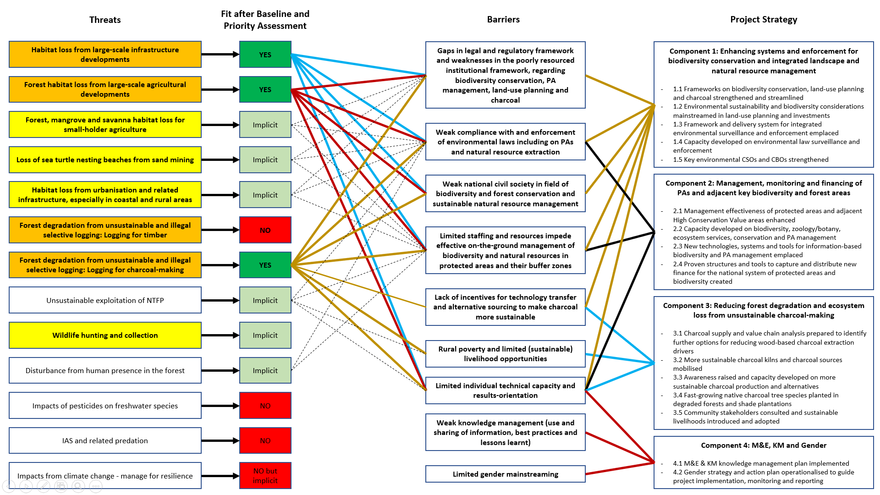

Annex 9: Stakeholders consultations during project design
During project development, the project development team met a broad range of stakeholders at the national and local/community levels on both islands, to identify and prioritize project sites, brainstorm on the actions, seek consent to the build-up of partnerships, gather information and validate the project design. Specific activities included the following:
- Stakeholders’ Consultations – several rounds of consultations took place between May 2019 and November 2019 with local stakeholders at proposed project sites to obtain their perspectives on project activities and ensure that the project would meet their needs. The consultations were carried out by the three National Consultants and the GEF Project Design Expert while on mission in country (mission 02 to 16 May & 02 to 30 November 2019). The consultation can be divided into three categories: (i) one-to-one meetings with specific stakeholders; (ii) meetings with focus groups (NGOs, private operators in the fields on tourism and agriculture/transformation, value chain cooperatives, financial operators); (iii) meetings with user groups and rural communities (with final validation by a representative selection of communities on the 5 & 9 December 2019). The meetings with communities were designed to create an informal atmosphere to make community members at ease. Community leaders were approached in advance and asked to gather representative groups, making sure that group of forest users (charcoal makers & loggers), women and young people would be equitably represented. The discussions were facilitated by community promotors / organizers and government officials with an experience in community participation work, who encouraged the participants to identify opportunities and risks related to the future project, express their wishes and concerns, and prioritize actions and interventions.
- Peer Consultations – several consultations took place with national and international institutions responsible for related initiatives, to explore coordination arrangements. These included: International Fund for Agricultural Development, Food and Agriculture Organization, African Development Bank, the World Bank Group, European Union Delegation, government ministries and directorates, private companies (Valudo, Agripalma, HBD, etc.), and NGOs (birdLife International, FFI, Oikos, Fundação Príncipe, Monte Pico, Alisei, etc.).
- Workshop to validate the general project framework – took place in the capital city of São Tomé on 14 May 2019, with the participation of the UNDP-GEF Project Design Expert, PPG consultants and representatives of government, civil society, donors and other agencies. The objective of the workshop was to introduce the project and the project development team, review proposed project preparation activities, review and assess other current initiatives relevant to this project, identify potential co-financing, endorse the project preparation approach, and trigger a preliminary debate on the objectives, scope, and actions of the project. In the continuum of this workshop, a representative group of actors was mobilized and regularly consulted to guide the development of the project.
- Validation Workshop – held in São Tomé (28 November 2019), with the participation of the UNDP-GEF Project Design Expert and representatives of government (central government and regional government), civil society, donors and other agencies to review and verify/endorse the project design, secure co-financing commitments, agree on implementation arrangements and project budget.
The outputs of these activities were consultation reports with list of participants, which were used to inform the project development exercise. The team felt a positive attitude towards the project, with high participation and lively discussions. No major concerns were raised by the interviewees. Among the most frequent recommendations: (i) ensure coordination with on-going initiatives and avoid duplication; (ii) build on past achievements and learn from mistakes and experiences from past projects; (iii) ensure empowerment of local actors and grassroots beneficiaries; (iv) fill capacity gaps through specific training; (v) maximize the use of national expertise and resources; (vi) ensure equal participation of men and women; (vii) work on both islands.
The in-depth consultations undertaken, to ensure compliance of objectives, promote further appropriation of project intervention, establish/strengthen partnerships and practical modalities for linking and collaborating with relevant ongoing and planned interventions, will be maintained and strengthened during project implementation. During the project development phase, lessons learned from similar projects carried out in the same or similar thematic and geographic areas were identified. The project development team reviewed project activity/evaluation reports and discussed with representatives of former, on-going and planned initiatives; primarily:
- UNDP-led GEF5-funded project (2016-2020) ‘Promotion of Environmentally Sustainable and Climate-Resilient Grid Isolated Grid Based Hydroelectric Electricity Through an Integrated Approach in São Tomé and Príncipe’ that addresses issues related to access to energy, deforestation and land use, especially regarding activities toward sustainable management of degraded agricultural lands and forests.
- FAO-led GEF6-funded project (2019-2023) ‘Landscape Restoration for Ecosystem Functionality and Climate Change Mitigation in the Republic of São Tomé e Príncipe’ framed into the Reforestation Initiative (TRI) led by DFB/FAO, and that has the objective to promote the restoration and sustainable management of the forest ecosystems of São Tomé and Príncipe to reduce carbon emissions from deforestation, and stop and reverse forest and soil degradation.
- AfDB-funded government led project (2018-2020) ‘National Land Use and Management Plan for São Tomé and Príncipe’ working on the elaboration of a National Policy for Spatial Planning and Urbanism to contribute to the development and reduction of poverty, through better use, occupation and transformation of the territory, allowing a more inclusive and sustainable socio-economic development.
- BirdLife-led ECOFAC VI initiative (2018-2022; coordinating a consortium of NGOs, including Oikos and Fundação Príncipe), funded mainly through the European Development Fund, with significant co-financing from the Rainforest Trust and Fondation Prince Albert II de Monaco, presenting risk of overlaps in terms of activities with proposed interventions. Indeed, the initiative, structured in three main components, aim to 1. develop effective management systems for the terrestrial protected areas, in particular the Natural Parks and also working on formal designation of pre-identified High Conservation Value areas in the buffer zone of the Obô Natural Park in São Tomé; 2. Engage communities in sustainable management of natural resources; and 3. Coordinate in an integrated way socio-economic & sectoral activities, reflecting a landscape approach that secures the future availability of ecosystem services for all stakeholders. Also, as per BirdLife International intrinsic approach, strong synergies are being developed with NGO/CSO to increase capacity for sustained conservation action & advocacy.
- University of Coimbra-led African Union-funded project (2018-2021) ‘Implementation of Agroforestry Systems (AFS) in S. Tomé and Príncipe degraded lands and development of non-wood forest products (NWFP) in Angola and S. Tomé e Príncipe to improve income-generation and food security’. FAO project (2018-2020) ‘Support for the development of rural activities to improve food and nutrition security and value chains of NTFPs in São Tomé and Príncipe’.
- Fauna & Flora International-led Global Tree Campaign-funded project (2018-2019; 2nd phase under preparation) ‘Taking action for Príncipe’s threatened trees’; as well as various CEPF-funded projects (2018/2019-2020), such as REDD+ oriented RSET-led project ‘Participatory Management for Community-based Avoided Deforestation in São Tomé Obô Natural Park’ and Missouri Botanical Garden (MBG)- led project ‘Characterization of the Threatened Flora of São Tomé and Príncipe’ (Small and medium grant).
The main lessons learned are exposed hereafter:
- Empowerment of Communities: interventions are most successful where empowerment of communities is strongest, especially in terms of: (i) local community definition of target areas; (ii) involvement of community leaders and legally recognized community-level management entities; (iii) involvement of communities in the establishment of community forest management rules governing access and use; and (iv) inclusion of marginalized groups that hold a stake in the resources.
- Partnerships and Outsourcing: given the small size and relatively low capacity of STP institutions, the achievement of project objectives, especially in the case of complex, articulated projects, is not possible without the establishment of and broad range of partnerships that can help the leading implementing agency to outsource and delegate the implementation to reliable partners from the civil society sector or private sector, while retaining the overall leadership and stewardship of the program, monitoring the progress of the work, and establishing connections between the different parts of the work plan.
- Coaching and Backup: The initial phase of implementation of a project is critical to its successful completion and the achievement of the objectives. It is important that UNDP (executing agency) ensures robust coaching at this stage, and makes sure that team members and partners gain a full understanding of the purpose of each intervention, the synergies between the different components.
- Learning and Capacity Building: local staff is critical in determining the degree of success of a project. The implementing agency should make sure that contracted staff gain and keep an adequate level of empowerment and motivation throughout the project lifetime. It is important to put in place mechanisms for on-going learning, through a regular assessment of capacity. Learning visits to best practices and case studies abroad are very valuable tools, as experience shows that the beneficiaries of these programs often return to their countries with renovated motivation and energy. This is particularly true for small, relatively isolated island countries like STP.
- Benefits and Incentives: interventions are more successful and sustainable over the long term where donor and/or government objectives coincide with community objectives. This is especially true when the benefits and incentives for communities are clear and tangible and equitably distributed between national and local level stakeholders, as well as within participating communities.
Key stakeholders consulted during the development of the project (in alphabetical order of institutions)
Instituição | Nome | Título/função | E-mail
Agência de Promoção de Comércio e Investimento | Celina Lima | Chefe de Departamento | celina.lima@apcistp.com
AGRIPALMA | José Cortez | Gestor | jcortez@agripalmastp.com
Assembleia Nacional | Cristina Dias | Deputada (4.ª Comissão Parlamentar) | crisdosanjos@hotmail.com
Assembleia Nacional | Jamiel Joana Segunda | Deputado (4.ª Comissão Parlamentar) | jamisegunda@gmail.com
Assembleia Nacional | Alcino Quaresma Afonso | Técnico Parlamentar (4.ª Comissão Parlamentar) | alcinoafonso3@gmail.com
Assembleia Nacional | Ediley de Andrade Mendes | Técnico Parlamentar (4.ª Comissão Parlamentar) | edileymendes8@hotmail.com
Associação Monte Pico | Luis Mário | Presidente (também presidente CECAFEB) | lumanovamoca@hotmail.com
BirdLife International | Jean-Baptiste Deffontaines | Coordenador Nacional / Gestor ECOFAC6 | Jean-baptiste.deffontaines@birdlife.org
BirdLife International | Marion Tafani | Assistente Gestor ECOFAC6 | marion.tafani@birdlife.org
BirdLife International | Marquinha Martins | Oficial de Campo | marquinha.martins@birdlife.org
Camaras Distritais | Luis Malheiro | Representante | luismalheiro@gmail.com
CE3C - Universidade de Lisboa | Ricardo Lima | Pesquisador | rfaustinol@gmail.com
Centro de Aperfeiçoamento Técnico Agropecuário | Ekzul do Nascimento | Diretor | Ajax.nascimento@yahoo.com.br
Centro de Apoio ao Desenvolvimento Rural | Marcelino Costa | Diretor | Martavar011@hotmail.com
Centro de Apoio ao Desenvolvimento Rural | Joaquim Rodrigues | Coordenador Técnico dos Projetos | j.r.f-nascimento@hotmail.com
Centro de Investigação Agronómica e Tecnológico | Xavier Mendes | Diretor | jxaviermendes@hotmail.com
Centro de Investigação Agronómica e Tecnológico | Severino Santo | Diretor Cientifico | ciatsp@cstome.net
CEPF Obo-Carbono | Inês Melo | Cogestor / consultor | ismelou@gmail.com
CEPF Obo-Carbono | Maria Vasconcelos | Cogestor / consultor | maria.perestrelo@gmail.com
Departamento da Reserva da Biosfera e do PNP | Plácida Lopes | Chefe de Departamento | placidaunb@gmail.com / rbiosfera.principe@gmail.com
Departamento da Reserva da Biosfera e do PNP | Daniel Ramos | Técnico Florestal PNP | dnelitoramos@hotmail.com
Departamento da Reserva da Biosfera e do PNP | Alberto Leal Soares | Chefe Técnico PNP | albertoleal82@hotmail.com
Direção da Agricultura e do Desenvolvimento Rural | Hermenegildo Santos | Diretor | sousaesantos60@gmail.com
Direção da Agricultura e do Desenvolvimento Rural | Armando Dias Monteiro | Diretor de Apoio ao Desenvolvimento da agricultura | kizo85@hotmail.com
Direção das Florestas e da Biodiversidade | Rute da Cruz | Técnica | rutesuane@hotmail.com
Direção das Florestas e da Biodiversidade | José Cabral da Silva | Técnico | cabraldasilva31@hotmail.com
Direção das Florestas e da Biodiversidade | Pascoal Sousa | Guarda Florestal | sousaelves18@gmail.com
Direção das Florestas e da Biodiversidade | João José C.M. D’Alva | Diretor | jjcm.alva@gmail.com
Direção das Florestas e da Biodiversidade | Sabino Pires Carvalho | Técnico Superior | carvalhosab@yahoo.com
Direção das Florestas e da Biodiversidade | Páscoa Costa | Chefe de Departamento | Rocosta_19@hotmail.com
Direção das Florestas e da Biodiversidade | Adilson da Mata | Chefe de Departamento | Adilmata77@hotmail.com
Direção das Florestas e da Biodiversidade | Rute da Cruz | Técnica | rutesuane@hotmail.com
Direção das Florestas e da Biodiversidade | Meyer António | Técnico / Ponto Focal FAO-TRI | meymadra@hotmail.com
Direção das Florestas e da Biodiversidade - PNOST | Aurélio Rita | Chefe de Departamento / Ponto Focal CBD | asoujerita@yahoo.com.br
Direção das Florestas e da Biodiversidade - PNOST | Wilder da Costa Carvalho | Técnico | wildercarvalhocosta@hotmail.com
Direção das Pescas | Filinto D’Alva | Chefe de Departamento | filintodalva@hotmail.com
Direção das Pescas | Aida Almeida | Diretora | aidadalmeida@yahoo.com.br
Direção de Pecuária | Natalina Vera Cruz | Diretora | Natalinalimao27@gmail.com
Direção de Planeamento | Adalgiza Cravid | Técnica | Ab.cl@hotmail.com
Direção de Planeamento | Joana Varela | Diretora | Jdvarela12@gmail.com
Direção de Planeamento | Fausto Neves | Ponto Focal Green Climate Fund
Direção de Planeamento | Joana Damiana | Diretora | jdvarela12@gmail.com
Direção de Planeamento e Estudo (MAPDR) | Celso Garrido | Diretor | celgapontes@.stp@gmail.com
Direção do Orçamento | Marivy Katia |  | marivysilveira_196@hotmail.com
Direção do Tesouro | Zósimo do Nascimento |  | zimodeu@yahoo.com.br
Direção do Tesouro | Maria de Sousa |  | sousamaria@yahoo.com.br
Direção dos Serviços Geográficos e Cadastrais | Heliodoro Quaresma | PF/UNCCD | heliocart@hotmail.com
Direção dos Serviços Geográficos e Cadastrais | Madival das Neves |  | madval15@hotmail.com
Direção Geral de Turismo e Hotelaria | Hugo Menezes | Diretor | hugolmenezes@gmail.com
Direção Geral de Turismo e Hotelaria | Mirian Daio | Técnica | mirbadaio@gmail.com
Direção Geral de Turismo e Hotelaria | José António | Técnico | zeveracruz@hotmail.com
Direção Geral do Ambiente | Aline Castro | Ponto Focal Nagoya | alinecastro527@hotmail.com
Direção Geral do Ambiente | Kassi Bragança Costa |  | kassicosta@hotmail.com
Direção Geral do Ambiente | Mirian Matias | Observatório do Ambiente | minia_007@hotmail.com
Direção Geral do Ambiente | Juvenal Santo | Chefe de Departamento | Juvenal_bomfim@hotmail.com
Direção Geral do Ambiente | Lourenço Monteiro | Diretor | lmonteirodejesus@gmail.com
Direção Geral do Ambiente | Sulisa Quaresma | Técnica | suligno@gmail.com
Direção Geral do Ambiente | Victor Bonfim | Consultor Nacional | victorbonfim2@hotmail.com
Direção para o Ambiente e Conservação da Natureza | Osório Lima dos Prazeres | técnico
Direção para o Ambiente e Conservação da Natureza | Maria José Prazeres | Diretora | cunyprazeres_rap@hotmail.com
Direção Regional da Agricultura, Pescas e Desenvolvimento Rural | Alfredo Delgado | técnico | fredome115@hotmail.com
Direção Regional da Agricultura, Pescas e Desenvolvimento Rural | Hilton Lima de Barros | técnico | hiltonbarros34@hotmail.com
Direção Regional da Agricultura, Pescas e Desenvolvimento Rural | José M. Pereira Miranda | técnico | zemirandapep@gmail.com
Direção Regional das Florestas e da Biodiversidade | Júlio Mendes | Diretor Regional | mpmendes120@gmail.com
Direção Regional das Florestas e da Biodiversidade | Paulo Jesus | Guarda Florestal
Direção-geral dos Recursos Naturais e Energia | Kilange Lima |  | kilangelima@hotmail.com
Diretor Regional de Planeamento | Timóteo Neves |  | temoteon@gmail.com
FAO | Argentino Santos | Assistente ao Representante | Argentino.piresdossantos@fao.org
FAO | Barbara Campos | Assistente ao Programa | Barbara.Campos@fao.org
FAO-TRI (Consultor) | Marco Pagliani | ICTA | mrcpagliani2@gmail.com
FAO-TRI (DGA/MOPIRNA) | Faustino Oliveira | Gestor | faconeol@yahoo.com.br
FAO-TRI (DGA/MOPIRNA) | Salvador Sousa Pontes | Assistente Técnico | salsousa@yahoo.com.br
Federação de Organizações Não Governamentais STP | Eduardo Elba | Presidente | eduardoelba93@hotmail.com
Finanças Príncipe | Carlos Manuel da Silva |  | ayometzger@gmail.com
Fundação Príncipe | Jaconias da Conceição Pereira |  | jaconias.pereira@fundacaoprincipe.org
Fundação Príncipe | Estrela Matilde | Diretora | estrela.matilde@fundacaoprincipe.org
Fundação Príncipe | Vanessa F. Schmitt | Desenvolvimento Comunitário | vanessa.schmitt@fundacaoprincipe.org
Fundação Príncipe - Fauna & Flora International | Laura Benitez Bosco | Assistente do Programa de Conservação | laura.benitez@fauna-flora.org
Fundação Príncipe - Fauna & Flora International | Frazer Sinclair | Assistente do Programa de Conservação | frazer.sinclair@fauna-flora.org
Fundação Príncipe - Fauna & Flora International | Luisa Madruga | Gestor de Projeto (BAF) | luisa.madrugada@fauna-flora.org
Governo Regional de Príncipe | José Cassandra | Presidente | josecassandra.jc@gmail.com
HBD Príncipe | Chris Táxis | CEO | chris.taxis@hbdprincipe.com
Jurista - Biblioteca Assembleia Nacional | Salustino Andrade | Consultor Nacional | lindosalu@gmail.com
MARAPA | Jorge Carvrio | Presidente | jorgecarvrio@hotmail.com
Ministério da Agricultura | José de D.L. Menezes | Membro da Comissão de Seguimento | jodeumenezes15817@hotmail.com
Ministério da Agricultura | Sumner Metzger | Técnico | sumnertrindade@outlook.com
Ministério da Agricultura | Hélder C. B de Menezes | Coordenador | Hdmenezes15@yahoo.com.br
MOPIRNA | Osvaldo ABREU | Ministro
OIKOS | Bastien Loloum | Coordenador Nacional | Coord.stp@oikos.pt
OIKOS | Ester Costa Alegre | Técnica da RA. do Príncipe | estercostalegre@gmail.com
OIKOS | Suzelle Verant | Componente de Desenvolvimento Comunitário | suzelle.oikos@gmail.com
OIKOS / ZATONA ADIL | Cândido Rodrigues | Promotor Comunitário | candidooikos@gmail.com
ONG ADAPPA | Carlos Tavares | Presidente | carlosrrtavares@gmail.com
ONG Alisei | Ruggero Tozzo | Coordenador | rtozzo.mi@alisei.org
ONG MARAPA | Danilsa Cunha de Almeida | Técnica | Danilsab2@hotmail.com
Plano Nacional de Ordenamento do Território | Manuel Filipe Moniz | Coordenador do projeto | monizfilipe@yahoo.com
Plano Nacional de Ordenamento do Território | Peterson Fernandes | Responsável Cartografia/SIG | petersonfernandes_7@hotmail.com
Plataforma de Turismo Responsável e Sustentável | Eugênio Neves | Presidente | egneves@hotmail.com
Policia Judicial | João Pereira | Representante | jopereira024@hotmail.com
Policia Judiciaria | Avelino Quaresma |  | avelinoquaresma59@gmail.com
Policia Nacional | Valdir Cunha Lisboa | Representante | vclisboa32@gmail.com
Presidência da Republica | Nilda B da Mata |  | nildabmata@hotmail.com
Programa das NU para o Desenvolvimento | Maria Mendizabal | Coordenadora da UADS | maria.mendizabal@undp.org
Programa das NU para o Desenvolvimento | Cristina Veloso | Analista de Programa | cristina.veloso@undp.org
Programa das NU para o Desenvolvimento | Liudmir Neto | UADS – Assistente Financeiro | Liudmir.neto@undp.org
Programa das NU para o Desenvolvimento | Edlena Barros | UADS - Assistente Comunicação | Edlena.barros@undp.org
Programa das NU para o Desenvolvimento | Gilberto Fernandes | UADS - Assistente Administrativo | gilislandcores@hotmail.com
Programa das NU para o Desenvolvimento | Aderito Santana | ARR | aderito.santana@undp.org
Programa Tatô | Betânia Ferreira Airaud | Diretora | ferreirabetania@gmail.com
Programa Tatô | Sara Vieira | Coordenadora técnica | saralexvieira@gmail.com
Programa Tatô | Frederic Airaud | Assessor Técnico / Consultor | airaudfrederic@gmail.com
Projeto Adaptação | Dinasalda Ceita | Coordenadora | dinaceita@gmail.com
Projeto de Apoio à Pequena Agricultura Comercial / PAPAC | Hadrien Abdelli | Assessor Técnico (AFD) | hadrien.abdelli@hotmail.fr
Projeto de Apoio à Pequena Agricultura Comercial / PAPAC | Carminda Viegas | Diretora | carmindaviegas642@hotmail.com
Projeto Energia | Belizardo Neto | Coordenador | Belyneto28@gmail.com
Projeto WACA | Arlindo Carvalho | Gestor | arlindode.carvalho54@gmail.com
Representante comunidade - Príncipe | Nicleise de Sousa Gouveia | Professor
Representante comunidade - Príncipe | Francisca Afonso | Carvoeira
Representante comunidade - Príncipe | Felisberto Vaz Almeida | Carvoeiro
Representante comunidade - Príncipe | Antonio Pereira | Carvoeiro
Representante comunidade - São Tomé | Martinho Lourenço | Operador de Motosserra
Representante comunidade - São Tomé | Simão do Rosário | Pequeno Agricultore
Representante comunidade - São Tomé | Alexandra Rocha | Promotora Comunitária
Representante comunidade - São Tomé | Gilmar Freitos Martins | Estudante
Representante comunidade - São Tomé | Abdulay Tavares | Carvoeiro
Representante Eco-Guia - Príncipe | Yodiney dos Santos | Eco-Guia | yodiney.santos@principetrust.org
Representante Eco-Guia - São Tomé | Antonio Alberto | Eco-Guia | antonioalberto26@gmail.com
Secretariado Regional para o Ambiente e Desenvolvimento Sustentável | Ana Alice Prazeres | Secretaria Geral | nacyprazeres@gmail.com
TESE | Carlos Albuquerque | Coordenador Nacional | c.albuquerque@tese.org.pt
UNESCO | Antonio De Sousa Abreu | Consultor | a.de-sousa-abreu@unesco.org
Universidade de Coimbra | Maria do Ceu Madureira | Projeto Tesouro d'Obo | mceu.madureira@gmail.com
USTP | Alzira Garcês | Bióloga | alziragarces-21@hotmail.com
Valudo | Guillaume Taufflieb | Sócio-gerente | g.taufflieb@valudo.st
WACT | equipa Bô Energia |  | boenergia17@gmail.com

Minutes of community consultation meetings
Acta da Consulta Comunitária
São Tomé, Plancas II, 05/12/2019 (11h:40 – 13h:45)

Intervenientes:

- Lourenço Monteiro de Jesus (Diretor – Direção Geral do Ambiente)
- José de D.L. Menezes (Membro da Comissão de Seguimento)
- Joaquim Rodrigues (Técnico do Centro de Apoio ao Desenvolvimento Rural)
- Cândido Rodrigues (Técnico do projeto ECOFAC6, consortium de implementação BirdLife-Oikos)
- Comunidade de Plancas II – 33 pessoas (24 homens e 9 mulheres [27%])

Síntese das discussões:

- Residem na comunidade de Planca II 193 pessoas e a maioria são crianças.
- Existem 74 Pequenos Agricultores beneficiários de título de posse de terra e todos dedicam a cultura de cacau, banana (pão e prata), fruta-pão essencialmente, entre eles a maioria têm campos onde dedicam a plantação de cana-de-açúcar, milho e horticultura. No período em que não há cacau a maioria dedica a queima de carvão.
- Em Plancas II, a maioria dos jovens e adolescentes não possuem parcela de terra/lote e dedicam à produção de carvão assim sendo existem mais de vinte palaiês de carvão - duas participaram na reunião de auscultação.
- Em Plancas II, há quatro vianteiros e três operadores de motosserra.
- Ninguém dedica a caça
- A maioria não tem conhecimento da Lei de Proteção da Floresta e do Parque.
- Têm pouca sensibilidade e motivação para questões de plantio de árvores como prova disto é um lote de plantas que lhes foi fornecido e que ainda se encontram na comunidade sem serem plantadas isto porque os Pequenos Agricultores ainda não foram receber.
- Dizem que havia uma área com muitas árvores e que servia de “para-vento”; entretanto a mesma foi entregue aos Pequenos Agricultores da Comunidade de Água Sampaio para implementarem a horticultura. Estes utilizam produtos químicos. A região está próxima da nascente que fornece água que os moradores de Plancas II consomem, criando dificuldades graves de agua para a mesma comunidade. Nesta mesma zona existiam muitas plantas medicinais que foram destruídas no momento de desbravamento.
- Dizem que gastam muito tempo e dinheiro quando solicitam autorização para abate de árvores porque têm que deslocar várias vezes para Cidade Capital até conseguirem uma autorização.
- Reconhecem que tem que ser identificada e implementada atividade alternativa para a conversão dos operadores de motosserra/madeireiros e carvoeiros assim como a realização de mais atividades de sensibilização para os vianteiros que extraiam vinho da palma de maneira não sustentável.
- Propõem como atividade de conversão, que haja mais investimentos:
  - Nos lotes agrícolas, no sector de transformação dos produtos locais envolvendo grupos de jovens que não possuem parcelas de terra, os pequenos agricultores e as palaiês de carvão, na formação/capacitação de pequenos agricultores e jovens que não possuem lotes de terra agrícola (especialização de grupos de jovens em diversas áreas profissionais);
  - Formação/capacitação sobretudo dos jovens na matéria de conservação da floresta e envolvê-los na vigilância e proteção da floresta assim como nas atividades inerentes aos guias e eco-guias.
- Apesar de pouca sensibilidade dos Pequenos agricultores em matéria de plantação de árvores é necessário que se continue a investir em plantio de árvores sobretudo as espécies de crescimento rápido e de valor comercial.
- Propõem maior envolvimento das Associações Comunitárias no processo de vigilância/conservação da floresta, na aplicação de legislação ambiental e na coordenação multissectorial.

Conclusões:

- Há uma grande dependência aos Recursos Naturais – especialmente através a produção de carvão, da produção até a venda.
- plantio é uma atividade chave mas há necessidade de maior integração da comunidade desde o início no desenvolvimento da atividade.
- A falta de fiscalização das autoridades, para a entrega de autorizações de corte (e os custos associados para os carvoeiros) implica a não implementação da lei – mesmo se existe conhecimento básico das regras (licenças de corte).
- Reconhecem a importância de procurar alternativas economicamente viáveis e com maior sustentabilidade mas têm dificuldades em propor soluções e promover atividade de fiscalização, especialmente virada a fiscalização comunitária.
- Além do carvão e do corte indiscriminado de madeira, levantou-se a questão dos vianteiros; também, tendo um impacto negativo considerável na floresta devido as práticas não sustentáveis praticadas.

Auscultação em relação ao projeto proposto:

A comunidade está aberta ao projeto, o que cria altas expectativas que eles esperam poder transformar em oportunidades para o desenvolvimento sustentável; com foco os jovens. A comunidade espera que o projeto se tornasse de facto participativo e amostra interesse em cooperar (representação digna nas plataformas de discussão – fiscalização e carvão) para maior envolvimento da comunidade e que, em conjunto, pudessem encontrar alternativas viáveis. A revisão da legislação terá que integrar / balancear as opiniões da comunidade, dos grupos de usuários dos recursos naturais (componente 1) com devida formação / capacitação na comunidade. A fiscalização, além de ser o papel do governo, é também da responsabilidade da comunidade (resultado 1.3) que acredita na fiscalização comunitária – se devidamente acompanhada com promoção de atividades alternativas (resultado 3.4). Os esforços de plantio são benvindos, as lições apreendidas das fases anteriores deveram ser consideradas e os pequenos agricultores deveram ser as partes interessadas principais quando planear as operações na comunidade (resultado 3.5). A comunidade está na expetativa de maior envolvimento na gestão dos recursos naturais, em particular na gestão da área protegida – as pessoas presentes têm consciência das oportunidades de desenvolvimento rural relacionadas com a conservação da biodiversidade (sublinhando a necessidade de maior formação / capacitação / sensibilização), tal como o turismo; e gostariam de receber formações para eco-guias / guias turísticos (resultado 2.1).

Recomendações feitas pela comunidade:

- Promover a participação ativa da comunidade ao longo da implementação do projeto – especialmente os jovens / pessoas desempregadas da comunidade e/ou não tendo lotes para agricultura – são os principais produtores de carvão e não tem alternativas econômicas;
- Acompanhar atividades alternativas desenvolvida pela comunidade (iniciativas individuais ou associações comunitárias);
- Integrar a comunidade na gestão da Area Protegida e da Biodiversidade, apoiar a formação / integração de fiscais comunitários para a vigilencia dos Recursos Naturais;
- Manter comunicação constante entre a Unidade de Gestão do projeto e as comunidades (exemplo dos promotores comunitários no âmbito do projeto ECOFAC6);
- Apoiar / Facilitar uma distribuição mais justa / equilibrada das terras agrícolas;
- Reduzir o uso de produtos fitossanitários que poluem os cursos de água.
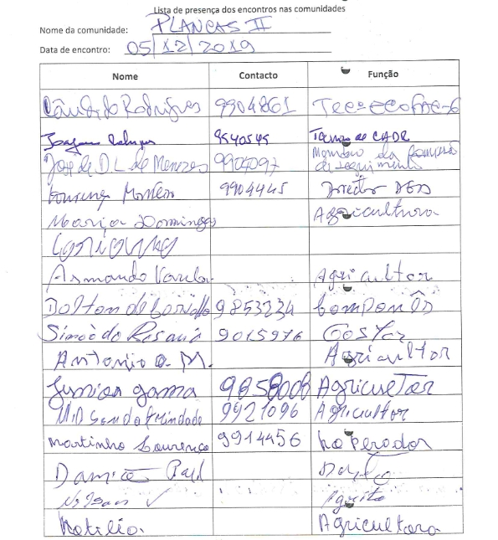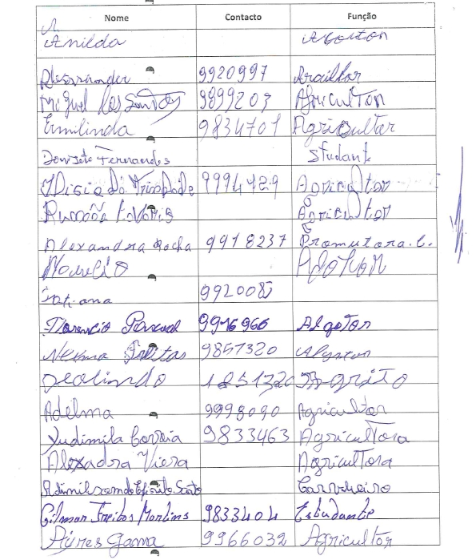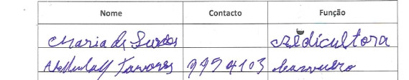
Acta da Consulta Comunitária
São Joaquim, Ilha do Príncipe
09/12/2019 (15h00 – 17h00)

Intervenientes:
- Maria José Prazeres – Diretora, Direção do Ambiente e da Conservação da Natureza
- Julio Mendes – Diretor, Direção Regional das Florestas
- Alberto Leal – Chefe de Secção, Departamento da Reserva da Biosfera e do Parque Natural do Príncipe
- Ester Costa Alegre – Técnica Regional, Oikos
- Marion Tafani – Assistente Gestor de Projeto, BirdLife
- Osvaldo Lima – Estagiário, Fundação Príncipe
- Comunidade de São Joaquim – 36 pessoas (23 homens e 13 mulheres [27%]); 21 participantes indicaram que a produção de carvão vegetal é a sua atividade principal

A discussão foi liderada pelo Governo Regional, com a participação das ONGs.

Síntese das discussões:

- Conhecimento geral das áreas protegidas pela comunidade

- Dentro da comunidade de São Joaquim, a ideia que prevalece, tanto dos homens como das mulheres, é que as Áreas Protegidas são florestas/locais limpos e preservados; onde não se pode cortar arvores e não se pode fazer agricultura.
- impacto da comunidade sobre o meio ambiente é principalmente a produção de lixos, a falta de saneamento que pode impactar os rios e o abate de arvores. As comunidades dependem em grande medida do meio ambiente / recursos naturais para a sua sobrevivência e os usos abusivos agravam-se sempre que as condições de emprego não estão garantidas.
- Todos têm vontade de melhorar a situação e a preservação do meio ambiente / recursos naturais. O poder da comunidade para proteger as Áreas Protegidas é, segundo eles, dar seu apoio nas atividades de vigilância para informar as autoridades sobre situações de abuso.

- A problemática do carvão na comunidade

- A comunidade de São Joaquim é isolada, não tem acesso à energia da companha nacional de eletricidade (depende de um gerador) e depende em grande maioridade de atividade de produção de carvão. Outras atividades incluem a suinocultura informal, a horticultura, e a extração de vinho de palma, para consumo local.
- A madeira mais utilizada para a produção de carvão é o Muandin, as outras espécies não têm bom rendimento para o carvão é são geralmente deixadas a estragar-se no solo após o corte/queda. Existe uma forte conscientização e crescente preocupação da comunidade, após a observação do declínio – alguns até dizem "o desaparecimento" – do Muandin na região, uma espécie importante para a produção de carvão.
- Os membros da comunidade estão cientes de que a pratica de produção de carvão, incluído o abate de arvores, pode prejudicar o ambiente. Eles também reconhecem que o carvão é um problema a longo prazo para a saúde das pessoas, homens e mulheres, que usam carvão para cozinhar.

- Recepção do projeto e opiniões sobre as alternativas ao carvão tradicional

- O projeto foi apresentado pelo governo regional, com a introdução do problema do carvão e o objetivo declarado de uma produção melhorada, sustentável e respeitadora do ambiente. As técnicas alternativas discutidas foram: a produção de briquetes para tornar os resíduos de madeira rentáveis e compactar os elementos combustíveis; e a utilização de fibras de coco (através de uma parceria com a Valudo) para substituir a madeira na produção de carvão.
- Uma grande preocupação da comunidade com este projeto é o potencial desaparecimento da atividade carvoeira, a principal fonte de atividade nessa comunidade: "se o carvão acabar com as nossas vidas". Mas a maioria deles também está consciente de que, num futuro próximo, o desaparecimento do Muandi porá fim à sua atividade de extração de carvão e espera compreender melhor e apropriar-se das soluções que o projeto pode oferecer para os apoiar.
- Existe um interesse da comunidade nas soluções alternativas propostas, e algumas questões técnicas foram levantadas pela comunidade; especialmente relacionada com (i) a participação da comunidade de São Joaquim na produção de carvão melhorado (PPP Valudo), (ii) o acesso à tecnologia de fornos de carvão melhorados para os carvoeiros de São Joaquim (com dúvidas em relação ao potencial funcionamento) e (iii) as alternativas econômicas de subsistência propostas.
- A equipa mencionou as oportunidades que o projeto trará através subsídios de valor baixo para meios de subsistência sustentáveis e iniciativas sustentáveis de carvão vegetal selecionados e distribuídos a indivíduos / comunidades; tal como Casamence, briquetes, biogás, NTFP, apicultura, avicultura, silvicultura sustentável. A ideia foi bem-recebida. Em relação as questões técnicas, a equipa de consulta mencionou os trabalhos subsequentes (pós lançamento do projeto) de assistência técnica em produção de carvão sustentável, que avaliará as necessidades e oportunidades com as comunidades para encontrar a maneira mais durável e inclusiva de melhorar a atividade de carvão na comunidade.

Conclusões:

Em geral, todos os membros da comunidade foram ativamente envolvidos na consulta até o final; e tiveram a oportunidade de apresentar as suas respetivas dúvidas. Maioria dos carvoeiros estão bastante preocupados com o risco de perder a sua atividade de rendimento principal. Contudo, a opinião geral da comunidade é subdividida e alguns pretendem encontrar soluções mais sustentáveis – tendo a oportunidade de ser apoiado pelo projeto; desde que sejam soluções sustentáveis, que melhorem as condições de vida da comunidade e tenham em conta a sua realidade diária.
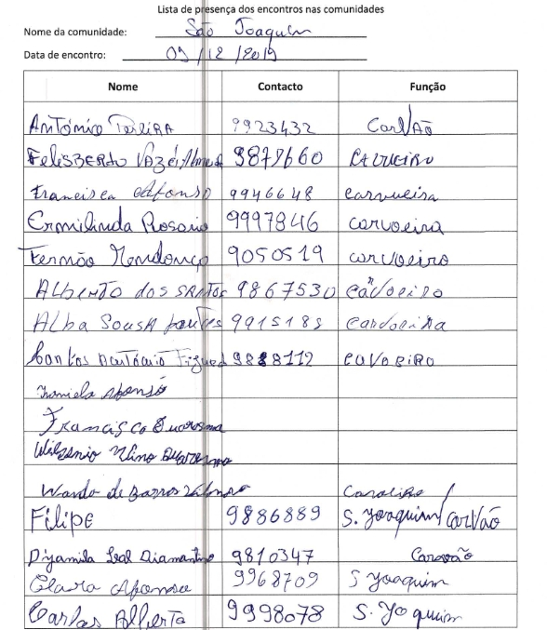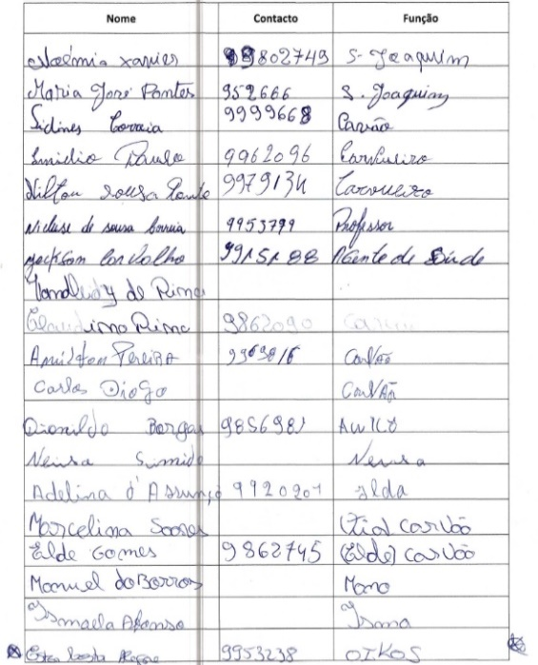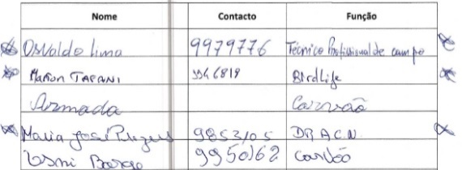

Annex 10: Stakeholder Engagement Plan
The Stakeholder Engagement Plan is designed to ensure effective engagement between various stakeholders throughout the lifecycle of the project. This plan will build on any other work which is being undertaken with regard to planning and impact assessment processes. The project will aim to maintain dialogue with the relevant government ministries and parastatals, selected local community groups, NGOs and international community.
1. Structure of Government
Fig. 1 – Composition of the XVII Government of Sao Tomé and Príncipe
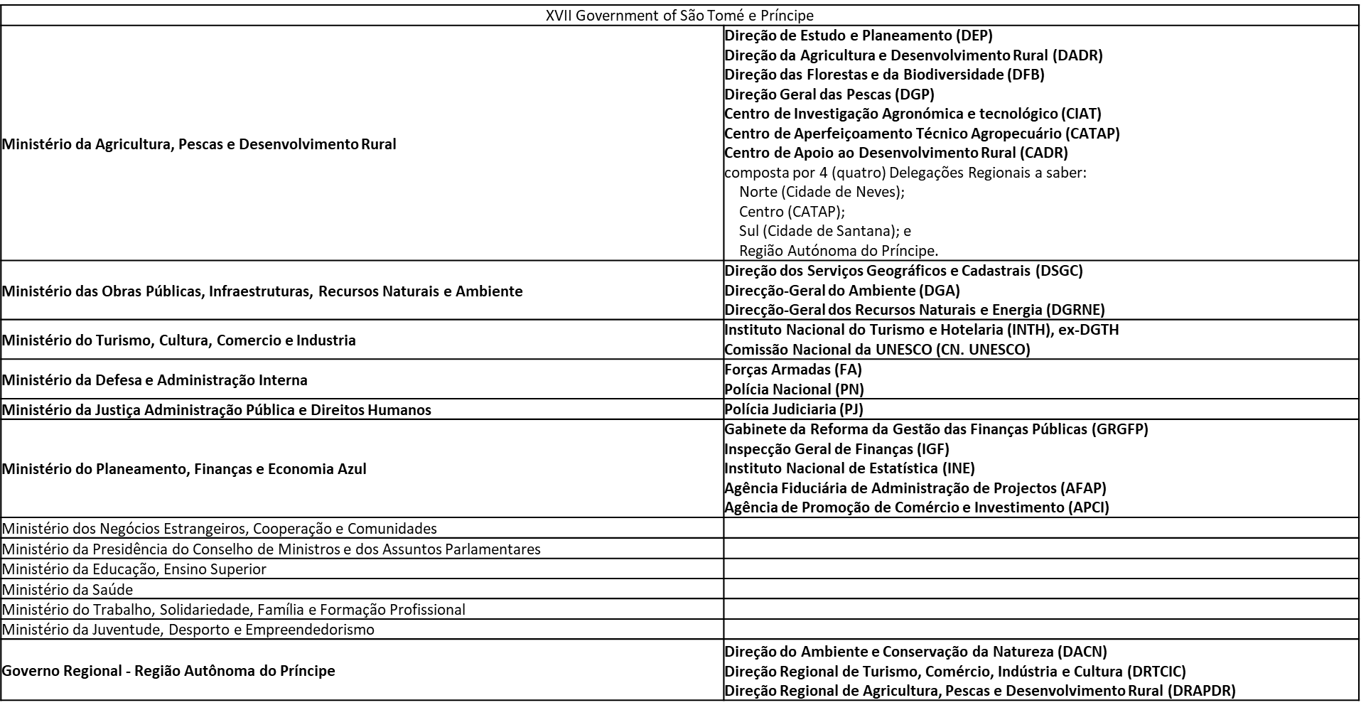

Fig. 2 – Composition of the Government of the Autonomous Region of Príncipe

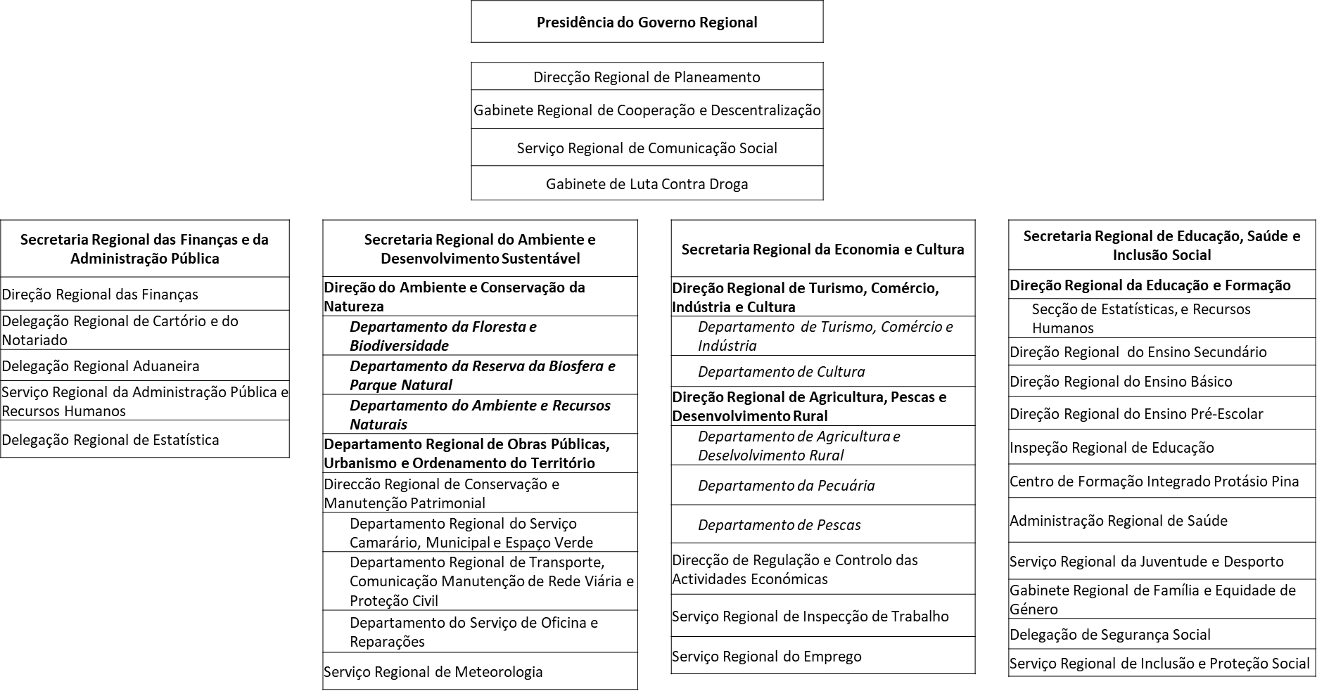

2. Project Stakeholders, Description and Project Role
The project will actively coordinate with relevant Government Ministries, Departments and Agencies and other development partners as well as NGOs and research institutions to facilitate synergies and avoid duplication of efforts. The goal of this Stakeholder Engagement Plan is to involve all stakeholders of the project, as early as possible in the implementation process and throughout project duration to ensure that, their views and concerns are made known and taken into account. The plan will help the project in implementing effective communication channels and working relationships. The Executing Agency will continue to hold consultations throughout project implementation as deemed necessary. This section provides a summary of the engagement of the major stakeholders. The Stakeholder Engagement Plan will be implemented in conjunction with the gender action plan included in the PRODOC Annexes, the Livelihood Action Plan and a Human Rights Action Plan that will be developed before launching the activities, and the process framework for restriction of access to natural resources.
Stakeholder | Summary Description | Project Role
National Central Government & Government of the Autonomous Region of Príncipe
MOPIRNA – Ministry of Infrastructure, Public Works, Natural Resources and Environment  General Directorate for Environment  Direcção-Geral do Ambiente (DGA). | Government body responsible for designing and implementing policies related to the environment, conservation / preservation of ecosystems and the longevity of species and life on Earth. The specific attributions are: to guarantee the effective application of laws and other environmental policy instruments, through evaluation and monitoring; collaborate in the elaboration of an integrated environmental policy, ensuring multisector coordination; create and coordinate the National Environmental Information System and produce statistical indicators; accreditation of companies in the environmental area; collaborate in the definition of a waste management policy; encourage the development of new technologies in the environmental area; coordinate the integration of environmental issues in international relations; to propose the appointment of Focal Points for certain environmental areas and to coordinate their actions. | - Implementing Partner – in charge of overall project implementation  - Exchange of information and best practices; participation in decision-making  - Project design and adaptive management, participatory elaboration of annual activities, participation in monitoring and evaluation (overall project implementation) / Project Board  - Data collection for research purposes  - Exchange of information and best practices  - Member of advisory body (overall project implementation)  - Beneficiaries and providers of training / capacity building activities  - Project ongoing support for biodiversity & sustainable land-use mainstreaming into activities; dialogue, outreach and consultation  - National Environmental Law Enforcement Platform  - National Sustainable Charcoal Platform  - Participatory appraisals of community needs (livelihoods, PAs, HCVs, law enforcement)  - Inception Workshop
 | 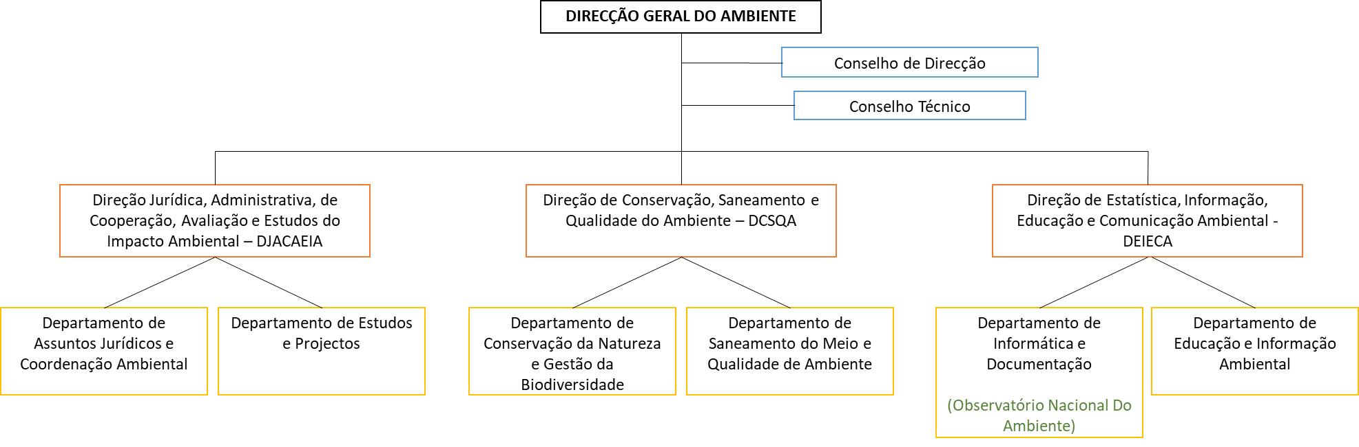
MAPDR – Ministry of Agriculture, Fisheries and Rural Development  Directorate for Forests and Biodiversity  Direção das Florestas e da Biodiversidade (DFB). | Government body responsible for designing and implementing policies approved for the area of forest promotion and biodiversity, inspection, statistics and promotion of the forest products industry (timber and non-timber product), as well as coordinating the activities of the Obô São Tomé Natural Park (PNOST). | - Lead Agency or Responsible Party to be designated by DGA – in charge of delivery of several output packages; dialogue, outreach and consultation; participation in decision-making  - Project design and adaptive management, participatory elaboration of annual activities, participation in monitoring and evaluation (overall project implementation) / Project Board  - Participation in high-level advocacy meetings  - Data collection for research purposes  - Exchange of information and best practices  - Member of advisory body  - Beneficiaries and providers of training / capacity building activities  - Project ongoing support for biodiversity & sustainable land-use mainstreaming into activities  - National Environmental Law Enforcement Platform  - National Sustainable Charcoal Platform  - Participatory appraisals of community needs (livelihoods, PAs, HCVs, reforestation)  - Inception Workshop
 | 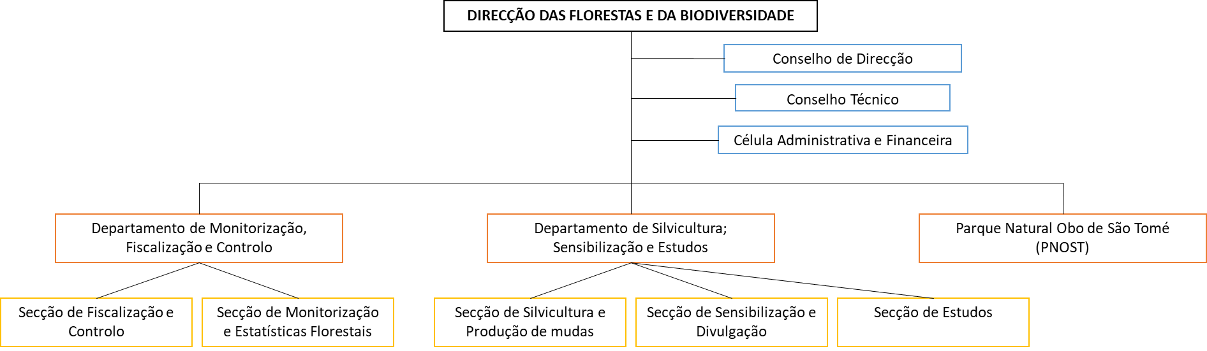
Regional Secretariat for Environment and Sustainable Development of Príncipe  Secretaria Regional do Ambiente e Desenvolvimento Sustentável  Directorate for Environment and Nature Conservation  Direção do Ambiente e Conservação da Natureza (DACN) | Regional delegation of the national General Directorate for Environment and the national Directorate for Forests and Biodiversity, yet under the Regional Autonomous Government of Príncipe. Responsible for designing, implementing, coordinating, monitoring and evaluating the policy defined and approved by the government for the areas of environment, nature and biosphere conservation, public works, natural resources, solid waste and urban development.  It entails three Departments: Forest & Biodiversity Department; Biosphere Reserve & Natural Park Department; Environment & Natural Resources Department | - As above.
MOPIRNA  Directorate of Geographical and Cadastral Services  Direção dos Serviços Geográficos e Cadastrais (DSGC). | Government body responsible for implementing policies in the fields of Cartography, Geodesy and Cadastre, including national spatial planning. In particular: to carry out topographical surveys as well as the elaboration of geographical and thematic maps, carry out calculations, projections and drawings of all the areas surveyed and which should serve as a basis for the elaboration of spatial planning and urban planning instruments; to ensure the application of the policy of land occupation, use and transformation, participating in the control and supervision, for the best protection of the environment; to participate in the elaboration of standards, technical-economic indices and working procedures for spatial planning; to participate in the elaboration and proposal of projects for the development of the urban system. | - Collaboration on specific action of Component 1 & member of advisory body; dialogue, outreach and consultation; participation in decision-making (Land Use / PNOT)  - Project design and adaptive management, participatory elaboration of annual activities, participation in monitoring and evaluation (C1 – PNOT)  - Participation in high-level advocacy meetings  - Beneficiaries and providers of training / capacity building activities  - Project ongoing support for biodiversity & sustainable land-use mainstreaming into activities; dialogue, outreach and consultation / awareness raising  - National Environmental Law Enforcement Platform  - Inception Workshop
 | 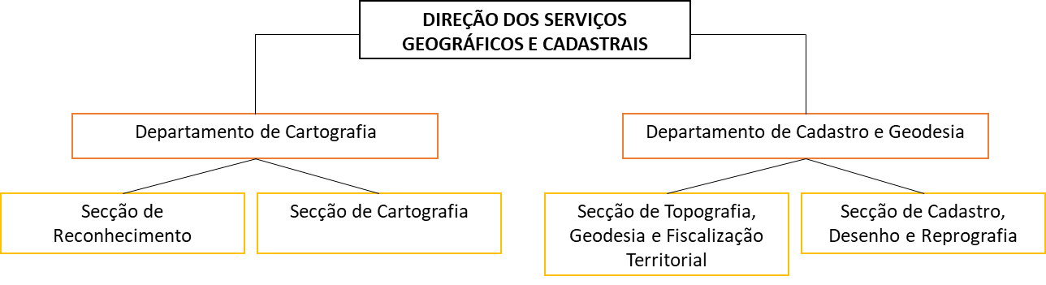
Regional Secretariat for Environment and Sustainable Development of Príncipe  Regional Department for Public Works, Urbanism and Spatial Planning  Departamento Regional de Obras Públicas, Urbanismo e Ordenamento do Território | This is the regional delegation of the national Directorate of Geographical and Cadastral Services, yet under the Regional Autonomous Government of Príncipe. | - As above
Regional Secretariat for Economy and Culture of Príncipe / Secretaria Regional da Economia e Cultura  Regional Directorate of Tourism, Commerce, Industry and Culture  Direção Regional de Turismo, Comércio, Indústria e Cultura | Regional delegation of Ministry of Tourism, Culture, Commerce and Industry | - As above
Regional Secretariat for Economy and Culture of Príncipe  Regional Directorate for Agriculture, Fisheries and Rural Development  Direção Regional de Agricultura, Pescas e Desenvolvimento Rural | Regional delegation of Directorate of Agriculture and Rural Development (including CADR) & Directorate for Fisheries and Fishery Resources | - As above
MAPDR  Department of Land Affairs  Departamento de Assuntos Fundiários (DAFu) | Department from the Directorate of Agriculture and Rural Development (see below), responsible for carrying out rural registration, land management and reorganization, and the supervision of land use. | - As above
National Platform for Forest and Landscape Restoration of São Tomé and Príncipe  Plataforma Nacional de Restauração Florestal e Paisagística de São Tomé e Príncipe (PNRFP-STP) | As part of the Landscape Restoration for Ecosystem Functionality and Climate Change Mitigation GEF6-funded FAO-led project, the PNRFP-STP was created and brings together all the relevant actors in the integrated management of forest resources, landscape restoration and promotion of more sustainable land use systems.  The main mission of the PNRFP-STP is to guide and support Forest and Landscape Restoration policies and strategies, as well as studies and other actions related to forest ecosystems. To this end, the following competencies and responsibilities are:  - To serve as a forum for discussion and promotion of debate on issues related to Forest and Landscape Restoration in São Tomé and Príncipe;  - Contribute to the dissemination of communication on Forest and Landscape Restoration and ongoing initiatives;  - Promote coordination and promote synergies between initiatives with an impact on Forest and Landscape Restoration and on the sustainable management of the country's forest ecosystems;  - Coordinate all actions/activities of planning and development of forest and landscape restoration policies in São Tomé and Príncipe;  - Play a leading role in identifying the most appropriate entry points for policy change, including strategic plans, laws, regulations, incentives and intersectoral integration, in formulating measures and changes for policy improvement and in designing concrete policies, regulations and incentives to be incorporated into the national policy framework through an agreed roadmap;  - Collaborate in the development of studies in the field of Forest and Landscape Restoration and in the implementation of other actions related to ecosystem services in forests, and proceed with their validation;  - Guide the Government of São Tomé and Príncipe on new initiatives in the field of forest conservation, management and restoration in the country. | - Collaboration on specific action of Component 3 (reforestation)  - Could host the proposed National Platform on Sustainable Charcoal  - Project design and adaptive management, participatory elaboration of annual activities, participation in monitoring and evaluation (reforestation activities)  - Exchange of information and best practices  - Beneficiaries of training / capacity building activities  - Project ongoing support for biodiversity & sustainable land-use mainstreaming into activities; dialogue, outreach and consultation / awareness raising  - Inception Workshop
Implementation Cell of the National Land Use and Management Plan  Célula de Execução do Plano Nacional de Ordenamento do Território de São Tomé e Príncipe | At the beginning of 2016, the African Development Bank granted a loan for the project entitled São Tomé and Príncipe National Land Use and Management Plan (PNOT), leaving the Ministry of Infrastructure, Environment and Natural Resources as the entity responsible for their implementation, having created its own structure for this purpose, called the Implementation Cell of the PNOT.  Mainly based on the observation that many stakeholders, not coordinated, intervene in issues of spatial planning, the PNOT proposes the creation of an authority, bringing together the main stakeholders, in particular the Directorate of Geographic and Cadastral Services and the Department of Land Affairs, which may later absorb other sectors : 'Create an institutional structure (similar to the PNOT Implementation Cell), properly equipped with human and material resources and, if necessary, supported by consultants with international experience, to manage the implementation of the PNOT and ensure the training of local staff'. | - Projected to continue in some form, will oversee the application of the PNOT land management plan, will benefit from or lead land use assessment by the project, and will host the project’s National Environment Mainstreaming Officer  - Inception Workshop
National Committee on Climate Change  Comité Nacional para as Mudanças Climáticas (CNMC) | Body for consultation, training, awareness-raising and facilitation in the design, financing, implementation, validation and monitoring of the different activities (programmes and projects) to be developed within the framework of the implementation of the United Nations Framework Convention on Climate Change and its additional legal instruments in São Tomé and Príncipe.  The CNMC should also ensure coherence between programmes/projects and national climate change priorities at the level of adaptation and mitigation.  The CNMC assumes the following responsibilities and attributions:  - Provide advice and technical assistance to the Government in making decisions on matters related to Climate Change;  - Promote public awareness and dissemination programs on Climate Change;  - Ensure the centralisation, capitalisation and dissemination of information on Climate Change;  - Provide technical and scientific support to the decisions and orientation of project/programme actions and regular monitoring of their implementation;  - Assume the role of steering committee or technical monitoring of any and all projects related to Climate Change that is implemented in the RDSTP, in order to avoid duplication of efforts;  - Validation of Climate Change projects before they are submitted to the international community for funding;  - Issue opinions on certain specific issues. | - Exchange of information and best practices  - Project ongoing support for biodiversity & sustainable land-use mainstreaming into activities; dialogue, outreach and consultation  - National Sustainable Charcoal Platform  - Inception Workshop
Ministry of Planning, Finance and Blue Economy  Trade and Investment Promotion Agency  Agência de Promoção de Comércio e Investimento (APCI). | Promotion agency, acting as a link between national and foreign investors and state institutions, to facilitate access to investment. | - Collaboration on specific action of Component 1 (PNOT) & 2 (innovative management/partnership models in PAs and HCV areas)  - Beneficiaries of training / capacity building activities  - Project ongoing support for biodiversity & sustainable land-use mainstreaming into activities; dialogue, outreach and consultation / awareness raising  - Inception Workshop
MOPIRNA  General-Directorate for Natural Resources and Energy  Direção-geral dos Recursos Naturais e Energia (DGRNE) | Government body responsible for designing and implementing policies related to Natural Resources and Energy. In particular: to elaborate studies and research on the characteristics and conditions of the country's natural resources, its territorial distribution and the level of exploitation; to analyse studies and investigations recommended by general guidelines on the use of the natural resources; to ensure the effective implementation of policy, laws and other policy instruments in the natural resources and energy sector; to ensure integrated management of natural and energy resources. | - Beneficiaries and providers of training / capacity building activities  - Member of advisory body, in particular for Component 3  - Project ongoing support for biodiversity & sustainable land-use mainstreaming into activities / strategies / planning; dialogue and outreach  - National Environmental Law Enforcement Platform  - National Sustainable Charcoal Platform  - Inception Workshop
 | 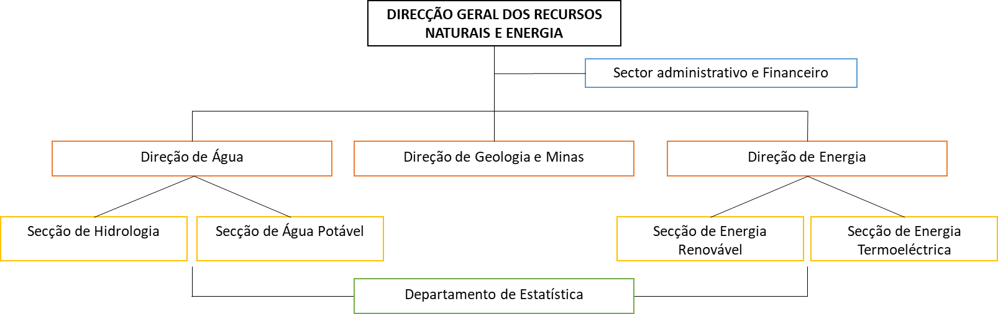
MAPDR  Directorate of Agriculture and Rural Development  Direção da Agricultura e Desenvolvimento Rural (DADR) | Government body responsible for designing and formulating policies in the fields of agricultural production, in particular export crops, horticultural and food crops, crop and soil protection, their conservation, and the promotion of agro-industrial activities, food security, as well as support for rural development, associativism and cooperativism. Some of its specific attributions are: to articulate and guide the Regional Delegations in the implementation of the policies approved for the areas of family agricultural production; to technically direct all questions related to the implementation of activities that ensure the efficient and diversified development of agriculture; to organize and technically coordinate all actions leading to the promotion of rural development and the promotion of associativism and sustained cooperativism in the rural world; to carry out rural registration, land management and reorganization, and the supervision of land use and sustainable irrigation. | - As above
 | 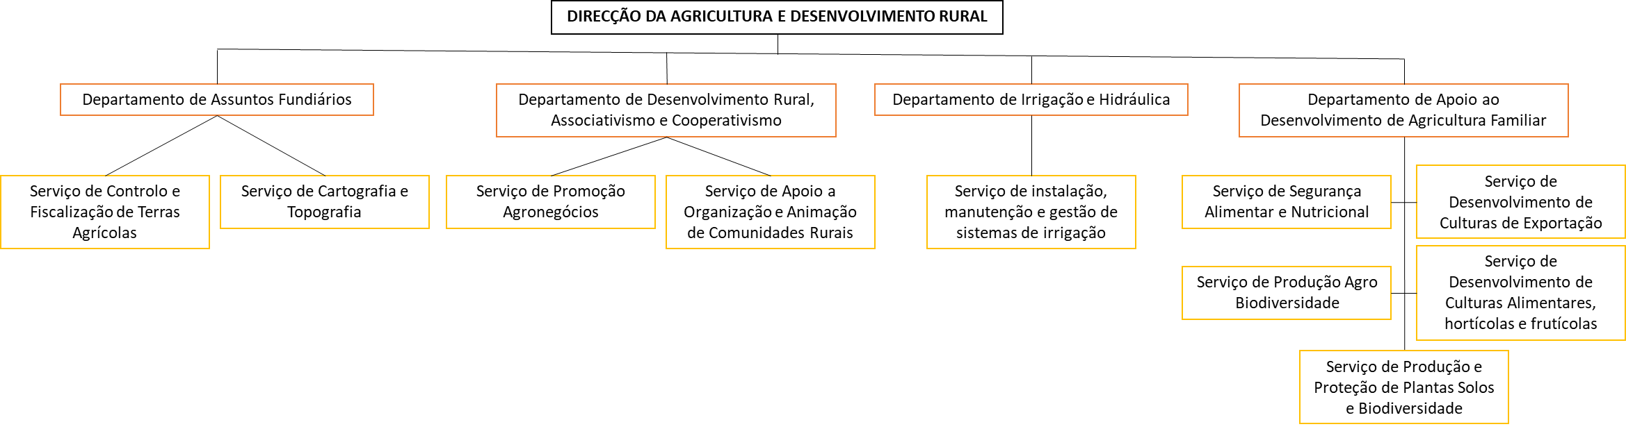
MAPDR  Directorate of Study and Planning  Direção de Estudo e Planeamento (DEP) | Government body responsible for planning, designing and developing the overall policy and strategic axes for agricultural and Food and Nutrition Security, as well as carry out due monitoring and evaluation of these policies within the ministry: coordinate the implementation of the development policies defined by the Ministry; articulate with the Technical Directorates and coordinate the activities of the Regional Delegations; participate in the definition and study of development programmes and projects for the sector; ensure the collection, production, processing and circulation of relevant data for the Ministry; propose actions to improve the process of logistics and adequate and timely procurement; establish mechanisms to monitor and evaluate development programmes and projects of the various services of the Ministry, proving their physical and financial implementation. | - As above
MAPDR  Rural Development Support Centre & Regional Delegations  Centro de Apoio ao Desenvolvimento Rural (CADR)  4 regional delegations:  . Norte (Cidade de Neves)  . Centro (CATAP)  . Sul (Cidade de Santana)  . Região do Príncipe | Agencies that articulate their actions with the respective technical directorates (Directorate for Agriculture and Rural Development, Directorate for Forestry and Biodiversity, Directorate for Fisheries, projects, and other institutions), and are accountable to the Directorate for Study and Planning, being responsible for the area of Technical Assistance and Rural Extension. It is the responsibility of the Rural Development Support centre: coordinate and execute the activities of technical assistance and rural extension throughout the national territory; draw up the annual plan for technical assistance and rural extension to producers and fishermen, in close collaboration with the technical directorates; participate and / or collaborate in studies or services for rural areas; follow up the activities of non-governmental organizations and other institutions that develop actions in rural areas; collaborate with research and training institutions in the field of agricultural extension and vulgarization; develop jointly with the department of associativism and cooperativism awareness activities on various topics that affect the rural areas; report to the ministry any possible problems or conflicts on agricultural, forestry and land-use in the area of jurisdiction; elaborate annually and submit to the ministry the needs for agricultural inputs, and proceed with their marketing. | - As above
MAPDR  Agricultural Technical Improvement Centre  Centre Centro de Aperfeiçoamento Técnico Agropecuário (CATAP) | Institution with administrative and financial autonomy focused on the capacity building of technical staff of the MADR, technical and professional training and capacity building of producers, promotion of courses and actions of vulgarization for small farmers, holding lectures and seminars on specific topics. | - As above
MAPDR  Agricultural and Technological Research Centre  Centro de Investigação Agronómica e Tecnológico (CIAT) | Institution with administrative and financial autonomy dedicated to research in the agronomic field and dissemination of results, with a view to increase productivity and diversification of agro-forestry-pastoral systems. Also, this institution is dedicated to carry out applied research in the area of Food Safety, Nutrition and Quality of Life in close collaboration with the Directorate for Studies and Planning and the Agricultural Development Directorate. | - As above
MAPDR  Directorate for Fisheries and Fishery Resources Direcção das Pescas e Recursos Haliêuticos (DPRH). | Government body responsible, amongst other activities, for the management of artisanal fisheries projects, registration of artisanal or industrial fishermen, and surveillance of fisheries activities in the EEZ of STP. | - Will be consulted in preliminary discussions about how new legal frameworks must be linked to future MPAs (Marine Protected Areas)  - Inception Workshop
 | 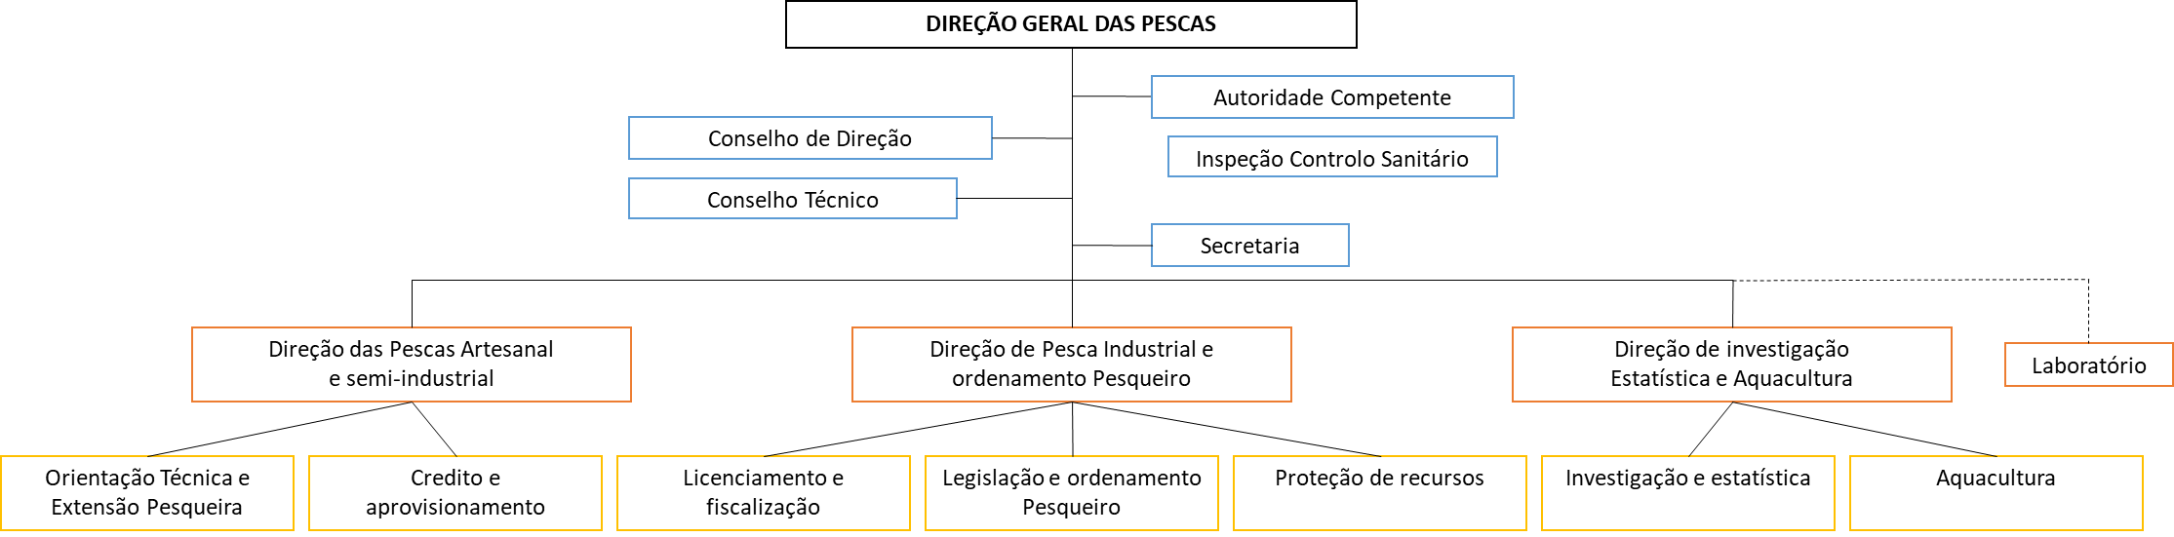
Ministry of Tourism, Culture, Commerce and Industry  General Directorate for Tourism and Hospitality  Direção-geral do Turismo e Hotelaria (DGTH). | Government body responsible for the design, implementation and evaluation of policies and overall objectives set by the Government in the fields of tourism and hospitality and regulation, monitoring and promotion of tourism activities. In particular: contribute to the definition of tourism policy and respective implementation and evaluation; promote the improvement of the quality of tourism services; collaborate in the preservation and enhancement of tourism resources, promote and guide their convenient use; contribute to the enrichment and diversification of the national tourism product; encourage and promote the implementation of activities of interest to the tourism sector; to ensure the country's tourism promotion; to support the government in negotiations and decisions, in international bodies, that are related to tourism policy; to ensure competitiveness and fair competition in tourism activities; to promote, with institutions and educational establishments, partnerships with a view to training and capacitating people in the tourism, hotel and restaurant sector. | - Collaboration on specific action of Component 2 (tourism practices, tourism revenue, tourism in PAs, HCV concessions, etc.)  - Member of advisory body  - Beneficiaries and providers of training / capacity building activities  - Project ongoing support for biodiversity & sustainable land-use mainstreaming into activities / strategies / planning; dialogue and outreach  - National Environmental Law Enforcement Platform  - Inception Workshop
 | 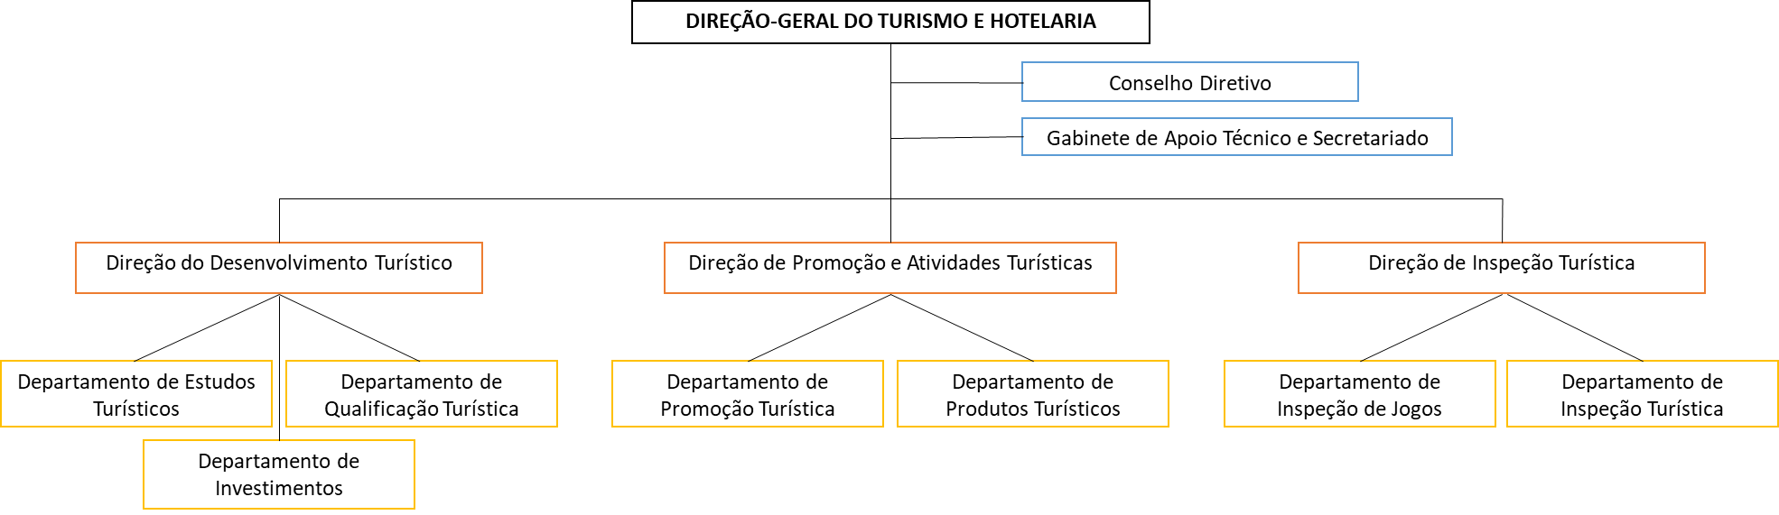
Ministry of Defence and Internal Affairs – military, national police, coast guard  Forças armadas, polícia nacional, guarda costeira | Government body responsible for, among other, ensure and supervise law enforcement, through the administration of the Military Forces, the Security Forces and Services and affiliated institutions. | - Collaboration on specific action of Component 1 (National Environmental Law Enforcement Platform, enforcement system, etc.); dialogue, and outreach  - Beneficiaries of training / capacity building activities  - Inception Workshop
Ministry of Justice, Public Administration and Human Rights | Government body responsible for leading, implementing and controlling the policies in the areas of Justice, Public Administration and Human Rights. | - Collaboration on specific action of Component 1 (Natural Resources Law Enforcement, land conflict resolution); dialogue, outreach and consultation  - National Environmental Law Enforcement Platform  - National Sustainable Charcoal Platform  - Inception Workshop
Bilateral and Multilateral Agencies
UNDP | GEF Implementing Agency  Sao Tomé and Príncipe office of the United Nations Development Programme | - GEF Implementing Agency – oversight and in that role on Project Board  - Project design and technical advisory services under oversight role  - Providing implementation support upon request from Government/Implementation Parties – procurement, payments, HR
IFAD | GEF Implementing Agency  Sao Tomé and Príncipe office of the International Fund for Agricultural Development | - Exchange of information and best practices  - Collaboration on specific action of Component 2 (IFAD/EU-HCVs) & 3 (DFB/FAO/TRI – reforestation / participation in decision-making)  - Project ongoing support for biodiversity & sustainable land-use mainstreaming into activities; dialogue and consultation  - Inception Workshop
FAO | GEF Implementing Agency  Sao Tomé and Príncipe office of the Food and Agriculture Organization of the United Nations
AfDB | GEF Implementing Agency  Sao Tomé and Príncipe office of the African Development Bank
WBG | GEF Implementing Agency  Sao Tomé and Príncipe office of the The World Bank Group
EU | Delegation of the European Union to Gabon, Sao Tomé-et-Príncipe and CEEAC | - As above
U.S. Government | Representation of the Government of the United States of America in ST/STP and Libreville/Gabon. | - Coordination with the United States government representation in Sao Tome and Libreville, via outreach to Rebecca Fisher (Rebecca.fisher@treasury.gov) and Elizabeth Nichols (nicholses@state.gov) to initiate this connection – upon project inception
COMIFAC & GIZ | Enhanced conservation and sustainable management of the forests of the Congo Basin. The objective of the GIZ-funded is programme is "the biological diversity and forest resources of the Congo Basin and surrounding savannah are better protected and are being exploited in an increasingly sustainable manner", on themes such as ABS, protected areas, organizational development, international dialogue, knowledge management, participation of indigenous peoples and local communities and civil society, forestry training through support to RIFFEAC, and forest certification. | - Actively engage in regional dialogues and build on orientation and tools on protected areas developed and promoted by COMIFAC and the regional GIZ programme “Sustainable Management of Forests in the Congo Basin”.
IUCN | GEF Implementing Agency  Sao Tomé and Príncipe office of the International Union for Conservation of Nature | - Exchange of information and best practices  - Experience sharing and collaboration on specific action of Component 2 (PAs, HCVs)
Non-Governmental Organization
BirdLife International | Oldest international conservation organisation and the largest global partnership of conservation organisations, BirdLife strives to conserve birds, their habitats and global biodiversity, working with people towards sustainability in the use of natural resources. Together there are 115 BirdLife Partners worldwide – one per country or territory – and growing.  BirdLife is widely recognised as the world leader in bird conservation and is the official IUCN Red List authority on birds. It provides data on population estimates, trends and conservation status of all (c. 11,000) bird species in the world. BirdLife’s Important Bird and Biodiversity Programme has identified around 13,000 global and regional sites in terrestrial, freshwater and marine ecosystems all over the world, making this the largest global network of sites of significance for biodiversity. Rigorous science informed by practical feedback from projects on the ground in important sites and habitats enables BirdLife to implement successful conservation programmes for birds and all nature. BirdLife actions are providing both practical and sustainable solutions significantly benefiting nature and people.  BirdLife International has been working in STP since 2006, initially studying the ecology and conservation needs of the four critically endangered bird species, developing action plans for them and undertaking some actions to implement these action plans. In 2017, BirdLife signed a Memorandum of Understanding, through the Ministry of Agriculture and Regional Government of Príncipe, for co-Management of the Conservation Areas. In 2018, the European Union (EU) 4-year (2018-21) project funded through the Ecosystèmes des Forets d'Afrique Centrale (ECOFAC VI) grant, was launched. BirdLife is coordinating the action (supporting several organizations) and has secured funding to start with key conservation activities on the ground. | - Responsible Party designated by UNDP – in charge of delivery of several output packages; participation in decision-making  - Project design and adaptive management, participatory elaboration of annual activities, participation in monitoring and evaluation (overall project implementation) / Project Board  - Participation in high-level advocacy meetings  - Data collection for research purposes  - Member of advisory body (overall project implementation)  - Exchange of information and best practices  - Providers of training / capacity building activities  - National Environmental Law Enforcement Platform  - National Sustainable Charcoal Platform  - Participatory appraisals of community needs (livelihoods, PAs, HCVs, reforestation, law enforcement)  - Inception Workshop
Fundação Príncipe | Active only on Príncipe island, the Príncipe Foundation (formerly the Príncipe Trust Foundation) is a non-profit non-governmental organisation that, since 2015, has been working in partnership with regional entities for the conservation and protection of the ecosystems of Príncipe Island, enhancing the economic and social development of local communities. Today, about 40 employees, who are trained for the implementation of marine and terrestrial conservation projects, together with a network of national and international partners (Fauna and Flora International, BirdLife International), who have contributed greatly to the exponential growth of the organisation and, above all, to the capacity of the team that currently coordinates and manages projects independently and with recognized success. | - Potential sub-grantees (of BirdLife International) under Component 2 & 3  - Beneficiaries and co-providers of training / capacity building activities  - Dialogue, outreach and consultation  - National Sustainable Charcoal Platform  - Data collection for research purposes  - Participatory appraisals of community needs (livelihoods, PAs, HCVs, etc.)  - Inception Workshop
Oikos – Cooperação e Desenvolvimento | Founded on February 23rd 1988, in Portugal, NGO specialized in Development, including Education, Social Mobilization and Public Influence. Oikos opened an office in São Tomé and Príncipe in 2015.  Currently implementation partner of the ECOFAC VI project and the Blue Action Fund, Oikos has carried out projects such as:  - Strengthening civil society and relevant stakeholders to participate in the institutional construction of biodiversity conservation policies and benefit sharing in São Tomé and Príncipe, and  - Sustainable co-management of fisheries in the south of São Tomé Island.
Federação de Organizações Não Governamentais em São Tomé e Príncipe (FONG-STP) | Created in April 2001, growing (currently 98 members), home to national and international NGOs, FONG-STP has the following main objectives:  - To represent the various Non-Governmental Organizations (NGOs) operating in São Tomé and Príncipe;  - To promote greater cooperation and coordination between National and Foreign NGOs and the Government of São Tomé and Príncipe, as well as with Donors and other individuals and/or institutions involved in Humanitarian Assistance and Development processes in the country;  - Promote and mediate the regional and international cooperation of NGOs as well as develop communication networks for better insertion and solidarity of its members;  - Promote the strengthening of National NGOs in order to facilitate their long-term sustainability. | - Collaboration on specific action of Component 1  - Beneficiaries and co-providers of training / capacity building activities; dialogue and outreach  - Inception Workshop
Platform for Responsible and Sustainable Tourism  Plataforma do Turismo Responsável e Sustentável (PTRS) | Based in the city of São Tomé, the PTRS aims to promote responsible and sustainable tourism, in order to protect ecosystems and biodiversity, and preserve cultural and social heritage, through tourist services of excellence.  Created under the GEF5-funded IFAD-led project, the platform brings together tourism operators, cooperatives, civil society, individuals and local associations. In 2018, Mucumbli, Cocoa Residence, HBD, Roça Abade / Príncipe Tours, ABS, AGSTP, Associação Monte Pico, Alisei, FENAPA STP, Zatona Adil, Navetur, Mistral Voyages, STP Tours, Eventur, Pestana Group, Monte Forte, Yam Beach, Mionga, CECAFEB, CECAQ-11, CECAB, Food Crops Sector, CEPIBA, LOBELIA, NGO Marapa / Jalé Ecolodge, Qua-Tela, Hull Blyth, ISLAND TOURS and ICEA were members of the Platform.  The values shared by the members are defined by 20 pillars described in the 'Sustainability Charter'. | - Collaboration on specific action of Component 2 (tourism practices, tourism revenue, tourism in PAs, HVC concessions, etc.)  - Beneficiaries of training / capacity building activities  - Dialogue and outreach  - National Environmental Law Enforcement Platform  - Inception Workshop
We Are Changing Together (WACT) | Portuguese NGO based in São Tomé e Príncipe since 2009.  In 2016, Bô Energia project was created by WACT: (i) raising public awareness of the environmental risks inherent to the use of fossil fuels, (ii) the reuse of flammable waste residues and (iii) the production of briquettes as a more sustainable and alternative source of energy to coal.  This transition presupposes the construction of a production centre and will take place without economic and social costs, through the reconversion and involvement of the current charcoal producers in the production and sale of briquettes. | - Collaboration on specific action of Component 3  - Beneficiaries and co-providers of training / capacity building activities  - Dialogue and consultation  - National Sustainable Charcoal Platform  - Inception Workshop
Gulf of Guinea Biodiversity Center  Centro de Biodiversidade do Golf de Guiné | In order to facilitate and promote comprehensive / coordinated research and education programmes on the unique diversity of plants and animals on the oceanic islands of São Tomé, Príncipe and Annobón, a group of biologists and educators is preparing to establish the Gulf of Guinea Biodiversity Centre.  The Centre will be based in São Tomé with delegation in Príncipe and Annobón.  The Gulf of Guinea Biodiversity Centre will:  - Have a research centre with rooms, library and laboratory for scientists, educators and students;  - Provide teaching spaces for nationals and tourists, including an interpretative museum, classrooms and auditorium;  - Create opportunities for inhabitants to develop ecotourism on the islands;  - Act as a logistic platform for research projects;  - Be a repository of information on flora, fauna and conservation on these islands.  The Centre shall be registered in STP by the end of 2020. | - Providers of training / capacity building activities  - Collaboration on specific action of Component 2 (scientific / research support), dialogue and consultation  - Data collection for research purposes
MAR Ambiente Pesca Artesanal (MARAPA) | Created in 1999, by fisheries technicians, marine biologists and development agents, MARAPA is recognised for its knowledge on marine environment, fishery resources and artisanal fisheries.  Its actions aimed at the protection of marine and coastal habitats, the co-management of fishery resources and support to actors in the fisheries sector.  The Tatô Programme, dedicated to sea turtles, and Operation Tunhã, an initiative for monitoring and follow-up of cetaceans, are noteworthy. | - Exchange of information and best practices (Law Enforcement experience)  - Consultations on basic legal framework layout linkages to future MPAs  - Inception Workshop
Associação Programa Tatô (APT) | In 2003, the NGO MARAPA created the Tatô Program, in order to protect sea turtles. For years, MARAPA had the support of several national and international organizations. Over the years, the Tatô Programme team has grown, and, in 2018, the coordination team created an international NGO, the APT, thus maintaining the name, already known by all communities, national authorities, civil society, as well as internationally.  Considering the challenges facing the conservation of sea turtles, the APT has an integrated approach to improve the protection and sustainable management of the main habitats of sea turtles (nesting beaches and feeding areas), through the involvement of national stakeholders, through capacity building, through the development of livelihoods alternative and increasing the awareness of coastal communities.  On the island of São Tomé, monitoring activities are led every year on 23 km of beach. 21 beaches are monitored to the north, east and south of the island, as well as on the beaches of Ilhéu das Rolas. In addition to the main spawning beaches, the feeding and resting areas of sea turtles off the island of São Tomé are also monitored.
Apoio ao Desenvolvimento de Iniciativas Locais (ZATONA ADIL) | Local association with weak resources and low capacity - Community awareness and mobilization for the environment. | - Collaboration on specific action of Component 2  - Beneficiaries of training / capacity building activities  - Dialogue, outreach and consultation / awareness raising  - Inception Workshop
Associação Monte Pico | Local association with weak resources and low capacity - Headquartered in Monte Café and operating mainly in the São Tomé Obô Natural Park and its Buffer Zone. Assistance to scientific research, field guides and awareness-raising activities.
Ação para o Desenvolvimento Agropecuário e Proteção Ambiental (ADAPPA) | Local association with weak resources and low capacity - Fighting poverty, promoting food and nutrition security, and ensuring sustainable development.
ALISEI | (Italian NGO) Promote knowledge, studies and initiatives to combat poverty in underdeveloped countries. In partnership with MARAPA, manages Jalé Ecolodge. | - Collaboration on specific action of Component 2 (PAs – link with CEPF projects)  - Beneficiaries of training / capacity building activities  - Dialogue, outreach and consultation / awareness raising  - Inception Workshop
TESE - Associação para o desenvolvimento | (Portuguese NGO) Specialized in waste management in São Tomé and Príncipe. TESE supports, among other initiatives, the Waste Processing Centre (CPR) in São Tomé, near Santa Casa da Misericórdia. | - Collaboration on specific action of Component 3 (waste management)  - Exchange of information and best practices  - Inception Workshop
Quá-Téla & Federação Nacional dos Pequenos Agricultores (FENAPA) | Local association with weak resources and low capacity - Valorisation of national products (agri-businesses). | - Beneficiaries of training / capacity building activities  - Dialogue, outreach and consultation / awareness raising
Community Based Organisations & Groups
Local communities | In São Tomé, the target communities may include those considered to be important production hotspots for charcoal (Praia das Conchas, Plancas 1&2, Ribeira Funda, Ponta Figa), as well as the other urban centers where resale is centralized (Neves, Guadalupe and the capital São Tomé). Porto Alegre in the south will also be targeted, as it is known to be an important region for coconut harvesting, with also high consumption rates for charcoal. In Príncipe, the project will target São Joaquim, Gaspar and Azeitona, all known to be important charcoal production centers.  However, all communities surrounding PAs or located in forested areas are susceptible to be involved in project activities (Natural Resources Law Enforcement). | - Beneficiaries (low-value grants for sustainable livelihoods and sustainable charcoal initiatives, community-based surveillance, planting of fast-growing charcoal tree species)  - Beneficiaries of training / capacity building activities  - Project ongoing support for biodiversity & sustainable land-use mainstreaming; dialogue, outreach and consultation / awareness raising  - National Environmental Law Enforcement Platform & National Sustainable Charcoal Platform (community / charcoal makers / logger representatives)  - Participatory appraisals of community needs  - Inception Workshop (representatives)  - (+) potential PPP Partner (innovative management/partnership models in PAs and HCV areas)
Landowners
Charcoal makers
Loggers
Academia
Ministry of Education and Higher Education /  University of São Tomé and Príncipe  Universidade de São Tomé e Príncipe (USTP) | Government body responsible for responsible for designing, implementing, coordinating and evaluating the policies for the sectors of Education and Higher Education, preparing and executing the national policy of education, training and higher education. It is also responsible for the administration and management of schools, development, planning, regulation, evaluation and inspection of the educational system.  USTP is a public institution of higher education in São Tomé and Príncipe. It is the only public university in the country. Converted in 2014 into a university after many years existing as several independent educational institutions. Four university campuses, three of which are only in the capital: three organic institutions and a research and extension centre; (i) Higher Institute of Education and Communication; (ii) Higher Institute of Health Sciences, (iii) Superior Polytechnic Institute, offering, among others, the following courses: Degree in Biology, Degree in Agronomy, Degree in Hotel Management, Degree in Information System and Technology; and (iv) Study Centre for Development - Centre for Agricultural Technical Improvement (CATAP), under the supervision of the Ministry of Agriculture.  Several universities have shown interest in sending master's, doctoral or post-doctoral students, mainly Portuguese universities. | - Collaboration on specific action of Component 1 (internships) & 2 (post-graduate trainings)  - Awareness raising  - Data collection for research purposes  - Inception Workshop
Private Sector - Agribusiness and Agriculture
Valudo | Created in 2018, Valudo is a growing Santomean company specialized in transformation of coconuts with organic and fair-trade certifications.  Valudo out-grower project and the Fair-Trade certification provide growers and harvesters with stable financial benefits in exchange of the supply of coconuts, and so, equally throughout the year. They provide inputs and technical supports to the growers and harvesters in order to improve the productivity of their culture; by combining traditional Santomean practices with modern processes of quality and control. Valudo is responsible for transport and logistics to reach the out-growers and their production, including the ones who live in remote communities. This service allows for the greatest number possible of out-growers to have a source of income.  Valudo is supporting more than 300 Santomean coconut harvesters, and process more than 2,880,000 coconuts per year in Favorita processing center. The selected coconuts are first stored in collection areas closed to where they were collected. They are then transported to the processing center where Valudo produces oil and other coconut products.  The company's objective is to successfully recycle 100% of coconut waste. | - Collaboration on specific action of Component 3 – beneficiary / PPP partner, project design and adaptive management, participatory elaboration of annual activities, participation in monitoring and evaluation (semi-industrial charcoal kilns)  - Beneficiaries and co-providers of training / capacity building activities  - Dialogue and consultation  - National Sustainable Charcoal Platform  - Participatory appraisals of community needs (coconuts)  - Inception Workshop
HBD | Investment group (Mark Shuttleworth) - sustainable eco-tourism project on Príncipe: currently 3 high-class tourism lodges ‘0-carbon’, Sundy Praia, Bom Bom, Roça Sundy. Large investor on Príncipe island in tourism, private, philanthropic, HBD works in close collaboration with the Regional Government. HBD has played a major role in the impressive development of Príncipe Island for the past 8 years, by investing in infrastructures, roads and supporting government-endorsed socio-environmental projects. Pro-active actor for the development of the island's sustainable development agenda. Financing / supporting Fundação Príncipe (NGO initially created to take the lead on the corporate activities of the investment group and gradually becoming independent). Also, behind schemes to resettle communities into forest areas designated by government, bordering the Azeitona forest (northern area of the PNP. Large local and expatriate workforce. 1st producer of coconut on Príncipe island. | - Collaboration on specific action of Component 2 (PAs, HCVs) & 3 (charcoal / coconuts)  - Beneficiaries and co-providers of training / capacity building activities  - Project ongoing support for biodiversity & sustainable land-use mainstreaming; dialogue, outreach and consultation / awareness raising  - Catalyst / Ally for Biodiversity & PAs finance planning; and to mobilise endowment capital for STP Conservation Trust Fund from private sector and philanthropists  - National Sustainable Charcoal Platform  - Inception Workshop
Export Cooperatives | CECAB (Cooperativa de Exportação de Cacau Biológico), CECAQ-11 (Cooperativa de Exportação de Cacau Convencional), CECAFEB (Cooperativa de Exportação de Café Biológico) and CEPIBA (Cooperativa de Exportação de Pimenta Biológica) are cocoa, pepper and vanilla export cooperatives.  Over the past two decades, the Ministry of Agriculture, with financial support from IFAD and the French Agency for Development, has fostered the creation of 4 export cooperatives and the development of partnerships with European companies working in the field of bio-equitable trade (KAOKA, CaféDirect, GEPA, Hom & Ter, Malongo, SlowFood). By 2015, these cooperatives exported about 50% of cocoa beans national production and 100% of coffee and pepper. Recent studies (2014) show that the economic profitability of cooperative members has more than doubled in ten years for cocoa. Since January 2012, the oldest of the four cooperatives has achieved full managerial and financial autonomy (CECAB). Cocoa remains the country's most exported agricultural production and the largest source of income. | - Beneficiaries of training / capacity building activities  - Awareness raising  - National Environmental Law Enforcement Platform & National Sustainable Charcoal Platform  - Inception Workshop  - (+) potential PPP partner (innovative management/partnership models in PAs and HCV areas)
Agripalma | Concession of 4,917ha in the south of São Tomé Island - palm trees for the production of oil. Approximately 2,100ha of palm trees planted to the South-East / South of the island of São Tomé. The factory, being built in Emolve, will start producing oil 2020. On the RSPO route, Agripalma is showing a growing interest in actively participating (financially) in conservation & biodiversity in Sao Tomé. | - As above
Satocao | Plantation of about 275ha (concession of about 2,500ha for a period of 25 years renewable, currently under review with the Government of STP due to important overlaps with the Protected Area - PNOST), and buyer of cocoa gum from small farmers, Satocao exports cocoa in dry gum (purchase on the scale of São Tomé Island / Dryer in Morro Peixe). | - As above
Diogo Vaz | Producer / Buyer (Diogo Vaz Farm, North-West of São Tomé Island) of cocoa gum and local transformation into chocolate and derived products (processing factory and tasting/restoration centre in the city of São Tomé). Diogo Vaz began diversifying its production (essential oils, pepper, etc.) in 2018. | - Beneficiaries of training / capacity building activities  - Awareness raising  - Inception Workshop  - (+) potential PPP partner (innovative management/partnership models in PAs and HCV areas)
Claudio Corallo | Producer of cocoa (Terreiro Velho no Príncipe) and coffee (Nova Moca in São Tomé), and local transformation into chocolate and derived products (processing factory and tasting/visiting centre in the city of São Tomé). | - As above
3. Stakeholder Engagement Methods / Means and Rules for Communication
The Project Manager, supported by the Project Management Unit and, if necessary, by the Project Board/Project Steering Committee, will hold responsibility for implementation of the project’s stakeholder engagement plan at the whole-project level (see section 3). The resources required are IT equipment, supplies and staff time; travel support and/or travel to project sites; meeting venue and/or catering for community meetings.
Stakeholder | Engagement Methods | Engagement Means | Rules for communication | Responsibilities
General Directorate for Environment | Project Management Unit meetings, Project Board meetings, e-mails, face-to-face meetings, workshops / platform meetings | Exchange of correspondences, meetings / minutes, memos / briefs, newsletters, brochures, field reports, training courses, design supervision, and any relevant documents for project implementation (Feasibility studies / External consultancy reports)  Data collection templates and procedures  Progress reporting (Interim, annual and final reports; external reports; cofinancier activities reports; etc.) | An internal communication plan will be developed by the PM with PMU/RP support to establish basis of transparent and continuous communication between internal stakeholders who are involved in project implementation at the earliest stage of the project. | PM/PMU/RP  In accordance with the rules for internal communication, meetings and the grievance mechanism for workers (employees and contract labour suppliers)
Directorate for Forests and Biodiversity
Environment and Sustainable Development Regional Secretariat - Directorate for Environment and Conservation of Nature
BirdLife International
United Nations Development Programme (UNDP) | Project Board meetings, e-mails, face-to-face meetings, workshops
Directorate of Geographical and Cadastral Services | E-mails, face-to-face meetings, workshops / platform meetings | Progress reporting  [briefs / newsletters / brochures]  Exchange of correspondences, meetings / minutes, field reports, training courses, design supervision, Feasibility studies / External consultancy reports  Data collection templates and procedures  Official letters | In accordance with administrative procedure requirements | PM/PMU/RP
Environment and Sustainable Development Regional Secretariat - Regional Department for Public Works, Urbanism and Spatial Planning
Department of Land Affairs
Agricultural Technical Improvement Centre
Rural Development Support Centre & Regional Delegations
General-Directorate for Natural Resources and Energy
Directorate of Agriculture and Rural Development
Directorate of Study and Planning
Agricultural and Technological Research Centre
General Directorate for Tourism and Hospitality
Military Forces
National Police
Trade and Investment Promotion Agency | E-mails, face-to-face meetings, workshops |  | In accordance with administrative procedure requirements | PM/PMU/RP
Ministry of Education and Higher Education / USTP
Ministry of Justice, Public Administration and Human Rights
International Fund for Agricultural Development
Food and Agriculture Organization
African Development Bank
the World Bank Group
International Union for Conservation of Nature
Delegation of the European Union to Gabon, Sao Tomé-et-Príncipe and CEEAC
Valudo | E-mails, face-to-face meetings, workshops / platform meetings |  | In accordance with administrative procedure requirements | PM/PMU/RP
National Platform for Forest and Landscape Restoration of São Tomé and Príncipe | E-mails, workshops / platform meetings | Progress reporting  [briefs / newsletters / brochures]  Project decisions  Data usage decisions | In accordance with PNRPF-STP procedure requirements | PM/PMU/RP
National Committee on Climate Change
Oikos – Cooperação e Desenvolvimento | E-mails, face-to-face meetings, workshops / platform meetings | Progress reporting  [briefs / newsletters / brochures]  Exchange of correspondences, meetings / minutes, field reports, training courses, design supervision  Data collection templates and procedures  Official letters | Through RP – BirdLife International | RP – BirdLife International
Fundação Príncipe
Local communities | Through face-to-face community meetings, individual interviews and workshops | [briefs / newsletters / brochures]  Consultation meetings – providing information, exchange of documentations and correspondences associated with projects, booklets / posters / brochures | In accordance with the rules for internal communication, and the accepted custom.  Direct communication (and indirect through announcements issued to the public). | PM/PMU (e.g., Community Organizers), including RP teams (e.g., Field officers)
Land owners
Charcoal makers
Loggers
Platform for Responsible and Sustainable Tourism | E-mails, face-to-face meetings, workshops / platform meetings | Progress reporting  [briefs / newsletters / brochures]  Official letters | Communication to be done by persons authorised to communicate. Public communication can be done through national reporting rules | PM/PMU/RP
We Are Changing Together (WACT)
Bo Energia
Gulf of Guinea Biodiversity Center | E-mails, face-to-face meetings, workshops |  |  | PM/PMU/RP
Export Cooperatives | E-mails, face-to-face meetings, workshops / platform meetings |  |  | PM/PMU/RP
HBD
Agripalma
Satocao
Diogo Vaz
Claudio Corallo
HBD | E-mails, face-to-face meetings | Progress reporting  [briefs / newsletters / brochures]  Feasibility studies / External consultancy reports  Official letters |  | PM/PMU/RP
Federação de Organizações Não Governamentais em São Tomé e Príncipe (FONG-STP) | E-mails, face-to-face meetings, workshops | [briefs / newsletters / brochures]  Official letters |  | PM/PMU/RP
Apoio ao Desenvolvimento de Iniciativas Locais (ZATONA ADIL)
Associação Monte Pico
Ação para o Desenvolvimento Agropecuário e Proteção Ambiental (ADAPPA)
MAR Ambiente Pesca Artesanal (MARAPA) | E-mails, face-to-face meetings | [briefs / newsletters / brochures]  Official letters |  | PM/PMU/RP
Associação Programa Tatô

4. Monitoring and Reporting
The project will endeavour to make information available to the public to allow stakeholders to get to know and understand both the environmental and social risks and impacts associated with the project, as well as opportunities provided by the project. This will enable them to utilise the project data to make informed decision in areas associated with Biodiversity Conservation and Sustainable Land & Natural Resource Management.
On an ongoing basis, the project will have a routine disclosure and consultation on the project’s environmental and socio-economic performance including grievances and other new emerging issues on the project. The disclosures will be done to all stakeholders’ thorough project briefs, newsletter or annual reporting through brochures. While providing this disclosure, the project will also provide:
An update on the Project achievements and how its contributing to enhancing transparency in reporting for Sustainable Development Goals implementation in the country ;
An overview of the stakeholder engagement process and how affected parties can participate and provide feedback through meeting or other avenues;
Project impacts on development and how the government is using the project data to enhance the livelihoods of the people at the same time conserve the environment and report on Biodiversity Conservation and Sustainable Land & Natural Resource Management.
Monitoring is an integral component of project management as it tracks and assesses progress towards achieving tangible development results associated with the project being implemented. It is an essential management tool which provides an opportunity to know whether results are being achieved as planned, what corrective action are needed to ensure delivery of the intended results and how they are making positive development contributions. This helps to detect problems earlier and coming up with appropriate measures to address them. Therefore, monitoring usually provides data used for analysis and synthesis prior to reporting for decision-making.
Parameters for Reporting and Monitoring

Parameter |  | Monitoring and reporting responsibility | Reporting period
1. | Number of government agencies, civil society organizations, private sector, local communities & user groups, and other stakeholder groups that have been involved in the project implementation phase | PM/PMU with RP support | Annual basis
2. | Number persons (sex disaggregated) that have been involved in project implementation phase | PM/PMU with RP support | Annual basis
3. | Number of engagement (e.g. meeting, workshops, consultations) with stakeholders during the project implementation phase | PM/PMU with RP support | Annual basis
4. | Percentage of stakeholders who rate as satisfactory the level at which their views and concerns are taken into account by the project | UNDP-GEF Agency (external hire consultant) | Midterm and final project evaluation
5. | Grievances handling mechanism – how grievances are received, and results communicated to all stakeholders | PM/PMU with RP support | Annual basis

This monitoring and reporting requirement is important not only to track what is happening with projects, but to provide a basis for actions and adjustments that will be needed to address challenges that may arise, and ensure that a project is meeting its objectives. The reports will also provide a window for stakeholders to better understand project activities during the implementation stage, in support of their more informed participation. To this end, the Project Management Unit and Responsible Parties will also develop user-friendly and accessible systems to make information available to stakeholders on stakeholder engagement during the course of the project, and on project progress, changes and outcomes (e.g., use of social media and local TV / radio).
In addition, wherever feasible, the process of monitoring and reporting will also include “participatory monitoring” by stakeholders. This is an important tool that will enhance both the independence, strength and accuracy of monitoring information. As indicated in the GEF-Policy, local communities and CSOs possess essential knowledge, expertise and capabilities relevant to project interventions. Participatory monitoring, which will be based on gender inclusion and other core principles in the Policy and will be one means to harness this for the benefit of the project and better results. In terms of frequency of preparation of the reports, the GEF-UNDP guidelines will be followed.

6. Timetable of stakeholder engagement during project implementation
 | Timeline | 2020 |  |  |  | 2021 |  |  |  |  |  |  |  | 2022 |  |  |  |  |  |  |  | 2023 |  |  |  |  |  |  |  | 2024 |  |  |  |  |  |  |  | 2025
 | Activities | 3 |  | 4 |  | 1 |  | 2 |  | 3 |  | 4 |  | 1 |  | 2 |  | 3 |  | 4 |  | 1 |  | 2 |  | 3 |  | 4 |  | 1 |  | 2 |  | 3 |  | 4 |  | 1 |  | 2 |  | 3 |  | 4
1 | Inception Workshop
2 | Participatory elaboration of annual activities
3 | Monitoring and evaluation (including participation of ext. stakeholders)
4 | Participation in program balance
5 | Project Board
6 | Midterm and final project evaluation
7 | Participatory appraisals of community needs
8 | Participation in high-level advocacy meetings
9 | Continuous Dialogue, outreach and consultation
10 | Project ongoing support for biodiversity & sustainable land-use mainstreaming into activities
11 | National Environmental Law Enforcement Platform
12 | National Sustainable Charcoal Platform
13 | Training / capacity building activities
14 | Awareness raising
15 | Collaboration on specific action
16 | Data collection for research purposes
17 | Advisory body
18 | Exchange of information and best practices
19 | Project design and adaptive management
20 | Identify/Revision the role of stakeholders in project execution (incl. review of Stakeholders Engagement Plan if needed)
21 | Ensure Stakeholders are engaged in respect to environmental and social issues related to the project, and are informed about actions taken in response to their input
22 | Creating and making available a complaint management system

Annex 11: Gender Analysis and Gender Action Plan
Project Information
Project Title | Enhancing Biodiversity Conservation and Sustainable Land and Natural Resource Management
Project Number | UNDP # 5881, GEF# 10007
Location | São Tomé & Príncipe / Africa

Part A – Context-based approach to gender mainstreaming
A small island facing poverty issues and a growing population
São Tomé and Príncipe is a small insular territory with limited agricultural production and exportations and a strong dependence to external financial help. The GDP (Gross Domestic Product) has an estimated value of 0.42 billion USD in 2018. The GDP is made principally of services (73.4%), followed by industry (14.8%) and agriculture (11.8%), with an annual growth rate of 4%, which resulted in 2017 from an improvement of exportations of cocoa, tourism and public-private investment. It is interesting to note that the tourism sector has been growing fast, with tourist arrivals increasing average by 7.5% annually since 1995. The tourism sector already accounts for around 11-14% of both GDP and employment (IMF, 2016; WTTC, 2018). However, despite its recent economic development, the 2015 Human Development index is estimated at 0.574 and poverty is still affecting 66.2% of its population with 11.5% people living under the level of extreme poverty. Poverty is more prevalent in women (71.3%) than in men (63.4%).
A relatively well performing maternal and child health but fertility is still too high for young women, impairing later empowerment
The indicators of maternal and child health have improved and perform relatively well. The contraceptive prevalence rate has increased from 28.1% in 2000 to 42.4% in 2016 and maternal mortality rate have reduced from 222 to 156 per 1000. Neo-natal and infant mortality rates dropped respectively from 24.5 to 17.1 per 1000 and from 58.5 to 34.6 per 1000. However, STP women still have a high fertility index of 4.5 (higher in rural areas) and the adolescent birth rate is 94.8 births per 1,000 women of ages 15-19, closer to neighbouring low-income countries’ values. There is also an important disparity between urban and rural areas, the latter being most affected by early childbearing and rate of single parent households led by women. This has a significant impact on the limited economic empowerment of women, because early childbearing often results in higher secondary school dropout rates and potentially contributes to maintaining the social norms around their domestic responsibilities.
Gender gaps have been progressively closing in terms of school enrolments: Primary school is mandatory in STP, thus the gross enrolment rate is high and relatively gender-balanced in primary school (112.2% for girls vs 117.7% for boys in 2016). The trend is similar but inverse for the secondary school enrolment (91.7% for girls vs 80.8% for boys in 2016). This has resulted in the decrease of the adult illiteracy rate from 30.5% (39.9% for women vs 19.7% for men) to 8.3% (12% for women vs 4.4% for men). However, there is a smaller percentage of both women and men who complete their secondary education. In 2017, 31.1% of adult women have reached at least a secondary level of education compared to 45.2% of their male counterparts. The gender gap in school completion is improving, but women are still a very sensitive part of the population, with high dropout rates due to early childbearing and an associated low institutional support to continue their studies (lack of availability of night classes, limited availability of schools in rural areas); as well as patriarchal social norms, leading to school abandonment to find an informal income generating activity while performing domestic chores.
A low presence of women in the country’s work force and in decision-making positions
Among STP’s total working population, representing 68,000 people in 2016, only 38.2% are women, this phenomenon being even more pronounced in rural areas (34%); and according to a 2012 census, women still constitute most of the unemployed population (59%), in particular for youth. The agricultural sector employs 22% of the working population, with the male share dominant (27% vs 14.3%). Cacao, café and pepper are the country’s main export crops, generator of revenues and employment. Most of the other agricultural activities are family-based or medium-sized private enterprises oriented towards subsistence farming. Women are otherwise mainly classified into independent workers or workers without qualifications (71%) and services and traders (58.9%) category.
The collection and transformation of forest products is an important secondary activity for 82.7% of rural households who depend on them mainly for subsistence and commercialize wood and non-wood products to increase family income. There is a strong division of roles by gender, with 84.1% of women in charge of the collection of non-wood products and the commercialization of wood (charcoal) and non-wood (snails, fruits, spices, etc.) products at local markets (vs 15.9% of men). Men are responsible for the extraction of wood products (construction wood and charcoal) and the commercialisation of wood products, except charcoal. These activities, however, are not generally contributing to women’s economic empowerment, as in a conjugal context, most revenues are managed by the husband.
Traditional society still enforces women’s domestic role as their primary responsibility, to the extent that, for rural women, their participation in productive agricultural activities is viewed more as “help” than as real work, even though they are often working on the same tasks as men; and, in the conjugal context, they often remain under the economic supervision of men. In addition, this discriminatory social context induces a multiplication of tasks for women, who still spend significantly more time than men on unpaid work, in particular domestic tasks. Women spend an average of 8 hours per day on unpaid work, compared to just 2 hours on paid work (INPG, 2017). Unpaid work includes childcare, and water and firewood collection. While the government covers 100% of the costs of maternity leave, it does not support childcare services that could alleviate women’s domestic burden and allow them to increase their participation in the labor force.
A study on gender strategy for the education sector found evidence of gender bias in school teaching materials and in the opinions on suitable careers for women and men, which may ultimately lead to occupational sex segregation (women oriented towards caring and secretarial positions, while men would be oriented towards physical or decision-making careers). Women are almost entirely absent from jobs in the fishing, extractives, energy, water, construction, and transport sectors; and underrepresented in surveillance and law enforcement jobs, occupying just 20% of military and 34% of police jobs (INPG, 2017). A recent study suggests that the tourism sector offers more opportunities for women than many other sectors: The Tourism Marketing and Strategic Plan (2018) notes employment of 53% women vs 47% men and a predominance of women in sectors such as restaurant / catering. In spite of this, this sector is not discussed in the national gender strategy (2007-2012 ENIEG).
Women also tend to be holding lower level positions inside private companies and sectors compared to men. While women make up around half of jobs in public administration, defense, and social security, they represent only 25% of legislators or directors and 27% of town councillors (INPG, 2017). In 2017, the share of women in parliament reached 18.2%, but dropped again to 13% in 2018 with women occupying only 7 out of 55 seats.
Discriminatory social norms have hindered the translation of an improving schooling rate into the successful empowerment of women in the work force. Women are thus increasingly involved in multiple activities, domestic and economic, yet still not recognized equally due to slowly evolving mentalities, often leading to a certain acceptance or minimization of gender-based violence by men towards women. In a recent DHS survey, a significant portion of the population (20%) reported that wife-beating was acceptable, particularly in cases of adultery; and 15% of women had experienced sexual and/or physical violence in the last 12 months.
Summary gender indexes compared to neighbouring countries
The Gender Development Index (GDI) is a disaggregated measure of the Human Development Index (HDI), defined as the ratio of the female to the male HDI. The GDI is calculated for 164 countries. The 2017 GDI value of São Tomé and Príncipe is 0.892. In comparison, the GDI value for Cabo Verde is 0.949.
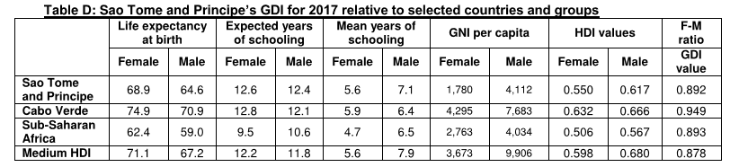
The Gender Inequality Index (GII), reflecting gender-based inequalities in three dimensions – reproductive health, empowerment (measured by the share of parliamentary seats held by women and attainment in secondary and higher education by each gender), and economic activity for São Tomé and Príncipe has a value of 0.538, ranking it 131 out of 160 countries in 2017.

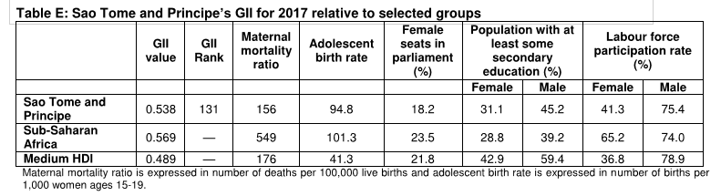
Moving forward, national initiatives and remaining challenges
Improving economic empowerment for women in São Tomé and Príncipe requires the development of strategies that are based on the economic and social realities in the country, identifying and removing the obstacles that prevent women from achieving their full potential. The solutions require the active involvement of all members of society.
Key barriers to women’s economic empowerment and financial inclusion include unpaid care work, high adolescent pregnancy rates, high school dropout rates, gender-based violence, lack of access to microcredits, occupational sex segregation and discriminatory social norms. However, the current political orientation as well as the existing legal framework surrounding gender equity issues in São Tomé and Príncipe is very favourable to gender equality development in terms of human, social, economic, cultural, civic and political rights. The juridical system is well equipped to support gender equality in the country, despite few gaps in the laws (for example, the lack of awareness of and diligence in applying the family rights law n°2/77 to defend gender equality of rights and responsibilities inside the household; and the status of abortion, which is tolerated in practice but still considered illegal by law). The obstacles to gender equity thus mainly remain in the effective application of the available framework, in part because of:
- The social acceptance of the subordinate role of women within the Santomense society
- The generalised lack of awareness about this gender equity legal framework, women’s rights and legal tools to enforce it
- The lack of training, and gender imbalance amongst staff supposed to enforce this legal framework
- A shy voice from civil society exerting only a low pressure towards mentality changes
- Stereotypes still present about women’s recruitment, limiting them to lower ranking positions than men
- The lack of women’s inclusivity in the institutional and political spheres, leading to an unequal participation in the management of public affairs, regulations design and decision making
- The lack of funding for a global/transversal vision and approach to include gender equity considerations, often limiting actions to only one aspect of the problem (i.e. increasing opportunities for economic activities)
Women’s economic empowerment and financial inclusion should be mainstreamed into the legal framework, budget process, and development strategies. Existing laws on gender equality and gender-based violence should be enforced. Stakeholders include not only the Ministry of Finance and sectoral ministries but also parliament, the private sector, civil society, non-governmental organizations, development partners, citizens, and the media. Reliable gender-disaggregated data are necessary for monitoring the country’s progress on the targets identified in the national action plan.

Part B – Gender Action Plan
Definition of the Gender Action Plan
The following Action Plan aims to make the project’s interventions more socially inclusive, by ensuring a close fit with local contexts, culture and livelihoods, and to safeguard the interests of women as the weaker sections of the population. The objectives of the Gender Action Plan are to promote gender equity practices in biodiversity related issues and improve the living conditions of communities bordering conservation areas, often using the resources provided by the forest. This will allow monitoring the progress of project outcomes disaggregated by sex, to ensure an integrated and participatory implementation of the project.
The project will apply gender-based principles in the selection and contracting of their local technical and administrative personnel, including for the environmental surveillance and enforcement unit to be created, as well as in relation to capacity-building activities.
The project will adopt participatory approaches where possible to include all relevant social groups, including marginalized people (e.g. unemployed youth), with attention to the participation and inclusion of women in targeted communities. A minimum quota of 30% of women will be required for the setup of the platforms to be created by the project, 50% of staff recruited by and for the project will be women, and the capacity-building activities will ensure that at least 1/3 of the participants are women.
The project will pursue the engagement of women and youth in decision-making, training, participatory mapping, and ensure that there are both direct and indirect women project beneficiaries.
With respect to the project’s third component that addresses charcoal, because women generally play important roles in the charcoal value chain but earn less than men, the project will include and promote gender equity criteria in the selection of the low-value grants for alternative livelihoods and sustainable charcoal initiatives. Moreover, the project will support production of plant-based charcoal briquettes (especially from coconut shells and fibres), of very low volatile matter content, to limit health risks associated with inhalation of charcoal smoke, in particular for women and children who are more exposed to it because of their higher involvement in domestic tasks (including cooking).
Action Plan Table
Component/Output | Gender Sensitive Action (GSA) | Gender Sensitive Indicator (GSI) | Responsible Institution
Component 1: Enhancing capacities and frameworks for biodiversity and natural resource management, integrated land management and environmental law enforcement
Output 1.1 Frameworks on biodiversity conservation, land-use planning and charcoal strengthened and streamlined | GSA1: The revision/streamlining of legal and regulatory frameworks under the project integrates explicit gender considerations where appropriate, based on the existing but underused gender equity legal framework  GSA2: The revised institutional framework ensures equal job opportunities for men and women, as reflected in recruitment  GSA3: Office space designed to accommodate specific needs of women to facilitate women’s employment | - GSI1: Inclusion of references to gender in laws, decrees, and regulations prepared by the project  - GSI2(a): Job announcements encourage women applicants  - GSI2(b): At least 50% of staff hired or retained by government after institutional review/ streamlining are women  - GSI3: Office space selected offers services (in/nearby) facilitating better inclusion of women in the work place (i.e. day-care facility, nursing space, etc.) | General Directorate for the Environment (DGA), Directorate for Forestry and Biodiversity (DFB), Regional Secretariat for Environment & SD Príncipe (RSESD), with Technical Assistance
Output 1.2 Environmental sustainability and biodiversity considerations mainstreamed in land-use planning and investments | GSA4: Ensure representation of women in technical processes associated with integration of environmental sustainability and biodiversity considerations in the recently concluded National Land Use and Management Plan (PNOT)  GSA5: Ensure that technicians and field officers involved in land use assessment and further field work in forest and agricultural lands/plots are aware of gender equity issues in land use decisions | - GSI4: Women and/or gender-equity NGOs are included in mainstreaming processes/consultations  - GSI5: 100% of technicians and field officers involved in land use assessment and further field work in forest and agricultural lands/plots participate in a training session on gender equity issues in land use decisions | DGA, DFB, and RSESD, with Technical Assistance
Output 1.3 Framework and delivery system for integrated environmental surveillance and enforcement emplaced | GSA6: National Environmental Law Enforcement Strategy and Action Plan takes into account gender issues  GSA7: Ensure women are represented in multi-stakeholder consultation process to build consensus on the most appropriate national environmental law enforcement framework  GSA8: Women are well-represented in the National Platform for Environmental Law Enforcement  GSA9: Women are hired as environmental guards  GSA10: Provide economic opportunities to women-owned small businesses in sites affected by law enforcement | - GSI6(a): Strategy includes section on men and women and their differentiated roles in natural resource use, the additional burden on women, and the significance of this in environmental law enforcement  - GSI6(b): Integrate a family/health benefit/pension plan to secure family income for environmental guards for the case of illness, injury or death in the performance of duties  - GSI7: At least one NGO working on women’s rights participates in consultations  - GSI8: At least 30% women members on the National Platform for Environmental Law Enforcement  - GSI9: At least 30% of environmental guards hired are women  - GSI10: At least 10% of PA field equipment is sourced from local communities and women-owned small businesses (uniforms, etc.) | DGA, DFB, RSESD with Technical Assistance
Output 1.4 Capacity developed on environmental law surveillance and enforcement | GSA11: Ensure inclusion of women in capacity development workshops  GSA12: Ensure workshops include a session on men and women and their differentiated roles in natural resource use and the significance of this in environmental law enforcement | - GSI11(a): At least 50% of technicians, legal/ enforcement cadre, and guards who are trained are women  - GSI11(b): At least 1/3rd of fellowship/course fees are granted to women  - GSI11(c): Training workshops for communities have 50% women participants  - GSI11(d): At least 1/3 women involved in, or elected as focal point for, regular surveillance activities in each community  - GSI12(a): 100% of technicians, legal/ enforcement cadre, and guards have knowledge of gender differentiated roles and implications for law enforcement  - GSI12(b): Initial workshops with communities include discussion of the role of women in community surveillance activities | DGA, DFB, RSESD; with Technical Assistance
Output 1.5 Key environmental CSOs and CBOs strengthened | GSA13: Ensure inclusion of women in CSO capacity development activities  GSA14: Ensure intern training includes a component on gender equity issues in CBNRM | - GSI13(a): Equal number of men and women recruited and trained  - GSI13(b): At least 50% of women amongst fellowships/ internships granted  - GSI14: 100% of interns aware of gender equity issues prior to preparing reports or materials | BirdLife International, with Technical Assistance
Component 2: Management, monitoring and financing of PAs and adjacent key biodiversity and forest areas
Output 2.1 Management effectiveness of protected areas and adjacent High Conservation Value areas enhanced | GSA15: Ensure that the operational governance structure for biodiversity and Protected Areas does not discriminate on the basis of gender  GSA16: Ensure participation of women in the integrative multi-stakeholder coordination mechanism that is designed to involve local communities in the governance and management of the buffer zone  GSA17: Support women in taking up the vocation of eco-guides  GSA18: Ensure the communication campaign for biodiversity, protected areas and ecotourism is inclusive (gender and age) | - GSI15: At least 30% of participants in the PAs governance structure are women from local government partners  - GSI16(a): Women account for at least 30% of membership of the multi-stakeholder mechanism  - GSI16(b): Women and vulnerable groups are also represented through civil society (e.g. gender inclusion NGOs or women groups)  - GSI17(a): Targeted advertising to women of eco-guides profession, training and certification  - GSI17(b): At least 15% of those trained as eco-guides are women  - GSI18(a): Communication campaign targets 80% of the population, including at least 50% of women and young people, with the help of gender inclusive media and supports  - GSI18(b): At least 50% of followers of social media campaign are women | BirdLife International, with Technical Assistance
Output 2.2 Capacity developed on biodiversity, zoology/botany, ecosystem services, conservation and PA management | GSA19: Ensure inclusion of women in cohort of conservation professionals through training abroad  GSA20: Gender equity issues included in training workshops for politicians, technicians & community staff (biodiversity/PA, forests, agriculture, land use planning, enforcement, NGOs)  GSA21: Gender equity issues included in training workshops for communities | - GSI19: 50% of scholarship awardees are women  - GSI20: Training program includes at least ½ day session on gender differentiated roles in CBNRM and the importance of including women in NR decision-making  - GSI21: Training program includes at least ½ day session on gender differentiated roles in CBNRM and the importance of including women in NR decision-making | DGA, with Technical Assistance  & RSESD
Output 2.3 New technologies, systems and tools for information-based biodiversity and PA management emplaced | GSA22: Ensure participation of women staff in the MOMS monitoring systems of threats to biodiversity  GSA23: Studies on the economic value of ecosystem services and biodiversity are gender specific | - GSI22: At least 1/3 of technicians involved in the field monitoring and MOMS system development are women  - GSI23: Studies report on economic costs and benefits to women | BirdLife International, with Technical Assistance
Output 2.4 Proven structures and tools to capture and distribute new finance for the national system of protected areas and biodiversity created | GSA24: Ensure inclusion of women in the governance structure of the STP CTF  GSA25: Highlight STP’s women in the international campaigns for mobilizing financing for the STP CTF | - GSI24: At least 1/3rd of the governance structure is women  - GSI25: The international campaign includes at least 1 sub-campaign that showcases development of women-led alternative, biodiversity-friendly, income-generating activities in communities bordering PAs | BirdLife International, with Technical Assistance
Component 3: Reducing forest degradation and ecosystem services loss from unsustainable charcoal-making
Output 3.1 Charcoal supply and value chain analysis prepared to identify further options for reducing wood-based charcoal extraction drivers | GSA26: Ensure the charcoal value chain analysis adequately reflects women’s perspectives as they have a prominent role in this value chain | - GSI26(a): Field surveys/workshops have at least 50% participation by women  - GSI26(b): Analysis is disaggregated by gender  - GSI26(c): Includes recommendations on how women can be more economically empowered in this value chain to which they are prominent contributors | DGA, DFB, RSESD; with Technical Assistance
Output 3.2 More sustainable charcoal kilns and charcoal sources mobilised | GSA31: Ensure the participation of women in the sustainable charcoal kiln demonstrations, especially highlighting the role women can play in supplying materials for plant-based charcoal production | - GSI31: At least 50% of attendees at demonstrations are women | DGA, DFB, RSESD with Technical Assistance
Output 3.3 Awareness raised and capacity developed on more sustainable charcoal production and alternatives | GSA27: Ensure women’s perspectives are reflected in the National Sustainable Charcoal Platform  GSA28: Ensure inclusion of women in training workshop for technicians & community staff (biodiversity/PA, forests, agriculture, enforcement, NGOs, private companies)  GSA29: Ensure inclusion of women in training workshop for charcoal-makers, coconut producers and communities.  GSA30: Target communication materials to issues relevant to women | - GSI27(a): At least 1 representative of women charcoal traders chairs the Platform  - GSI27(b): At least 1/3 of platform members are current/former women traders of forest products  - GSI28: At least 50% of trainees are women  - GSI29(a): At least 50% of workshop participants are women  - GSI29(b): At least 30% of workshops are organized exclusively for women  - GSI30: Flyers on health impact of charcoal stove use on children | DGA, DFB, RSESD RSESD with Technical Assistance
Output 3.4 Fast-growing native charcoal tree species planted in degraded forests and shade plantations | GSA32: Ensure inclusion of women in expansion of nursery and seedling production capacity | - GSI32: At least 30% of itinerant teams are comprised of women | DGA, RSESD; with Technical Assistance
Output 3.5 3.5 Community stakeholders consulted and sustainable livelihoods introduced and adopted | GSA33: Appoint gender-focused community organizers for community work on protected areas, charcoal, livelihoods and gender  GSA34: Include women in the jury for grant attribution  GSA35: Train project staff in gender-sensitive sustainable livelihood development  GSA36: Gender-sensitive sustainable livelihood activities researched in a participatory manner and emplaced including through low value grants issued by the project  GSA37: Capacitate women involved in the charcoal value chain in more sustainable alternative livelihoods | - GSI33: 2 gender-focused community organizers appointed  - GSI34: At least 50% of the jury for grant attribution comprises wome  - GSI35: 100% project staff trained in gender-sensitive sustainable livelihood development and/or nursery management and/or charcoal tree planting  - GSI36: 50% of low-value grants issued to gender-sensitive livelihood activities and/or livelihood activities led by targeted women, especially including those involved in the charcoal value chain  - GSI37: At least 200 women involved in the charcoal value chain capacitated in alternative income generating activities | BirdLife International, with Technical Assistance
Component 4: M&E, Knowledge Management and Gender
Output 4.1: M&E and knowledge management plans implemented | GSA38: Ensure gender-disaggregated M&E, where appropriate  GSA39: Ensure gender-disaggregated KM, where appropriate  GSA40: PMU and further project staff are trained on gender equity issues and their integration in project activities | - GSI38: Gender-specific indicators are included and tracked in Project Results Framework  - GSI39: KM products generated by the project include a section on gender equity (when relevant)  - GSI40: All PMU and further project staff participate in at least 1 training session on gender equity issues | DGA, DFB, RSESD with Technical Assistance
Output 4.2 Gender strategy and action plan operationalized to guide project implementation, monitoring and reporting | N/A | N/A | N/A

Main references:
Perfil de género na agricultura e no desenvolvimento rural, 2017, INPG
Kirkwood Daniel, Country Economic Memorandum for STP - Background Notes -13 - What do we know about gender?
Gender Poverty and Environmental Indicators on African Countries, 2017, African Development Bank
São Tomé and Príncipe National Gender Strategy, SNEGG, 2004,
Plano Nacional de Ordenamento do Território de Sao Tomé e Príncipe (PNOT), Caracterização e Diagnostico, 2018
Human Development Indices and Indicators: 2018 Statistical Update, UNDP

Annex 12: Overview of Technical Consultancies and Contractual Services under IP
Position | Time Input | Tasks, Inputs and Outputs
Nationally Procured for Project / PMU / Implementing Partner
National Project Coordinator @ 1600/m | 12mths*5yrs | The National Project Coordinator (NPC), together with the CTA, will be responsible for the overall management of the project, including the mobilization of all project inputs, supervision over project staff, consultants and sub-contractors
National Project Procurement, Admin & Finance Officer @ 700/m | 12mths*5yrs | PMU – all work packages under IP
National M&E, KM and Project Safeguards Officer @ 1000/m | 12mths*5yrs. | PMU – all work packages under IP
National Environment Mainstreaming Officer in PNOT @ 1000/m | 12mths*5yrs | Outputs 1.1, 1.2, (1.3), (1.4), 2.2
National PA & Biodiversity Finance Officer @ 1000/m | 12mths*5yrs | Output 1.1, 1.5, 2.4
2 National Field Officers @ 1000/m each | 12mths each | Output 1.2 assessment of land use in forest and agricultural lands/plots
2 National gender-focused conservationists-community organisers for local/community work on PAs, charcoal, livelihoods and gender – 1 for São Tomé, 1 for Príncipe @500/m each | 12*5yrs each | Outputs 2.1, 2.2, 3.1, 3.2, 3.3, 3.4, 3.5, 4.2
International / Regional and Global Contracting
International Chief Technical Advisor (Biodiversity-Charcoal-Enforcement) @ pro rata of $200,000/yr | 50% in Yr 1, 100% in Yrs 2-3, 50% in Yrs 4-6. | The Chief Technical Adviser (CTA) will be responsible for providing overall technical backstopping and management support to the Project: 30% C1, 30% C2, 30%C3, 10%C4.
International Expert in Human Rights Risk Assessment, 10 weeks @ $3,000/wk | 100% Yr1 | Conduct Human Rights Risk Assessment and Prepare Human Rights Action Plan
International Expert in Environmental Law @ pro rata of $100,000/yr | 40% Yr1, 20% Yrs 2-3 | In close coordination with the National Project Coordinator and CTA, this contract will provide international perspective, strategic guidance and technical inputs to the implementation of activities under Outputs 1.1, 1.2, 1.3, 1.4, 2.1 new land management models
International Expert in Environmental Law Enforcement @ pro rata of $100,000/yr | 20%, 5 yrs | In close coordination with the National Project Coordinator and CTA, this contract will provide international perspective, strategic guidance and technical inputs to the implementation of activities under Outputs 1.3, 1.4, 2.1, 2.3

Annex 13: Terms of References
National Project Coordinator (NPC)

Background
The National Project Coordinator (NPC) will be appointed by the project implementing partner. The NPC, together with the CTA, will be responsible for the overall management of the Project, including the mobilisation of all project inputs, supervision over project staff, consultants and sub-contractors.
Duties and Responsibilities
- Manage the overall conduct of the project.
- Plan the activities of the project and monitor progress against the approved workplan.
- Execute activities by managing personnel, goods and services, training and low-value grants, including drafting terms of reference and work specifications, and overseeing all contractors’ work.
- Monitor events as determined in the project monitoring plan, and update the plan as required.
- Provide support for completion of assessments required by UNDP, spot checks and audits.
- Manage requests for the provision of UNDP financial resources through funding advances, direct payments or reimbursement using the FACE form.
- Monitor financial resources and accounting to ensure the accuracy and reliability of financial reports.
- Monitor progress, watch for plan deviations and make course corrections when needed within project board-agreed tolerances to achieve results.
- Ensure that changes are controlled, and problems addressed.
- Perform regular progress reporting to the project board as agreed with the board, including measures to address challenges and opportunities.
- Prepare and submit financial reports to UNDP on a quarterly basis.
- Manage and monitor the project risks – including social and environmental risks - initially identified and submit new risks to the Project Board for consideration and decision on possible actions if required; update the status of these risks by maintaining the project risks log.
- Capture lessons learned during project implementation.
- Prepare revisions to the multi-year workplan, as needed, as well as annual and quarterly plans if required.
- Prepare the inception report no later than one month after the inception workshop.
- Ensure that the indicators included in the project results framework are monitored annually in advance of the GEF PIR submission deadline so that progress can be reported in the GEF PIR.
- Prepare the GEF PIR.
- Assess major and minor amendments to the project within the parameters set by UNDP-GEF.
- Monitor implementation plans including the gender action plan, stakeholder engagement plan, and any environmental and social management plans.
- Monitor and track progress against the GEF Core indicators.
- Support the Mid-term review and Terminal Evaluation process.
Required skills and expertise
- Degree in natural resource management, environmental sciences or a related field.
- At least 5 years of demonstrable project/programme management experience.
- At least 5 years of experience working with ministries, national or provincial institutions that are concerned with natural resource and/or environmental management.
Competencies
- Strong leadership, managerial and coordination skills, with a demonstrated ability to effectively coordinate the implementation of large multi-stakeholder projects, including financial and technical aspects.
- Ability to effectively manage technical and administrative teams, work with a wide range of stakeholders across various sectors and at all levels, to develop durable partnerships with collaborating agencies.
- Ability to administer budgets, train and work effectively with counterpart staff at all levels and with all groups involved in the project.
- Ability to coordinate and supervise multiple Project Implementation Units in their implementation of technical activities in partnership with a variety of subnational stakeholder groups, including community and government.
- Strong drafting, presentation and reporting skills.
- Strong communication skills, especially in timely and accurate responses to emails.
- Strong computer skills, in particular mastery of all applications of the MS Office package and internet search.
- Strong knowledge about the political and socio-economic context related to the STP protected area system, biodiversity conservation and law enforcement at national and subnational levels.
- Excellent command of Portuguese, with English skills preferred.

National Project Procurement Admin & Finance Officer

Under the overall supervision and guidance of the NPC, the Procurement, Admin & Finance Officer will provide administrative support and manage the project’s finances as well as procurement of goods and services required by the Project, ensuring transparency and integrity. Specific responsibilities will include:
- Provide inputs to preparation of the Project Procurement Plan based on the Annual Work Plans and its timely and regular updating according to the project activities
- Organize procurement processes including preparation and conduct of RFQs, ITBs or RFPs, receipt of quotations, bids or proposals, their evaluation, negotiation of certain conditions of contracts in full compliance with UNDP rules and regulations. Support the procurement process to ensure that it is fair, competitive, transparent, ethical and provides best value for money as well as the procurement action is in accordance with UNDP rules and regulations, procedures and instructions.
- Keep records of project funds and expenditures and ensure all project-related financial documentation are well maintained and readily available when required by the NPC.
- Review project expenditures and ensure that project funds are used in compliance with the Project Document and government financial rules and procedures.
- Validate and certify FACE forms before submission to UNDP.
- Provide necessary financial information as and when required for project management decisions.
- Provide necessary financial information during project audit(s).
- Review annual budgets and project expenditure reports and notify the NPC if there are any discrepancies or issues.
- Consolidate financial progress reports submitted by the responsible parties for implementation of project activities.
- Liaise and follow up with the responsible parties for implementation of project activities in matters related to project funds and financial progress reports.
Qualifications
- Degree or an advanced diploma in accounting/ financial management or a related field.
- At least five years of relevant work experience preferably in a project management setting involving multi-lateral/ international funding agency. Previous experience with UNDP or UN project will be a definite asset.
- Proficiency in the use of computer software applications particularly MS Excel.
- Excellent command of Portuguese, with English skills preferred.

National M&E, KM and Project Safeguards Officer

Under the overall supervision and guidance of the NPC, the National M&E + KM Officer will have the responsibility for project monitoring and evaluation, as well as knowledge management aspects of the project. Specific responsibilities will include:
M&E
- Monitor project progress and participate in the production of progress reports ensuring that they meet the necessary reporting requirements and standards.
- Ensure project’s M&E meets the requirements of the Government, the UNDP Country Office, and UNDP-GEF; develop project-specific M&E tools as necessary.
- Oversee and ensure the implementation of the project’s M&E plan, including periodic appraisal of the Project’s Theory of Change and Results Framework with reference to actual and potential project progress and results.
- Oversee/develop/coordinate the implementation of the stakeholder engagement plan.
- Oversee and guide the design of surveys/ assessments commissioned for monitoring and evaluating project results.
- Facilitate mid-term and terminal evaluations of the project; including management responses.
- Facilitate annual reviews of the project and produce analytical reports from these annual reviews, including learning and other knowledge management products.
- Support project site M&E and learning missions.
- Visit project sites as and when required to appraise project progress on the ground and validate written progress reports.
KM
- Develop a project knowledge management strategy / plan, incorporate it with the annual work plans and update it annually in consultation with project stakeholders; coordinate its implementation.
- Coordinate the implementation of knowledge management outputs of the project.
- Coordinate and oversee the implementation of public awareness activities across all project components.
- Facilitate the design and maintenance of the project website/webpages and ensure it is up-to-date and dynamic.
- Facilitate learning and sharing of knowledge and experiences relevant to the project.
Safeguards
- Accompany the Human Rights Risk Assessment as well as the preparation of the Human Rights Action Plan (if not yet completed by project start)
- Accompany the Economic Displacement Risk Assessment as well as the preparation of the Livelihood Action Plan (if not yet completed by project start)
- Oversee adequate implementation of the Human Rights Action Plan by project staff and stakeholders, including the avoidance of violence
- Oversee adequate implementation of the Livelihood Action Plan by project staff and stakeholders
- Ensure that work on land use and tenure avoids or mitigates for any undesirable social & environmental impacts
- Ensure that interventions are climate-proofed, and do not inadvertently increase social and environmental vulnerability to climate change
Qualifications
- Degree or advanced diploma in environmental or natural resources management or a related field.
- At least five years of relevant work experience preferably in a project management setting involving multi-lateral/ international funding agency. Previous experience with UN project will be a definite asset.
- Significant experience in collating, analyzing and writing up results for reporting purposes.
- Very good knowledge of results-based management and project cycle management, particularly with regards to M&E approach and methods. Formal training in RBM/ PCM will be a definite asset.
- Knowledge and working experience of the application of gender mainstreaming in international projects.
- Understanding of biodiversity conservation, law enforcement, sustainable livelihoods and associated issues.
- Very good inter-personal skills.
- Proficiency in computer application and information technology.
- Excellent command of Portuguese, with English skills preferred.

National Environment Mainstreaming in PNOT

STP has recently concluded a National Land Use and Management Plan (PNOT). A key focus of Component 1 of the project is to mainstream environmental sustainability and biodiversity conservation considerations in land-use planning and investments informed by the resulting processes and structures (for a detailed description of outputs and activities under Component 1, please see the main document). Under the overall supervision and guidance of the NPC and CTA, the National Environment Mainstreaming Officer in PNOT will have the following specific responsibilities:
- Take the lead on engaging different stakeholders on mainstreaming environmental sustainability and biodiversity considerations into the PNOT.
- Review PNOT and lead and coordinate inputs to integrate environmental sustainability and biodiversity considerations into the PNOT.
- Monitor multi-sectoral land-use planning and management, land allocation, land management and investment decisions, ensuring that these are aligned with PNOT and integrate environment and biodiversity considerations.
- Provide inputs and expert advice on environmental mainstreaming in land use planning to the International Expert on Environmental Law Enforcement as requested.
- Provide training on topics related to mainstreaming of environmental and biodiversity conservation issues in land use planning and management.
- Visit project sites as and when required to build the case for and facilitate adoption of environmental mainstreaming.

The National Environment Mainstreaming Officer in PNOT will be recruited based on the following qualifications:
- Degree or an advanced diploma in environmental or natural resources management or a related field.
- At least five years of relevant work experience preferably in a project setting involving multi-lateral/ international funding agency. Previous experience with UN project will be a definite asset.
- Experience with the land use planning process.
- Experience in working with government and other stakeholders in STP.
- Strong writing, communication and inter-personal skills.
- Proficiency in computer applications and information technology.
- Excellent command of Portuguese, with English skills preferred.

National PA & Biodiversity Finance Officer

Under the overall supervision and guidance of the NPC and CTA, the National PA & Biodiversity Finance Officer will work closely with the International Expert on PA Finance and Conservation Trust Fund on issues related to financing of PAs and biodiversity conservation; the National PA & Biodiversity Finance Officer is expected to be trained by the International Expert in the process. Specific responsibilities will include:
- Provide inputs on PA financing and biodiversity conservation finance to the process of streamlining regulatory and institutional frameworks for biodiversity conservation, land-use planning and management and charcoal (Output 1.1)
- Organize training sessions on PA and biodiversity finance (Output 1.5)
- Conduct data search, legal work, networking, and such to support the work of the International Expert on PA Finance and Conservation Trust Fund to deliver the following (Output 2.4): (i) Finance Plan for Biodiversity and Protected Areas, including Finance Needs and Gap Assessment, considering the regional specificity for the Autonomous Region of Príncipe, including viability studies and a suitable revenue management model in line with the legislation; design of an independent São Tomé & Príncipe Conservation Trust Fund; design of an international campaign to raise funds for STP Conservation Trust Fund.
- Create and maintain a database on biodiversity and PA financing in STP.

The National PA & Biodiversity Finance Officer will be recruited based on the following qualifications:
- Degree or an advanced diploma in public finance, environmental economics, or related field.
- At least five years of relevant work experience preferably in a project setting involving multi-lateral/ international funding agency. Previous experience with UN project will be a definite asset.
- Experience with protected area financing.
- Experience in working with government and other stakeholders in STP.
- Strong writing, communication and inter-personal skills.
- Proficiency in computer applications and information technology.
- Excellent command of Portuguese, with English skills preferred.

National Field Officers (two)

Under the overall supervision and guidance of the NPC and CTA, the National Field Officers (two) will be responsible for
- conducting an assessment of land use in forest and agricultural lands/plots through, involving desk work that combines cadaster, satellite imagery, topo maps etc.; field work; preparation of a report on land use in forest and agricultural lands/ plots
The National Field Officers will be recruited based on the following qualifications:
- Degree or diploma in geography, land surveying and mapping or a related field, or with significant proven relevant professional experience in lieu
- At least 3 years of technical and practical work experience in land mapping and surveying
- Knowledge of institutional and/or administrative aspects relevant to the forest and agricultural lands being assessed
- Ability to work with satellite maps and the program "Google Earth".
- Proficiency in computer applications and information technology.
- Excellent command of Portuguese, with English skills preferred.

National gender-focused conservationists-community organisers for local/community work on PAs, charcoal, livelihoods and gender (two – 1 for São Tomé, 1 for Príncipe)

Under the overall supervision and guidance of the NPC and CTA, the National gender-focused conservationists-community organizers will lead the project’s community mobilization efforts in support of the project’s objective. Specific responsibilities will include:
- Mobilize communities to participate in the governance and management of the PA buffer zone through the multi-stakeholder coordination mechanism.
- Mobilize communities to participate in actions to make charcoal production more sustainable, as well as find alternatives to charcoal.
- Mobilize communities to participate in prioritization of green enterprise (e.g. sustainable exploitation of non-timber forest products, ecotourism, biodiversity compensation and payment for ecosystem services.
- In all of the above community mobilization efforts, pay special attention to economic and socio-cultural barriers to participation faced by women, and devise creative methods to overcome these barriers to participation.
- Take the lead on implementing the project’s gender strategy and action plan.
- Undertake annual monitoring and reporting on the project’s gender strategy and action plan ensuring that targets are fully met and the reporting requirements are fulfilled.
- Work with the M&E + KM officer to ensure reporting, monitoring and evaluation of the overall project fully address the gender issues of the project.
- Constantly engage and train CBOs to strengthen and structure them.

The National gender-focused conservationists-community organizers will be recruited based on the following qualifications:
- Degree or diploma in social work, gender and development, environment, sustainable development or closely related area, or with significant proven relevant professional experience in lieu.
- Demonstrated understanding of issues related to community mobilization for sustainable development; at least 5 years of practical working experience in working with communities on sustainable natural resource use and/or community-based natural resource management in STP.
- Demonstrated understanding of issues related to gender and sustainable development; at least 5 years of practical working experience in gender mainstreaming, women’s empowerment and sustainable development in STP.
- Previous experience with UN projects will be a definite asset;
- Experience in gender-responsive capacity building;
- Excellent advocacy, presentation, and communications skills.

International Chief Technical Advisor (Biodiversity-Charcoal-Enforcement)

Background
The International Chief Technical Advisor (CTA) will provide technical advisory services and management support and will work closely with the NPC to ensure that the implementation of the Project meets the highest technical standards and is informed by the latest thinking and best practice in conservation circles. The CTA will provide technical expertise to all components of the Project as follows: 30% C1, 30% C2, 30%C3, 10%C4.
Duties and Responsibilities
- Support the NPC in mobilisation of all project inputs, supervision over project staff, consultants and sub-contractors
- Provide technical review of project outputs and make recommendations to the NPC.
- Advise on the achievement of project level outcomes and impacts in terms of increasing the management effectiveness of PAs, reducing forest degradation from charcoal production, and improving environmental law enforcement.
- Provide strategic inputs into project implementation, including adaptive management measures.
- Provide inputs to the NPC on a strategic approach to stakeholder engagement with governmental and non-governmental partners.
- Strengthen partnerships with leading national and international institutions and expert groups.
- Assist in project risk management, through identifying critical issues, helping to troubleshoot problems and developing mitigation measures.
- Participate in project meetings, on an as-needed basis.
- Work with the NPC and the project M&E + KM Officer to develop clear messaging for project stakeholders.
- Assist in the implementation of knowledge management activities, including distilling and documenting lessons learned, and developing strategic messaging for the project.
- Draft technical documents and terms of reference, as required.
- Organize and lead technical meetings.
Required skills and expertise:
- A university degree (MSc or PhD) in a subject related to natural resource management or environmental sciences or a related field.
- At least 5 years of experience in natural resource management (preferably in the context of protected area design, monitoring and management).
- At least 5 years of experience working with ministries, national or provincial institutions that are concerned with natural resource and/or environmental management.
- Experience providing technical advisory services preferred.
Competencies:
- Strong knowledge about the political and socio-economic context related to protected area system in STP.
- Ability to lead on strategic planning, change processes, results-based management and reporting.
- Excellent interpersonal and communication skills.
- Ability to work independently and in teams.
- Excellent collaborative work style.
- Constructive advocacy skills.
- Ability to coordinate and supervise multiple responsible parties in their implementation of technical activities in partnership with a variety of subnational stakeholder groups, including community and government.
- Excellent command of English (writing, speaking and reading); working knowledge of Portuguese or Spanish required.

International Expert in Environmental Law

In close coordination with the NPC and CTA, this expert will provide an international perspective, strategic guidance and technical inputs to the implementation of activities related to environmental law under Outputs 1.1, 1.2, 1.3, 1.4, 2.1 new land management models. Specific responsibilities will include:
- Provide inputs on how to streamline the existing environmental legal and regulatory framework in STP on the following aspects (Output 1.1):
  - biodiversity and PAs, hunting, CONFFAP, etc.
  - domestic environmental finance (Environment Fund, Special PA Funds, etc.)
  - exploitation of charcoal, exploitation of NTFP, licensing regulations, taxation, sustainable extraction, replanting, oversight, production, trade (complementing emerging work by DFB-FAO)
  - land conversion, infrastructure and development investments (licensing, EIA, integrate SEA)
  - legal aspects that must be taken into account for enhancing management effectiveness of PAs and adjacent High Conservation Value areas especially new management models
- Take stock of the current institutional framework on biodiversity, forests and land-use planning and management. Provide expert advice on how to streamline it for most effective implementation of the modified regulatory framework.
- Identify and advise on legal aspects that must be taken into account in efforts to integrate environmental sustainability and biodiversity considerations in the recently concluded National Land Use and Management Plan PNOT (Output 1.2).
- Work closely with the International Environmental Law Enforcement Expert to provide advice on a framework and delivery system for integrated environmental surveillance and enforcement (forests, agriculture, PAs, land use, coastal, etc.) (Output 1.3).
- Lead the project’s capacity development efforts related to issues of environmental law and implications for biodiversity conservation, management effectiveness of PAs, mainstreaming sustainability in land use planning, etc. (Output 1.4).

The International Expert in Environmental Law will be recruited based on the following qualifications:
- At least 5 years of experience in environmental law, including experience in protected areas, biodiversity conservation and community based natural resource management.
- Master or higher degree in law, preferably in environmental law (natural resource management).
- Willingness to rapidly gain an understanding of the institutional and legal framework of conservation in STP, as well as of relevant policy issues.
- Experience in developing and/or analysing policy and legislative documents in environment and natural resources management.
- Familiarity with government processes is strongly desired.
- Good working relationships with relevant organizations, such as NGO, private sector, local and national government.
- Skilled at building consensus with conservation partners and other stakeholders.
- Strong communication skills.
- Working proficiency in English; ability to speak Portuguese or Spanish preferred, or French as a substitute.

International Expert in Environmental Law Enforcement

In close coordination with the NPC and CTA, this expert will provide an international perspective, strategic guidance and technical leadership to the implementation of activities related to environmental law enforcement under Outputs 1.3, 1.4, 2.1, and 2.3. Specific responsibilities will include:

- Draft an internationally benchmarked but nationally adapted national environmental law enforcement strategy and action plan; lead discussions with key stakeholders in the drafting process (Output 1.3).
- Provide technical benchmarking to the project’s work on strengthening environmental law enforcement (institutions, statutes, mandates, responsibilities, prevention, inspections, detentions, negotiations, responses civil and criminal legal/penalties, jurisprudence, etc.; balancing stringency and feasibility) (Output 1.3).
- Lead capacity development efforts for environmental law surveillance and enforcement (Output 1.4).
- Provide inputs on law enforcement issues that need to be taken into account to enhance management effectiveness of PAs and adjacent High Conservation Value areas (Output 2.1).
- Provide inputs from a law enforcement perspective on issues that must be taken into account when using enhanced technologies, systems and tools for information-based biodiversity and PA management (Output 2.3)

The International Expert in Law Enforcement will be recruited based on the following qualifications:
- At least 5 years of experience leading, managing, and/or advising on environmental law enforcement operations.
- Proven experience in implementing intelligence-led law enforcement and managing a law enforcement monitoring system.
- Strong leadership and team management experience, including ability to motivate, set objectives, and manage performance of a multidisciplinary team.
- Demonstrated experience in successfully building: (i) the skills and knowledge of others and (ii) working partnerships and individual relationships with a national law enforcement body.
- Skilled at building consensus with conservation partners and other stakeholders.
- Willingness to rapidly gain an understanding of the institutional and legal framework of conservation in STP, as well as of relevant policy issues.
- Strong communication skills.
- Ability to lead and mentor staff leading to professional growth, along with a commitment to working collegially with all staff, and professionally and diplomatically with all partner organisations – government and non-government.
- Flexibility, optimism, good humour, passion for excellence, self-motivated to achieve a collective purpose.
- Working proficiency in English; ability to speak Portuguese or Spanish preferred, or French as a substitute.

Expert for Human Rights Impact Assessment and Action Plan

Background
This contract is being requested for the UNDP-GEF (GEF ID 10007) project in São Tomé & Príncipe Enhancing Biodiversity Conservation and Sustainable Land and Natural Resource Management.

Scope of the assignment
UNDP seeks the services of a consultant with experience in the rights of forest dependent communities to undertake a targeted assessment, with support from national counterparts, to describe and quantify the risk to the local populations of infringement of human rights support the project in ensuring that the project’s actions under Components 1 to 3 are in compliance with Principle 1 Human Rights under UNDP's Social and Environmental Standards (SES).

The focus will be on ensuring that the project’s actions comply with UNDP’s Social and Environmental Screening Procedure (SESP). The scope of the assessment must consider all potential sources of human rights infringements – most notably the work on environmental law enforcement under project component 1, the strengthening of protected area management under component 2, and the work on sustainable charcoal under component 3.

Outputs of the assignment
The consultant will work closely with UNDP (Country Office, Regional Technical Advisor) and counterparts from the Government as well as with the Expert for Charcoal Value Chain Analysis and Economic Displacement Risk Assessment (see separate TORs) to produce the following outputs and related activities.

Output 1: Human Rights Risk Assessment
- Undertake a targeted assessment to identify the risk-based applicability of Principle 1 Human Rights of the SES Overarching Principles
- Identify and describe actions that could potentially violate human rights and also determine the risk level (high/medium/low)
- Prepare an assessment report to be used as the basis for the Human Rights Action Plan (below)

Output 2: Human Rights Action Plan and Grievance Redress Mechanism
- Identify the procedures and actions that need to be undertaken in order to ensure that human rights are not violated by project actions
- Prepare a Human Rights Action Plan that reflects the commitment by the Implementing Partner and UNDP to affected people and communities to respect their human rights
- Support the mandatory disclosure process for the draft human rights action plan
- Finalize the action plan based on feedback received during the disclosure period
- Train and advise PMU on the implementation of the action plan
- Considering both the Human Rights Risk Assessment and the simultaneously conducted Economic Displacement Risk Assessment, design and facilitate the setup of a Grievance Redress Mechanism, if required and appropriate, for stakeholders to voice concerns about the project, its goals and implementation and the potential impacts it may have on them.

Duration of the assignment
The maximum number of days under this assignment is 40 working days to be worked over a 4-month period from December 2019. The assignment will include at least one extended mission with extensive field visits on both São Tomé and Príncipe Islands. Mission dates will need to be agreed in advance with UNDP (Country Office, Regional Technical Advisor) and counterparts from the Governments of São Tomé and Príncipe.

Qualifications
- Education: Degree in the field of human rights studies and/or human rights law; can be substituted by significant relevant and proven experience in the required fields
- Experience:
  - At least 5 years of experience with assessing socio-cultural and/or human rights impacts of natural resource management projects in Africa
  - Prior experience with Free, Prior and Informed Consent (FPIC)
  - Prior experience in working with forest dependent communities in STP is an advantage
- Language: Excellent command of Portuguese, or Spanish or French as substitutes; English skills an advantage

Annex 14: Initial Project Procurement Plan (Year 1)
The national Implementing Partner / Executing Agency shall, with support from UNDP, through the project management unit, update the procurement plan throughout the duration of the project at least annually by including contracts previously awarded. The procurement plan below is merely an indication and, due to the volatility of various costs and the necessity for adaptive management, is subject to change during implementation. As a result, there should be room for flexibility during project implementation.

Project Name: Enhancing Biodiversity Conservation and Sustainable Land and Natural Resource Management
Country: São Tomé and Príncipe | Implementing Partner: General Directorate for Environment
Tentative Date of First Procurement: July 2020 | Date of this Procurement Plan: 09 December 2019

1. Project Procurement Thresholds

The following UNDP procurement thresholds shall apply to procurement of goods, services and works:

Procurement method | Contract value | Type of requirement | Method of solicitation | Type of competition
Micro-purchasing | Below US $5,000 | Goods, services or simple works | Canvassing (by phone, internet, shopping, etc.) | Limited international or national
Request for quotation | US $5,000-$149,999 | Goods, services or simple works | Written request for quotation | Limited international or national
Invitation to bid | US $150,000 and above | Goods or works | Advertisement in international media | Open international
Request for proposal | US $150,000 and above | Services | Direct invitation or negotiation | Open international
Direct contracting | Any amount within permissible circumstances | Services, goods or works |  | None

2. Prior or Post Review

The following UNDP prior or post review requirements apply to the various procurement and consultant recruitment methods used for the project.

 | Level 1 (Country): | Level 2 (Regional): | Level 3 (HQ):
 | Contracts, Assets and Procurement Committee | Regional Advisory Committee on Procurement  (country offices only) | Advisory Committee on Procurement
Competitive procurement process
Any contract or series of contracts including amendments to be awarded to a vendor in a calendar year that in aggregate has a cumulative value: | Above US $50,000 (above US $100,000 for Individual Contracts) and up to the standard delegated procurement authority – Direct Review by CAP Chairperson  Above the standard delegated procurement authority and up to any increased delegated procurement authority – by CAP Committee | Above the delegated procurement authority and up to US $2 million (applies per year for Long-Term Agreements) | Country offices: above US $2 million (applies per year for Long-Term Agreements)
Direct contracting
Any contract or series of contracts, including amendments to be awarded to a vendor in a calendar year that in aggregate has a cumulative value: | Above US $50,000 and up to 50 percent of the standard delegated procurement authority – Direct Review by CAP Chairperson  Above 50 percent of the standard delegated procurement authority and up to 50 percent of any increased delegated procurement authority – by CAP Committee | Above 50 percent of the delegated procurement authority and up to US $2 million (applies per year for long-term agreements) | Headquarters units: above 50 percent of the delegated procurement authority  Country offices: above US $2 million (applies per year for long-term agreements)
Amendment of all contracts
Any amendment or series of amendments to a contract which, in aggregate, increases the contract value by 20 percent or the delegated procurement authority, whichever is less: | Above US $50,000 and up to the standard delegated procurement authority – Direct Review by CAP Chairperson.  Above the standard delegated procurement authority and up to the increased delegated procurement authority - by CAP Committee | Above the delegated procurement authority and up to US $2 million (applies per year for long-term agreements) | Country offices: above US $2 million (applies per year for long-term agreements)
Ex ante review
Ex ante review refers to the review of the procurement strategy roadmap prior to commencement of the procurement process for complex procurement actions with a value: | N/A | Above US $1 million and up to US $2 million (applies per year for long-term agreements) | Above US $2 million (applies per year for long- term agreements)
Notes:
1. The procurement support unit shall participate when requested in the committee review of ex ante submissions.
2. An ex ante review is not required if:
(a) The business unit has had a previous successful experience in the procurement of similar goods/services/works that was already subject to an ex ante review; or
(b) There is sufficient specific corporate guidance and templates on the procurement of the said goods/services.
3. Irrespective of the above, the procurement authority may submit the cases for ex ante review if significant risks are perceived.

No | General Description | Contract Value USD  Year 1  (cumulative) | Procurement Method | Procurement By | No of Contracts | Advertisement Date (quarter/year) | Implementation Start date (quarter/year) | Prior or Post review
Procurement Plan Table 1: Expected Goods and Non-Consulting Services under the GEF project “Enhancing Biodiversity Conservation and Sustainable Land and Natural Resource Management” for Year 1
1 | Field Equipment for Guardas Ambientais: 20 @ 1000: uniforms, boots, monitoring gear (binos, tents, tablet, mobile trackers) + camera traps | 20,000 | Request for quotation | UNDP | 1 | Q3/2020 | Q3/2020 | PRIOR
2 | Motor bike insurance. 200/yr * 10 | 1,000 | Request for quotation | UNDP | 1 | Q3/2020 | Q3/2020 | PRIOR
3 | Motor bike maintenance. 200/yr * 10 | 1,000 | Request for quotation | UNDP | 1 | Q3/2020 | Q3/2020 | PRIOR
4 | Motor bike fuel. 30/wk | 7,800 | Request for quotation | UNDP | 1 | Q3/2020 | Q3/2020 | PRIOR
5 | Motor bikes. 10 Yamaha @ 4000, 7 ST, 3 P | 40,000 | Request for quotation | UNDP | 1 | Q3/2020 | Q3/2020 | PRIOR
6 | Vehicle insurance. 1000/yr * 4 | 2,000 | Request for quotation | UNDP | 1 | Q3/2020 | Q3/2020 | PRIOR
7 | Vehicle maintenance. 1000/yr * 3 | 2,000 | Request for quotation | UNDP | 1 | Q3/2020 | Q3/2020 | PRIOR
8 | Vehicle fuel. 50/wk/veh | 5,200 | Request for quotation | UNDP | 1 | Q3/2020 | Q3/2020 | PRIOR
9 | Vehicles: 3 lifted HiLux @ USD 35,000 (2 ST Govt, 1 Príncipe Govt) + 1 small 4x4 @ USD 20,000 ST Gov | 125,000 | Request for quotation | UNDP | 1 | Q3/2020 | Q3/2020 | PRIOR
10 | Purchase of one of two semi-industrial charcoal kilns | 110,000 | Request for quotation | UNDP | 1 | Q3/2020 | Q3/2020 | PRIOR
11 | Demonstration of improved charcoal kilns in selected pilot sites and communities in ST & P | 15,000 | Request for quotation | UNDP | 1 | Q3/2020 | Q3/2020 | PRIOR
12 | Cap Dev Charcoal - Produce, print and disseminate information on sustainable charcoal and coconut-based charcoal manuals/posters (5,000 copies) | 5,000 | Request for quotation | IP | 1 | Q3/2020 | Q3/2020 | PRIOR
13 | 8 * (PC@1000 + Office Equipment@500) + Printer @500 | 12,500 | Request for quotation | UNDP | 1 | Q3/2020 | Q3/2020 | PRIOR
Procurement Plan Table 2: Expected Work Contracts under the GEF project “Enhancing Biodiversity Conservation and Sustainable Land and Natural Resource Management” for Year 1
1 | National Service Contract Company Legal Expert (Outputs 1.1, 1.2, 1.3, 1.4, 2.1 new land management models) | 12,000 | IC | UNDP | 1 | Q3/2020 | Q3/2020 | PRIOR
2 | Cap Dev Envt Enfor - Technicians and legal/enforcement cadre [40pax*3-day training events*incentive10 + 10*local flights@300 + 10*80perdiem * 4 times altogether | 5,000 | Request for quotation | UNDP | 1 | Q3/2020 | Q3/2020 | PRIOR
3 | IP: Inter-island travel 1 trips/mth*12m*5yrs @ 300 USD + Domestic Per Diems 4 days/m @ 80 | 3,720 | Request for quotation | UNDP | 1 | Q3/2020 | Q3/2020 | PRIOR
4 | IP: International Travel & Per Diem for TA missions | 6,000 | Request for quotation | UNDP |  | Q3/2020 | Q3/2020 | PRIOR
5 | Cap Dev Biodiversity - One-day awareness/training workshops on key topics for politicians: 100pax@10perdiem +10*travel from P@400 incl. per diem * 1/yr * 6 altogether | 5,000 | Request for quotation | IP | 1 | Q3/2020 | Q3/2020 | PRIOR
6 | Cap Dev Biodiversity - Training workshop for Technicians & Community Staff:(pax: biodiversity/PA, forests, agriculture, land use planning, enforcement, NGOs). ST: 40pax*5-day training events*incentive10*1/y*6yrs. Príncipe: 20pax*5-day training events*incentive10*1/y * 6 altogether | 3,000 | Request for quotation | IP | 1 | Q3/2020 | Q3/2020 | PRIOR
7 | Expansion of nursery and seedling production capacity: equipment, basic construction | 10,000 | RFQ | IP |  | Q3/2020 | Q3/2020 | PRIOR
8 | Annual Audit Fee | 4,000 | RFQ | UNDP |  | Q3/2020 | Q3/2020 | PRIOR
9 | DGA: Adoption of and training on Accounting Software taken from Ministry of Finance/AFAP or similar, in response to HACT for DGA | 5,000 | RFQ | IP |  | Q3/2020 | Q3/2020
10 | Supplies | 2,000 | RFQ | IP |  | Q3/2020 | Q3/2020 | PRIOR
Procurement Plan Table 3: Expected Consultancy Services under the GEF project “Enhancing Biodiversity Conservation and Sustainable Land and Natural Resource Management” for Year 1
1 | National Environment Mainstreaming Officer in PNOT (Outputs 1.1, 1.2, (1.3), (1.4), 2.2) | 6,000 | IC | UNDP | 1 | Q3/2020 | Q3/2020 | PRIOR
2 | CTA - International Chief Technical Advisor (Biodiversity-Charcoal-Enforcement) @ pro rata of $200,000/yr: 50% in Yr 1, 100% in Yrs 2-3, 50% in Yrs 4-6. | 100,000 | IC | UNDP | 1 | Q3/2020 | Q3/2020 | PRIOR
3 | IC LTA International Expert in Environmental Law. (Outputs 1.1, 1.2, 1.3, 1.4, 2.1 new land management models) | 40,000 | IC | UNDP | 1 | Q3/2020 | Q3/2020 | PRIOR
4 | Príncipe Technical Lead, 500/m*12mth*5yrs. (All of IP in Príncipe) | 3,000 | IC | UNDP | 1 | Q3/2020 | Q3/2020 | PRIOR
5 | National PA & Biodiversity Finance Officer, 1000/m*12mths*5yrs. (Output 1.1, 1.5, 2.4) | 6,000 | IC | UNDP | 1 | Q3/2020 | Q3/2020 | PRIOR
6 | 2 * National gender-focused conservationists-community organisers for local/community work on PAs, charcoal, livelihoods and gender, 1ST+1P@500/m*12*5yrs. (Outputs 2.1, 2.2, 3.1, 3.2, 3.3, 3.4, 3.5, 4.2) | 6,000 | IC | UNDP | 2 | Q3/2020 | Q3/2020 | PRIOR
7 | 4+2 community staff @ 100/m * 5yrs for Expansion of nursery and seedling production capacity | 3,600 | IC | IP | 2 | Q3/2020 | Q3/2020 | PRIOR
8 | Planting of fast-growing charcoal tree species across the landscape, under continuous supervision by technicians, employing charcoal-makers (community-based, private sector, PPP) [(itinerant teams made from selected professional char coalers of 8@100/m*12*5 + 1 supervisor@600/m*12*5) *2 in ST/P)] | 16,800 | RFQ | IP | 8 | Q3/2020 | Q3/2020 | PRIOR
9 | National M&E, KM and Project Safeguards Officer, 1000/m*12mths*5yrs. (PMU – All of IP) | 6,000 | IC | UNDP | 1 | Q3/2020 | Q3/2020 | PRIOR
10 | National Project Coordinator, 1600/m*12mth*5yrs. (PMU – All of IP) | 9,600 | SC | IP | 1 | Q3/2020 | Q3/2020 | PRIOR
11 | Driver / Logistics Support @200/m * 5yrs | 1,200 | SC | IP | 1 | Q3/2020 | Q3/2020 | PRIOR
12 | National Project Procurement, Admin and Finance Officer, 700/m*12mths*5yrs. (PMU – All of IP) | 4,200 | SC | IP | 1 | Q3/2020 | Q3/2020 | PRIOR

Annex 15: Knowledge Management Plan
The Knowledge Management Plan (KMP) aims to capture, distil, create, store, share, and effectively use knowledge to realize the project’s objective which is to “Safeguard globally significant terrestrial biodiversity and ecosystems services by strengthening national capacities and frameworks for biodiversity and natural resource management, integrated land use planning and environmental law enforcement as well as enhancing protected area management and the sustainability of charcoal production”.
Under component 4 of the project, resources are allocated to knowledge management (along with M&E and gender issues). The project team will ensure extraction and dissemination of lessons learned and good practices to (a) promote learning and adaptive management within the project, and (b) facilitate upscaling or replication at local and global scales. While the main elements of the plan are broadly outlined below, a detailed knowledge management plan will be prepared during the inception phase.
Guiding principles. In developing the KMP, the following principles will be adhered to.
- KM must be people-centered and demand-driven with the focus being on improving local communities' self-reliance, social justice, and participatory decision-making
- KM must explicitly take into account the need to empower women in community based natural resource management
- Transfer of knowledge needs to be context specific with technology and process playing appropriate and enabling functions
Critical knowledge areas for the project. The detailed KMP to be developed in the inception phase will identify and prioritize critical knowledge areas for the project through consultations with stakeholders. Broadly, key topics that the project needs to learn about and/or topics that it will gain knowledge about that can be shared with others are listed below.
- How to undertake cross-sectoral, integrated land use planning
- How to mainstream biodiversity considerations in land use planning and management
- How to estimate the economic value of ecosystem services and biodiversity and integrate this in decision-making on land use
- How to strengthen environmental surveillance and law enforcement
- How to understand the differentiated roles of men and women in natural resource use and the significance of this in environmental law enforcement
- How to strengthen the planning and management capacity of NGOs and CBOs
- How to apply biological science in PA and natural resource monitoring and management
- How to monitor threats to biodiversity
- How to implement new management models for conservation areas
- How to establish new revenue streams for biodiversity and PA management including through conservation trust funds
- How to make the charcoal value chain more sustainable
- How to support alternative sustainable livelihoods in communities
- How to empower women in the area of community based natural resource management
- How to disseminate project results at least on an annual basis to a wider interested audience
- How to asses and share experience gained in the mixed Govt / NGO implementation arrangements and make a success of it
Knowledge management approaches. The project will use different methods for the documentation and dissemination of knowledge tailored to the topic area and audience. The KMP that is to be developed in the inception phase will outline the approaches and actions needed for sourcing knowledge for the benefit for project stakeholder as well as actions for documenting knowledge generated by the project in the priority knowledge areas. These could include:
- Community of practitioners to bring together stakeholders across organizational boundaries and stakeholder groups to discuss and learn from practice (one or several could be considered based on needs determined in the inception phase)
- Knowledge products (KM products generated by the project will include a section on gender equity and/or gender-disaggregated data when relevant) such as:
  - lessons learned briefs
  - best practice notes
  - articles for peer-reviewed journals
  - database of the Management Oriented Biodiversity Monitoring System
  - database on biodiversity and PA financing in STP
  - showcasing project successes and challenges through story-telling and integrating these in the national environmental education and communication campaign as well as the international campaign for mobilizing financing for the STP conservation trust fund (showcasing women-led initiatives)
  - articles/reports by conservation professionals returning from training abroad
  - manuals/posters on sustainable charcoal and coconut-based charcoal
  - study on the economic value of ecosystem services and biodiversity
  - annual reports from the conservation trust fund once successfully established
- Knowledge sharing through a project website
- Knowledge sharing via a national clearing house mechanism for biodiversity
- Knowledge exchange through more active forms such as specialized workshops for capacity building and knowledge exchange arranged at the community level and national level (the project will host a series of these covering environmental law enforcement, planning/management of NGOs and CBOs, biodiversity/PAs, sustainable forest management, sustainable agriculture, land use planning, sustainable charcoal value chains, etc.)
- Annual national workshop on project progress
- Awareness raising workshops for politicians
- Postgraduate training abroad
- Mentoring, internships
- Dissemination of knowledge beyond the project by providing content, and/or enabling participation of stakeholders/beneficiaries in relevant information-sharing forums and networks
Accountability. The main responsibility for knowledge management rests with the national M&E, KM and Safeguards Officer who will lead on the following:
- Develop a project knowledge management strategy / plan, incorporate it with the annual work plans and update it annually in consultation with project stakeholders; coordinate its implementation.
- Coordinate the implementation of knowledge management outputs of the project.
- Coordinate and oversee the implementation of public awareness activities across all project components.
- Facilitate the design and maintenance of the project website/webpages and ensure it is up-to-date and dynamic.
- Facilitate learning and sharing of knowledge and experiences relevant to the project
In addition, the national M&E, KM and Safeguards Officer will receive inputs on KM activities from the Chief Technical Adviser (Biodiversity-Charcoal-Enforcement), the Príncipe Technical Lead, the gender-focused conservationists-community organisers – and equally from the core team of the responsible party BirdLife International – regarding local/community work on PAs, charcoal, livelihoods and gender.

Annex 16: GEF OFP Endorsement Letter
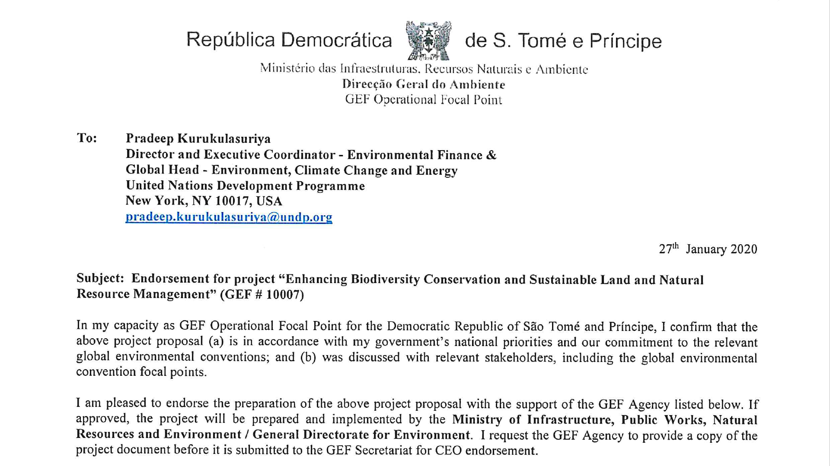
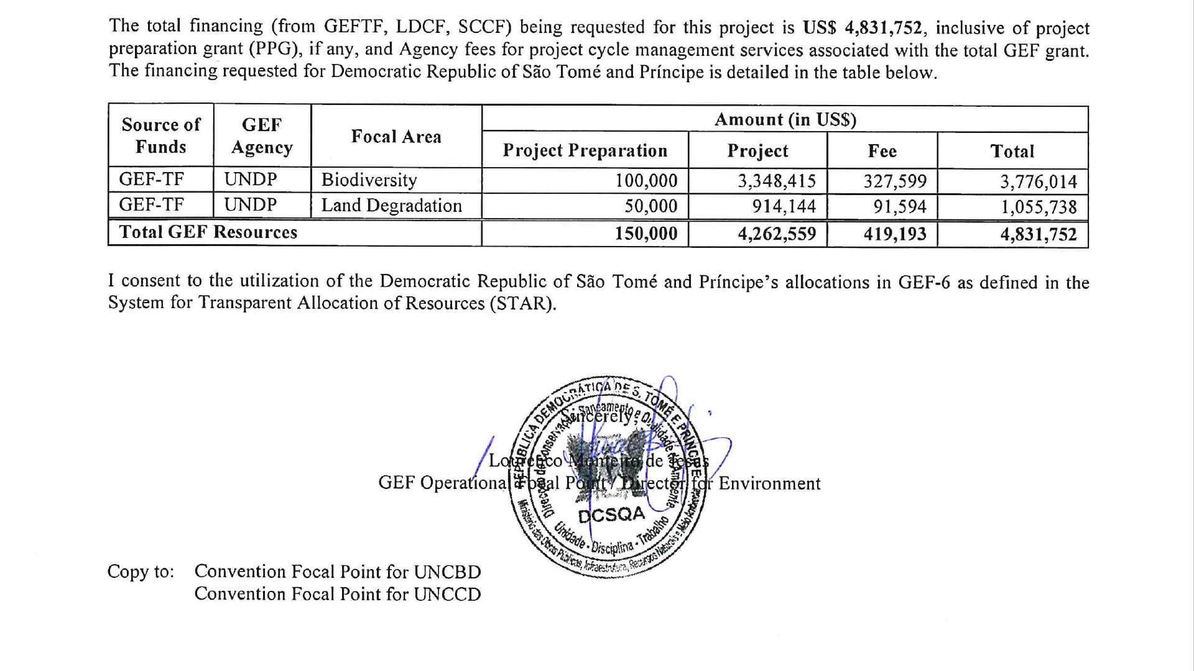

Annex 17a: UNDP Support Services: GEF OFP Request Letter
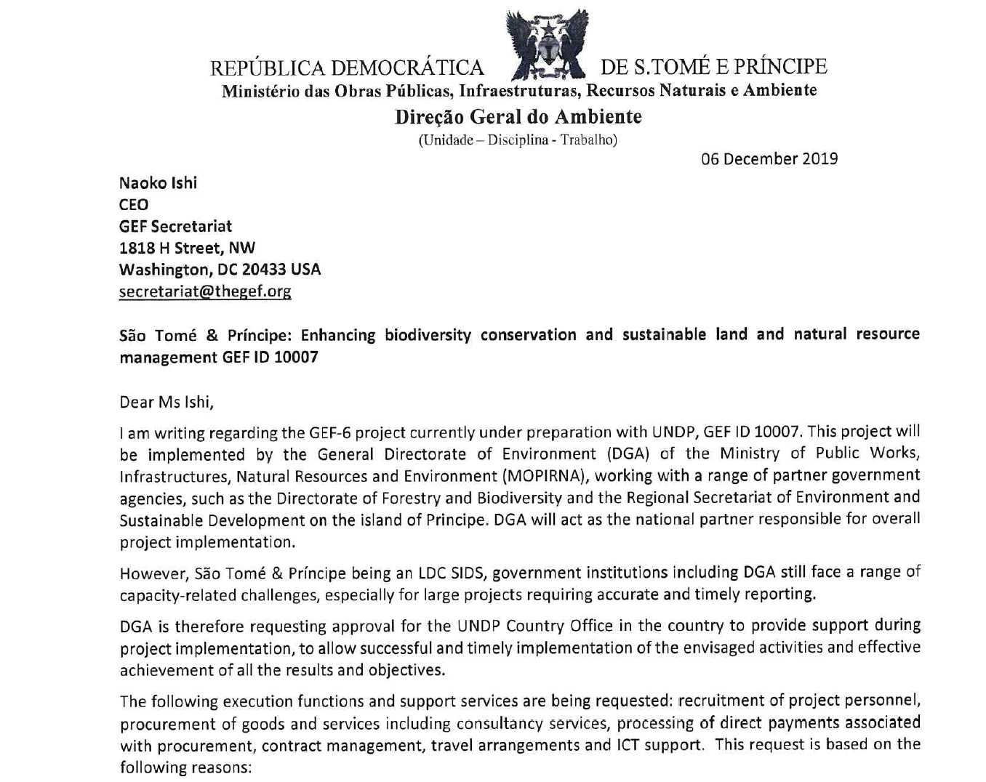
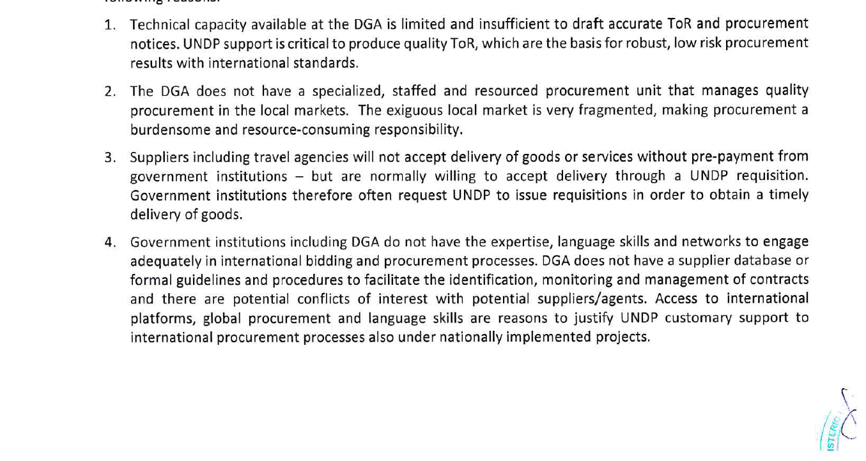

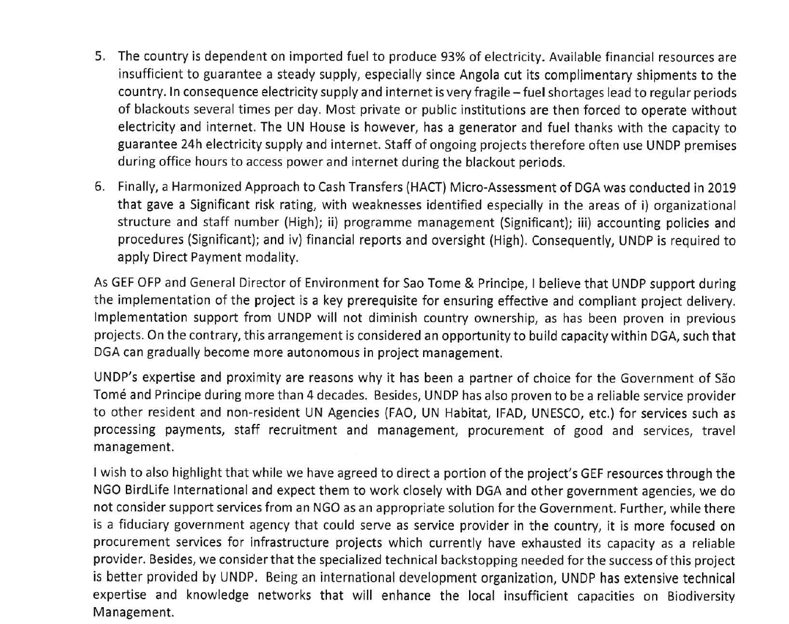
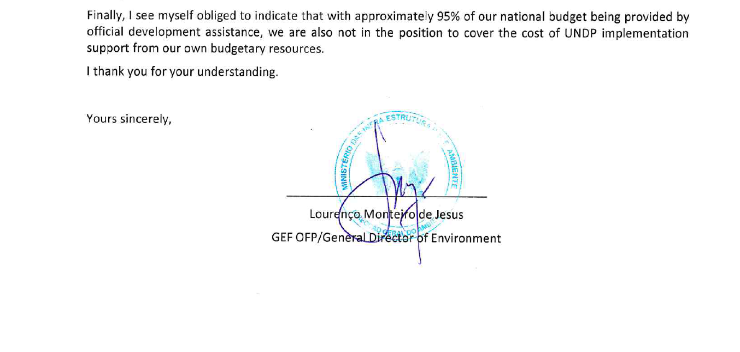

Annex 17b: UNDP Support Services: Letter of Agreement
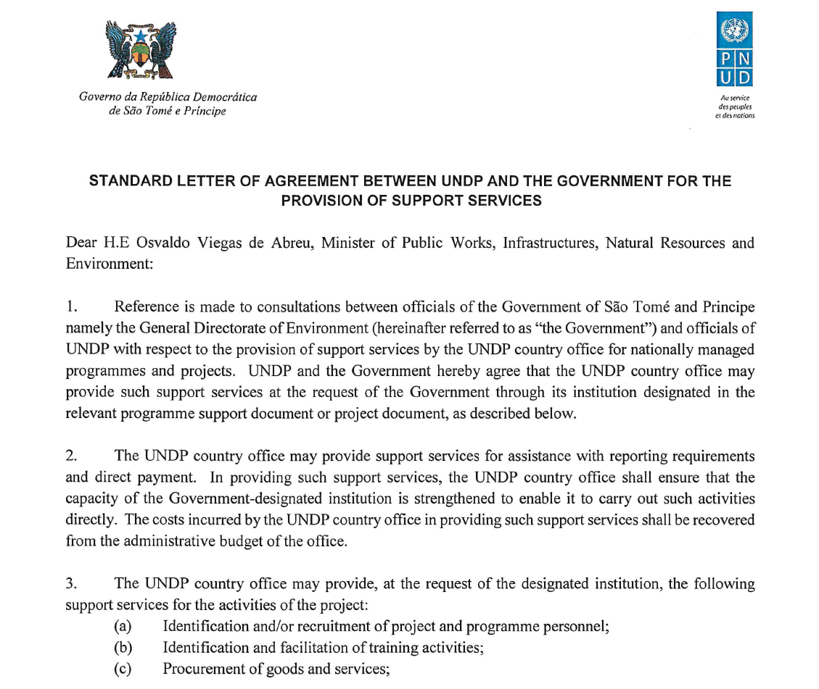
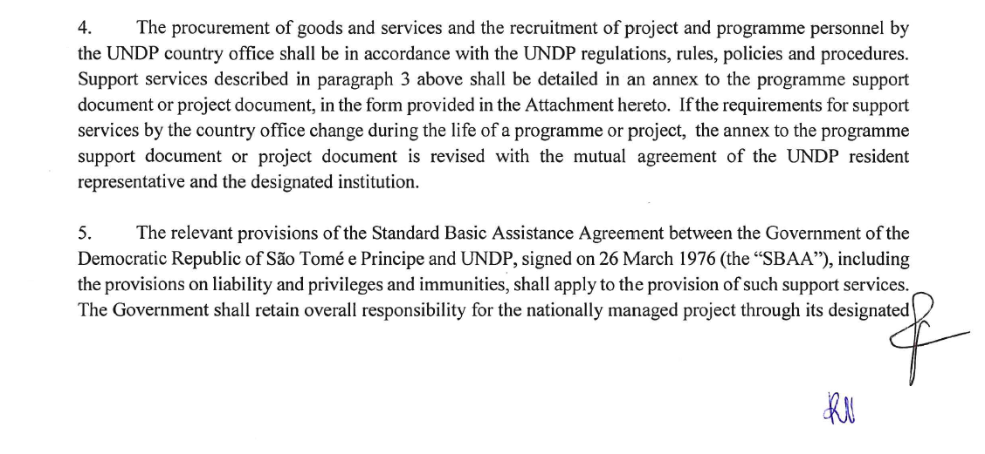

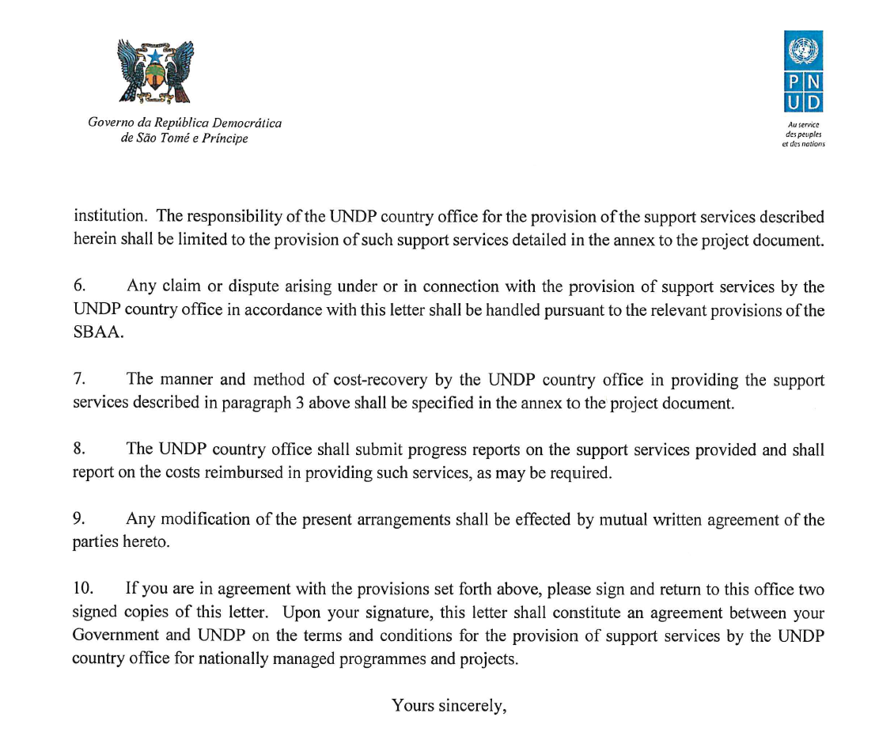


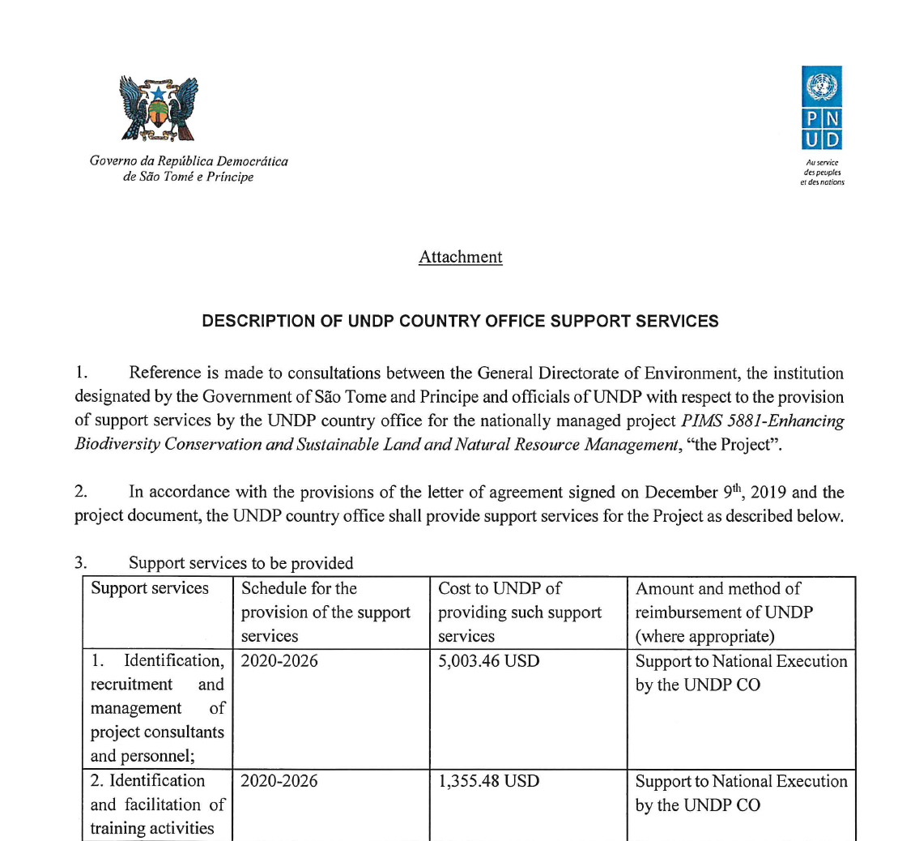
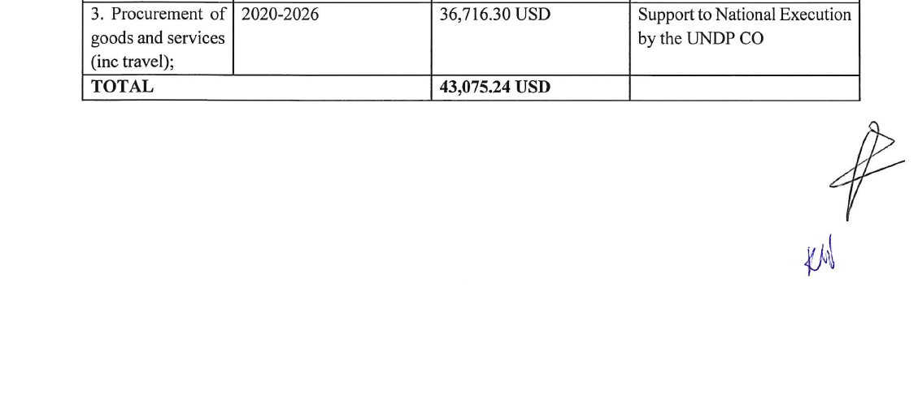
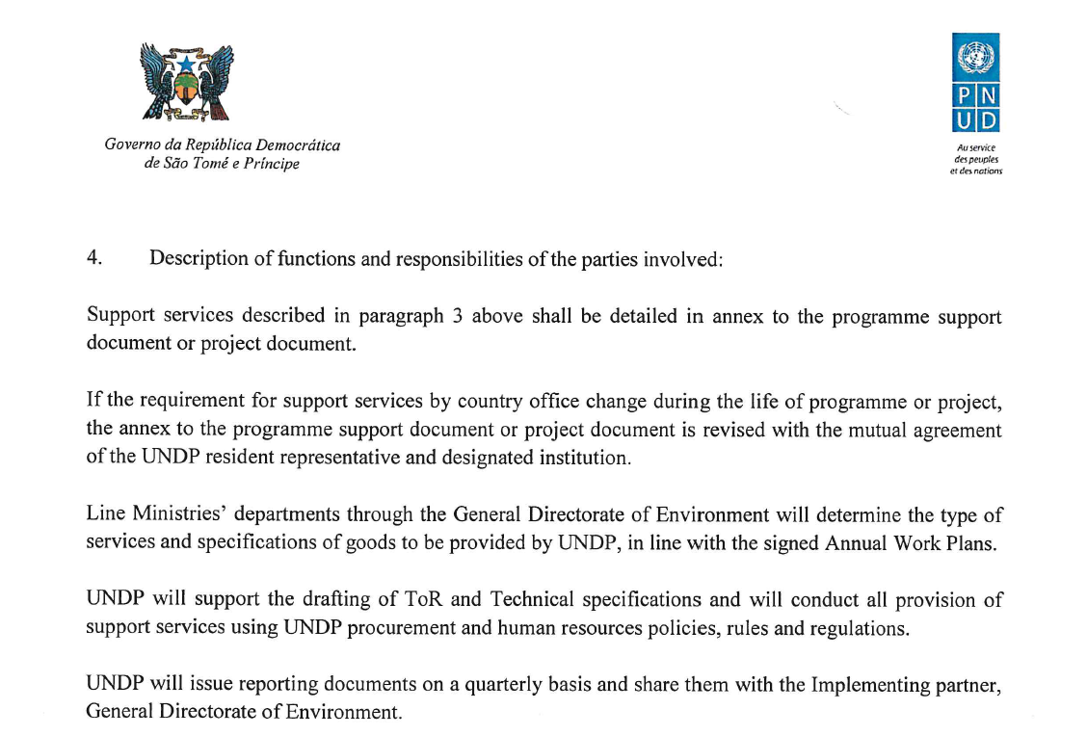
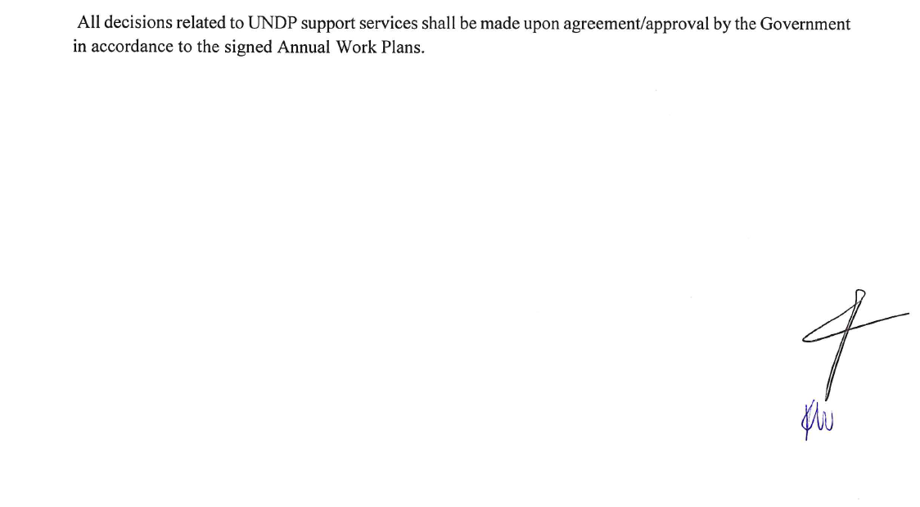

Annex 18: Co-financing letters
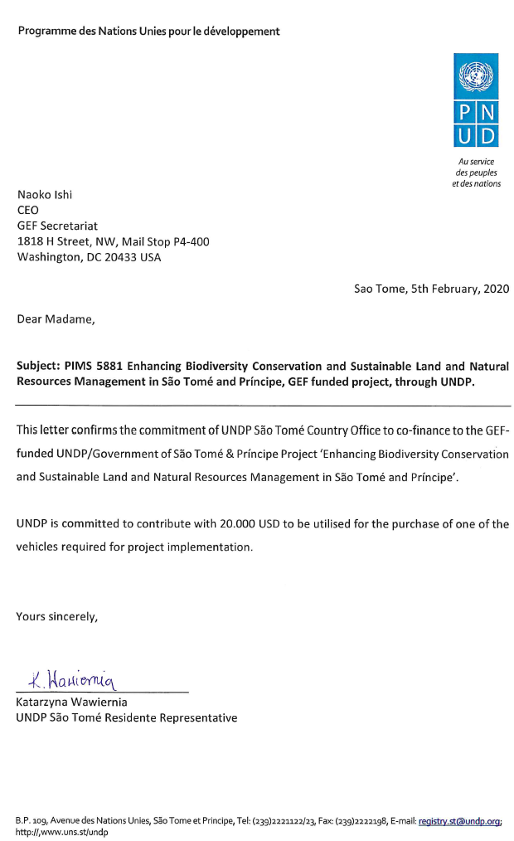

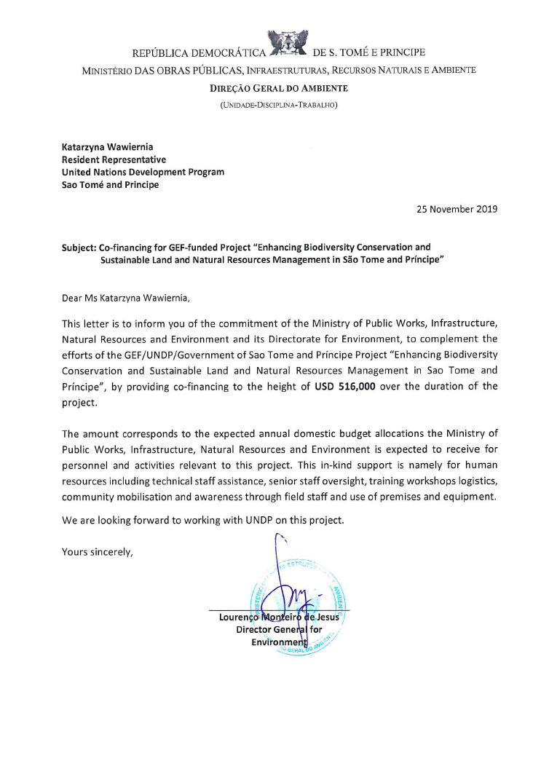

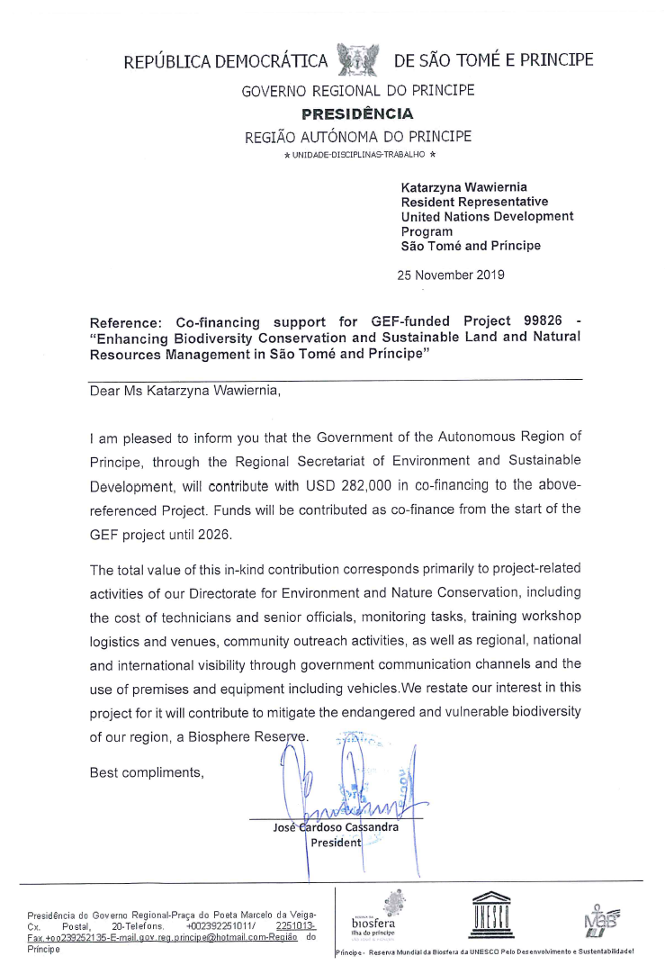

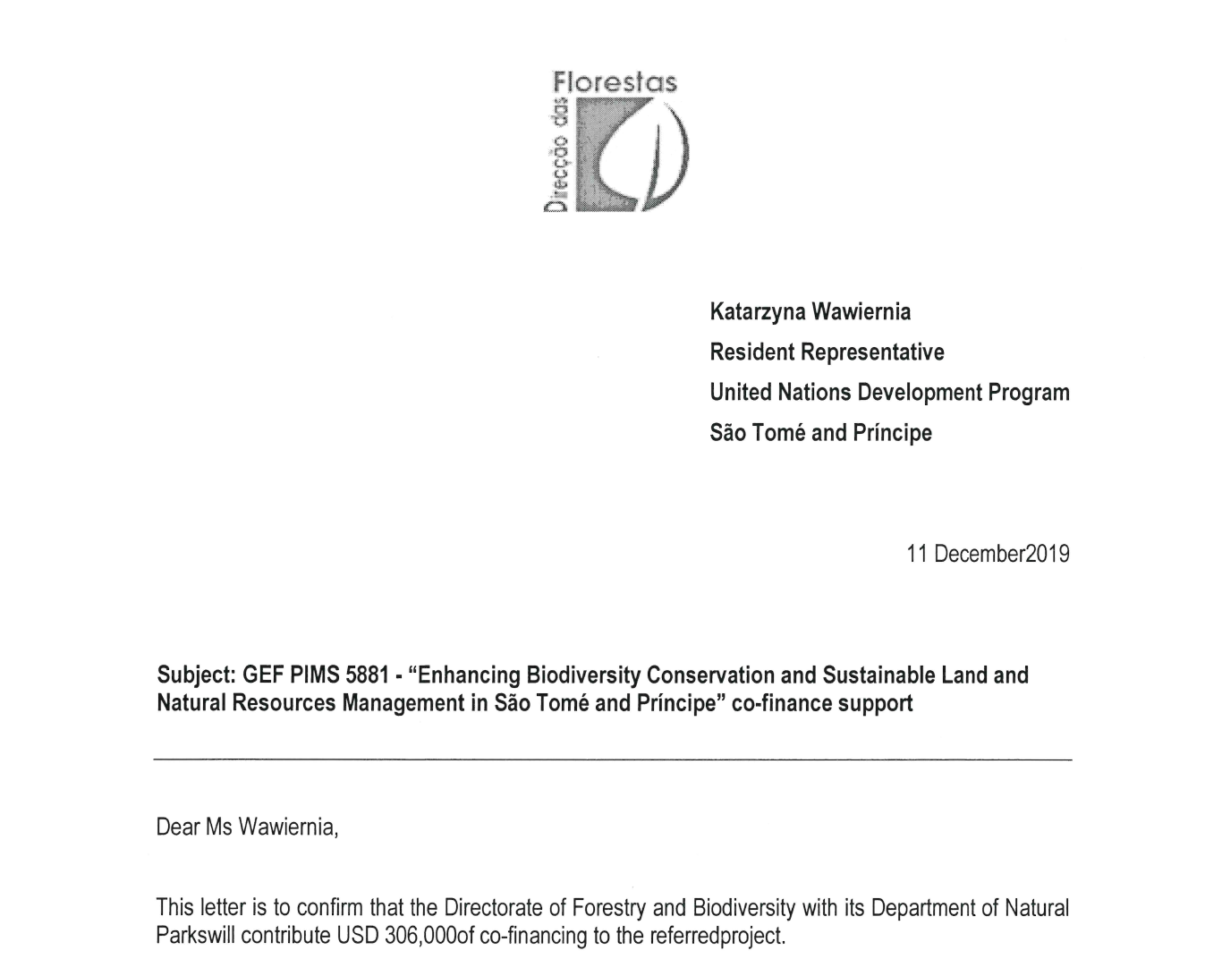
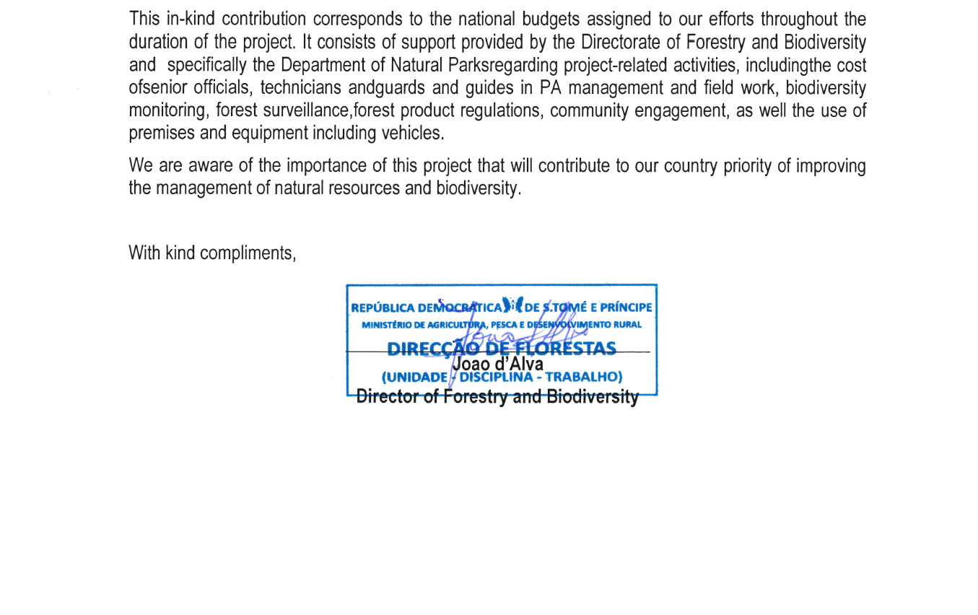

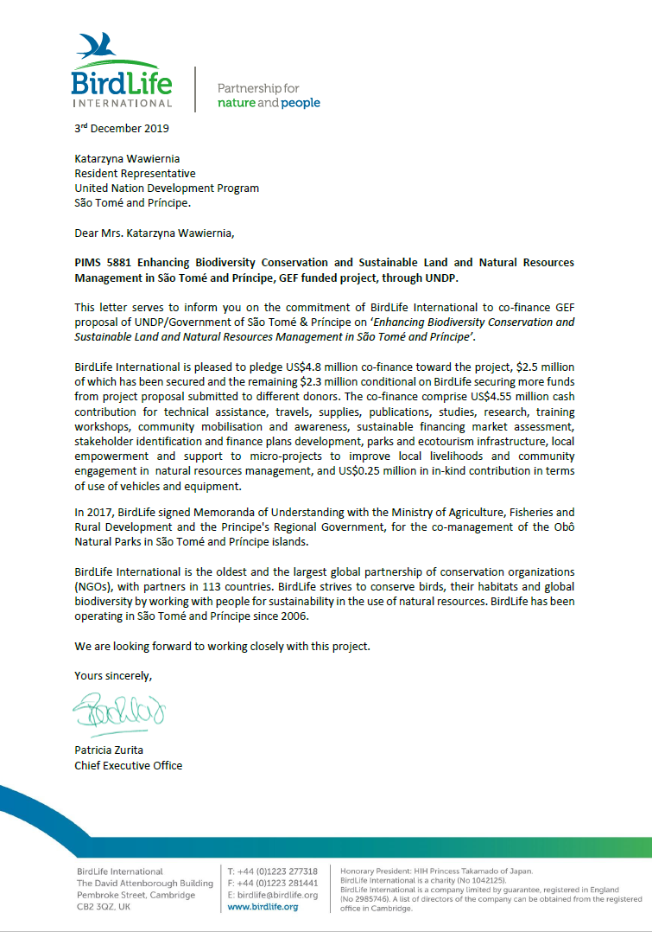

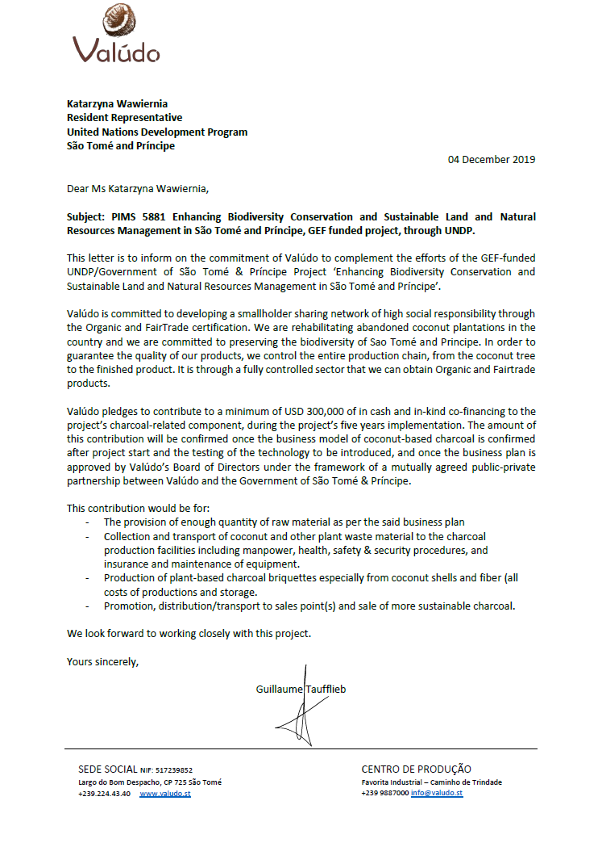

Annex 19: Responsible Party Agreement between UNDP and BirdLife International
RESPONSIBLE PARTY AGREEMENT

Between the United Nations Development Programme and a Civil Society Organization

1. Country: São Tomé e Príncipe
2. Name of Civil Society Organization (CSO): BirdLife International (incorporated in the UK, at: The David Attenborough Building, 1st Floor, Pembroke Street, Cambridge, CB2 3QZ, UK) implementing through its project office in Sao Tomé
3a. Project Number / Title: PIMS5881 - Enhancing Biodiversity Conservation and Sustainable Land and Natural Resource Management
Project Atlas Award ID: 00118062 / Atlas Project/Output ID: 00118062
3b. Subject Matter of the Agreement: [ ] goods [X] services [ ] goods and services
4. Implementation Period: From 01 July 2020 to 31 December 2025
5. Budget: USD 1,280,100
6. Information for CSO Bank Account into Which Funds Will Be Disbursed:
TBD – presumably UK BLI account
7. Notices to CSO:  TBD – presumably BLI Africa Regional Director | 8. Notices to UNDP:  Name: Adérito Santana, ARR Programme  Address: Avda Nações Unidas, São Tomé, São Tomé e Príncipe  Tel: +239 222-1123. Email: aderito.santana@undp.org
IN WITNESS WHEREOF, the undersigned, being duly authorized thereto, have on behalf of the Parties hereto signed this Contract at the place and on the day set forth below.
9. Signed for BirdLife International by its Authorized Representative
Patricia Zurita, Chief Executive Officer

Date: Signature:
10. Signed for the United Nations Development Program by its Authorized Representative
Katarzyna Wawiernia, Resident Representative CO – STP

Date: Signature:
The following documents constitute the entire Agreement (the “Agreement”) between the Parties and supersedes all prior agreements, understandings, communications and representations concerning the subject matter:7

- This FACE Sheet
- Standard Terms and Conditions
- Annex A: On-Granting Provisions applicable to a Responsible Party under Supported NIM (Rev. Nov 2019)
- Annex B: Project Document (including the Work Plan)
- Annex C: CSO Technical and Financial Proposals dated XX Month 2020

If there is inconsistency between any of the documents forming part of this Agreement, the Agreement will be interpreted in the above order of priority.

STANDARD TERMS AND CONDITIONS
WHEREAS the Government of the Host Country indicated in block 1 of the Face Sheet and the United Nations Development Programme, a subsidiary organ of the United Nations established by the General Assembly of the United Nations (hereinafter “UNDP”) concluded a project document (hereinafter the “Project Document”) for the project named in block 3 of the Face Sheet (hereinafter the “Project”);
WHEREAS, pursuant to the Project Document, UNDP serves as an implementing partner under the Project;
WHEREAS in its capacity as an implementing partner, UNDP has selected the civil society organization named in block 2 of the Face Sheet (hereinafter the “CSO”), as a responsible party to implement activities (hereinafter the “Activities”) and achieve deliverables (hereinafter the “Deliverables”) within the time frames and pursuant to the budget set forth in the Work Plan which forms part of the Project Document (hereinafter the “Work Plan”);
WHEREAS UNDP and the CSO (together referred to as the “Parties” or, individually, a “Party”), pursuant to their respective mandates and policies, share a common aim in the furtherance of sustainable development; and
WHEREAS the CSO understands and agrees that the overall goal of this Agreement is to contribute to producing the outputs and achieving the outcomes set forth in the Project Document.
NOW, THEREFORE, on the basis of mutual trust and in the spirit of cooperation, the Parties have entered into this Agreement under the terms and conditions set forth herein.
1.0 Objectives and General Responsibilities of the Parties
1.1 The Parties agree that the main objective of this Agreement is to further the goals of the Project through the successful implementation of the Activities and achievement of the Deliverables.
1.2 Consistent with this objective, the CSO shall commence and implement the Activities and achieve the Deliverables with due diligence and efficiency, pursuant to the schedule set forth in the Work Plan, and in accordance with the terms and conditions of this Agreement. The Activities must be consistent with the regulations, rules, policies and procedures of UNDP.
1.3 All deadlines and time limits contained in this Agreement shall be deemed to be of the essence in respect of the implementation of the Activities and achievement of the Deliverables under this Agreement.
1.4 Any information or data provided by the CSO to UNDP for the purpose of entering into this Agreement, as well as the quality of the Activities, Deliverables and reports foreseen under this Agreement, will conform to the highest professional standards.
1.5 The Parties shall on a regular basis keep each other informed of, and consult on matters pertaining to the implementation of the Activities and achievement of the Deliverables under this Agreement.
2.0 Financial Arrangements
2.1 Pursuant to the budget contained in the Work Plan, UNDP shall make available to the CSO funds up to the maximum amount indicated in block 5 of the Face Sheet upon timely achievement of the Deliverables and in accordance with the schedule set forth in the Work Plan.
2.2 The amounts stated above shall not be subject to any adjustment or revision because of price or currency fluctuations, or the actual costs incurred by the CSO in the implementation of the Activities.
2.3 All payments shall be made by UNDP to the CSO bank account indicated in block 6 of the Face Sheet.
2.4 Payments effected by UNDP to the CSO shall be deemed neither to relieve the CSO of its obligations under this Agreement nor as acceptance by UNDP of the CSO’s performance of the Activities.
2.5 The CSO shall notify UNDP about any expected budget variations. The CSO shall be authorized to make variations not exceeding twenty (20) per cent on any one budget line item in the Work Plan, provided that the maximum amount allocated by UNDP pursuant to paragraph 2.1 above, is not exceeded. Any variations exceeding twenty (20) per cent on any one budget line item that may be necessary for the proper and successful implementation of the Activities under this Agreement shall be subject to prior consultations with, and written approval by, UNDP.
2.6 UNDP shall not be liable for the payment of any expenses, fees, tolls, or any other costs not expressly provided for in the Work Plan, not authorized by UNDP pursuant to the preceding paragraph, or exceeding the maximum amount referred to in paragraph 2.1 above.
2.7 Unless otherwise agreed in writing by UNDP, the CSO shall return all unspent funds and income (including interest) to UNDP within one (1) month of completion of the Activities or termination of this Agreement, whichever is earlier.
3.0 Refund
3.1 The CSO shall disburse the funds made available to it by UNDP and incur expenditures in connection with the Activities on the terms and conditions set forth in this Agreement and the Work Plan. In the event that the CSO disburses the funds or incurs expenditures in violation of this Agreement and/or the Work Plan, notwithstanding the availability or exercise of any other remedies under this Agreement, the CSO shall refund the amounts to UNDP not later than thirty (30) days after the CSO receives a written request for such refund from UNDP. Failing that, UNDP may deduct the amount of the requested refund from any payments due to the CSO under this Agreement.
4.0 The CSO Personnel
4.1 The CSO shall be fully responsible and liable for all persons engaged by it in connection with the Activities, including employees, consultants, agents, accountants, advisers, and contractors (hereinafter the “CSO Personnel”). The CSO shall ensure that the CSO Personnel meet the highest standards of professional qualifications and competence necessary for the implementation of the Activities and achievement of the Deliverables under this Agreement, are free from any conflicts of interest related to the Activities, respect the local laws and customs, and conform to the highest standards of moral and ethical conduct.
4.2 The CSO Personnel shall not be considered in any respect as being the officials, personnel, employees, staff or agents of UNDP or the United Nations.
4.3 The CSO agrees and shall ensure that the CSO Personnel performing the Activities under this Agreement:
- Shall not seek nor accept instructions regarding the Project from any Government or other authority external to the CSO or UNDP;
- Shall refrain from any conduct that would adversely reflect on UNDP or the United Nations, and shall not engage in any activity that is incompatible with the aims, objectives or mandate of UNDP or the United Nations; and
- Shall not use information that is considered confidential without the prior written authorization of UNDP, as required by Article 12.0 below.
4.4 The CSO’s decisions related to the CSO Personnel, including employment or dismissal, shall be free of discrimination on the basis of race, religion or creed, ethnicity or national origin, gender, sexual orientation, handicapped status, or other similar factors.
5.0 Assignment
5.1 The CSO shall not assign, transfer, pledge or make other disposition of this Agreement or any part thereof, or any of the CSO’s rights, claims or obligations under this Agreement except with the prior written consent of UNDP.
6.0 Contracting
6.1 In the event the CSO requires the services of contractors, the CSO shall remain responsible for their acts and omissions in relation to the Activities as if they were the acts and omissions of the CSO. The terms of any contract with any such contractor shall be subject to and conform to the provisions of this Agreement.
7.0 Procurement
7.1 Procurement of goods, services and technical assistance required under the Work Plan will be conducted by the CSO in accordance with the principles of highest quality, transparency, economy and efficiency. Such procurement will be based on the assessment of competitive quotations, bids, or other proposals, unless otherwise agreed in writing by UNDP.
8.0 Equipment
8.1 Any non-consumable supplies, equipment, vehicles and materials financed by UNDP or furnished by UNDP to the CSO under this Agreement (hereinafter the “Equipment”) shall remain the property of UNDP.
8.2 The CSO shall be responsible for the proper custody, maintenance and care of the Equipment. It shall also maintain complete and accurate records of the Equipment, and shall regularly verify the inventory thereof. In addition, it shall purchase and maintain appropriate insurance for the Equipment in the amounts agreed upon between the Parties and incorporated in the budget contained in the Work Plan.
8.3 UNDP shall provide reasonable assistance to the CSO in connection with clearing the Equipment through customs at ports of entry into the country where the Activities are to be implemented.
8.4 In the event of damage, theft, loss or other forfeiture of the Equipment, the CSO shall provide UNDP with a complete written report supported, where appropriate, by a police report and any other evidence, giving full particulars of the events leading to the loss of, or damage to the Equipment.
8.5 The CSO shall return the Equipment to UNDP within thirty (30) days upon completion of the Activities or termination of this Agreement, whichever is earlier, or when no longer needed by the CSO. When returned to UNDP, the Equipment shall be in the same condition as when furnished to the CSO, subject to normal wear and tear.
8.6 UNDP may request compensation for the damaged, stolen, lost or otherwise forfeited Equipment, or the Equipment determined by UNDP to be degraded beyond normal wear and tear. If the CSO fails to compensate UNDP within thirty (30) days of UNDP’s request, UNDP may deduct the amount thereof from any payments due to the CSO under this Agreement.
9.0 Copyrights, Patents, and Other Proprietary Rights
9.1 Except as may be otherwise agreed by the Parties in this Agreement, UNDP shall be entitled to all intellectual property and other proprietary rights including, but not limited to, patents, copyrights, and trademarks, with regard to products, processes, inventions, ideas, know-how, or documents and other materials which the CSO has developed for UNDP under this Agreement and which bear a direct relation to, or are produced, prepared or collected in consequence of, or during the course of, the performance of this Agreement. The CSO acknowledges and agrees that such products, documents and other materials constitute works made for hire for UNDP.
9.2 The CSO shall be responsible for obtaining any licenses and permits required by national laws in connection with the Activities. UNDP shall cooperate as appropriate and necessary.
10.0 Reporting
10.1 The CSO shall report to UNDP on the implementation of the Activities and achievement of the Deliverables under this Agreement.
10.2 The CSO shall provide UNDP with (a) quarterly reports, due within thirty (30) days after the end of each quarter; (b) if the duration of this Agreement exceeds one (1) year, annual reports, due within sixty (60) days after the end of each year; and (c) a final report, due within sixty (60) days after the completion of the Activities or expiration or prior termination of this Agreement.
10.3 Each report must be written in the English language and must, inter alia, contain information on:
- Activities carried out under the Agreement during the reported period;
- Progress towards achieving the Deliverables during the reported period;
- Corresponding indicators, baselines, sources of data, and data collection methods;
- Any new issues, risks, challenges and opportunities that should be considered in implementing the Activities;
- Financial data, including cash receipts and disbursements incurred by the CSO, reconciliation of outstanding advances and foreign exchange loss or gain during the reported period, if applicable; and
- Cumulative financial data, showing satisfactory management and use of UNDP resources.
10.4 In addition, the annual report and final reports, referred to in paragraph 10.2 above, must contain audited financial statements and records related to the Activities.
10.5 The CSO shall provide such additional reports related to the Activities as may be reasonably required by UNDP under its regulations, rules, policies and procedures.
11.0 Maintenance of Records
11.1 The CSO shall keep accurate and up-to-date records and documents, including original invoices, bills, and receipts pertinent to each transaction related to the Activities under this Agreement.
11.2 The CSO shall promptly disclose to UNDP any income, including interest, arising from the Activities. Such income shall be reflected in a revised Work Plan and recorded as accrued income to UNDP, unless otherwise agreed by the Parties.
11.3 Upon completion of the Activities, or the termination of this Agreement, the CSO shall maintain the records for a period of at least five (5) years, unless otherwise agreed by the Parties.
12.0 Confidentiality
12.1 Information and data that is considered proprietary by either Party and that is delivered or disclosed by one Party to the other Party during the term of this Agreement shall be considered confidential and shall be handled pursuant to the UNDP Information Disclosure Policy, not attached hereto but known to and in the possession of the Parties.
12.2 The CSO may disclose information to the extent required by law, provided that and without any waiver of the privileges and immunities of the United Nations, the CSO will give UNDP sufficient prior notice of a request for the disclosure of information in order to allow UNDP to have a reasonable opportunity to take protective measures or such other action as may be appropriate before any such disclosure is made.
12.3 UNDP may disclose information to the extent required pursuant to the Charter of the United Nations, resolutions or regulations of the General Assembly, or rules promulgated by the Secretary-General of the United Nations.
12.4 These obligations shall not lapse upon completion of the Activities or termination of this Agreement, whichever is earlier.
13.0 Insurance and Liabilities to Third Parties
13.1 The CSO shall provide and thereafter maintain insurance against all risks in respect of its property and any equipment used in connection with the Activities under this Agreement.
13.2 The CSO shall provide and thereafter maintain all appropriate workmen's compensation insurance, or the equivalent, with respect to the CSO Personnel to cover claims for personal injury or death in connection with this Agreement.
13.3 The CSO shall also provide and thereafter maintain liability insurance in an adequate amount to cover third party claims for death or bodily injury, or loss of or damage to property, arising from or in connection with the Activities, as well as the use of the Equipment owned or leased by the CSO or the CSO Personnel, or furnished or financed by UNDP pursuant to Article 8.0 above.
14.0 Indemnity
14.1 The CSO shall indemnify, hold and save harmless, and defend, at its own expense, UNDP, its officials and persons performing services for UNDP from and against all suits, claims, demands, and liability of any nature or kind, including their costs and expenses, on account of, based or resulting from, arising out of (or which may be claimed to arise out of) or relating to acts or omissions of the CSO, including the CSO Personnel, under this Agreement. This provision shall extend, inter alia, to claims and liability in the nature of workmen’s compensation, damage to property or other hazards that may be suffered by the CSO Personnel as a result of their services pertaining to the Activities, products liability and liability arising out of the use of patented inventions or devices, copyrighted material or other intellectual property by the CSO or the CSO Personnel.
15.0 Tax Exemptions
15.1 Section 7 of the Convention on the Privileges and Immunities of the United Nations provides, inter alia, that the United Nations, including its subsidiary organs, is exempt from all direct taxes, except charges for public utility services, and is exempt from customs duties and charges of a similar nature in respect of articles imported or exported for its official use. In the event any governmental authority refuses to recognize the United Nations’ exemption from such taxes, duties or charges, the CSO shall immediately consult with UNDP to determine a mutually acceptable solution.
15.2 Accordingly, the CSO authorizes UNDP to deduct from the CSO’s invoice any amount representing such taxes, duties or charges, unless the CSO has consulted with UNDP before the payment thereof and UNDP has, in each instance, specifically provided written authorization to the CSO to pay such taxes, duties or charges under protest. In that event, the CSO shall provide UNDP with written evidence that payment of such taxes, duties or charges has been made and appropriately authorized.
16.0 Security and Anti-Terrorism
16.1 The responsibility for the safety and security of the CSO and the CSO Personnel and property, as well as of the Equipment and other UNDP property in the CSO’s custody, shall rest with the CSO.
16.2 UNDP reserves the right to verify whether the necessary security arrangements are in place, and to suggest modifications thereto when necessary. 16.3 The CSO agrees to undertake all reasonable efforts to ensure that none of the UNDP funds received under this Agreement are used to provide support to individuals or entities associated with terrorism and that the recipients of any amounts provided by UNDP hereunder do not appear on the list maintained by the Security Council Committee established pursuant to resolution 1267 (1999). The list can be accessed via http://www.un.org/sc/committees/1267/1267.htm. This provision must be included in all contracts entered into under this Agreement.
17.0 Audit and Investigations
17.1 All payments made by UNDP under this Agreement shall be subject to a post-payment audit by auditors, whether internal or external, of UNDP or by other authorized and qualified agents of UNDP at any time during the term of this Agreement and for a period of five (5) years following the completion of the Activities or the termination of this Agreement.
17.2 The CSO acknowledges and agrees that, from time to time, UNDP may conduct investigations relating to any aspect of this Agreement or the selection of the CSO as a responsible party, the obligations performed under this Agreement, and the operations of the CSO generally relating to the performance of this Agreement. The right of UNDP to conduct an investigation and the CSO’s obligation to comply with such an investigation shall not lapse upon completion of the Activities or the termination of this Agreement, whichever is earlier.
17.3 The CSO shall provide its full and timely cooperation with any post-payment audits or investigations. Such cooperation shall include, but shall not be limited to, the CSO’s obligation to make available the CSO Personnel and any relevant documentation for such purposes at reasonable times and on reasonable conditions, and to grant to UNDP access to the CSO’s premises at reasonable times and on reasonable conditions. The CSO shall cause the CSO Personnel to reasonably cooperate with any post-payment audits or investigations carried out by UNDP hereunder.
17.4 UNDP shall be entitled to a refund from the CSO for any amounts shown by audits and investigations to have been paid by UNDP other than in accordance with the terms and conditions of this Agreement.
18.0 Force Majeure
18.1 In the event of, and as soon as possible after, the occurrence of any cause constituting force majeure, the Party affected by it shall give the other Party notice and full particulars in writing of such occurrence. If the affected Party is thereby rendered unable, in whole or in part, to perform its obligations or meet its responsibilities under this Agreement, the Parties shall consult on the appropriate action to be taken, which may include termination of this Agreement by UNDP pursuant to Article 28.0, or termination of this Agreement by the CSO with at least seven (7) days written notice of such termination.
18.2 In the event that this Agreement is terminated owing to causes constituting force majeure, the provisions of Article 28.0 below, shall apply.
18.3 Force majeure as used herein means any unforeseeable and irresistible act of nature, any act of war (whether declared or not), invasion, revolution, insurrection, terrorism, or any other acts of a similar nature or force, provided that such acts arise from causes beyond the control and without the fault or negligence of the Party invoking force majeure. The CSO acknowledges and agrees that, with respect to any obligations under this Agreement that the CSO must perform in areas in which the United Nations is engaged in, preparing to engage in, or disengaging from any peacekeeping, humanitarian or similar operations, any delays or failure to perform such obligations arising from or relating to harsh conditions within such areas, or to any incidents of civil unrest occurring in such areas, shall not, in and of itself, constitute force majeure under this Agreement.
19.0 Use of the Name, Emblem and Official Seal of UNDP
19.1 The CSO shall only use the name (including abbreviations), emblem or official seal of the United Nations or UNDP in direct connection with the Activities under this Agreement and upon receiving prior written consent of UNDP. Under no circumstances shall such consent be provided in connection with the use of the name (including abbreviations), emblem or official seal of the United Nations or UNDP for commercial purposes or goodwill.
19.2 The Parties shall cooperate in any public relations or publicity exercises when UNDP deems these appropriate or useful.
20.0 Privileges and Immunities
20.1 Nothing in or relating to this Agreement shall be deemed a waiver, express or implied, of any of the privileges and immunities of the United Nations and UNDP.
21.0 Officials Not to Benefit
21.1 The CSO represents and warrants that it has not and shall not offer any direct or indirect benefit arising from or related to the performance of the Agreement or the award thereof, to any representative, official, employee, or other agent of UNDP.
22.0 Observance of the Law
22.1 The CSO shall comply with all laws, ordinances, rules, and regulations applicable to the performance of its obligations under this Agreement.
23.0 Child Labor
23.1 The CSO represents and warrants that neither it, its parent entities (if any), any of the CSO’s subsidiary or affiliated entities (if any) nor the CSO Personnel are engaged in any practice inconsistent with the rights set forth in the Convention on the Rights of the Child, including Article 32 thereof, which, inter alia, requires that a child shall be protected from performing any work that is likely to be hazardous or to interfere with the child's education, or to be harmful to the child’s health or physical mental, spiritual, moral or social development.
24.0 Mines
24.1 The CSO represents and warrants that neither it, its parent entities (if any), any of the CSO’s subsidiaries or affiliated entities (if any) nor any CSO Personnel is engaged in the sale or manufacture of anti-personnel mines or components utilized in the manufacture of anti-personnel mines.
25.0 Sexual Exploitation
25.1 In the performance of this Agreement, the CSO shall comply with the Standards of Conduct set forth in the Secretary-General’s bulletin ST/SGB/2003/13 of 9 October 2003, concerning “Special measures for protection from sexual exploitation and sexual abuse.” In particular, the CSO shall not engage in any conduct that would constitute sexual exploitation or sexual abuse, as defined in that bulletin.
25.2 The CSO shall take all appropriate measures to prevent sexual exploitation or abuse of anyone by the CSO Personnel. For these purposes, sexual activity with any person less than eighteen years of age, regardless of any laws relating to consent, shall constitute the sexual exploitation and abuse of such person. In addition, the CSO shall refrain from, and shall take all reasonable and appropriate measures to prohibit the CSO Personnel or any other persons engaged and controlled by it from exchanging any money, goods, services, or other things of value, for sexual favors or activities, or from engaging in any sexual activities that are exploitive or degrading to any person. The CSO acknowledges and agrees that the provisions of this Article 25.0 constitute an essential term of the Agreement and that any breach of these provisions shall entitle UNDP to terminate the Agreement immediately upon notice to the CSO, without any liability for termination charges or any other liability of any kind.
25.3 UNDP shall not apply the foregoing standard relating to age in any case in which the CSO Personnel is married to the person less than the age of eighteen years with whom sexual activity has occurred and in which such marriage is recognized as valid under the laws of the country of citizenship of such CSO Personnel.
26.0 Conflicts of Interest; Anti-Corruption
26.1 The Parties agree that it is important that all necessary precautions are taken to avoid conflicts of interest and corrupt practices. To this end, the CSO shall maintain standards of conflict that govern the performance of the CSO Personnel, including the prohibition of conflicts of interest and corrupt practices in connection with the award and administration of contracts, grants, or other benefits.
26.2 The CSO and persons affiliated with it, including the CSO Personnel, shall not engage in the following practices:
- participating in the selection, award, or administration of a contract, grant or other benefit or transaction funded by UNDP, in which the person, members of the person’s immediate family or his or her business partners, or organizations controlled by or substantially involving such person, has or have a financial interest;
- participating in such transactions involving organizations or entities with which or whom that person is negotiating or has any arrangement concerning prospective employment;
- offering, giving, soliciting or receiving gratuities, favors, gifts or anything else of value to influence the action of any person involvement in a procurement process or contract execution;
- misrepresenting or omitting facts in order to influence the procurement process or the execution of a contract;
- engaging in a scheme or arrangement between two or more bidders, with or without the knowledge of the CSP, designed to establish bid prices at artificial, non-competitive levels; or
- participating in any other practice that is or could be construed as an illegal or corrupt practice under domestic law.
26.3 If the CSO has knowledge or becomes aware of any of the practices outlined in paragraph 2 of this Article 26 undertaken by anyone affiliated with the CSO, the CSO shall immediately disclose the existence of such practices to UNDP.
26.4 The CSO acknowledges and agrees that each of the provisions in Articles 21 to 26 hereof constitutes an essential term of the Agreement and that any breach of any of these provisions shall entitle UNDP to terminate the Agreement or any other contract with UNDP immediately upon notice to the CSO, without any liability for termination charges or any other liability of any kind. In addition, nothing herein shall limit the right of UNDP to refer any alleged breach of the said essential terms to the relevant national authorities for appropriate legal action.
27.0 Dispute Settlement
27.1 The Parties shall use their best efforts to settle amicably any dispute, controversy or claim arising out of this Agreement, or the breach, termination or invalidity thereof. Where the Parties wish to seek such an amicable settlement through conciliation, the conciliation shall take place in accordance with the Conciliation Rules then obtaining of the United Nations Commission on International Trade Law (“UNCITRAL”), or according to such other procedure as may be agreed between the Parties in writing.
27.2 If such dispute, controversy or claim between the Parties is not settled amicably under the preceding paragraph within sixty (60) days after receipt by one Party of the other Party's request for such amicable settlement, it shall be referred by either Party to arbitration in accordance with the UNCITRAL Arbitration Rules then obtaining. The decisions of the arbitral tribunal shall be based on general principles of international commercial law. The arbitral tribunal shall be empowered to order the return or destruction of goods or any property, whether tangible or intangible, or of any confidential information provided under the Contract, order the termination of the Contract, or order that any other protective measures be taken with respect to the goods, services or any other property, whether tangible or intangible, or of any confidential information provided under the Contract, as appropriate, all in accordance with the authority of the arbitral tribunal pursuant to Article 26 (“Interim measures”) and Article 34 (“Form and effect of the award”) of the UNCITRAL Arbitration Rules. The arbitral tribunal shall have no authority to award punitive damages. In addition, unless otherwise expressly provided in the Contract, the arbitral tribunal shall have no authority to award interest in excess of the London Inter-Bank Offered Rate (“LIBOR”) then prevailing, and any such interest shall be simple interest only. The Parties shall be bound by any arbitration award rendered as a result of such arbitration as the final adjudication of any such dispute, controversy, or claim.
28.0 Termination of this Agreement
28.1 The Parties recognize that successful implementation and completion of the Activities and achievement of the Deliverables are of paramount importance, and that UNDP may find it necessary to terminate or to modify the Activities, should circumstances arise that jeopardize successful completion of the Project. The provisions of the present Article shall apply to any such situation.
28.2 UNDP shall consult with the CSO if any circumstances arise that, in the judgment of UNDP, interfere or threaten to interfere with the successful implementation or completion of the Activities, or achievement of the Deliverables. For its part, the CSO shall promptly inform UNDP of any such circumstances that might come to its attention. The Parties shall cooperate towards the rectification or elimination of the circumstances in question and shall exert all reasonable efforts to that end, including prompt corrective steps by the CSO, where such circumstances are attributable to it or within its responsibility or control. The Parties shall also cooperate in assessing the consequences of possible termination of this Agreement on the beneficiaries of the Project.
28.3 UNDP may, at any time after occurrence of the circumstances in question, and after appropriate consultations with the CSO, suspend or terminate this Agreement by written notice to the CSO, without prejudice to the initiation or continuation of any of the measures envisaged in the preceding paragraph.
28.4 Upon receipt of a notice of termination by UNDP under the present Article, the CSO shall take immediate steps to terminate the Activities under this Agreement, in a prompt and orderly manner, so as to minimize losses and further expenditures. The CSO shall undertake no forward commitments and shall return to UNDP, within thirty (30) days, all unspent funds made available to it by UNDP under Article 2.0, and the Equipment financed by UNDP or furnished to it by UNDP pursuant to Article 8.0.
28.5 In the event of termination by UNDP under this Article 28.0, UNDP shall only reimburse the CSO the costs incurred in connection with the Activities carried out in accordance with the terms and conditions of this Agreement. Such reimbursement, when added to the amounts previously made available to the CSO by UNDP in accordance with Article 2.0 above, shall not exceed the maximum amount of funds referred to in paragraph 2.1 of that Article.28.6. Following the termination, in the event UNDP decides to transfer the responsibilities of the CSO for the Activities to another entity, the CSO shall cooperate with UNDP and the other entity to ensure the orderly transfer of such responsibilities.
28.7 Notwithstanding anything in this Agreement to the contrary, UNDP may terminate this Agreement at any time without having to provide any justification therefor upon sixty (60) days’ advance written notice to the CSO.
29.0 Notices
29.1 Any notice, request, document, report, or other communication submitted by either the CSO or UNDP shall be in writing and sent to the other party at the address information set forth in block 7 or block 8 of the Face Sheet, as appropriate.
30.0 Survival
30.1 The provisions of Article 3.0 (Refund), Article 4.0 (The CSO Personnel), Article 7.0 (Procurement), Article 8.0 (Equipment), Article 9.0 (Copyrights, Patents, and Other Proprietary Rights), Article 10.0 (Reporting), Article 11.0 (Maintenance of Records), Article 12.0 (Confidentiality), Article 14.0 (Indemnity), Article 17.0 (Audit and Investigations), Article 20.0 (Privileges and Immunities), and Article 27.0 (Dispute Settlement) shall survive and remain in full force and effect regardless of the expiry of the Project term or the termination of this Agreement.
31.0 Other CSO Representations and Warranties
31.1 The CSO represents and warrants that: (a) it is a legal entity validly existing under the laws of the jurisdiction in which it was formed and it has all the necessary powers, authority and legal capacity to: (i) own its assets, (ii) conduct Project activities, and (iii) enter into this Agreement; and (b) this Agreement has been duly executed and delivered by the CSO and is enforceable against it in accordance with its terms.
32. Entry into Force, Duration, Extension and Modification of this Agreement
32.1 This Agreement shall enter into force on the date of its signature by both the CSO and UNDP, acting through their duly Authorized Representatives identified in blocks 9 and 10 of the Face Sheet, and terminate on the Implementation Period end date indicated in block 4 of the Face Sheet.
32.2 Should it become evident to the CSO during the implementation of the Activities that an extension beyond the Implementation Period end date set forth in block 4 of the Face Sheet will be necessary to achieve the Deliverables, the CSO shall, without delay, inform UNDP and give full particulars. UNDP shall take such action as, in its sole discretion, it considers appropriate or necessary under the circumstances, including the granting to the CSO of a reasonable extension of time in which to perform its obligations under this Agreement.
32.3 This Agreement, including its Annexes, may be modified or amended only by written agreement between the Parties.
32.4 Failure by either Party to exercise any rights available to it, whether under this Agreement or otherwise, shall not be deemed for any purposes to constitute a waiver by the other Party of any such right or any remedy associated therewith, and shall not relieve the Parties of any of their obligations under the Agreement.

Annex A: On-Granting Provisions applicable to a Responsible Party under Supported NIM (Rev. Nov 2019)

Whereas BirdLife International has been selected by UNDP to undertake grant-making activities under the Agreement in accordance with the Project Document, BirdLife International (hereinafter referred to as the “Responsible Party” or “RP”) agrees to be bound by the following additional provisions:
1. Grant Award Process
1.1 The RP shall be fully accountable for the completion of all grant making activities in accordance with its financial regulations, rules and policies, to the extent that they are consistent with UNDP’s grant policies and Financial Regulations and Rules. If they are not consistent, UNDP's grant policies and Financial Regulations and Rules must be followed.
1.2 The RP shall conduct an assessment of the grant recipient proposal(s) against set selection criteria established in the Project Document or in the call for proposals, and shall submit eligible grant proposal(s) to the Project Board or designated grant selection committee for consideration and final selection and/or recommendation as agreed for each specific case.
1.3 The RP shall ensure that:
- the grant award process is organized in a fully transparent manner that guarantees impartiality and equal treatment to all applicants;
- all stages of the grant award process are formally documented through standardized checklists and forms;
- grants are awarded in accordance with formal rules of procedure, including adequate due diligence policies and processes;
- the evaluation process is based solely on the established criteria for eligibility, selection and exclusion as indicated in the call for proposals;
- the grant recipient is duly organized and an in good standing in its state/country of organization, and the activities to be carried out with the grant award are eligible;
- all applicants are notified in writing of the grant award outcome;
- the grant award decision is made public within a reasonable timeframe following its issuance;
- grant funds are channelled transparently and effectively to grant recipients;
- no grant is awarded retroactively for activities already started or completed at the time of the application; and
- procedures are in place (and set forth in any agreements the RP enters into with the grant recipients pursuant to this Agreement) to:
  - recover grant funds unduly paid, and/or to prevent and address irregularities and fraud by the grant recipient; and
  - suspend, reduce or terminate the grant if the grant recipient fails to comply with its obligations.
2. Managing and Monitoring Performance of Grant Recipient(s)
2.1 The RP shall supervise and monitor the grant recipient’s activities and its achievement of specified results pursuant to the grant proposal selected by the Project Board or designated grant selection committee, including the schedules set forth therein.
2.2 The RP shall measure the grant recipient’s performance based on results achieved against agreed performance targets in the grant agreement, with the agreed grant proposal attached. Performance shall be monitored and assessed through the progress narrative and financial reports specified in Section 3 below.
2.3 The RP shall ensure that each deliverable that a grant recipient is responsible for achieving has an effective performance target against which the grant recipient must report periodically and which the RP will monitor through regular reporting, at least on an annual basis.
2.4 UNDP may, during the term of the Agreement, undertake various independent assurance measures (such as spot checks or audits) regarding the RP’s activities that are the subject of this Agreement, including monitoring and oversight, as well as independent assurance measures of the RP (where applicable) and grant recipients’ programmatic and financial activities.
3. Reporting and Audit
3.1 The RP shall have in place its own systems to assess and monitor the grant recipient’s activities and use of grant funds, including reporting and audit requirements.
3.2 The RP shall ensure the timeliness and accuracy of the grant recipient’s reporting in relation to the grant and shall be responsible for the management of the grant recipient’s audits. The RP shall determine the frequency of audits of grant recipient(s), evaluate audit quality, and monitor audit findings and any corrective measures to ensure resolution. Notwithstanding the above, UNDP shall have the right to audit or review the RP’s and the grant recipient’s related books and records as it may require.
3.3 The RP shall consolidate the reporting from grant recipient(s) and shall provide progress reports (“Performance Reports”) including financial and narrative information, to UNDP at least 30 days before the expected release of the next tranche or at least annually within 30 days after the end of each year until the activities have been completed. The Performance Reports should include a dated certification by the RP’s representative with institutional responsibility for financial reporting.
3.4 The RP shall ensure that the grant recipient(s) are audited in accordance with the terms of the relevant agreements. Upon request, the RP shall furnish or cause to be furnished to UNDP a copy of audit reports of the grant recipient(s).
4. Responsibility of the RP
4.1 The RP shall be solely liable for claims by third parties arising from the grant recipient’s acts and/or omissions in the course of performing activities under the agreement entered into with the RP pursuant to this Agreement. UNDP shall assume no responsibility for the actions of grant recipients and shall in no way be held liable for third party claims arising therefrom.
4.2 The RP shall ensure that the grant agreement it enters into with grant recipient(s) under this Agreement shall be subject to, and construed in a manner that is fully in accordance with, all of the provisions of this Agreement.
4.3 Funding provided by the RP to any individual grant recipient shall not exceed $60,000 per individual grant and $120,000 on a cumulative basis within the same programme period.
4.4 Upon request, the RP shall furnish or cause to be furnished to UNDP a copy of audit reports of the RP.
4.5 Any attempted or purported assignment, delegation or other transfer of obligations of the RP set forth in the above on-granting provisions shall be void and have no effect, except with the prior written consent of UNDP.

Annex B: Project Document (including the Work Plan)

To be included

Annex C: CSO Technical and Financial Proposals dated Day Month 2020

To be included
CS0/NGO SELECTION – COMPARATIVE ADVANTAGE
ANALYSIS CONDUCTED BASED ON TOR FOR THE ENGAGEMENT

File: 00095756
UNDP-GEF FSP: Enhancing Biodiversity Conservation and Sustainable Land and Natural Resource Management
Date: 26 November 2019

Comparative Advantage Component (In order of priority) | Name: BIRDLIFE INTERNATIONAL / YES/NO -Comment  Yes/No responses relate to an assessment of whether the criteria are deemed to be a comparative advantage for this CSO/NGO within the specific context of the engagement TOR.
Internationally recognized CSO | YES – BLI is a robust global partner in the Biodiversity sector
Capacity to deliver | YES – BLI is a well-known global NGO with solid reputation as a quality results deliverer in biodiversity projects
Knowledge and proven experience of the topic: Terrestrial Biodiversity/Protected Area Management, Sustainable Land Management, Socioeconomic Development and Livelihoods,  Stakeholder Engagement and Gender Mainstreaming | YES – BLI is the most relevant international NGO currently working in São Tomé in Terrestrial Biodiversity, for it is leading the implementation of EU-funded project ECOFAC VI and the RAINFOREST TRUST-funded project Expanding Critical and High Value Forest.  BLI accumulates worldwide experience in the fields of conservation of sites and habitats, the promotion of policies that support ecological sustainability, promotion and advocacy for nature’s value and local conservation practices and empowering local people by building capacities and accountability. It is through the ECOFAC VI project that BLI has gained the knowledge and proven experience in the São Tomé and Príncipe context. This capacity mix will allow BLI to play an essential role in the project implementation, being in charge of the delivery of several Output packages (1.5, 2.1, 2.3, 2.4 and 3.4), providing additional technical assistance to government, and liaising with other conservation and community NGOs in STP. BirdLife will be directly responsible for the work on the island of São Tomé, but will deliver the work packages under its auspices on the island of Príncipe through the locally established NGO Fundação Príncipe (in coordination with the Regional Secretariat for Environment & SD), with due supervision.
Geographical/Established Access to the target groups | YES – BLI is currently working through the EU project with a 20+ community network in the islands’ natural parks buffer zones; and has developed, after two years of project implementation, a good understanding of the target groups.
Value for money | YES – BLI technical proposal is robust and the financial proposal is good value for money since the NGO has a local delegation here and can save costs in comparison to the services provided by many international consultants. The proposal is within the financial ceiling allocated in the budget.
Language skills | YES – it is difficult to find quality experts that speak Portuguese to be able to communicate adequately with communities and local technicians and government officials.
Opportunity for capacity development and partnership development | YES – UNDP is keen to work with CSO, through this important assignment, UNDP will further build the capacity of the CSO and also extend capacity development to other local-level NGOs in STP; also, UNDP will be able to further assess the quality of work and engagement of the CSO in STP.
Number of Ys | 7
Number of Ns | 0
Actual Risk Level | Low

Assessment Panel Members:
1. President - Aderito Santana, ARR/P
2. Member - Cristina Veloso, Programme Officer UNDP
3. Member – Cesaltina Seabra, Procurement Assistant UNDP
Panel Recommendation: It is recommended to engage BIRDLIFE INTERNATIONAL as a partner to provide consultancy services for UNDP for the UNDP-GEF Full Size Project PIMS5881 - Enhancing Biodiversity Conservation and Sustainable Land and Natural Resource Management, based on the specific unique collaborative advantage as explained above in the table.

I agree with the recommendation of the panel
Katarzyna Wawiernia
Resident Representative
25 November 2019

Annex 20: Threats to biodiversity and ecosystems
A Threats to marine life and ecosystems
A1 Habitat loss
There is presently no evidence for noteworthy marine habitat loss in STP. Coastal constructions affecting actual marine habitats are limited, but port construction and sedimentation may have caused local impacts. Some fishing techniques are known to cause habitat degradation and loss, most notably bottom-trawling and dynamite fishing. As dynamite fishing is still being practiced in STP one can surmise that impacts exist. There are no reports from impacts by bottom-trawlers. As the corals in STP are not reef-building, there are only limited impacts from traditional line and net fisheries.
Sand mining is negatively impacting beach habitats and therefore major threat to sea turtle reproduction, see below; but this is counted as a threat under the terrestrial biodiversity section because the management response falls under terrestrial intervention mandates.
A2 Natural resource use and over-exploitation
A2.1 Unsustainable and harmful fisheries and related impacts
Fishing at unsustainable levels and using harmful practices (e.g. dynamite fishing, non-selective gear, scuba spearfishing) have led to local stock declines of fisheries resources (especially demersal) with avalanche effects on the marine trophic chain and ecosystems. In Príncipe, 67% out of 355 surveyed fishers and fish traders have perceived a decline in total fish catches over the last 10 years, suggesting significant changes in marine ecosystems. With the decline of resources (especially of the most valuable species such as Atlantic Wreckfish (Cherne) Polyprion americanus), local artisanal fishermen are now increasingly travelling further, often without suitable fishing boats and safety gear, risking their lives. On São Tomé fishing is very intense in the northern part of the island due to the concentration of populations and the proximity of the capital, and fishers are now increasingly targeting the rich waters of the south. According to recent surveys, 70% of all fishers actively exploiting the southern fishing grounds reside in communities located on the northern coast of São Tomé. Fishers from São Tomé also increasingly travel to the less exploited waters around Príncipe and the surrounding islets including the Tinhosas Islands that will be proclaimed a marine PA in the future –, which generates conflict between fishers from the two islands.
In São Tomé and Príncipe, 15% of the working population is involved in artisanal fisheries, and more than 30,000 people benefit indirectly from the fishing sector. Coastal communities depend essentially on fish resources for animal protein consumption and income generation. A gradual decline in fish abundance and the growing use of maladaptive fishing techniques are growing threats to the main source of protein for the island population. Today, overfishing and habitat degradation are negatively impacting the viability of fishing livelihoods on both islands. As a result, fishers are resorting to illegal wildlife harvesting and/or unsustainable fishing practices.
The threat from unsustainable artisanal fisheries is compounded by foreign industrial trawlers operating in STP’s EEZ. Some of these operate under bilateral agreements with the STP government, however both these and others without any licenses and are engaged in IUU fisheries. AIS systems are in place and were due to be put into practise by 2018, but overall, government capacity to patrol and enforce its marine area is limited.
In addition, there is a growing whale and dolphin watching industry that can cause harm if not adequately regulated and monitored. Also, cetaceans and sea turtles are caught accidentally as bycatch.
A2.2 Sea turtles: capture, egg collection and bycatch
Sea turtles have been traditionally exploited for human consumption in STP, adult turtles being killed for their meat and eggs being collected on nesting beaches – with adult sea turtles indiscriminately captured through hooks, harpoons and gillnets set in front of the main nesting beaches surrounding the island (Castroviejo et al. 1994). In addition, some sea turtle byproducts are used for traditional medicinal purposes; noting that in STP sea turtles are not used in religious ceremonies like in some countries in west Africa. The manufacture of handicraft (mainly jewelry) from its shell was the greatest driver behind the indiscriminate harvesting of Hawksbill Turtle (CR) in the past, especially in the 1990s. Until recently it was common to find sea turtle jewelry in the street and in shops of São Tomé for sale to unaware tourists, yet such products are difficult to find in local markets today. However, local crafters have reported trade with Angola.
Despite the promulgation of a national law in 2014 for the protection of sea turtles, the decline in fish abundance and growing demand for animal protein (linked to human population growth) encouraged local communities to target even more sea turtles than traditionally the case.
In 2003, the local NGO MARAPA (Sea, Environment and Artisanal Fisheries) created Programa Tatô with the purpose of protecting sea turtles. For years, MARAPA had the support of several national and international organizations, most notably the EU under past phases of the ECOFAC project. In 2018, the Association Programa Tatô was created to give more sustainability to this program thus maintaining the name, already known by all communities, national authorities, civil society. The association incentivizes community rangers to monitor and register any kind of suspicious activity to capture sea turtles or eggs on nesting beaches. Through the efforts over the last 4-5 years, the illegal captures have been reduced by a factor 10 in São Tomé. However, the threat remains strong in the northern part of the island, in the communities between Morro Peixe and Micoló (Programa Tatô, 2019; Praia Gamboa, Neves and Santa Catarina), wherefore these practices continue to represent an important threat to sea turtles in STP. Egg poaching for subsistence continues to be a common practice in local communities and a variety of animals, including crabs, rats, dogs and pigs, also predate eggs and hatchlings. Similar interventions are being led on Príncipe island, through the Fundação Príncipe.
In addition, sand mining is negatively impacting beach habitats and therefore major threat to sea turtle reproduction; but this is counted as a threat under the terrestrial biodiversity section because the management response falls under terrestrial intervention mandates.
A3 Pollution
Pollution from rivers carrying pesticides and from urban liquid waste emissaries are a major threat to marine ecosystems in STP. There are anecdotal reports that the application of pesticides in the fight against malaria has damaged marine life (corals) in at least parts of São Tomé.
The pollution with plastics (plastic bags and items, fishing lines and nets, micro plastics) from land sources as well as from cargo and fishing boats is becoming an emerging problem that has affected sea turtles and cetaceans. It may potentially affect the entire marine food chain yet there is no evidence at this stage.
Noise pollution from shipping and seismic surveys linked to oil and gas exploration are transforming the marine soundscape and there is a growing concern over the potential impacts on marine fauna (Compton et al. 2008; Hatch and Wright 2007), Lavender et al. 2014; Weir and Dolman 2007).
The anticipated start of oil & gas exploitation in STP’s territorial waters may also cause pollution both from continuing emissions from deep water wells but also from accidents. This is not a threat at this stage yet there have been cases of oil tankers cleaning their tanks in the waters of STP.
A4 Invasive alien species
There are no reports or evidence yet for the presence of or impacts from marine IAS, yet this may be due to the lack of relevant research.
A5 Climate change
Climate change is expected to cause major impacts on fish stocks affecting reproduction, distributional ranges of stocks and migration patterns. Given that STP relies heavily on fisheries resources in terms of food security, as explained above, impacts may be severe unless fisheries and marine ecosystems are managed for resilience – which will require stock management, marine ecosystem and conservation, and reducing other stress factors such as disturbance and pollution.
B Threats to terrestrial, freshwater and coastal biodiversity and ecosystems
As explained in detail in PRODOC Section 1.2 Terrestrial and coastal biodiversity and ecosystems including forests, the land ecosystems in STP have been exposed to human change for centuries, associated with its history of human occupation. The plantation agriculture introduced under the Portuguese colonial system led to the conversion of major parts of the islands’ primary forests into to produce sugar cane, cocoa and coffee as well as bananas and maize, subsistence and commercial crops. Most of the lowland forest as well as part of the forest in mountain areas were deforested in the northern and eastern areas of the island of São Tomé (Carvalho et al. 2004). In the mid-nineteenth century, about 70% of the island was cultivated in a system of large farms, where cocoa and coffee crops were grown under shade trees, mainly Erythrina sp. (Peet and Atkinson, 1994; Birdlife International, 2014; Jones and Tye, 2006).
The present analysis focuses on the current situation against this background, to identify the main direct drivers that today threaten the significant endemic and threatened biodiversity that STP retains, especially in its forest ecosystems.
B1 Land-use change and habitat loss
B1.1 Habitat loss from large-scale infrastructure developments
This is one of the larger-scale threats that could cause transformative, devastating impacts on key ecosystems if not addressed and managed properly. This type of threat can result from singular, discrete large-scale land conversions promoted or endorsed by government decision-makers.
The below presents examples and discusses known current risks but there will be others. Environmental Impact Assessment might be expected to halt these, however the EIA framework and its implementation in practice may not be able to halt such developments where social or political pressure will be strong.
There are long-standing plans in governments to complete the road around São Tomé, constructing the missing quarter (c. 25 km in straight line) in the SW needed to close the loop; this includes the last area where the PNOST stretches from the mountain peaks down to the coast covered in mostly primary forests. The construction and road would cause major direct and indirect damage, impacting forests, opening access, causing landslides, erosion and sedimentation.
There is a risk of large-scale tourism infrastructure developments, including some promoted by foreign countries, that could be placed in valuable coastal areas including for purposes such as casinos that cannot be expected to benefit ecosystem conservation. If approved at all under the national tourism strategy (which focuses on a “remote paradise” image), such developments should be placed in areas of low landscape and conservation value.
On Príncipe, the new settlement Terra Prometida is currently being finalized to resettle 100 inhabitants of a colonial plantation farm (Roça Sundy) being converted into a luxury hotel, led by UN-Habitat with funding from private tourism operator HBD. A forest area was granted in the centre of the island for that purpose, next to the Azeitona Forest PA.
The government has for long had plans to build one or several hydro dams on São Tomé, for which it has sought international funding, to solve the island’s chronic electricity shortages. An alternative will be the construction of several mini or micro hydro-energy projects, for which the plans must be developed.
Currently, the Power Sector Recovery Project (PSRP) is the first World Bank (WB) lending operation in the energy sector in STP, with parallel co-financing by the EIB. The PSRP focuses on the rehabilitation and expansion of the hydroelectric power generation system of Contador, in the watershed of the Contador River, in the north-west of the island. This system has been operating for about 50 years and in the last few decades has not received the required maintenance. The project is implemented in the District of Lembá and, in addition to the Contador River itself, it concerns five of its tributaries: Zico, Vilela, Angolar, Lisboa, and Agrião. The upper part of the Contador River watershed lies within the boundaries of the PNOST, in an area of high environmental and biodiversity value. The project is classified as Category B in the WB’s Environmental Assessment classification due to the small size and site-specific nature of its anticipated social and environmental risks and impacts. According to the Environmental and Social Management Framework report prepared for the project in April 2016, the potential negative impacts likely to be caused by the project are site-specific, limited, and mostly temporary. However, while the project is consensual and a priority for the sector, the WB’s rules to identify the Category are of international criteria that hardly apply to a Small Island State. An Environmental and Social Impact Assessment, and an Environmental and Social Management Plan is currently being developed by the consulting company JGP, in partnership with AFAP (Agencia Fiduciária para Administração de Projeto). The results are expected by the end of 2019.
Plans also exist to build three hydroelectric dams in Yô Grande River, in the district of Caué in the SSE of São Tomé. The proposed project location challenges the goals of the PNOST (Fig. 13). The project stretches into the NP’s core zone and would have direct adverse impacts on key biodiversity sites – for example, it would impact the habitats of two endemic and Critically Endangered birds, the Sao Tomé Grosbeak and the Dwarf Olive Ibis. Alternative plans must be sought that reconcile the legitimate need for electricity generation with biodiversity and ecosystem conservation.
Localization of the proposed dam and records of Critically Endangered birds, São Tomé Dwarf Ibis (green), Newton’s Fiscal (yellow) and São Tomé Grosbeak (red):
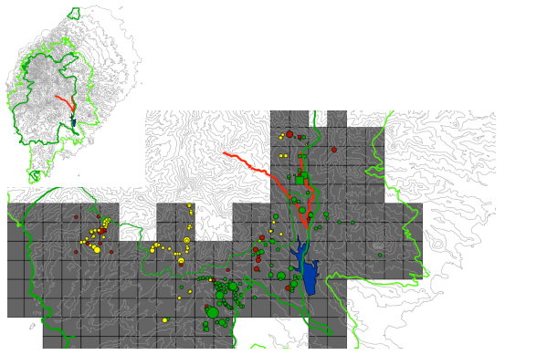

B1.2 Forest habitat loss due to conversion for agriculture
Deforestation in STP peaked in the early 20th century, driven by the expansion of commodity plantations (coffee, cacao), many of which were subsequently abandoned after the country gained independence in the 1970s, creating most of today’s secondary forest. More recently, the granting of new agricultural concessions and the spread of small-scale farming (agriculture and agroforestry, for subsistence and local markets) have prompted renewed levels of deforestation – of both secondary forests and of valuable forests including HCV areas, including significant areas in PA buffer zones. This is done in the hope to bring abandoned agricultural plantations back into use to rehabilitate the cash-crop industry (Barros, 2013), however, the spread of small-holder farming that increasingly encroaches illegally on public forest lands and the NP is also a result of a dated land tenure regime as well as of weak land use planning and surveillance.
On the island of Príncipe, recent deforestation from land conversion has been limited and largely confined to the north of the island.
For São Tomé, the following map shows the deforestation that occurred between 2009 and 2013, with the different sources of impact. The estimated average annual deforestation rate on the island for the 2009-2013 period was 0.5% (R-PP, 2014).

Deforestation in Sao Tomé 2009-2012/13 (Source: GeoVille, 2013)
Main causes of deforestation over the period (red):

North:
- Slash & burn agriculture,
- Unregulated fires,
- Charcoal production,
- Urbanization.

Center:
- Horticulture

South:
- Large red/yellow area: AgriPalma oil palm plantations (the survey period coinciding with the investment phase of the AgriPlama plantation)
- Malanza, Porto Alegre in the far south: firewood, urbanisation & construction (tourism), charcoal (in mangrove area)

There are two types of threats in this section with very distinct stakeholder groups and response mechanisms, which are discussed separately in the following.
Forest habitat loss from large-scale agricultural developments
This is the second larger-scale threat that could cause transformative, devastating impacts on key ecosystems if not addressed and managed properly. As for the threat from large infrastructure developments, it can result from singular, discrete large-scale land conversions endorsed or promoted by government decision-makers.
The above deforestation map underlines the impact of one large-scale agricultural development: the clearing between 2009-2012/2013 of 2,100 ha of valuable forests in southern São Tomé for oil palm plantations, as part of a 4,917-ha concession the government of STP granted to AgriPalma (a company of the Luxembourgian/Belgian Société Financière des Caoutchoucs, Socfin). In addition to the direct loss of suitable habitat by forest clearance, the plantation causes forest fragmentation and disturbance; and roads for improving transportation between concession areas split potential home range/suitable habitat patches for the São Tomé Fiscal and São Tomé Grosbeak. The remaining c 2,800 ha of the concession were not converted after opposition led by civil society, and it appears will now be returned to the government. A similar oil palm concession granted by the central government on Príncipe was halted by the island’s regional government.
A similar development occurred in the cocoa sector. The company SATOCAO, STP’s largest cocoa trader/exporter, was granted a c. 2,500 ha-large concession on São Tomé for a period of 25 years that included large areas of forest to be newly cleared for planting with cocoa. 275 ha were converted. The concession is currently under review due to important overlaps with the PNOST.
Forest, mangrove and savanna habitat loss for small-holder agriculture
This is a growing threat linked primarily to the growth of the human population including in rural areas. The impacts are more gradual and dispersed than in the case of land conversions by large agricultural concessions, but also more difficult to manage due to the large number of stakeholders involved and their fragmentation.
Small-holder farming leading to actual deforestation is especially for crops like pepper and vanilla and horticulture at mid-altitude in the centre of São Tomé offering suitable climatic conditions, grown largely after tree cover has been removed. Low-intensity agroforestry areas surrounding the PNOST are increasingly being cleared in the more accessible areas of the island, such as in the centre around Bom Sucesso. Such clearance is encouraged by investment in transport infrastructure and increased market opportunities for agricultural produce.
An additional pressure is forest conversion by farmers planting crops in agroforestry systems; this is less visible on satellite imagery or deforestation maps because some tree cover is retained but in fact affects a far larger area that has not been adequately quantified recently.
The mangrove habitats of STP are threatened by historical conversion to arable land, overharvesting for firewood and charcoal-making.
On a smaller scale, the (anthropogenic) savanna area in northern ST has seen forest loss and habitat degradation caused by slash-and burn practices (widely used in this part of the island for maize and sugarcane production by family farming), compounded by charcoal-production and infrastructure development.
B1.3 Loss of sea turtle nesting beaches from sand mining
The extraction of sand and rolled stones from beaches for construction purposes causes destruction of beaches with potential for tourism or that represent turtle breeding areas (Polovina et al. 2004, Programa Tatô 2019). The resulting coastal erosion is also heavily affecting São Tomé leading to the destruction of coastal infrastructures such as roads and promenades.
B1.4 Habitat loss from urbanisation and related infrastructure, especially in coastal and rural areas
Urbanisation in rural and coastal areas and related infrastructure is spreading in an uncontrolled manner, especially on São Tomé, causing both direct and indirect impacts on natural ecosystems, affecting forests, coastal habitats including mangroves, and beaches that may be sea turtle nesting beaches. This is a result of the growth of STP’s human population, but also of weaknesses in land-use planning, surveillance and law enforcement.
B2 Natural resource use and over-exploitation
B2.1 Forest degradation from unsustainable and illegal selective logging
This is the third major threat that could cause transformative impacts on key ecosystems if not addressed and managed properly. Selective logging to source timber for construction purposes (primarily houses given that 80% of houses in STP are made of wood; and for furniture and boats; there are no timber exports) and wood to produce charcoal for local use or sale are the primary two drivers of forest degradation in STP – although there are important differences between the two islands. In some areas forest degradation has advanced sufficiently that it could be classified under deforestation.
Forest degradation is hard to capture by remote sensing and there is only limited quantitative data, the latest forest inventory dating back to 1999. However, enough information is available to indicate that this threat must be urgently managed.
The timber and charcoal value chains are different and impact forests in different manners and places. Stakeholders and especially the response mechanisms differ between the two. These two value chains and drivers of forest degradation are therefore described separately in the following.
Logging to source timber for construction purposes
Between 1989 and 1999, the interval between the two existing national forest inventories, there was an increase in the total volume of all species (which can be explained by secondary forest growth) yet a decrease in the volume of commercial species by c. 196,000 m3 (i.e. an average annual decrease of about 19,600 m3) resulting from the increase in consumption of sawn timber and its derivatives. Although these data are outdated, this illustrates the trend regarding timber needs in STP. According to the later study of Espírito & al. (2015), the pressure on forest resources had increased further since, noting a further sharp decrease in the commercial volume of standing timber.
Turning to the situation today, in Príncipe logging for timber is by majority compliant with the licenses issues and the pressure is not yet critical (noting that the severity of the impacts is not quantified). In São Tomé in contrast, most of these activities (80-95%) are unlicensed and illegal, and exploitation is poorly controlled and unsustainable. In 2014, the Forest Directorate authorized the felling of 1,452 trees on Príncipe (where illegal logging is rare) – and of only 1,269 trees on São Tomé, which shows how poorly controlled logging is in ST.
There is a clear trend for a sharp decrease in standing timber commercial volume along the gradient of land-use intensity. A trend that holds for the higher quality timber species, with close to no volume existing outside native and secondary forests. In shade plantation the small volume of timber is almost entirely composed by low quality timber and in non-forested lands barely any timber persists. Also shifts in the market to lower quality timbers suggest that the stocks of higher quality timber are becoming depleted, with households and traders agreeing that the situation is bad (do Espirito & al., 2015).
The number of tree species being targeted for timber (c. 17) is limited if compared to the overall species richness of the country’s forests (350+ spp.). However, the shifts to lower quality timber is prone to widen the spectrum of species targeted.
Species like Azeitona and Viro are key to the health of the ecosystem and provide important ecosystem services (do Espirito, 2015). In addition, several species of conservation concern are affected, namely “pau-vermelho” Staudtia pterocarpa, which is endemic to São Tomé and classified as Vulnerable by the IUCN Red List, and Carapa gogo and Santiria sp., which are endemic to São Tomé and to STP, respectively, but have not yet been formally described, and as such have not yet been assessed by IUCN. It is also noteworthy that Milicia excelsa, the species that is by far the most used, is classified as Nearly Threatened, and that the also often used Cedrela odorata is Vulnerable, despite having been introduced to São Tomé.
The following maps show the current prevalence of timber logging on the islands of São Tomé and Príncipe. One can see that how activities are concentrated around and inside the buffer zones but also extend into the actual NPs. This is an indicator that there are no valuable resources left outside the NP and BZ in other parts of the island. On São Tomé, logging begins to impact areas inside the PNOST, particularly around the northern border where the forest is accessible and in better condition.
Logging largely relies on access by roads reachable from the forest via trails, however also affects the SW-quarter of ST (where there is no coastal road) where timber is brought to the coast to be transported by boat.

Heatmap of timber logging activities in Sao Tomé and Príncipe
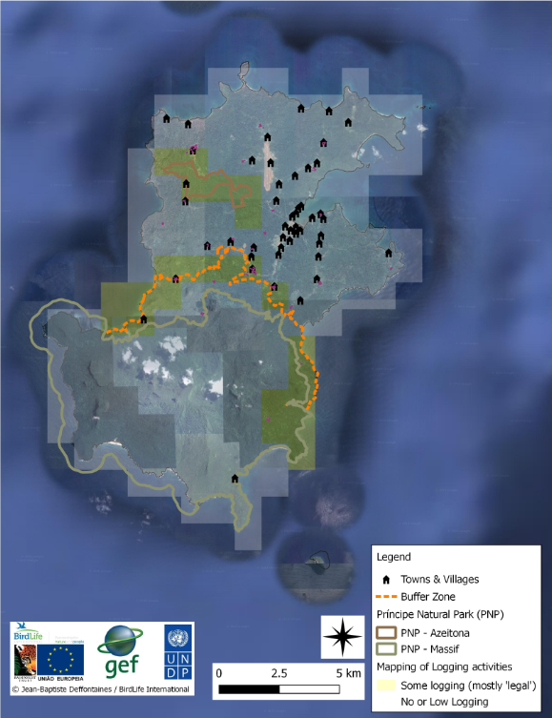

Logging for charcoal-making
Logging for charcoal-making is the other key driver of forest degradation in STP. According to the 2012 census of the National Institute of Statistics (INE, 2012), around 57.6% of the population uses firewood and/or charcoal resource as energy source. Charcoal is used extensively in urban areas that have less access to firewood, for grilling fish. FAO provided an estimate of 8 tons of charcoal used in STP per year, but this number appears to be very low.
Extraction is selective in initial stages when resources are abundant: the native African Oil Bean (Moandi) Pentaclethra macrophylla is the most sought-after species for the quality of its charcoal. It is still being targeted in Príncipe even though resources are declining. However, once resources decline, charcoal-makers turn to other lower-quality species, such as in São Tomé where the preferred Moandi has disappeared from the charcoal market. Charcoal-making can clear out any woody vegetation. In that sense, charcoal-making is more widespread than timber logging, it can be done in agricultural plots where no timber species remain, and it can have wider systemic impacts than timber logging leading to wholesale deforestation. Charcoal-making is also prone to be more opportunistic than timber logging.
Mangrove habitats are also lost due to overharvesting for charcoal-making and firewood.
The following maps show the current prevalence of charcoal-making on the islands of São Tomé and Príncipe. One can see how activities on ST are spread across the island’s area except for the NPs core area – in shade plantations, secondary forests and high-quality forests. However, there are hotspots in the north and south where pressure on forest areas next to the NP has become severe and where exploitation approaches the NP core area.
The PPG estimated that there are around 500 dedicated charcoal-makers on São Tomé, including around 300 in the north-western district of Lobata. This does not include the much larger number of occasional and opportunistic charcoal-makers which include farmers clearing their fields anywhere on the island. DFB estimated the total number of charcoal-makers to 5000.
On Príncipe, according to the Regional Forestry Department, there are 100 active charcoal workers on the island, concentrated in the communities of S. Joaquim and around the Azeitona forest (Gaspar and Azeitona). However, this will include also more opportunistic charcoal-makers, because the demand and pressure from charcoal-making is much smaller in Príncipe.
There are contradictory views on whether charcoal is (illegally) exported from Príncipe to São Tomé.

Heatmap of charcoal production in Sao Tomé (left) and Príncipe. On the right, Fundação Príncipe 2019: Circles (red) extend from each community based on the maximum reported distance that community members travel for each activity, as obtained from the group and/or individual questionnaires. Circles are semi-opaque; such that overlapping regions appear darker – i.e. increasingly dark regions indicate that multiple communities may be using the same area.
 | 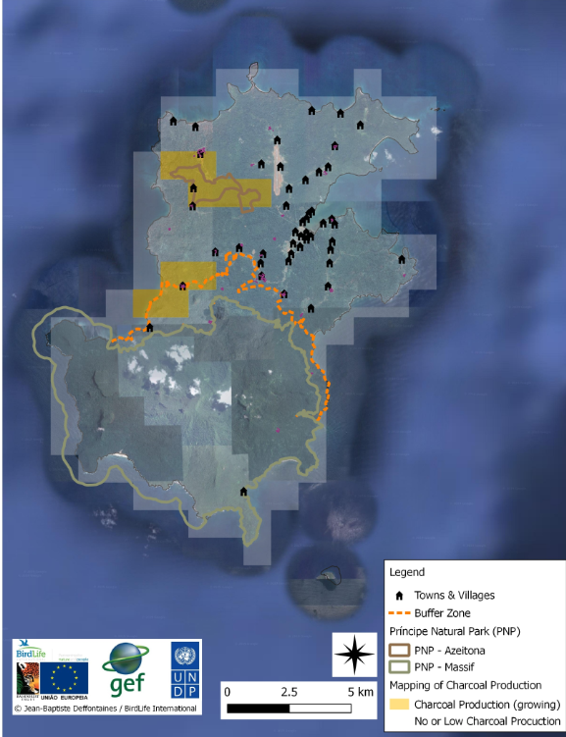 | 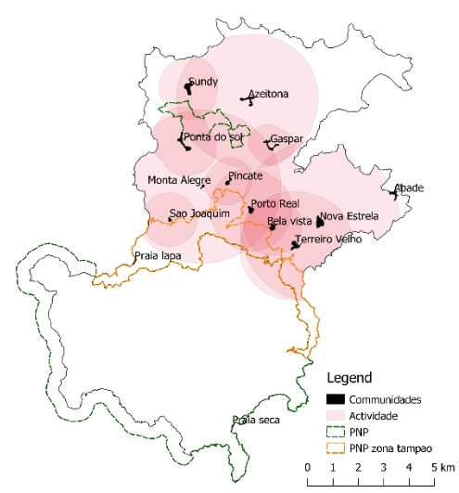

B2.2 Unsustainable exploitation of NTFP
NTFPs are important resources for local communities. In STP many NTFPs are part of the diet, others are used for income generation and for prevention and treatment of many diseases by traditional doctors and present pharmaceuticals values; some are ornamental, and others are used for handicrafts. The exploitation of NTFP contributes to the well-being and poverty reduction, especially in rural areas, especially for women who key stakeholders in some NTFP value chains. Another aspect to emphasize is its physical and economic accessibility, even for people who do not have agricultural land or regular incomes (Biloso, 2008). However, there is a lack of studies on their real importance in the Santomean economy.
Sustainably harvested NTFP are a typical sustainable livelihood intervention aimed at diversifying local revenue sources without harming forests. However, in many cases NTFP are an open-access resource – when exploitation quickly becomes unsustainable and contributes to the increasing pressure on forests (Carvalho, 2013). NTFP collection also leads to unintended indirect impacts, most notably the spread of IAS plants and disturbance of habitats critical for sensitive birds during the breeding season.
The main NTFPs exploited in STP are the following:
- African Giant Land Snail and Sao Tomé and Príncipe Giant Land Snail, please see in the next section.
- Palm Wine, the third most consumed drink in São Tomé (and Príncipe). Directly harvested from palm trees, it is the main beverage in local communities, thus creating, apart from the environmental threat, serious social issues. Agricultural growth is limited around palm trees; it is for this reason that few are present on agricultural plots and that most of the trees exploited are mainly in secondary forest, either outside the conservation areas or inside. The daily harvest and maintenance of the palm trees, with regeneration being facilitated by the collectors, plays an important role in the expansion of palm trees inside the forest, and the increasing invasion into native forests.
- Wild and domesticated honey, a product that is particularly interesting economically since there is national and international demand; collection of wild honey was a direct threat to the Park causing the diminution of wild beehives. In Príncipe this was significantly decreased with the development of the bee project, started under GEF5-funded Biodiversity project, extended and monitored through the Fundação Príncipe led CEPF-funded project; but it is still happening in and around the park. People cut the tree to access the beehives and burn it to not suffer stings from the bees (due to the lack of equipment against it). The training provided by the bee project has reduced (but not eliminated) this practice by providing equipment, training, locals and partnership with HBD’s roça paciencia to secure pots for the production and sell of honey.
- African Oil Bean Pentaclethra macrophylla, of which the seeds are collected for export especially to Nigeria, with the traded volume having grown so much that most seeds are collected from the forest soil and there is hardly any regeneration left of this tree – which also happens to be the most highly-prized wood for traditional charcoal;
- African Cardamom Aframomum danielli, mainly for the preparation of one of the typical dishes of São Tomé and Príncipe, the ‘calulu’;
- Kola nuts Cola acuminata, powerful stimulant locally consumed with palm wine, export market to Nigeria and Angola;
- Ashanti pepper Piper guineense, locally used for cuisine and potential export product; a pilot initiative in Príncipe island, led by the NGO Oikos, in the framework of the ECOFAC6 project, aims to develop the value chain of wild pepper, with potential buyers already identified;
- African fan palm Borassus aethiopicum, construction and handicrafts;
- African breadfruit Treculia africana, edible traditional fruit (seeds are of particular interest because of their high nutritional value);
- Medicinal and aromatic plants, most based on traditional knowledge, some of which are used excessively. A list of species is included in the 3rd
B2.3 Wildlife hunting and collection
Decree-Law no. 1/2016 defines hunting as "Any action aimed at pursuing, capturing or killing a wild animal, as well as the collection of eggs and the destruction of nests of birds and reptiles". Hunting activities are carried out all year long with no respect to the natural cycles of specific species.
Hunting on the island of São Tomé is carried out with three different purposes (Carvalho, 2015):
- Subsistence hunting – predominantly in rural areas and aimed mainly for feral pigs;
- Commercial hunting – practiced mainly by urban hunters who sell the product in bars, restaurants or to private consumers, targeting birds, monkeys and bats;
- Sport hunting – practiced by members of STP’s higher socio-economic classes, usually during holidays or weekends and targeting mainly birds, but also monkeys and bats.
Rural populations in STP rely on introduced wild and feral animals for protein. Feral pigs and the introduced Mona Monkey Cercophitecus mona are the main vertebrate source of wild meat consumed in São Tomé and Príncipe. These non-native species are widely hunted and represent a relevant opportunity for subsistence and revenue generation to rural populations. The second-most hunted vertebrate group are bats, which are widely consumed by rural populations, particularly the Straw-coloured Fruit Bat Eidolon helvum NT and Egyptian Fruit Bat Rousettus aegyptiacus.
Hunting is a major threat for the Dwarf Ibis CR and São Tomé Olive-pigeon EN, given their low population sizes and limited range. Other species of birds hunted in great numbers and consumed as delicacies include the São Tomé Bronze-naped Pigeon Columba malherbii NT, São Tomé Green-pigeon Treron sanctithomae EN, Príncipe African Green-pigeon Treron calvus ssp. virescens, Lemon Dove Aplopelia larvata ssp. simplex/principalis and Laughing Dove Spilopelia senegalensis LC.
Uncontrolled collection for food of the endemic Obô Giant Land Snail Archachatina bicarinata VU is a notable threat to this endemic species, considered a conservation priority. Managing the threat is difficult because it is similar to the West African Giant Land Snail Archachatina marginata, an invasive pest species that was introduced to the islands 30 years ago and has become the third most important source of protein in STP (after fish & feral pig meat) – a preliminary study found that it accounted for 46% of all protein consumed in one community (Carvalho et al., 2015). Research, awareness activities and concrete conservation action are underway to protect the species, mainly through CEPF funding.
Also, a growing and undocumented threat is the uncontrolled collection of insects and the informal and illegal market of insects.
B2.4 Threats related to increasing disturbance from human presence in the forest
Studies conducted by Olmos & Tursshat (2007 and 2010) and Gascoigne in litt. (2000) mention the existence of considerable human movement within forests, including in protected areas, by hunters, loggers, wine collectors, land snail collectors, healers using traditional medicines, etc. In addition, as infrastructure improvements proceed, forest areas become more accessible.
B3 Pollution
Pollution by chemical pesticides is a threat especially for the freshwater biodiversity in the country’s rivers, creeks and streams. These stem from discarded pesticide-impregnated anti-malaria mosquito nets, and from agricultural (especially horticultural) fields where farmers apply pesticides with hardly any controls in place. There are growing calls for a reduction or ban in pesticide use given the effects on human health. There has been a decrease in the fish Eleotris vittata and the freshwater shrimp Sicydium bustamantei, which play an important role in food security of rural communities.
B4 Invasive alien species
While there is no evidence that IAS have had any systemic impact on the ecology and diversity of STP’s ecosystems or led to the extinction of species like on other SIDS, they are a growing background concern.
In terms of animal IAS, feral cats Felis silvestris, Black Rat Rattus rattus, African Civet Civettictis civetta and Least Weasel Mustela nivalis are present. While civets and weasels have been observed to prefer plantations, rats and civets have both colonized native forest or certainly the edges of it and are very likely to have had a deleterious effect upon birds and other vertebrate species. Predation of adults, juveniles and bird nests by IAS could be a potential threat for all endangered species, in particular for the Dwarf Ibis.
Introduced feral pigs affect the forest floor by churning up the undergrowth, which reduces tree regeneration. This could also have a positive impact on the Ibis as it creates potentially good feeding habitat.
The Mona Monkey Cercopithecus mona is an exotic species but not considered invasive, which impacts the forest vegetation through seed dispersal, including of non-native plants.
The West African Giant Land Snail Archachatina marginata, introduced 30 years ago on the islands, is fully established in the coastal areas and secondary forests of São Tomé and Príncipe. The species has begin to expand into areas of native forest, which strongly correlates with the decrease of the endemic Obô Giant Land Snail Archachatina bicarinata VU (Conservation Status currently being reviewed), and will have impacts also on other fauna and flora. Both species are collected for food, see above.
The expansion of invasive and exotic plants into native and secondary forests is a further concern, especially in Sao Tomé that has been exposed to more trade, inhabitants and agricultural transformation. The expansion of IAS plants causes increasingly dense vegetation in the forest understory reducing for instance the suitability of forest habitat for the critically endangered Dwarf Ibis and São Tomé Fiscal Fiscal. The Missouri Botanical Garden (2010) named especially the following species of concern:
- Common bamboo Bambusa vulgaris – Originally from China and recognized as invasive in New Zealand, the Cooks Islands, Fiji Islands, Reunion Island and Jamaica. This perennial herbaceous tree penetrates the forest by spreading along streams through vegetative reproduction from the rhyzome, which is particularly effective. It removes native plants by forming very dense monospecific groups. It is reported in the PNOST.
- West Indian Raspberry Rubus rosifolius – Native to Australia and Asia and invasive in Hawaii, French Polynesia and New Caledonia. This thorny shrub is appreciated for its edible berries but it forms dense groves that close the passages and compete with the natives by competition and overcrowding. It was introduced into the archipelago after 1906. It is currently very abundant in secondary bushes, plantations and along roads where it multiplies vegetatively by suckers and sexually. It can occur in native forests if the vegetation is open. There is therefore a risk that the birds that consume its berries will carry the seeds to the high altitude forests of the archipelago where this species would find a suitable habitat for its expansion. In Tahiti, this species can be observed up to 2200 m above sea level. It is reported in the PNOST.
- Lantana Lantana camara – Native to central and northern South America, naturalized in nearly 60 countries and invasive in Africa, China, New Caledonia, India, Australia, Dominican Republic, etc. This horticultural crop is found in agricultural areas, on coastal areas, in natural and planted forests, in ruderal areas and in wetlands. It is one of the 100 most problematic species in the world. Its impacts are multiple: form dense populations that reduce biodiversity, alter the fire regime, reduce the productivity of agricultural areas, increase the risk of erosion and poison livestock. It is reported in the north of São Tomé.
- Herbst's Bloodleaf Iresine herbstii – This perennial herbaceous plant native to Brazil does not currently have invasive status. In São Tomé it can be observed along the paths of the PNOST and its rapid progress is worrying because it forms very dense populations and competes notably with the giant Begonia of São Tomé, emblem of the PNOST. In its area of origin it has been found up to 2500 m above sea level. If it continues to progress in the Park, there is a risk that when it reaches more open environments, conducive to its development, there will be an "explosion" of its distribution.
- Mexican Sunflower Tithonia diversifolia – Native to Central America and invasive in the Pacific Islands (Hawaii, Cook Islands, Galapagos, Fiji Islands, French Polynesia, New Caledonia), Australia, Reunion Island, Southwest China and Nigeria. This stoloniferous perennial herbaceous plant, 2 to 3 m high, is used in São Tomé as a hedge between crops. Its absence from pre-bimillennial inventories suggests that its introduction is very recent. Its highly invasive nature in other areas, its rapid clonal reproduction and high production of light seeds, its ability to grow at high elevations (China up to 2000 m), its ability to colonize open forest areas and its ability to form dense stands that prevent the growth of young native plants are of concern to scientists, as it is grown in the buffer zone. On the other hand, experience has shown that when man loses control the consequences can be disastrous for agriculture, which seems to be the case in the Bom Sucesso area, adjacent to the main entrance to the PNOST.
B5 Climate change
Like many other small island states, São Tomé and Príncipe is highly exposed and vulnerable to the impacts of climate change, such as sea-level rise and extreme weather events. Water resources, infrastructure, health and food security and coastal protection will be affected. The majority of livelihoods are highly dependent on limited natural resources and climate-sensitive activities, namely agriculture and forestry (crop production, shade plantation, livestock, forest resources) and fisheries. Higher and increasingly competing demands for food, energy, and space are accelerating the degradation of natural resources and ecosystems, which reduces their resilience to climate change. This situation increases the vulnerability of small-holders and creates a vicious cycle of low adaptive capacity, poverty, further degradation and hunger.
The identified threats to ecosystems from climate change are:
- Accelerated erosion of soils due to the very rugged nature of the islands.
- Flooding and subsequent degradation of forest areas on flat relief, such as shade forests located in the plateaus.
- Increase of the extent of the savannah zone to the north-east of the island of São Tomé, which is already suffering from degradation due to indiscriminate trees and shrubs cutting to produce charcoal.
- Increasing trend of annual mean temperature values and decrease in rainfall.
- Loss of forest cover by landslides, as about 90 percent of forests are located on sharp relief regions.
- Reduction of forest area in case of prolonged drought, especially shade forests and secondary forests.
- Proliferation of pests and diseases in forest ecosystems.
- Local extinction of animal and plant taxa (which will imply global extinction for endemic taxa)
- Loss of plant and animal (insect) biomass
- Reduction of soil water content, especially in black and brown clays and savannah soils that are already exposed to water shortage.
- Sea-level rise & extreme events, loss of sea turtle nesting beaches.
- Changing hydrology and coastal erosion, increasing with forest degradation and the illegal/uncontrolled felling of tree.
There is at least anecdotal evidence that weather patterns have started to change, with temperatures rising and shorter rainy seasons leading to reduced water flows in mountain streams. However, there is no evidence to date of any changes in the ecological communities that could be linked to climate change.
The biggest national challenge is to integrate climate change into the national planning process and to prepare rapid and effective responses with the affected socio-economic sectors. Regarding the forest sector, there is a consensus at the level of plans and strategies for the development and sustainable management of forests and agroforestry ecosystems by 2030. However, experiments with species that adapt to changing soil and climate conditions should be encouraged.

Annex 21: HCV of São Tomé and Príncipe

INTRODUCTION
An area designated on the basis of High Conservation Values (HCVs has biological, ecological, social or cultural values that are considered exceptionally significant at national, regional or global level. These areas need to be appropriately managed in order to maintain or enhance the identified values. The High Conservation Value concept was originally developed by the Forest Stewardship Council (FSC) in 1999 for use in forest management certification. In 2005 the HCV Resource Network was established, and the scope expanded. Today it is a fundamental principle of sustainability standards for palm oil, soy, sugar, biofuels and carbon, and is widely used for landscape mapping, conservation and planning and protection of natural resources. In practice, many HCV areas are managed by companies or communities outside protected area networks. HCV management can range from complete protection to extractive uses, such as selective logging or harvesting of natural products. Any extractive use needs to be managed according to an agreed standard and monitored for any negative effects. The HCV cannot be converted to other land uses that compromise classification as HCV. Legal recognition and protection are not basic criteria for the identification of HCV. Most are usually outside the network of legally protected areas. The criteria for identifying High Conservation Value forests do not guarantee the protection of the identified areas. However, in the context of São Tomé there are adequate procedures for the formal recognition of HCV forests, including management and monitoring aspects, participating in the creation of a land use gradient surrounding the Parks (in the respective Buffer Zones and beyond), responding to the fundamental environmental need for the ecological integrity of the island. The project will therefore promote further advancement, management and expansion of internationally benchmarked innovative management/partnership models for HCV areas.
HCVS TRIGGERS IN SÃO TOMÉ AND PRÍNCIPE
The islands of São Tomé and Príncipe have several forests that fit the criteria of High Conservation Value, being of global relevance to biodiversity. Most of these forests are located in the São Tomé Obô Natural Park (PNOST) and Príncipe Natural Park (PNP) and their respective buffer zones (UNEP-WCMC 2019). These include HCV linked to species diversity (HCV1), to landscape-level ecosystems and mosaics (HCV2), to ecosystems and habitats (HCV3), to ecosystem services (HCV4), community needs (HCV5) and cultural value (HCV6) (Brown et al. 2013).
HCV1 – species diversity
In terms of HCV1, São Tomé and Príncipe holds globally significant concentrations of endemic and threatened species, many of which occur in natural patterns of distribution and abundance:
- Sao Tomé and Príncipe holds several hundreds of endemic fauna and flora species, most of which are still being described. Some of these are shared with other islands in the Gulf of Guinea, but most are restricted to Sao Tomé and Príncipe. In total, STP hosts 59 threatened fauna and flora species, including 33 Vulnerable (VU), 22 Endangered (EN) and four Critically Endangered (CR) species (IUCN, 2019).
- Most of the endemic birds are found in the forests, including four of the endemic bird species listed as Critically Endangered in the 2019 IUCN Red List: Dwarf Ibis Bostrychia bocagei, Newton’s Fiscal Lanius newtoni, São Tomé Grosbeak Crithagra concolor and Príncipe Thrush Turdus xanthorhynchus.
- The list of endemic plants of the archipelago contains at least 148 endemic taxa, of which 123 exist in São Tomé and 50 in Príncipe (RDSTP, 2014) and new species are still being discovered today on both island. Since 2016, on Príncipe Island, a project aiming at describing the tree diversity is ongoing (Global Tree Campaign/GTC Phase 2, activity report, 2018) and a 2019 CEPF funded project (led by the Missouri Botanical Garden) is currently extending the flora study to both islands to improve taxonomy and evaluate its conservation status (for the IUCN red list).
- The Príncipe Island region holds most breeding seabirds of the tropical eastern Atlantic Ocean (Valle et al. 2016). The seabird colonies of the Tinhosas islands, south-west of Príncipe, are the largest in the Gulf of Guinea with an estimated 300000 birds, including sooty terns Onychoprion fuscatus, brown boobies, black noddies Anous minutus and Brown Noddies Anous stolidus (Valle & al., 2016);Native terrestrial vertebrates of STP includes 4 endemic bats, 1 endemic shrew, 9 endemic reptiles and 8 endemic amphibians.
- 7 species of snakes are present in STP and all are endemic (including 2 in Príncipe island); and 6 endemic species of mollusc new to science have been discovered in Príncipe island in 2019 (Fundação Príncipe, 2019).
- It is also important to note that STP waters and beaches, including ones in the Parks and their buffer zones, host five species of sea turtles, all VU to CR, who use the beaches for nesting (including the CR hawksbill sea turtle Eretmochelys imbricate and the EN green sea turtle Chelonia mydas).
STP is part of the Guinean Forests of West Africa biodiversity hotspot (Myers et al. 2000). STP has been recognized as part of a Centre of Plant Diversity (WWF & IUCN 1994-7). It holds two Alliance for Zero Extinction sites (AZE): the São Tomé Uplands, covering 4,839 ha triggered by the Endangered São Tomé shrew Crocidura thomensis and São Tomé giant treefrog Hyperolius thomensis, and the São Tomé lowlands, covering 21,832 ha triggered by the Critically Endangered Dwarf Olive Ibis, São Tomé fiscal and São Tomé grosbeak (Alliance for Zero Extinction, 2019). STP holds five Important Bird Areas (IBA), 3 in Sao Tomé (lowland forest, mountain and mist forest, and northern savannahs), 1 in Príncipe (southern forest) and 1 covers Tinhosas islands (Christy, 2001). The set of conservation priority areas described above led to the identification of 7 Key Biodiversity Areas (KBA), 5 in Sao Tomé and 2 in Príncipe; largely overlapping with the IBA. However, following the KBA protocols for identification, a review is needed (BirdLife International, 2019). STP is an Endemic Bird Area of Critical Priority (Stattersfield & al, 1998; BirdLife International, 2019).
Worldwide, the Obô Natural Parks, are considered the 32nd most important protected areas for the conservation of mammals, birds and amphibians, the 17th if only threatened species are accounted for, and the 2nd ex aequo for the conservation of threatened bird species (Saout et al. 2013).
HCV2 – landscape-level ecosystems and mosaics
In terms of HCV2, the focal area (parks and buffer zones) does not reach the 500 km² threshold, but São Tomé and Príncipe being islands means that most naturally occurring species have adapted and are constrained to smaller areas than species occurring in the continent. The São Tomé, Príncipe and Annobón moist lowland forests (AT0127) are part of the afro-tropical ecoregion category (WWF), status vulnerable, and have been identified as the 3rd most important ecoregion for the conservation of forest-dependent birds worldwide (Buchanan et al., 2011). The islands support viable populations of naturally occurring species, and the focal areas hold relatively undisturbed ecosystems that support most endemic and threatened species, as well as most environmental values of the islands. Despite its small size, both islands are made of a mosaic of habitats, including lowland forest which are most similar to the continental forest, mountain and mist forest that are probably the most intact due to their uneasy access, and coastal formations (including savannahs in Sao Tomé and mangroves in both islands). Despite not being pristine, the focal areas are well preserved and maintains most naturally occurring species and ecological functions. Very few terrestrial species are thought to have been extirpated from São Tomé and Príncipe. Furthermore, it holds one of the largest and best-preserved patches of forest in the Gulf of Guinea Islands, including some of the most charismatic species of this biome, such as the Dwarf Olive Ibis and the Príncipe Thrush (BirdLife, 2019). The country is densely populated (estimated at 204,454 inhabitants, source: INE), but the rugged terrain ensures that most of the focal areas are difficult to access.
HCV3 – ecosystems and habitats
In terms of HCV3, São Tomé and Príncipe present, as stated above, a wide range of ecologically important ecosystems (mangroves, savannahs, lowland and mist forests, more specific ecosystems such as riparian, coastal, etc.) over a limited area. These ecosystems are of global and local rarity, as recognised by WWF through the map of ecoregions. The focus area is the key habitat for most endemic and threatened species occurring in São Tomé (Jones et al. 1991) and Príncipe (Fundação Príncipe, 2019). Ecological and evolutionary refuges are predominant in São Tomé and Príncipe, including mountains and the role of the oceans as climate buffers. The extent of São Tomé's native forest ecosystems is greatly reduced, when compared to the original extent, due to human activities. Large-scale agricultural development and land concessions, industrial developments such as quarries, fires, illegal logging and charcoal production, among other relevant threats, further threaten persistent native forest habitats. Lowland and coastal forests are probably the ecosystems that have suffered the greatest reduction in São Tomé and Príncipe over the period of colonization due to deforestation for sugar cane, coffee and cocoa production. Most of the extension of these two ecosystems has suffered continuous attacks and the likelihood of finding well-preserved areas is low. Most of the existing habitat is a result of the natural regeneration of the forest after the abandonment of plantations.
According to the PNOST Management Plan, the last remaining areas of low altitude forests in Sao Tomé are concentrated around Maria Fernandes, Iô Grande, Angolares, Pico Cão Grande, Caué, Quija, Mussacavu and São Miguel, especially around the southeast limit of the Park. Regarding the dry forest, this ecosystem occupies the border regions of Guadalupe, including the banks of the rivers Água Castelo, Água Guadalupe and Rio do Ouro, in areas with rainfall between 1,000 and 1,500 mm per year and a marked dry period. Some marginal areas of this vegetation typology are included in the northernmost component of the PNOST (Albuquerque et al. 2015, 2008). According to the 2015-2017 Praia das Conchas Mangrove Management Plan (Loloum et al. 2015), currently under review with funding from CEPF (project led by Oikos), the protected area should be expanded by 450ha to include the entire area of dry forest and Praia Grande, Praia de Plancas and Mutamba. Additionally, the PNOST Management Plan states that it is plausible that the most important areas with conservation value in the buffer zone are in the fourth northwest of the island, namely between the Praia das Conchas area and the northwest boundary of the central forest block of the PNOST and that these are possibly the most threatened natural ecosystems and, at the same time, the most valuable sites for biodiversity conservation on the island of São Tomé. The smaller island of Príncipe was once entirely covered by forest, although less varied than Sao Tomé’s was. While it also largely suffered from the expansion of human activities starting during the colonization era, the entire southern zone of the island is still covered by relatively well preserved low-land forests. Four types of vegetation were recognised, and main drivers were the annual rainfall, the elevation and the degradation of the forest (GTC Phase 2, activity report, 2018). While the North part of the island is dryer and has only one forest type, mainly degraded, the South and the Center harbor three vegetation types, two of them being almost intact, the third one being an old secondary forest. The most important habitat for conservation is the lowland forest around Rio Porco, which constitutes an old forest, possessing a high biodiversity and being probably one of the last intact ecosystems in the Gulf of Guinea (FFI Conservation manager, pers. com.). The submontane forest around 600m at the Pico do Príncipe is also of importance since it holds a unique flora on a small surface, with many unidentified species. These two types of vegetation are unique mature forest, possessing many huge trees that allow bird breeding. The Príncipe Natural Park, covering the southern third of the island, protects key habitats where most endemics are restricted, in particular the endemic and endangered Príncipe Thrush depends on a limited area of 40km² and the Príncipe giant land snails an area of 46km² (Fundação Príncipe, 2019). The newly discovered and endemic scoops owl is also restricted to the PNP area. The PNP management plan includes a buffer zone of secondary forests and a minority of shade plantations, covering an area of around 1157ha bordering the PNP – not gazette as such, and since the island recognition by UNESCO as a biosphere reserve, the ecological transition zone / buffer zone is being assimilated to the entire Príncipe landscape These areas have been less studied but they include potentially important coastal and mangrove habitat (COBIO-NET project, 2018-21).
HCV4 – ecosystem services
In terms of HCV4, ecosystem services are the benefits people obtain from ecosystems, including provisioning services such as food and water; regulating services such as regulation of floods, drought, water purification, climate, land degradation, and disease; supporting services such as soil formation, nutrient cycling, primary production and genetic resources; and cultural services such as recreational, spiritual, religious and other nonmaterial benefits (IPBES, 2018).
In practice, many HCV National Interpretations have used three main headings under HCV4: areas critical to water catchments, areas critical to erosion control (vulnerable soils and slopes), and areas providing barriers to destructive fire (Brown et al. 2013).
STP ecosystems are rich, diverse, and capable of providing multiple services and resources. The main natural risks in STP are related to landslides, floods and coastal erosion, typologies of risks that generally occur associated. The geomorphologic characteristics of some areas, with strong slopes and high instability, allied to dominant meteorological conditions, favour sliding-type mass movements, falls of blocks and flows of earth or mud. The frequent and intense rainfall facilitates the saturation of the soils and products that cover the rocky substrate, and the lubrication of rock mass near the surface, favouring the mobilization of materials and the fall of blocks. This type of risk is especially present in the Northern and Central regions, already with some history of landslides (Carvalho et al. 2015).
Ecosystem services are also threatened throughout the national territory because of human activities, including land conversion to agriculture (agro-industry, vegetables production) or macro-projects (hydroelectric energy, dams projects), forest degradation (logging, charcoal making), exploitation of wildlife (hunting) and other natural resources (Non-Timber Forest product), erosion (in-land or coastal, natural or due to unregulated felling of trees, sand extraction, etc.) (Albuquerque, 2015), exacerbated by climate change and drought.
More specifically, the coastal zone in São Tomé and Príncipe is the economic area par excellence and a vulnerable area per se, where almost all of the economic infrastructure, including the social habitat, is concentrated. The coastal zone is subject to multiple anthropogenic aggressions (for instance extraction of sand and rolled stones for construction), consequently causing the destruction of beaches of great tourist potential or that represent turtle breeding areas (Polovina et al., 2004, Programa Tatô, 2019). In Príncipe, the coastal area is occupied for a great portion by luxury hotel concessions (HBD Príncipe, Belo Monte, etc.), which to some extent tried maintaining a green tourism label for their clients, therefore limiting their impact on biodiversity. However, the expansion of those resorts and the potential acquisition of more concessions from less environmentally friendly companies, in a very small island where the number of beaches is limited, is an important threat to the remaining preserved beaches. Communities are occupying most of the remaining beaches and according to the Management Plan of the PNP, most of them should be monitored through awareness programs to limit their impact on the coastal biodiversity and incursions in the nearby forest (wood cutting to build canoa, unregulated fisheries, water contamination, etc.). Relevant beaches in the Buffer Zones should be protected with proven importance for endangered species conservation, as touristic attraction and to prevent coastal erosion. Mangroves are probably the most peculiar coastal ecosystem of São Tomé and Príncipe, a transition zone between rivers and the sea, which contains brackish water and serves as nurseries for different marine or coastal organisms, a key ecosystem to maintain fisheries activities. Additionally, they play an important role in protecting the coast and controlling coastal erosion (de Lima et al. 2016, Haroun et al. 2018). The country’s largest mangrove areas are located on São Tomé near Praia das Conchas, Praia dos Tamarindos, Pantufo, Água-Izé and Malanza, which also have a critical role in maintaining the integrity of the island’s territory (Jewell et al. 2009). In Príncipe Island, there are three main remnants of mangrove forests, Praia Salgada, Praia Caixão and Praia Grande, all of them outside the Príncipe Natural Park (Haroun et al. 2018). A previous plan developed for STP proposed the extension, with an additional 500ha, around the Malanza Mangrove Area in order to include the lowland forests around Cantagalo (North) and the sand beaches around Porto Alegre, for their importance for sea turtle breeding (South) (Jewell et al. 2009).
Finally, the country and by extension critical habitats, are vulnerable to climate change, with potential significant environmental and socio-economic impacts including an acceleration of habitat and biodiversity erosion and deep changes in the landscape dynamics (depending on climate scenarios: potential reduction of forest cover and expansion of savannahs through increased droughts, soil erosion and habitat loss through increased landslides, erosion of coastal habitat through increased sea level, and invasion of alien species – e.g. plants, insects (Carvalho & al. 2011). Water resources are also highly vulnerable to climate change, and watercourses and river basins quality and microbiomes will depend even more on adequate forest cover and appropriate agricultural/human sanitation practices (Bonfim, 2002; Carvalho et al. 2011).
HCV5 & HCV6 – local communities and culture
Both HCV5, sites and resources fundamental for satisfying the basic necessities of local communities, and HCV6, sites, resources, habitats and landscapes of global or national cultural, archaeological or historical significance, and/or of critical cultural, ecological, economic or religious/sacred importance for the traditional cultures, present interesting criterias and can be considered in some cases. However, these categories are secondary in the context of São Tomé and Príncipe; as HCV 1-4 already cover most of the expectations for achieving the High Conservation Value forests designation expected outcome.
HCV PRELIMINARY IDENTIFICATION IN SÃO TOMÉ
A study carried out in 2019 led to the preliminary identification of potential High Conservation Value forests in Sao Tomé, which, for the time being, includes 19 separate areas (BirdLife, 2019). Following on the recent work on the flora and fauna of Príncipe Island, a similar approach to identify Príncipe’s HCVs would make sense in order to ensure better protection of its unique biodiversity.

The background shows the 100 m altitudinal isolines (thin black lines), over-imposed on São Tomé’s preliminary land-use (native forest – dark green; secondary forest – light green; agroforest – orange; non-forested – yellow). The Obô Natural Park is shown by the thick black line and the buffer zone by the intermediate black line (ECOFAC IV). In grey is a proposed alternative to the boundaries of the buffer zone.

Code | Name | Area (ha)
A1 | Praia de Plancas | 33.7
A2 | Ribeira Funda | 110.3
B1 | Ponta Furada | 254.9
B2 | Claudina | 143.0
B3 | Morros de Bindá | 2,165.6
C | Contador | 100.4
D | Chamiço | 1,498.8
E | Zampalma | 846.4
F | Maria Fernandes | 3,982.9
G | Vila António | 152.9
H | Praia Grande | 76.3
I1 | Cão Pequeno | 506.3
I2 | Sarcinda | 494.1
K1 | Praias do Sul | 60.2
K2 | Jalé | 45.5
K3 | Cantagalo | 97.8
K4 | Xixi | 62.3
K5 | Mussacavú-Willy | 245.9
L | Pico Macurú | 35.5

Six of them are currently outside the PNOST buffer zone. The limits have also been proposed to be easily identified on the ground and to avoid overlap with agricultural concessions of familial agriculture. The current proposal, based primarily on an assessment of existing biodiversity values, will be the basis for the work and intervention of the Forest and Biodiversity Directorate, the subsequent public discussion, informing and engaging relevant stakeholders, while weighing these values against socio-economic interests (BirdLife, 2019).
The CEPF project ‘Characterization of the threatened flora of São Tomé & Príncipe’ May 2019-December 2020 aims to identify threatened plant species using categories and criteria of IUCN, characterize their distribution and their habitat and the threats they are facing, and shall therefore feed the identification process – to be updated with flora data’s by mid-2020.
The “Priority” codes indicate whether the area is mostly included in the most commonly accepted buffer zone boundaries or not (O or I, respectively) and categorize them according to the importance of the values it holds (1 – top; 2 – medium; 3 – low). Triggers list the type of values that have been identified in each area: 1 – Species diversity (Endemic species – End –indicated, but only listed if they are data deficient (DD) or threatened: CR – Critically endangered; EN – Endangered; VU – Vulnerable – IUCN 2019); 2 – Landscape; 3 – Ecosystems and habitats; 4 – Ecosystem services. * signals values identified during the field visits (Appendix). Other values were obtained from the bibliography (Mammals: Juste & Ibañez 1994; Rainho et al. 2010; de Lima et al. 2016. Birds: de Lima 2012; BirdLife International 2016; de Lima et al. 2016; Soares 2017. Herps: CAS 2019; Programa Tatô 2019. Plants: Joffroy 2000; BirdLife International 2016; Figueiredo et al. 2011. Giant land snail: Panisi 2017. Landscape and ecosystems: BirdLife International 2016; Soares 2017.)
Code | Name | Priority | (ha) | Triggers
A1 | Praia de Plancas | O3 | 33.7 | 2 – Connectivity (northern exclave to core park area).  3 – Secondary dry forest, savanna, shade plantation and stream. Bat roost: Eidolon helvum*.  4 – Charcoal*; Agriculture* (cocoa, coconut and banana); Canoe building* (Ceiba pentandra); Silviculture* (palm wine, tamarinds); Hunting*; Water*; Timber (Milicia excelsa); Medicinal plants* (Rauvolfia vomitoria, Momordica charantia).
A2 | Ribeira Funda | O1 | 110.3 | 1 – Staudtia pterocarpa (End&VU*); Archachatina bicarinata (End&VU*).  2 – Connectivity (northern exclave to core park).  3 – Native and secondary lowland dry forest, stream and cliffs. Bat roost: Eidolon helvum*.  4 – Timber* (Milicia excelsa, Cedrela odorata, Tetrorchidium didymostemon, Staudtia pterocarpa); Water*; Charcoal*; Hunting* (Eidolon helvum, Columba larvata); Medicinal plants* (Rauvolfia vomitoria).
B1 | Ponta Furada | O2 | 254.9 | 1 – Miniopterus newtoni (End&DD); Oriolus crassirostris (End&VU*); Treron sanctithomae (End&EN); Eretmochelys imbricata (CR); Polyscias quintasii (End&EN*); Pandanus thomensis (End&VU*).  2 – Buffering.  3 – Secondary coastal rainforest, beaches and river.  4 – Timber* (Cedrela odorata, Tetrorchidium didymostemon); Water*; Hunting* (Cercopithecus mona, Columba malherbii, Treron sanctithomae, Eidolon helvum); Silviculture* (Palm wine); Ecotourism; Medicinal plants* (Rauvolfia vomitoria, Voacanga africana).
B2 | Claudina | O3 | 143.0 | 2 – Buffering.  3 – Secondary lowland rainforest and river.  4 – Timber*; Water*; Hunting*; Silviculture* (Palm wine); Medicinal plants*.
B3 | Morros de Bindá | I1 | 2165.6 | 1 – Crocidura thomensis (End&EN); Miniopterus newtoni (End&DD); Bostrychia bocagei (End&CR); Lanius newtoni (End&CR); Crithagra concolor (End&CR); Motacilla bocagii (End&VU); Columba thomensis (End&EN); Dreptes thomensis (End&VU); Oriolus crassirostris (End&VU); Otus hartlaubi (End&VU); Treron sanctithomae (End&EN); Schefflera manni (VU); Staudtia pterocarpa (End&VU); Pandanus thomensis (End&VU*); Craterispermum montanum (VU); Archachatina bicarinata (End&VU).  2 – Additionality and buffering.  3 – Native forest, secondary lowland rainforest, secondary coastal forest, rivers and peaks.  4 – Timber; Silviculture* (palm wine); Water*; Hunting* (Cercopithecus mona, Archachatina marginata, Treron sanctithomae); Agriculture* (cocoa and banana); Ecotourism; Medicinal plants*.
C | Contador | I1 | 100.4 | 1 – Miniopterus newtoni (End&DD); Panaspis africana (End&VU).  2 – Additionality and buffering.  3 – Native forest, secondary lowland forest, cliffs and streams.  4 – Water*; Hunting.
D | Chamiço | I1 | 1498.8 | 1 – Crocidura thomensis (End&EN); Crithagra concolor (End&CR); Columba thomensis (End&EN); Dreptes thomensis (End&VU); Oriolus crassirostris (End&VU); Otus hartlaubi (End&VU); Treron sanctithomae (End&EN); Schefflera manni (VU); Croton stellulifer (End&VU); Discoclaoxylon occidentale (End&VU*); Staudtia pterocarpa (End&VU*); Craterispermum montanum (VU); Pavetta monticola (End&VU); Archachatina bicarinata (End&VU).  2 – Additionality, buffering and connectivity (northern exclave to core park).  3 – Native lowland and montane transitional forest, secondary lowland transitional forest and streams.  4 – Timber; Water*; Hunting* (Cercopithecus mona, Archachatina marginata, Treron sanctithomae, Columba thomensis); Agriculture* (coffee, banana, taro, pepper); Ecotourism; Medicinal plants* (Rauvolfia vomitoria, Syzygium guineense).
E | Zampalma | I1 | 846.4 | 1 – Crocidura thomensis (End&EN); Miniopterus newtoni (End&DD); Myonycteris brachicephala (End&EN); Crithagra concolor (End&CR); Columba thomensis (End&EN); Dreptes thomensis (End&VU); Oriolus crassirostris (End&VU); Otus hartlaubi (End&VU); Treron sanctithomae (End&EN); Hyperolius thomensis (End&EN); Panaspis africana (End&VU); Afrocarpus mannii (End&VU); Marsdenia exellii (EN); Polyscias quintasii (End&EN); Schefflera manni (VU); Mapania ferruginea (VU); Croton stellulifer (End&VU); Discoclaoxylon occidentale (End&VU); Staudtia pterocarpa (End&VU); Angraecum doratophyllum (EN); Bulbophyllum lizae (End&EN); Bulbophyllum mediocre (End&EN); Chamaeangis thomensis (End&EN); Cribbia pendula (End&EN); Prunus africana (VU); Craterispermum montanum (VU); Pauridiantha insularis (VU); Pavetta monticola (End&VU); Rinorea thomensis (End&VU); Archachatina bicarinata (End&VU).  2 – Additionality and buffering.  3 – Native and secondary lowland and montane rainforest, cliffs and streams.  4 – Silviculture (palm wine, pepper); Water; Timber; Hunting (Cercopithecus mona, Archachatina marginata, Treron sanctithomae, Columba thomensis, Sus scrofa); Ecotourism; Medicinal plants.
F | Maria Fernandes | I1 | 3982.9 | 1 – Crocidura thomensis (End&EN); Miniopterus newtoni (End&DD); Bostrychia bocagei (End&CR); Crithagra concolor (End&CR); Motacilla bocagii (End&VU); Columba thomensis (End&EN); Dreptes thomensis (End&VU); Oriolus crassirostris (End&VU); Otus hartlaubi (End&VU); Treron sanctithomae (End&EN); Polyscias quintasii (End&EN); Schefflera manni (VU); Mapania ferruginea (VU); Croton stellulifer (End&VU); Discoclaoxylon occidentale (End&VU); Staudtia pterocarpa (End&VU); Brachycorythis basifoliata (EN); Habenaria thomana (VU); Craterispermum montanum (VU); Archachatina bicarinata (End&VU).  2 – Additionality and buffering.  3 – Native and secondary lowland rainforest, peaks, cliffs, rivers and streams.  4 – Silviculture (palm wine, pepper); Water; Timber; Hunting (Cercopithecus mona, Archachatina marginata, Treron sanctithomae, Columba thomensis, Bostrychia bocagei); Ecotourism; Medicinal plants.
G | Vila António | I1 | 152.9 | 1 – Bostrychia bocagei (End&CR); Motacilla bocagii (End&VU); Dreptes thomensis (End&VU); Oriolus crassirostris (End&VU); Treron sanctithomae (End&EN); Schefflera manni (VU); Staudtia pterocarpa (End&VU).  2 – Additionality and buffering.  3 – Secondary lowland rainforest and river.  4 – Silviculture* (palm wine); Water*; Timber*; Hunting* (Cercopithecus mona, Archachatina marginata, Treron sanctithomae, Columba thomensis, Bostrychia bocagei); Medicinal plants.
H | Praia Grande | O2 | 76.3 | 1 – Miniopterus newtoni (End&DD), Eretmochelys imbricata (CR); Chelonia mydas (EN); Dermochelys coriacea (VU); Pandanus thomensis (End&VU*).  2 – Additionality and buffering.  3 – Mangroves, secondary coastal rainforest, coastal cliffs and river. Bat roost: Rousettus aegyptiacus thomensis (sEnd), Miniopterus newtoni (End&DD).  4 – Fishing*; Silviculture* (Coconut, Indian almond, Pandanus thomensis); Natural dyes* (Rhizophora sp.); Timber * (mangrove trees); Ecotourism; Recreation; Hunting; Medicinal plants.
I1 | Cão Pequeno | I2 | 506.3 | 1 – Motacilla bocagii (End&VU); Columba thomensis (End&EN); Oriolus crassirostris (End&VU); Treron sanctithomae (End&EN); Schefflera manni (VU); Croton stellulifer (End&VU); Staudtia pterocarpa (End&VU*); Craterispermum montanum (VU*).  2 – Additionality, buffering and connectivity (southern exclave to core park).  3 – Native and secondary lowland rainforest, secondary coastal rainforest, peaks, cliffs and rivers.  4 – Water*; Hunting (Cercopithecus mona); Timber; Ecotourism; Medicinal plants.
I2 | Sarcinda | I2 | 494.1 | 1 – Columba thomensis (End&EN); Oriolus crassirostris (End&VU); Otus hartlaubi (End&VU); Treron sanctithomae (End&EN); Schefflera manni (VU); Croton stellulifer (End&VU).  2 – Additionality, buffering and connectivity (southern exclave to core park).  3 – Native and secondary lowland rainforest, peaks, cliffs and streams.  4 – Water; Hunting (Cercopithecus mona); Timber; Silviculture (palm wine); Medicinal plants.
K1 | Praias do Sul | I2 | 60.2 | 1 – Eretmochelys imbricata (CR); Chelonia mydas (EN); Pandanus thomensis (End&VU).  2 – Additionality.  3 – Secondary coastal rainforest, beaches and coastal cliffs.  4 – Ecotourism; Recreation; Fishing; Silviculture* (Coconut, Indian almond, Pandanus thomensis); Hunting; Medicinal plants.
K2 | Jalé | I1 | 45.5 | 1 – Eretmochelys imbricata (CR); Chelonia mydas (EN); Dermochelys coriacea (VU); Pandanus thomensis (End&VU*).  2 – Additionality, buffering and connectivity (southern exclave to core park).  3 – Secondary coastal rainforest, beaches and coastal cliffs. Bat roost: Eidolon helvum.  4 – Ecotourism; Recreation; Fishing; Silviculture* (Coconut, Indian almond, Pandanus thomensis); Hunting; Medicinal plants.
K3 | Cantagalo | I3 | 97.8 | 1 – Miniopterus newtoni (End&DD); Treron sanctithomae (End&EN).  2 – Additionality, buffering and connectivity (southern exclave to core park).  3 – Secondary coastal and lowland rainforest, beaches, coastal cliffs, peak and streams.  4 – Water; Silviculture* (Palm wine, Coconut, Indian almond, Pandanus thomensis); Hunting (Cercopithecus mona); Timber; Medicinal plants.
K4 | Xixi | I1 | 62.3 | 1 – Eretmochelys imbricata (CR); Pandanus thomensis (End&VU*).  2 – Additionality, buffering and connectivity (southern exclave to core park).  3 – Secondary coastal and lowland rainforest, beaches, coastal cliffs and streams.  4 – Recreation; Fishing; Silviculture* (Coconut, Indian almond, Pandanus thomensis); Hunting; Timber; Medicinal plants.
K5 | Mussacavú-Willy | I1 | 245.9 | 1 – Columba thomensis (End&EN); Oriolus crassirostris (End&VU); Treron sanctithomae (End&EN); Eretmochelys imbricata (CR); Schefflera manni (VU); Pandanus thomensis (End&VU).  2 – Additionality, buffering and connectivity (southern exclave to core park).  3 – Native lowland rainforest, Secondary coastal and lowland rainforest, beaches, coastal cliffs, peaks and streams.  4 – Hunting (Cercopithecus mona, Archachatina marginata, Treron sanctithomae, Columba thomensis); Timber* (Manilkara obovata); Fishing; Silviculture (Palm wine, coconut, Indian almond, Pandanus thomensis); Ecotourism; Medicinal plants.
L | Pico Macurú | O2 | 35.5 | 2 – Additionality.  3 – Native and secondary lowland rainforest, cliffs and peak.  4 – Hunting (Cercopithecus mona, Archachatina marginata); Timber* (Manilkara obovata); Fishing; Silviculture (Palm wine, coconut, Indian almond, Pandanus thomensis); Medicinal plants.

MAIN REFERENCES
Albuquerque, C., and Cesarini, D. (2008). Plano de Manejo Parque Nacional Obô de S. Tomé 2009-2014. ECOFAC IV, São Tomé, São Tomé e Príncipe.
Albuquerque, C., and Cesarini, D. (2009). Plano de Manejo Parque Natural do Príncipe 2009-2014. ECOFAC IV, São Tomé, São Tomé e Príncipe.
Albuquerque, C., and Carvalho, A. (2015). 2015-2016 Management Plan Príncipe Natural Park. RAPAC, ECOFAC V, Sao Tomé, Sao Tomé and Príncipe.
Albuquerque, C., and Carvalho, A. (2015). 2015-2016 Management Plan São Tomé Obô Natural Park. RAPAC, ECOFAC V, Sao Tomé, Sao Tomé and Príncipe.
BirdLife International. (2019). Biodiversity and Ecosystems in São Tomé and Príncipe. A short review.
BirdLife International (2019) Important Bird Areas Factsheet: Parque Natural Obô de São Tomé e Zona Tampão.
BirdLife International (2019) The World Database of Key Biodiversity Areas. Developed by the Key Biodiversity Areas Partnership: BirdLife International, IUCN, Amphibien Survival Alliance, Conservation International, Critical Ecosystem Partnership Fund, Global Environnement Facility, Global Wildlife Conservation, NatureServe, Royal Society for the Protection of Birds, World Wildlife Fund and Nature Conservation Society.
Bonfim, F. L. B. (2002). Monografia Pecuario - Consolturia no quadro da elaboraçao da Estrategia Nacional e Plano de Acçao da Biodiversidade.
Brown, E., N. Dudley, A. Lindhe, D.R. Muhtaman, C. Stewart, and T. Synnott (2013). Common guidance for the identification of High Conservation Values. HCV Resource Network.
Buchanan, G.M., Donald, P.F. & Butchart, S.H.M. (2011). Identifying priority areas for conservation: a global assessment for forestdependent birds. PLoS ONE 6, e29080
Carvalho A., Santana A. (2011). “Segunda Comunicação Nacional Sobre Mudanças Climáticas.” Ministério das Obras Públicas e Recursos Naturais, República Democrática de Sao Tomé e Príncipe.
Carvalho A. d’Oliveira J., Vera Cruz G., de Jesus L., Castro A., Bonfim V., Pontes S., Rita A., de Barros A., Oliveira F., Mandinga M., Santiago G., Viegas M., Vera Cruz J., Carvalho S., Bandeira M., Diogo O., Matilde E. (2015). National Biodiversity Strategy and Action Plan 2015-2020 (NBSAP II). Ministry of Infrastructure, Natural Resources and Environment. Sao Tomé and Príncipe
Christy, P. (2001). “Sao Tomé and Príncipe,” in Important Bird Areas in Africa and associated islands: Priority sites for conservation. BirdLife Conservation Series. (Newbury and Cambridge, UK: Pisces Publications and BirdLife International), 727–732.
Fundação Príncipe. (2019) Understanding the Remarkable Biodiversity of Príncipe Island – Scientific Report. Fundação Príncipe, Santo Antonio, Príncipe Island, www.fundacaoPríncipe.org.
GTC Phase 2 (2018) Príncipe Island Botanical Sampling Follow Up Work. Universidade de Coimbra, Université Libre de Bruxelles, Missouri Botanical Garden, Direção das Florestas, Governo Regional do Príncipe, Parque Natural do Príncipe
Haroun, R., Herrero Barrencua, A., and Abreu, A. D. (2018). “Mangrove Habitats in São Tomé and Príncipe (Gulf of Guinea, Africa): Conservation and Management Status,” in Threats to Mangrove Forests, eds. C. Makowski and C. W. Finkl (Cham: Springer International Publishing), 589–605. doi:10.1007/978-3-319-73016-5_27.
INE (2012). Resultados Nacionais - IV Recenseamento geral da populaçao e habitaçao de 2012 (RGPH-2012).
IPBES (2018). Summary for policymakers of the regional assessment report on biodiversity and ecosystem services for Africa of the Intergovernmental Science-Policy Platform on Biodiversity and Ecosystem Services. E. Archer, L. E. Dziba, K. J. Mulongoy, M. A. Maoela, M. Walters, R. Biggs, M-C. Cormier-Salem, F. DeClerck, M. C. Diaw, A. E. Dunham, P. Failler, C. Gordon, K. A. Harhash, R. Kasisi, F. Kizito, W. D. Nyingi, N. Oguge, B. Osman-Elasha, L. C. Stringer, L. Tito de Morais, A. Assogbadjo, B. N. Egoh, M. W. Halmy, K. Heubach, A. Mensah, L. Pereira and N. Sitas (eds.). IPBES secretariat, Bonn, Germany. 49 pages.
IUCN (2019). The IUCN Red List of Threatened Species. Version 2019-1. http://www.iucnredlist.org. Downloaded on 1 July 2019.
Jewell N., Quaresma H. (2009). Plano Nacional de Ordenamento Ecológico do Território de São Tomé e Príncipe. Groupement BRL Ingénierie -SECA / GFA GmbH / DFS. Programme ECOFAC IV – Financement 9ème FED. Composante Parc National d’Obô. Republique de São Tomé & Príncipe
Jones, P.J., Burlison, J.P., Tye, A. (1991). Conservação dos Ecossistemas Florestais na República Democrática de São Tomé e Príncipe. Programa para as Florestas Tropicais. IUCN.
de Lima R., Chainho P., Félix P., Costa J., Almeida A., Domingos I., Silva C. & B., Carvalho F., Oquiongo G., Soares E., Gonçalves M. & Brito A., Silva T. (2016). Mangroves of São Tomé Island: A preliminary assessment.
Loloum, B., Lima, R., and Pisoni, T. (2015). Plano de Gestao do Mangal de Malanza 2015-2017.
Loloum, B., Lima, R., and Pisoni, T. (2015). Plano de Gestao do Mangal de Praia das Conchas 2015-2017.
Myers, N., Mittermeier, R.A., Mittermeier, C.G., da Fonseca, G.A.B. & Kent, J. (2000). Biodiversity hotspots for conservation priorities. Nature 403, 853–858.
Olson DM, Dinerstein E, Wikramanayake ED, Burgess ND, Powell GVN, et al. (2001). Terrestrial ecoregions of the world: a new map of life on Earth. Bioscience 51: 933–938.
Polovina, J. J., Balazs, G. H., Howell, E. A., Parker, D. M., Seki, M. P., and Dutton, P. H. (2004). Forage and migration habitat of loggerhead (Caretta caretta) and olive ridley (Lepidochelys olivacea) sea turtles in the central North Pacific Ocean. Fisheries Oceanography 13, 36–51. doi:10.1046/j.1365-2419.2003.00270.x.
Programa Tatô. (2019). Report on the sea turtles actual state in the island of São Tomé. Unpublished report.
RDSTP (2014). V Rapport National Sur la Diversité Biologique de Sao Tomé et Príncipe.
Saout, Soizic & Hoffmann, Michael & Shi, Yichuan & Hughes, Adrian & Bernard, Cyril & Brooks, Thomas & Bertzky, Bastian & Butchart, Stuart & Stuart, Simon & Badman, Tim & Rodrigues, Ana. (2013). Protected Areas and Effective Biodiversity Conservation. Science (New York, N.Y.). 342. 803-805.
Stattersfield, A. J., Crosby, M. J., Long, A. J. y Wege, D. C. (1998). Endemic Bird Areas of the World: Priorities for Biodiversity Conservation. BirdLife International (BirdLife Conservation Series No. 7). Cambridge, UK. 846 pp.
UNEP-WCMC (2019). Protected Area Profile for São Tomé and Príncipe from the World Database of Protected Areas, July 2019. Available at: https://www.protectedplanet.net/country/ST
Valle, S., Barros, N., Ramírez, I., and Wanless, R. M. (2016). Population estimates of the breeding birds of the Tinhosas islands (Gulf of Guinea), the only major seabird colony of the eastern tropical Atlantic. Ostrich, 1–7. doi:10.2989/00306525.2016.1207720.
WWF (World Wildlife Fund) and IUCN (International Union for the Conservation of Nature). 1994–7. Centres of plant diversity: a guide and strategy for their conservation. World Wide Fund for Nature, Gland, Switzerland.

Annex 22: Boundary definition of the two Natural Parks
PA | Boundaries
PNOST | Extract from Lei n°6/2006, Lei do Parque Natural Obô de Sao Tomé (Artigo 4 º)  MACIÇO CENTRAL  Limites Oeste  Toda a costa depois do rio Mussacavú até a Água Santa Isabel;  O curso da Água Santa Isabel até à quota 610 m;  Da quota 610 m, linha de cimo, passando pela quota 570 m e 730 m;  Da quota 730 m, unindo a nascente de Água Zagaia, e seguir no seu curso até a confluência com o rio Lembá;  Do rio Lembá até ao primeiro afluente a esquerda (perto de Santa Irene);  Do afluente do rio Lembá até ao Pico Irene (quota 746 m);  Do Pico Irene, nascente do curso de água a oeste, até à confluência com o rio Lembá Pequeno;  Do rio Lembá Pequeno até ao Morro Lembá (quota 1073 m);  Do Morro Lembá, nascente do curso de água ao oeste até ao Rio Contador;  Do rio Contador até à intersecção com o caminho para Dona Amélia;  Do caminho de Dona Amélia até à antiga dependência Paga Fogo;  Do caminho de Paga Fogo até à intersecção com a antiga linha do caminho-de-ferro;  Da antiga linha do caminho-de-ferro até à intersecção com a antiga linha de caminho-de-ferro da antiga dependência Morro das Quintas;  Intersecção do caminho-de-ferro, caminho para Santo José, até à antiga dependência Arribana;  Limites Norte  Da antiga dependência Arribana, até à quota 695 m ao longo do caminho;  Da quota 695 m, direcção Nordeste, até ao rio Maria Luisa (limite fonte de água Anobom, passando pela quota 641 m);  Na intersecção com o rio Maria Luísa, descer o curso desse rio até o seu primeiro afluente à direita;  Tornar a subir este afluente até ao afluente seguinte à direita e seguir o mesmo até à antiga dependência de Monte Castro;  Tornar a subir a linha de cimo até à quota 986 m;  Na quota 986 m, virar à direita e unir o curso de um afluente de Água Angolar;  Descer Água Angolar até Água Vilela e tornar a subi-la até à altura da dependência Cascata;  Do Caminho da dependência Cascata à dependência João Paulo;  A nível da dependência João Paulo, tomar o afluente da Água Zinco, à sua direita, tornar a subir para a quota 1374 m (Morro Provaz);  Da quota 1374 m à direcção da quota 1410, a Este; antes desta quota, virar à esquerda, a partir do curso de um afluente do rio do Ouro, até ao confluente com o Rio de Ouro;  Seguir o Rio do Ouro até a sua intersecção com o caminho que liga as dependências Mary e Chamiço;  Tornar a subir o caminho para Este, passando pelas dependências Mary, San Luís e Claudina;  Da dependência Claudina, tomar o caminho que passa entre as quotas 1105 e 1164 (Pico São Pedro);  Tornar o caminho que vai do Pico São Pedro, passando perto de Bom sucesso e Dirigindo-se para a Lagoa Amélia, até à quota 1477 m;  Da quota 1477 m, seguir o caminho que vai para sudeste, da direcção do Pico Calvário até à bifurcação com o caminho para a antiga dependência Nova Ceilão;  Tornar o caminho da antiga dependência Nova Ceilão e tornar a unir o Rio Abade;  Do curso do rio Abade até ao cume do Pico Calvário;  Da linha do cume do Pico Calvário, quota 1566 m, até ao Pico Morro de Dentro (quota 1382 m)  Da quota 1382 m até ao Pico Peninha (quota 1336 m);  Da quota 1336 m, linha de Cresta, até à quota 795 m;  Da quota 795 m, seguir o rio à direita até Água Bomba;  Da Água Bomba, em linha direita até ao Formoso Pequeno (quota 942 m).  Limites Este  Do Formoso Pequeno, pela linha de cimo, até atingir o curso da primeira ribeira que vai para pleno Sul;  Da ribeira que vai do pleno Sul até ao Rio Iô Grande;  Do Rio de Iô Grande até à confluência com o rio Miranda Gueres;  Da linha que vai da confluência dos rios Iô Grande e Miranda Gueres para as quotas 211 m, 182 m e 165 m, em direcção ao sul, até atingir uma ribeira;  Do curso dessa ribeira, em direcção ao Sul, até ao caminho perto da antiga dependência Serrania;  Do caminho da antiga dependência Serrania até ao rio Umbugú.  Limites Sul  Do cruzamento do rio Umbugú com o caminho, direcção Este ao longo do curso da ribeira, até ao cruzamento com a antiga via do caminho-de-ferro;  Do caminho-de-ferro direcção sul até ao cruzamento com a ribeira;  Do cruzamento com a ribeira, leito da ribeira, até à dependência Monte Carmo;  Da dependência Monte Carmo, caminho que passa pelas quotas 212 m e 190 m até a dependência Ermelinda;  De Santa Ermelinda, direcção Sul, até à ribeira Água Cascata  Do leito ribeira Água Cascata, direcção Sul, até à confluência com o rio Caué;  Da confluência do rio Caué, pelo caminho, até ao lugar chamado Anette;  Do lugar chamado Anette, pelo caminho, até ao lugar chamado Bórgia, passando a quota 125 m;  Do lugar chamado Bórgia, pelo caminho, até à quota 314 m;  Da quota 314 m, pelo caminho, até ao lugar chamado Santo Luís;  Do lugar chamado Santo Luís, pelo caminho, até ao lugar chamado Santo João;  Do lugar chamado Santo João até ao rio Mussacavú, pelo caminho, passando entre as quotas 105 m, 97 m, 76 m, 42 m, 44 m, 14 m;  Do rio Mussacavú até a seu confluente com o mar.  ZONA DE PRAIA DAS CONCHAS E LAGOA AZUL.  Da embocadura de Água Castelo (nível da ponte face a dependência Praia das Conchas) pelo caminho, até à intersecção com a estrada nacional;  Da intersecção com a estrada nacional, pela estrada nacional, até ao cruzamento com Água Lama;  Do cruzamento com Água Lama, seguir o seu leito principal até à colina I de Mato Amoreira;  Depois da colina de Mato Amoreira, em linha direita, até a quota 206 m;  Da quota 206 m, em linha direita, até à quota 254 m, Nova Olinda;  De Nova Olinda, em linha direita, até à ponte Praia das Plancas;  ZONA DE MALANZA  O Caminho petrolífero contornando esta zona
PNP | Extract from Lei n°7/2006, Lei do Parque Natural Obô do Príncipe (Artigo 4 º)  Do lugar chamado Nitreira (perto do Terreiro Velho) até ao rio Papagaio, pela “antiga via-férrea” ao nível da barragem;  Da barragem, atravessar o rio Papagaio e seguir o caminho que faz a volta do Pico Papagaio para atingir depois a antiga dependência Santo Carlos de Fundão;  De Santo Carlos de Fundão, seguir o antigo caminho até ao cruzamento com Água Cascata;  Do cruzamento com Água Cascata, continuar até o fim do caminho e ligar a quota 132 m;  Da quota 132 m, em linha direita à quota 144 m;  Da quota 144 m, em linha direita à quota 124 m;  Da quota 124 m, seguir a Água Agrião até encontrar a estrada ligando Lapa a Maria Correia;  Seguir a estrada encontrada até Maria Correia;  De Maria Correia, ligar a costa ao nível da embocadura do pequeno Rio, ao nível do lugar chamado Fortaleza;  Da linha costeira, após a embocadura da ribeira que se lança ao mar na Fortaleza (detrás de Francisco Mantero – Maria Correia), até Ilhéus Portinho, compreendendo a zona litoral marinha sobre uma distância de 500 m (quinhentos metros) em linha direita depois da costa;  De Ilhéus Portinho, seguir a linha costeira até à embocadura da Ribeira Chibala, ao nível da praia Calundo;  Da embocadura da Ribeira Chibala, seguir o curso até ao cruzamento com o caminho ligando as dependências Ribeira Fria e Infante Dom Henrique;  Da ponte sobre a Ribeira Chibala, seguir o caminho até à dependência Ribeira Fria;  Seguir o caminho até o lugar chamado Nitreiro (perto do Terreiro Velho).

Annex 23: Environmental Finance Options Matrix – Preliminary Assessment
 | Public funds | Special instruments |  | Fees from tourism sector |  | Sector-based environmental fees |  |  |  | Ecological payments for environmental services |  |  | Agencies, NGOs & projects | Private sector investments
 | Public funds | Trust Fund | Debt Conversion | Park fees | Concession | Petroleum | Fisheries | Bio-prospect | National certifications | Watershed | Energy | CO₂
(potential returns) | * | ٭٭٭ | * | ٭٭ | ٭ | ** | ٭٭ | ٭ | ٭٭ | ٭٭٭ | ٭٭ | ٭٭٭ | ٭٭ | ٭٭
(baseline, in kEUR) | 40 | 0 | 0 | 5 | 0 | 0 | 0 | 0 | 0 | 0 | 0 | 0 | 500 | 0
Terrestrial Protected Areas
São Tomé Obô Natual Park
Central Massif
São Tomé Obô Natual Park
Savannah
São Tomé Obô Natual Park
Malanza Mangrove
São Tomé High Conservation Value areas |  |  |  |  |  |  | Coastal  Bycatch
Príncipe Natural Park
Príncipe Biosphere reserve
Forest eco-systems
Spatial Planning and Sustainable Land-Use
Coastal & Marine Areas (including Marin Protected Areas) |  |  |  |  | Coastal
Pollution
Environmental awareness
Communication

Likely to be used and relatively easy to implement
Likely to be used with some implementation difficulties
Difficult to implement
Difficult and unlikely in short to medium term

CIA World Factbook
Taro Colocasia esculenta or Cocoyam Xanthosoma sagittifolium
https://www.ifad.org/en/web/operations/project/id/1100001027/country/sao_tome_and_Príncipe
https://ppl.pt/bet24/bo-energia
República Democrática de S. Tomé e Príncipe. Lei de Florestas, Lei n. º 05/2001, Direção Geral do Ambiente / Direção das Florestas.
República Democrática de S. Tomé e Príncipe. Lei de Conservação da Fauna, Flora e das Áreas Protegidas, Lei n. º 11/99, de 31 de dezembro.
República Democrática de S. Tomé e Príncipe. Lei n°6/2006, Lei do Parque Natural Obô de Sao Tomé & República Democrática de S. Tomé e Príncipe. Lei n°7/2006, Lei do Parque Natural Obô do Príncipe
República Democrática de S. Tomé e Príncipe. Lei Base do Ambiente, Lei n. º 10/99, de 31 de dezembro.
República Democrática de S. Tomé e Príncipe. DECRETO- LEI Nº 047/2013 Que Revoga o Decreto – Lei nº14/2003, de 31 de dezembro, 5º Suplemento, QUE INSTITUI A TAXA DE IMPACTO AMBIENTAL (TIA)
https://knowledge.unccd.int/countries/sao-tome-and-Príncipe
See https://www.thegef.org/gef/policies_guidelines
See http://www.undp.org/content/undp/en/home/operations/transparency/information_disclosurepolicy/
See https://www.thegef.org/gef/policies_guidelines
Or equivalent for regional or global project
The costs of UNDP CO and UNDP-GEF Unit’s participation and time are charged to the GEF Agency Fee.
Harmonized Approach to Cash Transfers Framework, which represents a common operational framework for UN agencies’ transfer of cash to government and non-governmental implementing partners. The Micro-Assessment assesses the IP’s control framework, providing an overall assessment of programme, financial and operations management policies, procedures, systems and internal controls. It results in a risk rating (low, moderate, significant or high). The overall risk rating is used by the UN agencies, along with other available information (e.g. history of engagement with the agency and previous assurance results), to determine the type and frequency of assurance activities as per each agency’s guideline and can be taken into consideration when selecting the appropriate cash transfer modality for an IP.
See https://popp.undp.org/_layouts/15/WopiFrame.aspx?sourcedoc=/UNDP_POPP_DOCUMENT_LIBRARY/Public/PPM_Project%20Management_Closing.docx&action=default.
Prohibited grounds of discrimination include race, ethnicity, gender, age, language, disability, sexual orientation, religion, political or other opinion, national or social or geographical origin, property, birth or other status including as an indigenous person or as a member of a minority. References to “women and men” or similar is understood to include women and men, boys and girls, and other groups discriminated against based on their gender identities, such as transgender people and transsexuals.
In regards to CO_{2,} ‘significant emissions’ corresponds generally to more than 25,000 tons per year (from both direct and indirect sources).
Forced evictions include acts and/or omissions involving the coerced or involuntary displacement of individuals, groups, or communities from homes and/or lands and common property resources that were occupied or depended upon, thus eliminating the ability of an individual, group, or community to reside or work in a particular dwelling, residence, or location without the provision of, and access to, appropriate forms of legal or other protections.
[Le partenaire devrait mettre en place un logiciel de comptabilité qui permettra un enregistrement précis des transactions financières du PNUD et d'autres donateurs. Ce logiciel doit inclure la possibilité de trier les dépenses par donateur, projet, type et poste budgétaire. Le système comptable devrait pouvoir fournir une piste d'audit établissant un lien entre les coûts déclarés dans les rapports financiers aux donateurs et les transactions individuelles inscrites dans le système. Par ailleurs, il devra veiller à ce que ce système puisse lui générer automatiquement tous ses rapports financiers y compris ceux établis pour les projets financés par des donateurs.]
https://www.socfin.com/en/investors/agripalma
https://www.cepf.net/grants/grantee-projects/save-sao-tome-giant-snail-learning-and-teaching-preserve
https://www.iucnredlist.org/
https://www.cepf.net/
https://zeroextinction.org/
http://datazone.birdlife.org/
www.keybiodiversityareas.org/
https://www.worldwildlife.org/ecoregions/at0127
www.mare-centre.pt/en/proj/cobio-net

